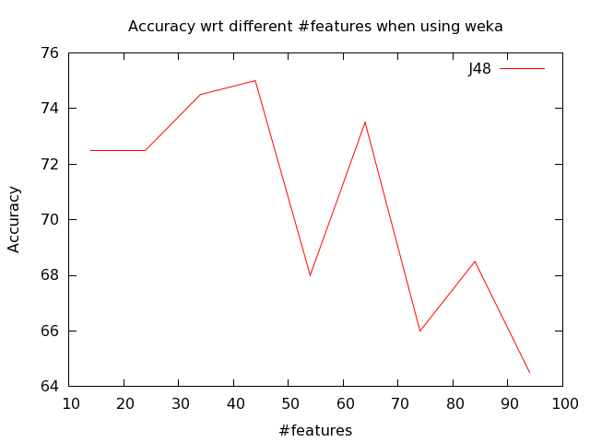
Conclusion: As the number of features increases, the accuracy for J48 is decreasing. Because random irrelevant features is added to the original features

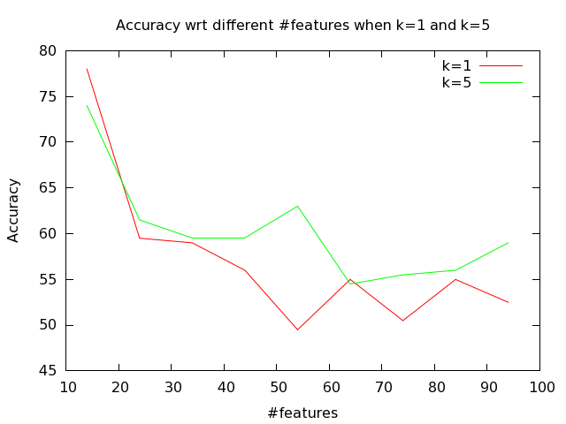
Conclusion: As k increases, the accuracy of KNN algorithm is increasing. Because the increase of k can help eliminate noisy data in data set. Same as J48, as number of features increases, the accuracy is decreasing. Compared to J48, the accuracy as a whole is lower for KNN than J48, especially as number of irrelevant features increases. Some accuracy for KNN goes below 50% which gives us no information than a guess.

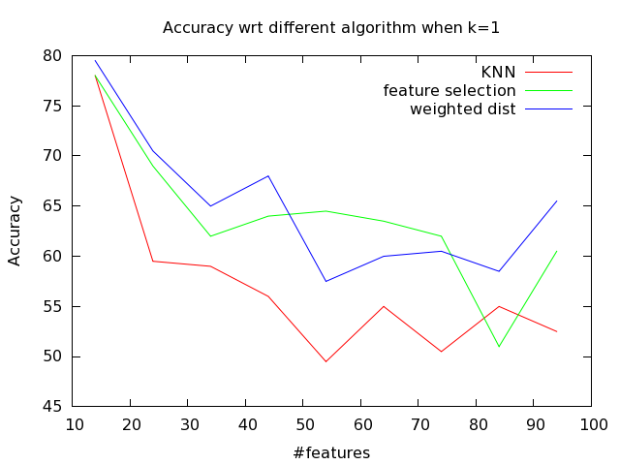
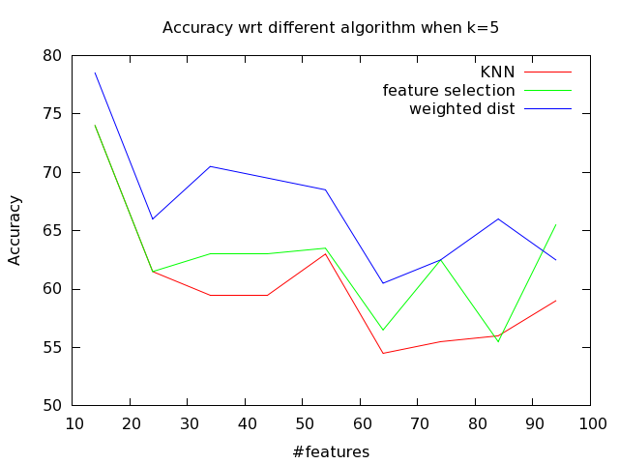

Conclusion: The relief method has better performance than regular KNN. Because the relief method minimizes the noisiness that irrelevant features bring to us. Also, k=5 has better performance than k=1. Weighted distance method is better than feature selection probably because the features that we selected is not the original features. The weighted distance method with k = 5 has almost the same performance as J48 algorithm. M is 10000 for each relief case.

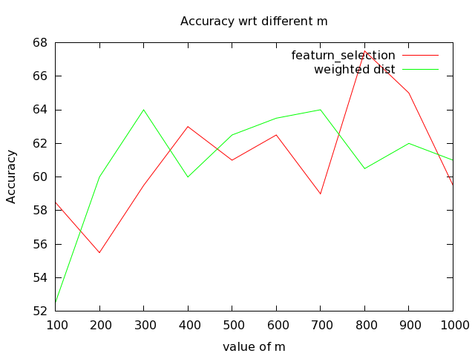
Conclusion: As m increases, the accuracy is increased generally. We actually do not need m to be too large than the training set size, because in that case we just need to consider the weight for each data point once would be enough.

