CprE 381, Computer Organization and Assembly-Level Programming, Fall 2017

Lab 2 Report

Lab Partners Larisa Andrews_________________________________

______________________________________________

______________________________________________

Section /Lab Time _____4-6 Thursday____________________

Refer to the highlighted language in the lab 2 instruction for the context of the following questions.

- [Part 1] Note down the endian-ness (big or little) and total number of instructions executed for each program using the table below. Also, for each test program, attach a screenshot of the terminal output from which you get the [# instructions]. (3 pts)

Test Program | # instructions | Endian-ness
Test-fmath | 53459 | Little
Test-printf | 1813891 | Little
Test-lswlr | 8877 | Little
Test-llong | 29642 | Little
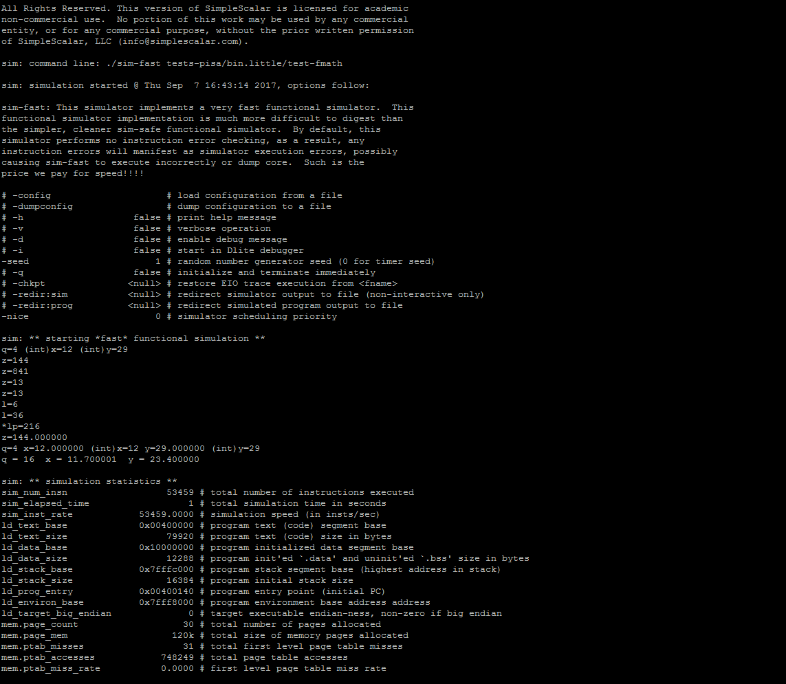
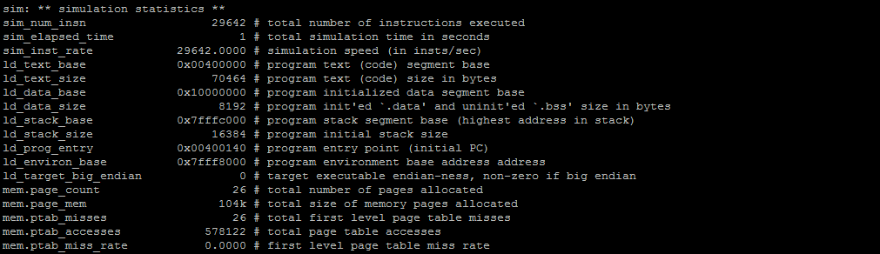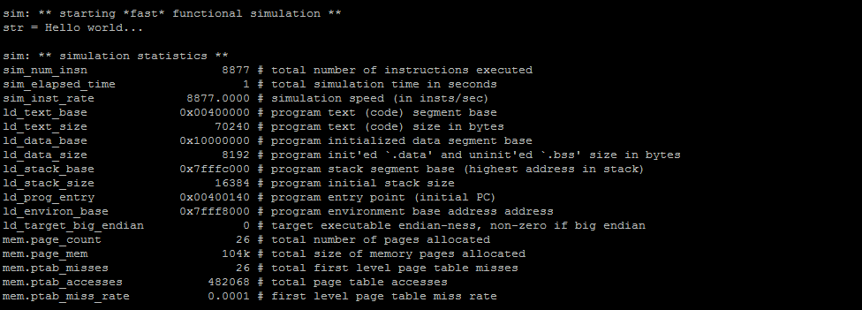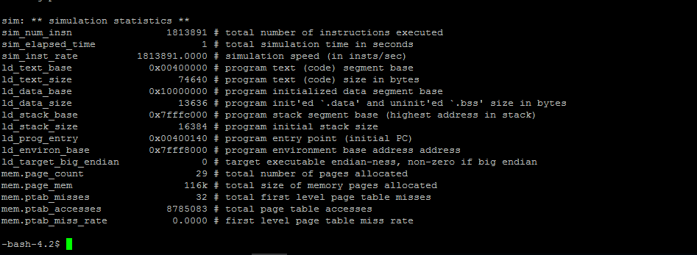
- [Part 2 Section i] Compare # instructions using the table below. Also, find the % reduction in # instructions. For each different level of optimization, attach a screenshot of the terminal output from which you get the [# instructions]. (3 pts)
Program | Optimization level 0  Number of instructions | Optimization level 3  Number of instructions
Math_unopt/math_opt | 2813753 | 1013734
% reduction in the number of instructions: 36%
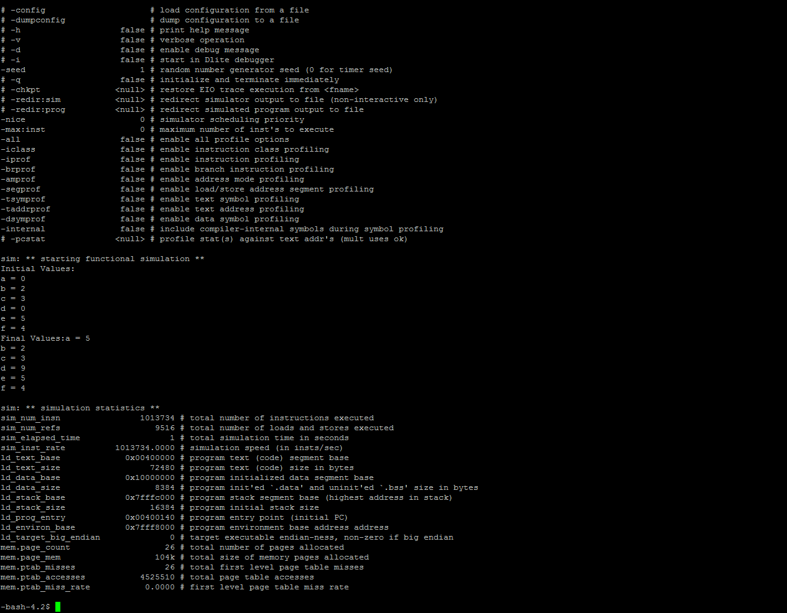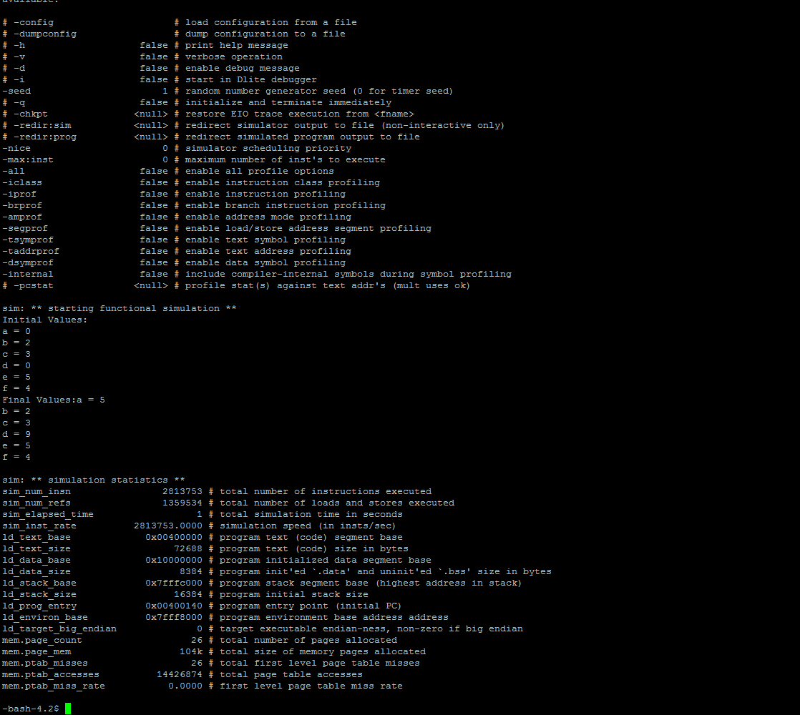

- [Part 2 Section ii] Compare # instructions using the table below. Also, find the % reduction in # instructions. For each different level of optimization, attach a screenshot of the terminal output from which you get the [# instructions]. Also, submit your code as well. (3 pts)

Program | Optimization level 0  Number of instructions | Optimization level 3  Number of instructions
Sort.c | 36855 | 20114
% reduction in the number of instructions: 54%
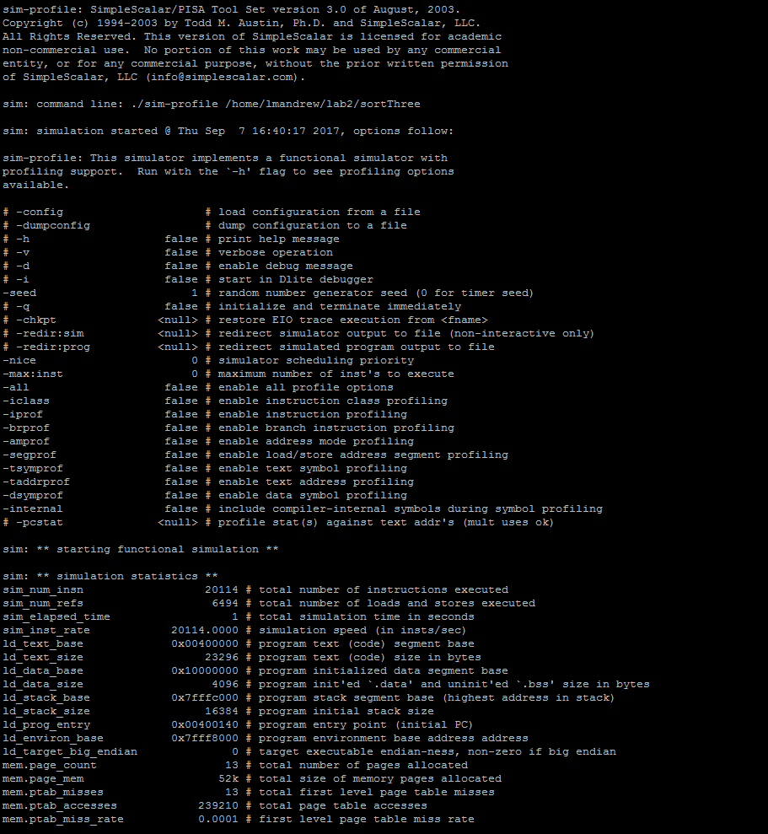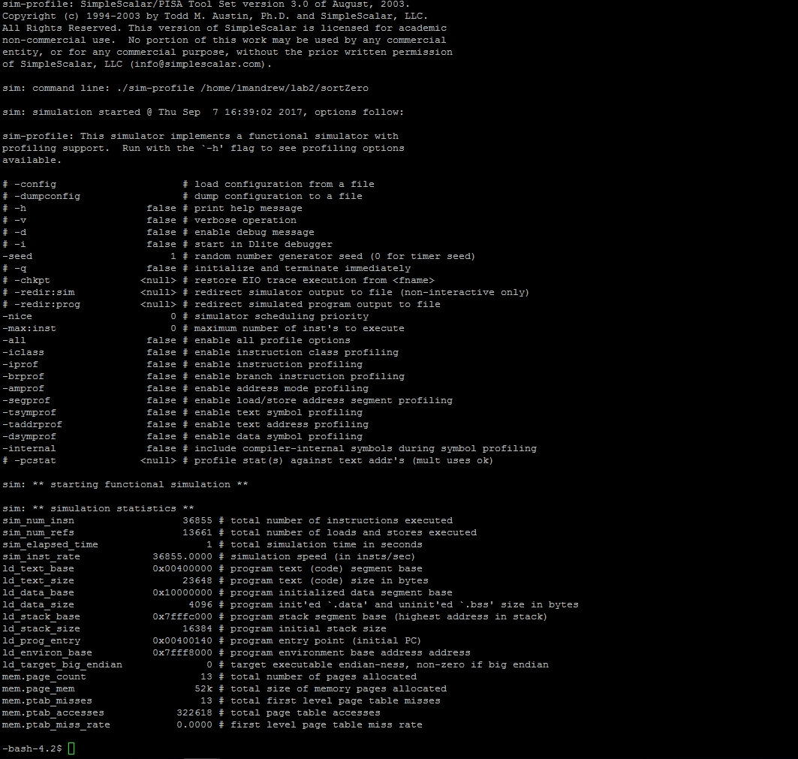

- [Part 3 Section i] Report the CPI and # instructions that you get. Attach a screenshot of the terminal output from which you get [CPI] and [# instructions]. (3 pts)
- Number of Instructions : 420558 CPI: 1.8995
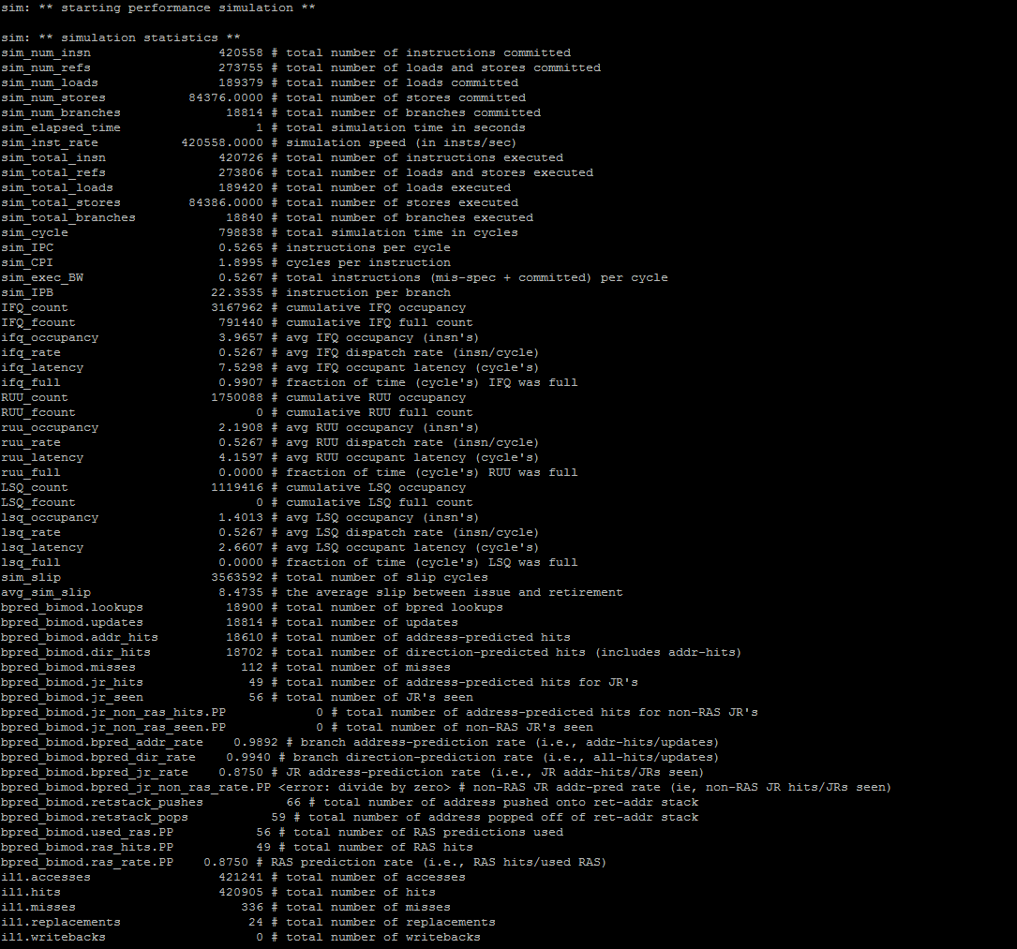

- [Part 3 Section ii] From your understanding of the code in hardware.c, make appropriate changes to the values in config_out file (do not go beyond 8) and report the best CPI. (3 pts)

I did not get a better CPI even with all available changes being 8.

