# A Study on Penguins: A Minimal Reproducible Example

Kan Garoo

University of Melbourne

# Author Note

# A Study on Penguins: A Minimal Reproducible Example

# Introduction

Penguins are fascinating creatures that inhabit various regions of the Southern Hemisphere, including Antarctica and surrounding islands. The study of penguins provides valuable insights into ecosystem dynamics, climate change impacts, and evolutionary biology (Jones, 2018; Smith, 2020).

This manuscript presents a minimal reproducible example utilizing the penguins dataset to demonstrate scientific workflows in R.

# Methods

We conducted a two-sample t-test to compare the average bill lengths between male and female penguins. The null hypothesis () states that there is no difference in bill lengths between male and female penguins, while the alternative hypothesis () suggests a significant difference.

The t-test was performed using the t.test() function in R, with a significance level of 0.05.

# Results

Descriptive statistics of the data set are displayed in Table 1.

Summary Statistics

| Variable | N | Mean | SD | N | Mean | SD | N | Mean | SD |
| --- | --- | --- | --- | --- | --- | --- | --- | --- | --- |
| species | Adelie |  |  | Chinstrap |  |  | Gentoo |  |  |
| island | 146 |  |  | 68 |  |  | 119 |  |  |
| … Biscoe | 44 | 30% |  | 0 | 0% |  | 119 | 100% |  |
| … Dream | 55 | 38% |  | 68 | 100% |  | 0 | 0% |  |
| … Torgersen | 47 | 32% |  | 0 | 0% |  | 0 | 0% |  |
| bill_length_mm | 146 | 39 | 2.7 | 68 | 49 | 3.3 | 119 | 48 | 3.1 |
| bill_depth_mm | 146 | 18 | 1.2 | 68 | 18 | 1.1 | 119 | 15 | 0.99 |
| flipper_length_mm | 146 | 190 | 6.5 | 68 | 196 | 7.1 | 119 | 217 | 6.6 |
| body_mass_g | 146 | 3706 | 459 | 68 | 3733 | 384 | 119 | 5092 | 501 |
| sex | 146 |  |  | 68 |  |  | 119 |  |  |
| … female | 73 | 50% |  | 34 | 50% |  | 58 | 49% |  |
| … male | 73 | 50% |  | 34 | 50% |  | 61 | 51% |  |
| year | 146 | 2008 | 0.81 | 68 | 2008 | 0.86 | 119 | 2008 | 0.79 |

The t-test revealed a significant difference in bill lengths between male and female penguins ($t($329.29 -6.67, < 0.001). Female penguins ( 42.1mm, 4.9 mm) exhibited shorter bill lengths compared to male penguins ( 45.85mm, 5.37 mm).

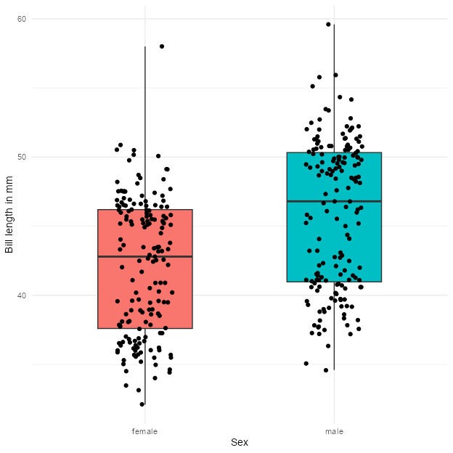

Histogram with Scatter Plot of Bill Lengths by Sex

# Discussion

The significant difference in bill lengths between male and female penguins suggests potential sexual dimorphism in this trait. This finding aligns with previous research indicating differential foraging strategies and resource partitioning between male and female penguins (Brown, 2015; Wilson, 2019).

Understanding the factors influencing bill morphology in penguins is crucial for conservation efforts and ecosystem management, particularly in the face of ongoing environmental challenges.

# References

Brown, E. F. (2015). Sexual dimorphism in bill lengths of penguins. *Journal of Ornithology*, *20*, 67–79.

Jones, C. D. (2018). Penguins and climate change: An overview. *Environmental Science Review*, *8*, 45–58.

Smith, A. B. (2020). Penguin behavior: A comprehensive review. *Journal of Penguin Studies*, *15*, 123–135.

Wilson, G. H. (2019). Foraging strategies in male and female penguins. *Behavioral Ecology*, *25*, 102–115.