# How-To Guide

Environmental Discover using the survey inputs

Contents

How-To Guide 1

Workflow 1

Steps 1

Survey form link 1

Extract survey Results 2

Run scripts 3

Python Details 3

## Workflow

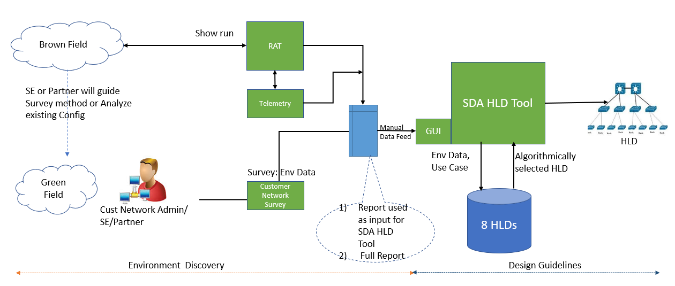

## Steps

* Customer/Partner fills in the survey form
* Extract survey information
* Run python scripts on this survey data to get the full report and input to HLD tool

### Survey form link

<https://www.ciscofeedback.vovici.com/se/6A5348A7320FAA8B>

### Extract survey Results

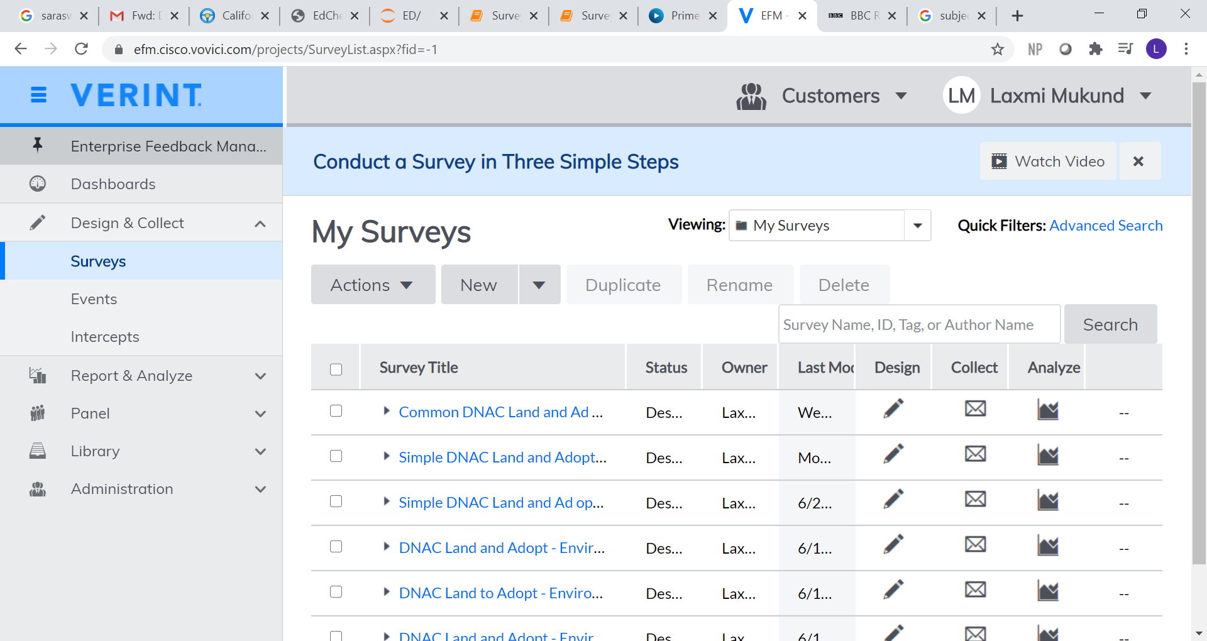

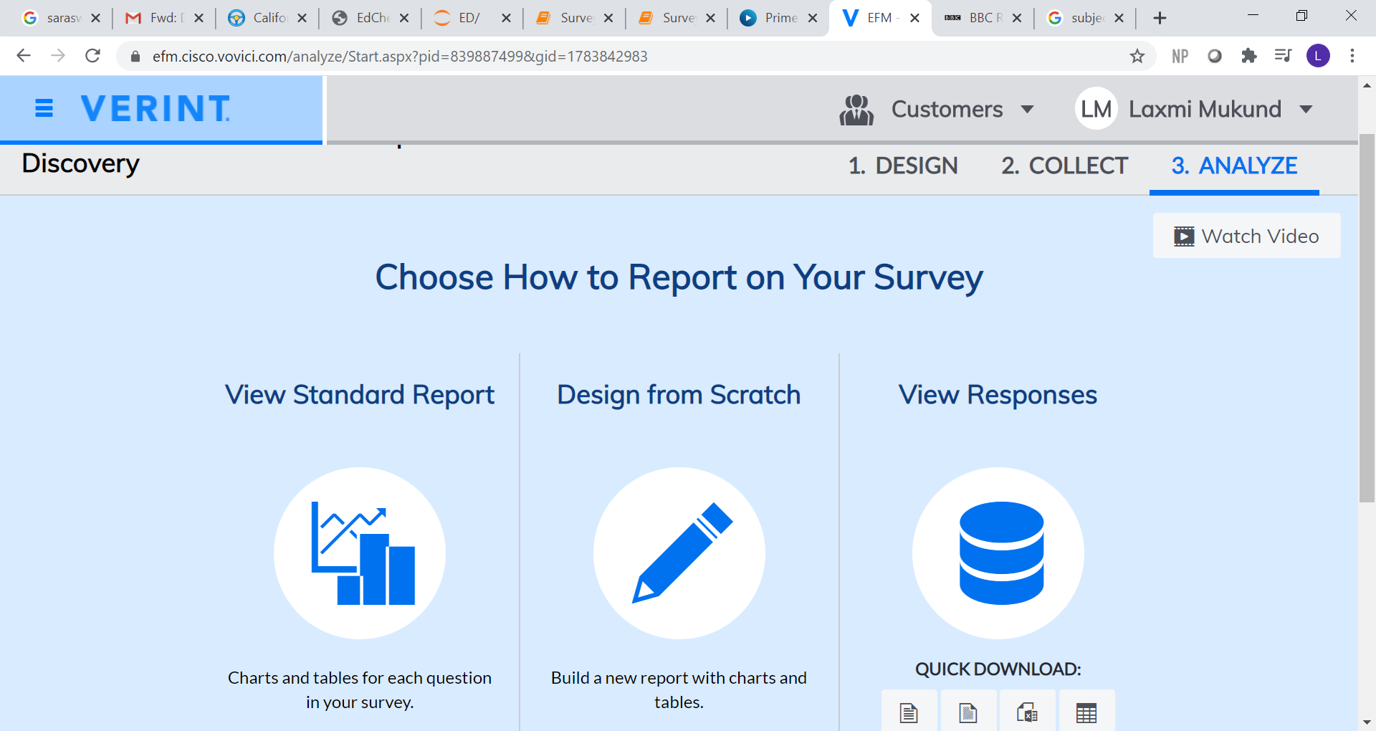

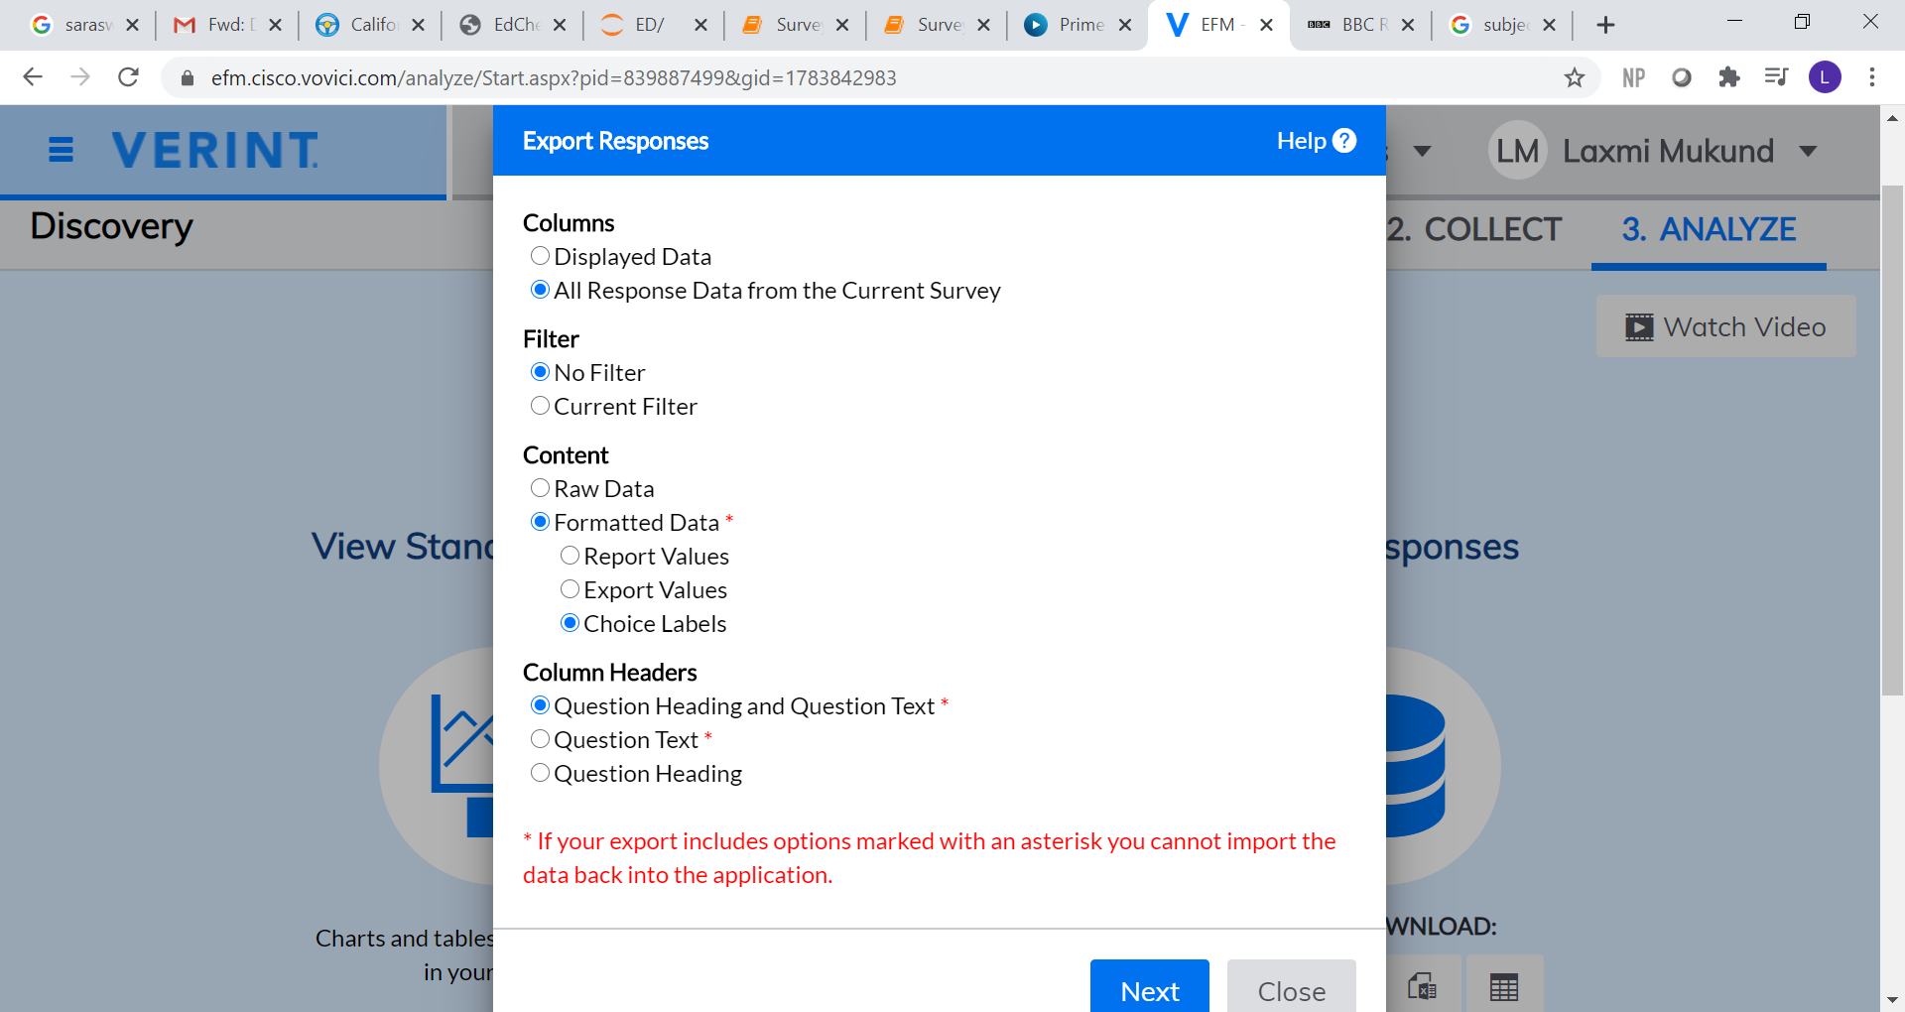

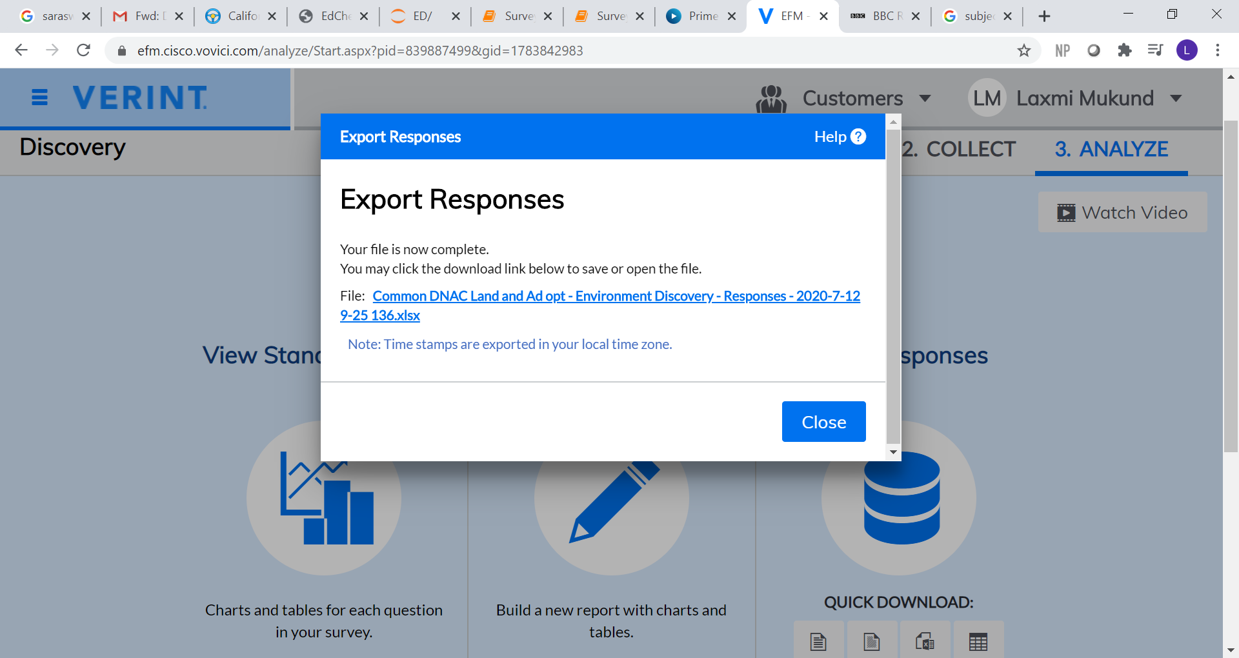

### Run scripts

Survey-Full-Report-Final.exe <Common DNAC Land and Ad opt - Environment Discovery - Responses - 2020-7-12 9-25 136 .xlsx>

Survey-HLD-Answers-Final.exe <Common DNAC Land and Ad opt - Environment Discovery - Responses - 2020-7-12 9-25 136 .xlsx>

Output files will be generated per customer

* SDA_HLD_input_<company name>
* SurveyReport_<company name>

## Python Details

* Create and test ipynb (jupyter notebook file)
* Convert it into py
  + jupyter nbconvert --to script Survey-Full-Report-Final.ipynb
    - Survey-Full-Report-Final.py
* Convert it to exe
  + pyinstaller --onefile Survey-Full-Report-Final.py --hiddenimport=pandas
    - dist/Survey-Full-Report-Final.exe
* Run Survey-Full-Report-Final.exe
  + C:\Users\lmukund\opencv\Scripts\ED\Final_Survey_Scripts\dist>Survey-Full-Report-Final.exe

This program is designed to create Environmental Discovery Reports for all

customers who have taken the survey

The output will be files named as SurveyReport_<customer name>.pdf for each customer

Please enter the full path and name of survey results xls file:

(Have the excel in the same directory (or give full path))