Luke Munro
Applying Machine Learning
- Debugging a learning algorithm
  - More training examples
  - Smaller set of features
  - Additional features
  - Polynomial features
  - Modify (+/-) λ
- Diagnostic – Test to gain insight what is/isn’t working, figure out how to best improve performance
- Evaluating a Hypothesis
- Breaking training set
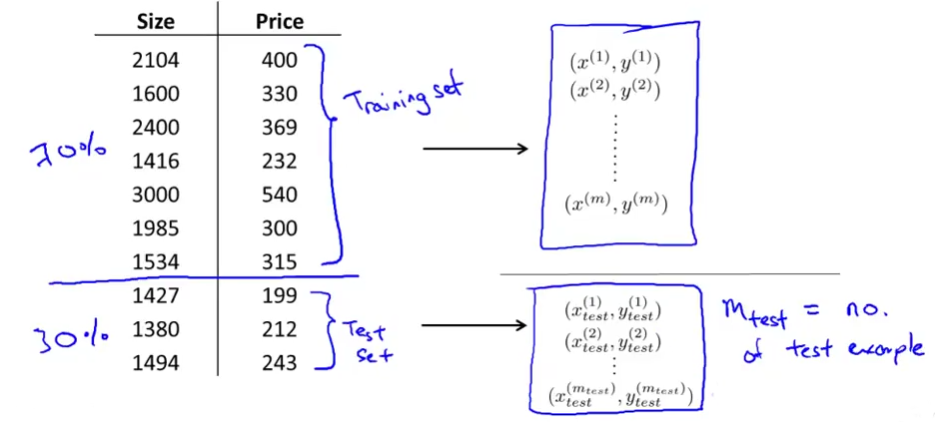
  - Randomly reorder before putting data in sets
  - Procedure for linear regression
    - Learn parameters θ from training set
    - Compute test set error
      - Same as cost function
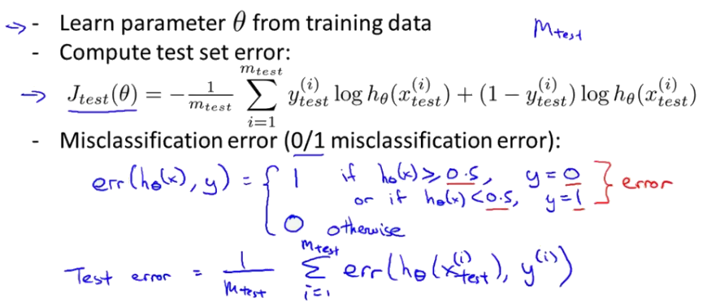
  - Procedure for logistic regression
Model Selection
- d = degree of polynomial
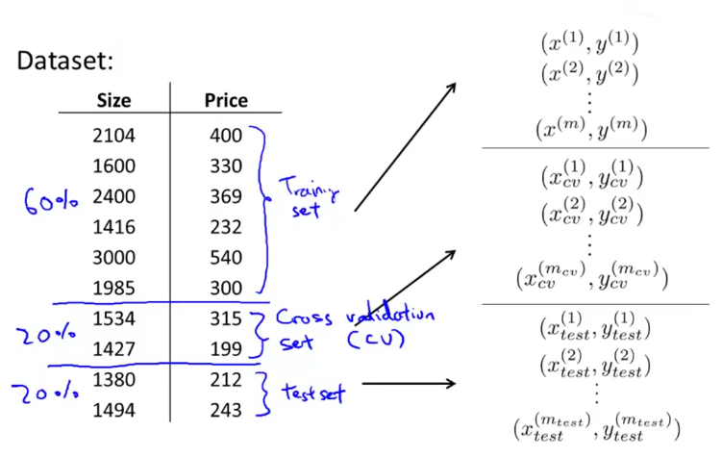
  - Test different values of d – find the error of each
- Split data set into 3 sections – Training/Validation/Test Sets
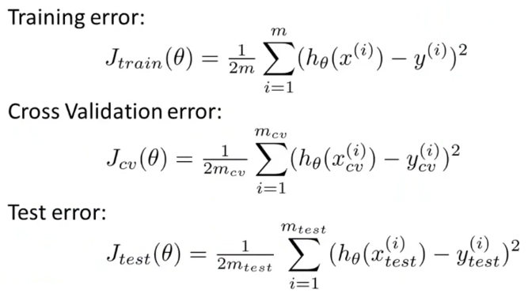
- Use CV error set to select model – choosing d
  - Don’t use training
  - Regularization (λ) not included in cost calculation – only needed for gradient descent

Diagnosing Bias vs. Variance
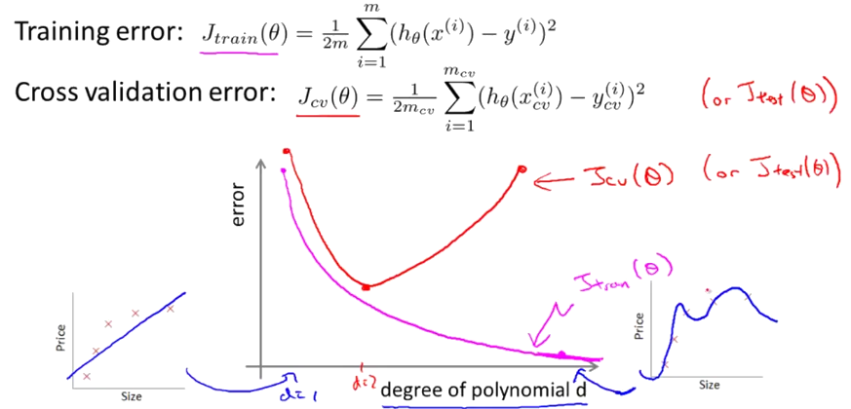
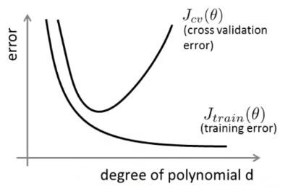
- Bias (underfit)
  - High J_{train}(Θ)
  - J_{cv}(Θ) ~ J_{train}(Θ)
- Variance (overfit)
  - Low J_{train}(Θ)
  - J_{cv}(Θ) >> J_{train}(Θ)
  - (>> much greater than)
- Choosing regularization parameter λ
  - Pick λ that gives lowest CV error
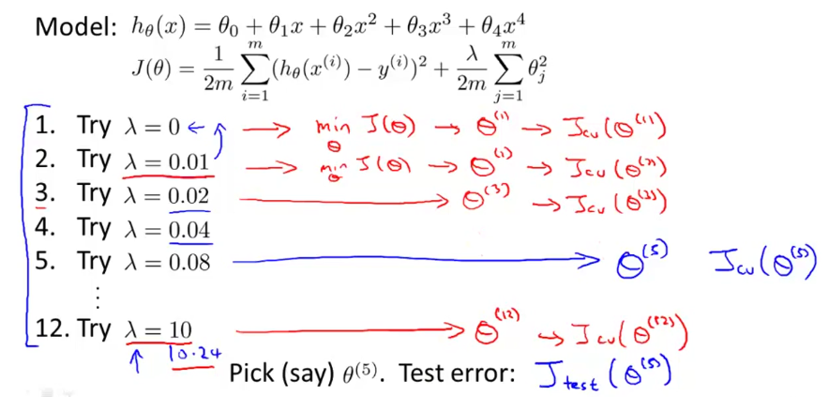

- Bias/variance as a function of λ
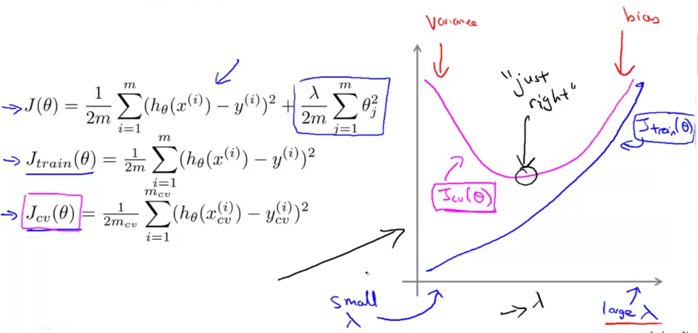
Learning Curves
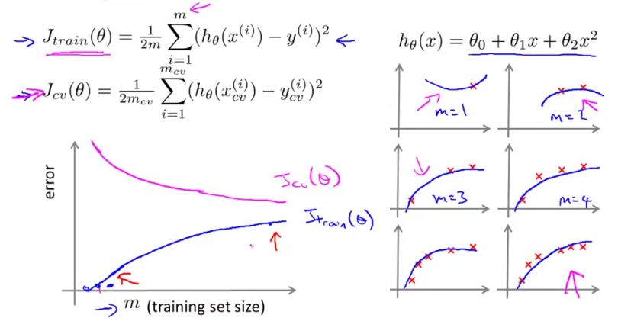
- How more data effects high bias and high variance
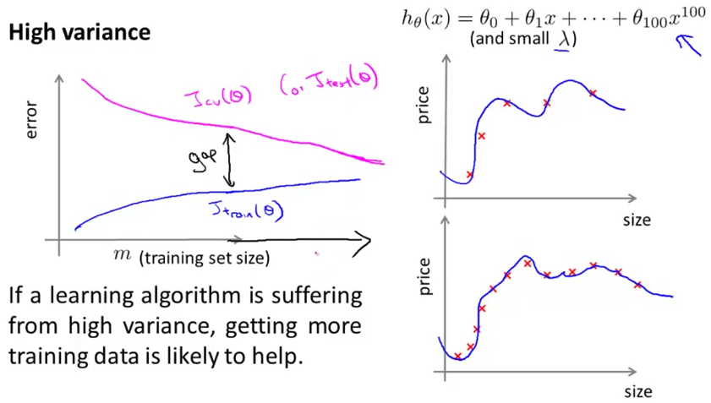
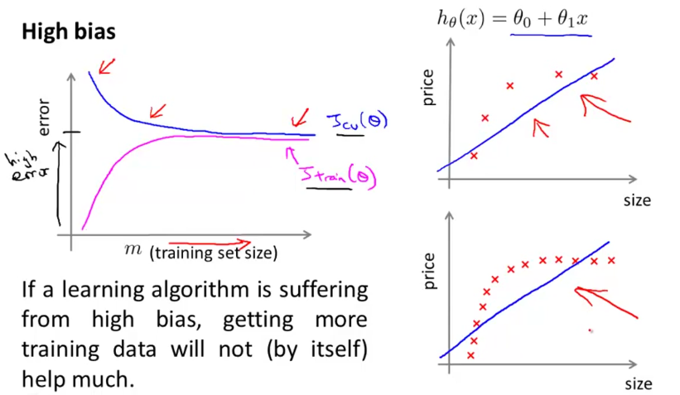

Deciding What to do Next
- Get more training examples – fixes high variance
- Try smaller set of features – fixes high variance
- Try getting additional features – fixes high bias
- Try adding polynomial features – fixes high bias
- Try decreasing λ
- Try increasing λ
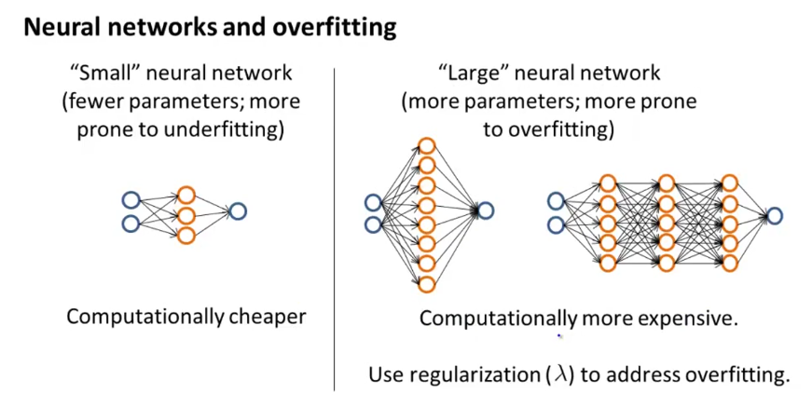

System Design
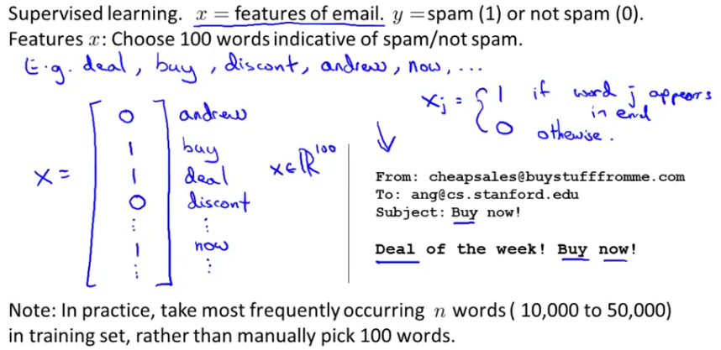
- Building a Spam classifier
- How should you pick your approach?
- From data
- Gut feeling

- Recommended Approach
  - Start with simple algorithm. Implement and test of CV data.
  - Plot learning curves to decide if more data, features, etc. will help
  - Error analysis: Manually examine examples (in CV) that algorithm made errors on. Spot systematic trends in what type of examples errors are made on.
- Importance of Numerical Evaluation
  - Stemming software
    - Looks just at first chars of word – discount/discounts/discounted/discounting
    - Can misclassify though – universe/university
- Run with and without stemming – pick minimal error
Error Metrics for Skewed Classes
- Cancer classification (y = 1 cancer, y = 0 otherwise)
  - 99% correct diagnoses 1% error – 0.5% of patients have cancer
  - Always returning y = 0 has less error
- Different evaluation – error calculation
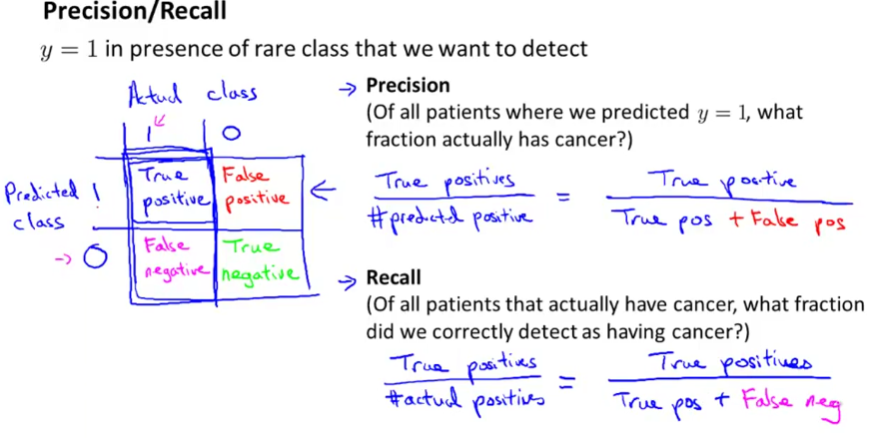
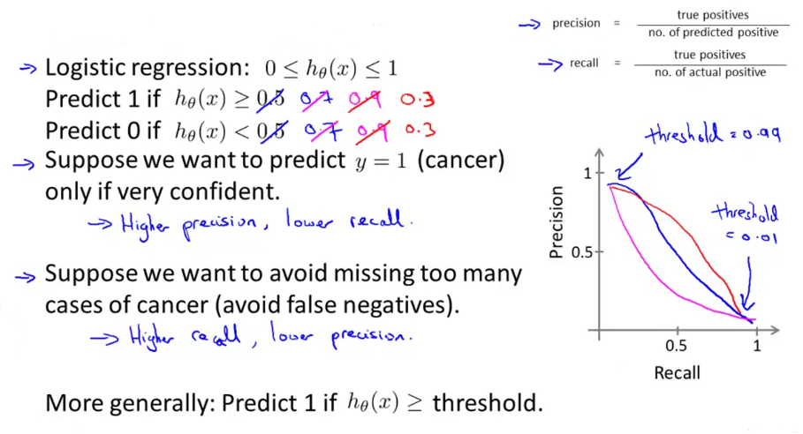
- Trade Offs – Precision and Recall

- Comparing precision/recall values?
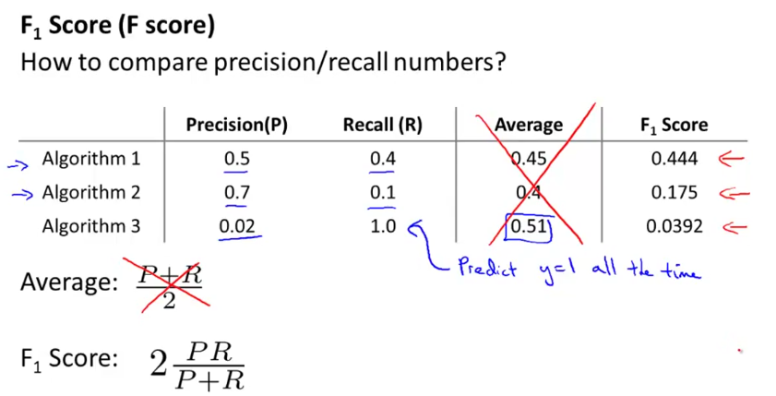
Large Data Sets
- “It’s not who has the best algorithm that wins. It’s who has the most data.”
- Large data rationale – Obtain low bias and variance algorithm
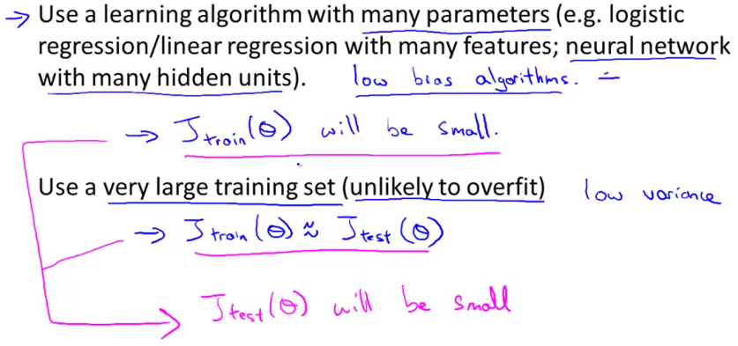
- Test can data accurately predict y – Can a human expert do it?

