Luke Munro
Machine Learning Notes

Supervised Learning – Right answers given
- Regression – Predict continuous valued output
- Classification Problem – Discrete valued output (0, 1, 2, 3, etc)
- Infinite number of features to determine outcome
Unsupervised Learning – answers are not given
- Clusters like elements
- Approach problems with no idea what results would look like.
- Derive structure from data where we don’t necessarily know the effect of the variables.
- Derive structure by clustering data based on relationships among the variables in the data.
Model Representation
- Training Example – (x^{(i)},y^{(i)}). (x^{(i)},y^{(i)}); I = 1, …, m – Training Set
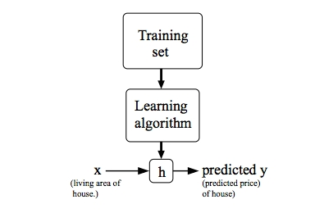
- Supervised Learning Problem – Given a training set. Learn a function h(x) such that
- h(x) → Y is a good prediction. H is called a hypothesis => yˆ=h_{θ}(x)=θ₀+θ₁x
- Cost Function – (average difference squared)/2. Referred to as “Squared error function” or “Mean squared error”
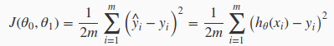

- ½ added for convenience for the computation of gradient descent, the derivative of the function will cancel out the ½.

Gradient Descent – Objective: find minimum for Cost Function
- alpha – learning rate
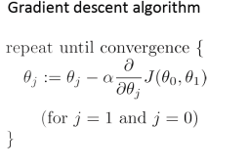
- batch – entire set of examples
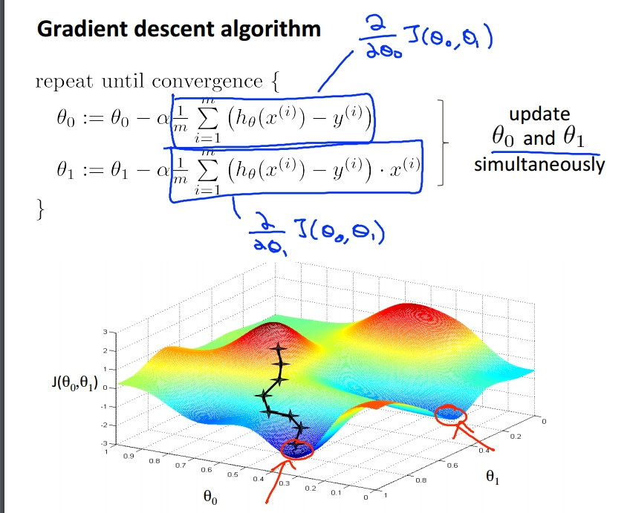

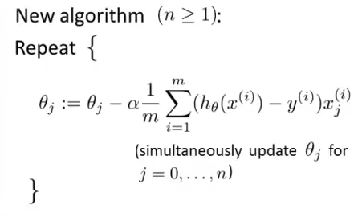
Multivariable Linear Regression
- Notation for data
  - n = number of features
  - x^{(i)} = input (features) of i^{th} training example
  - x^{(i)}_{j} = value of feature j in i^{th} training example
- h_{θ} (x) = θ^{T}x (T - transposed)
  - h_{θ} (x) = θ₀ + θ₁x₁ + θ₃x₃ + θ₃x₃ + . . . + θ_{n}x_{n}
- Feature Scaling – make features on a similar scale. For faster convergence.
- Every feature approximately -1 <= x_{i} <= 1
- Mean Normalization – replace x_{i} with x_{i} - u_{i} (make features have approximately zero mean. Not applied to x₀ = 1)
  - x_{i} = (x_{i} - u_{i} ) / (s_{i}) (where s_{i} is range (max – min) or standard deviation)
- Normal Equation – Find all θ to minimize J(θ)
  - θ = (X^{T}X)⁻¹X^{T}y why????
  - Use for if n < 10⁶

Classification
- y = {0, 1} => 0: “Negative Class” (benign tumor) 1: “Positive Class” (malignant tumor)
- Logistic Regression
  - h_{θ} (x) = g(θ^{T}x) or g(z) = 1/(1+e^{-z})
  - h_{θ} (x)= P(y = 1|x; θ) => returns probability y = 1, given x, parameterized by θ
  - h_{θ} (x) = 1/(1 + e^{-(θ^T x)})

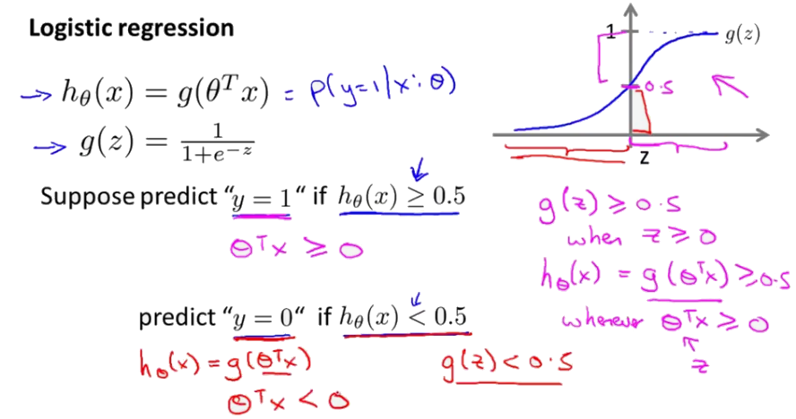

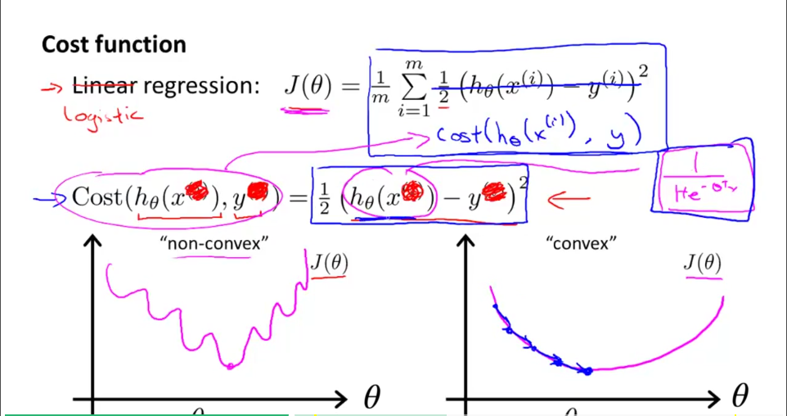
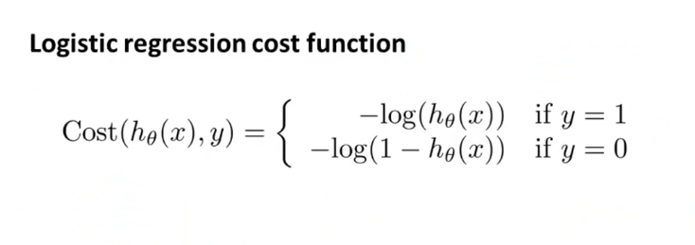
  - Using this Cost(h_{θ} (x), y) you get a non-convex curve since sigmoid function non linea
  - Use for convex
cost function:

- For -log(h_{θ} (x)) – y = 1
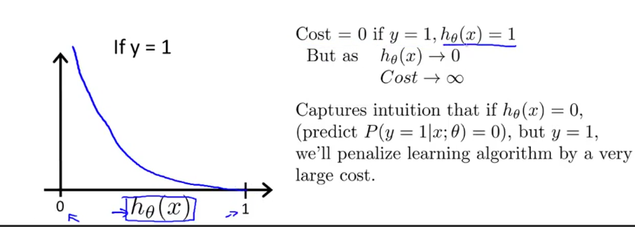
- For -log(h_{θ}(x)) – y = 0
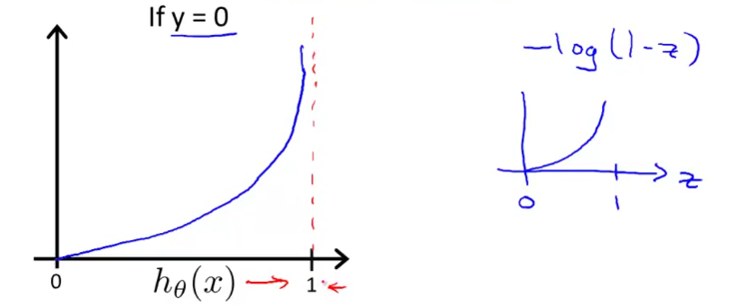

Optimization Algorithm
  - Gradient Descent (same as before)
  - Logistic Regression cost function

  - Cost(h_{θ}(x), y) = – ylog(h_{θ}(x)) – (1 – y)log(1 – h_{θ}(x))
    - If y = 1: Cost(h_{θ}(x), y) = – log(h_{θ}(x))
    - If y = 0: Cost(h_{θ}(x), y) = – log(h_{θ}(x))
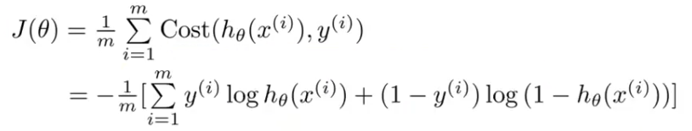
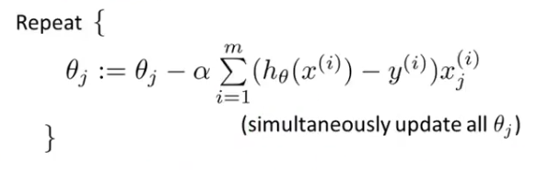
- Equation for Gradient Descent
  - Same except:
h_{θ} (x) = 1/(1 + e^{-(θ^T x)})
Advanced Optimization
- Optimization algorithms
  - Gradient descent, Conjugate gradient, BFGS, L-BFGS
    - Advantage: pick alpha autmoatically, converge faster Disadvantage: more complex
- fminunc(FCN, X0, OPTIONS)
Multiclass Classification
- More than 1 or 0 output… (0, 1, 2, 3… etc.)
- One-vs-all (one-vs-rest) – treat all other outputs as other (0 = 0 | 1, 2, 3 = 1) repeat for each
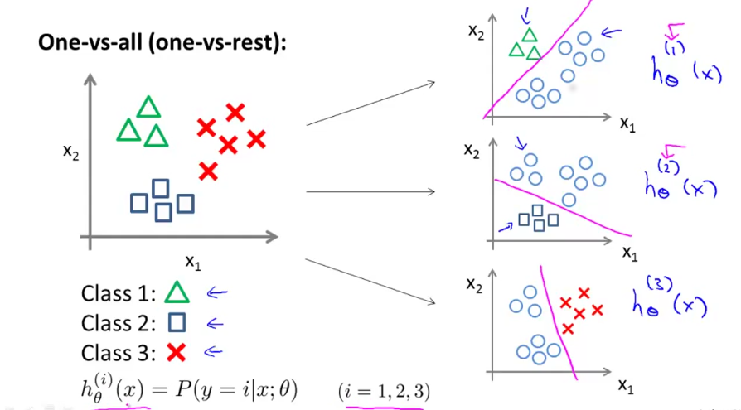
Train a logistic regression classifier
h_{θ} ^{i}(x) for each class i to predict the probability that y = I

- For new input x, pick whichever h_{θ} ^{i}(x) that returns highest probability
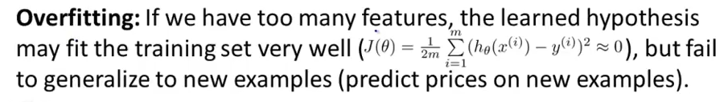
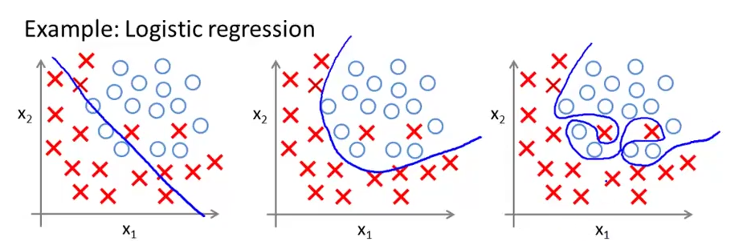
Addressing Overfitting
- Reduce # of features
  - Manually select or Model selection algorithm
- Regularization
  - Keep all features, reduce magnitude/values of parameters θ_{j} removes higher order polynomials
  - Works well with many features, each contribute slightly to the prediction
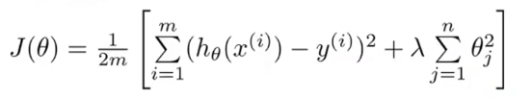
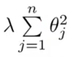
  - Regularization term – increases cost thus shrinking
influence of parameters (n = #features)
  - θ₀ not included – stays constant
- λ = regularization parameter
  - Controls balance: fitting the data well and keeping the parameters small to avoid overfitting

Regularized Linear Regression
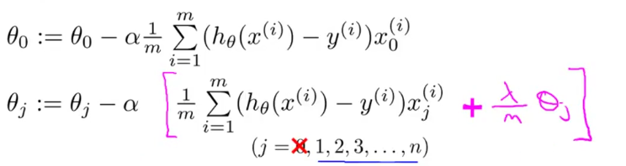
- Gradient Descent from regularized cost function
Repeat {
}
- Expanded
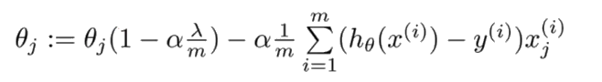
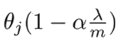
  - Same as non-regularized except for
    - 1 - αλ /m < 1
    - Shrinks θ_{j} => 0.99 * θ_{j}
Normal Equation w/ Regularization
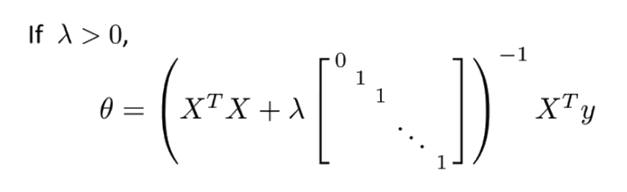

- Careful with m <= n (#examples less than or equal to #features)
  - Non-invertable, degenerative (research this)

Regularized Logistic Regression
- Same as linear. EXCEPT: h_{θ} (x) = 1/(1 + e^{-(θ^T x)}) and signs
- Optimization Function - fminunc(FCN, X0, OPTIONS)
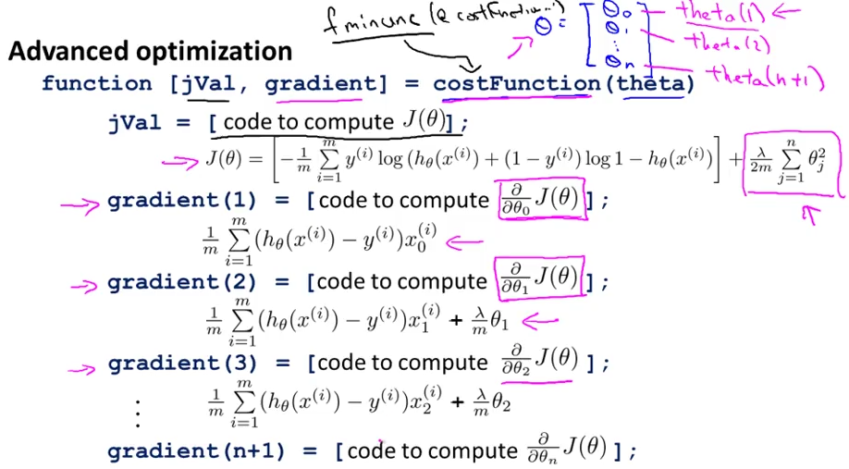
- Quadratic terms (x_{i} x_{j}) for non-linear h_{θ} (x)
  - Binomial expansion – C(m×n,2)
  - 100 x 100 pixels. Find # of quadratic terms (x_{i} x_{j}) => 50 million (5 x 10⁷)

