Luke Munro
Neural Networks
- The “one learning algorithm” hypothesis
  - Rewire sense to different part of the brain. Brain will adapt to utilize that sense Ex. Seeing tongue, frog with 3rd eye
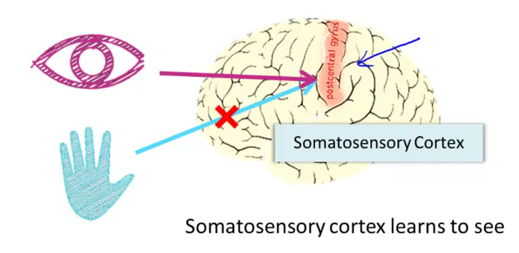

- Goal – create algorithm that can do the same, that can adapt
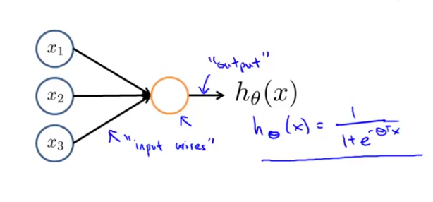
Model Representation
- Neuron Model: Logistic Unit
  - Sigmoid (logistic) – activation function
  - x₀ = 1 “bias unit” there but not included
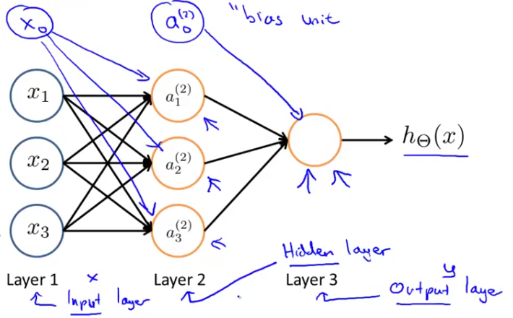
- Neural Network – Multiple neuron and levels
  - a_{i}^{(j)} = “activation” of unit i in layer j
  - Θ^{(j)}= matrix of θs (weights) controlling function mapping from layer j to j+1

a₁⁽²⁾ = g(Θ₁₀⁽¹⁾x₀ + Θ₁₁⁽¹⁾x₁ + Θ₁₂⁽¹⁾x₂ + Θ₁₃⁽¹⁾x₃)
a₂⁽²⁾ = g(Θ₂₀⁽¹⁾x₀ + Θ₂₁⁽¹⁾x₁ + Θ₂₂⁽¹⁾x₂ + Θ₂₃⁽¹⁾x₃)
a₃⁽²⁾ = g(Θ₃₀⁽¹⁾x₀ + Θ₃₁⁽¹⁾x₁ + Θ₃₂⁽¹⁾x₂ + Θ₃₃⁽¹⁾x₃)
h_{Θ}(x) = a₁⁽³⁾ = g(Θ₁₀⁽²⁾a₀⁽²⁾ + Θ₁₁⁽¹⁾a₁⁽²⁾ + Θ₁₂⁽¹⁾a₂⁽²⁾ + Θ₁₃⁽¹⁾a₃⁽²⁾) – Θ is 3x4
If network has s_{j} units in layer j, s_{j+1} units in layer j + 1, then Θ^{(j)} will have dimensions s_{j+1} * (s_{j} + 1).
- Forward propagation: Vectorized implementation
  - z₁⁽²⁾ = Θ₁₀⁽¹⁾x₀ + Θ₁₁⁽¹⁾x₁ + Θ₁₂⁽¹⁾x₂ + Θ₁₃⁽¹⁾x₃ = Θ⁽¹⁾(a⁽¹⁾ or x)
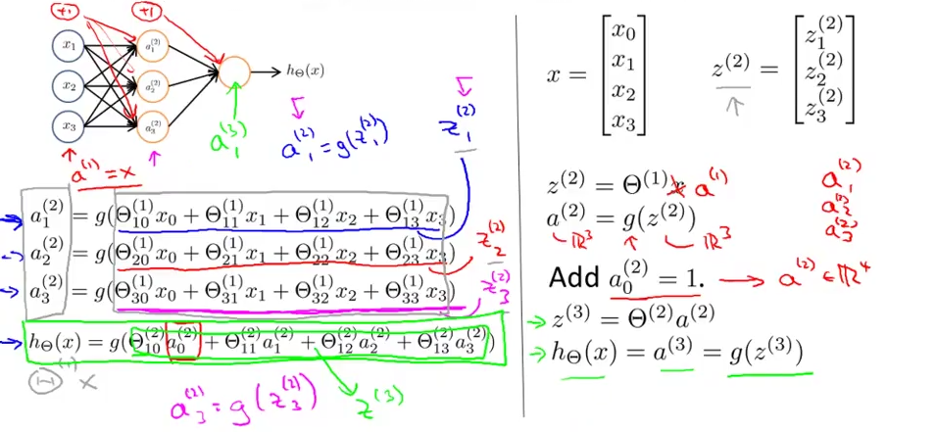
- Examples – New notation for classification XOR, XNOR, AND
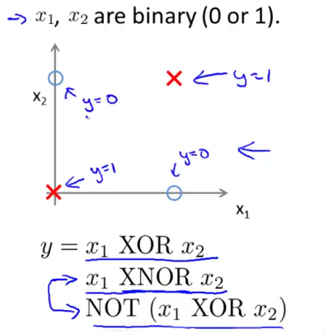
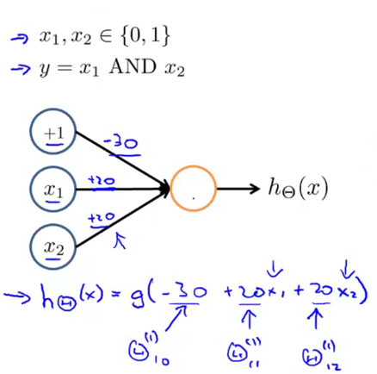

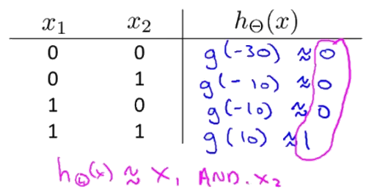

- Neural network computes the same as logical operators
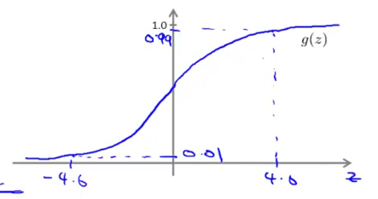
  - Sigmoid functions for examples
  - h(Θ) = g(z) = X₁ & X₂
  - h = ~1 if z > 4 | h = 0 if z < -4

- Logical operators, if, else – created from sigmoid/classification with z statement expression
  - Return 1 if true 0 if false through sigmoid function
    - Run through layers to determine a final solution/answer
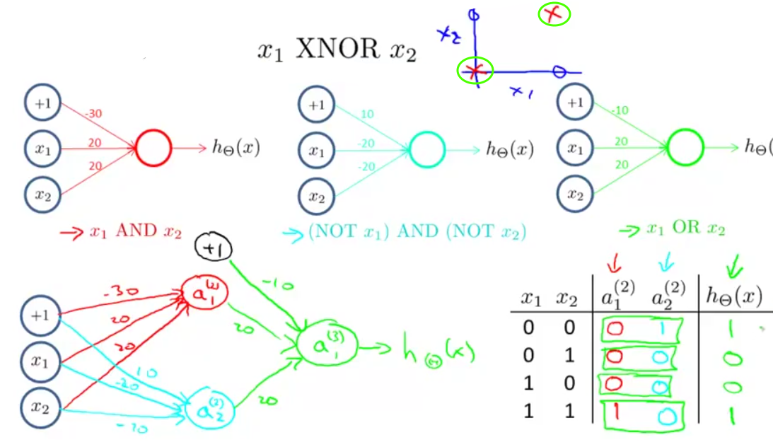
x₁ XNOR x₂ = (x₁ AND x₂) OR ((NOT x₂ ) AND (NOT x₁ ) )
Multiclass Classification
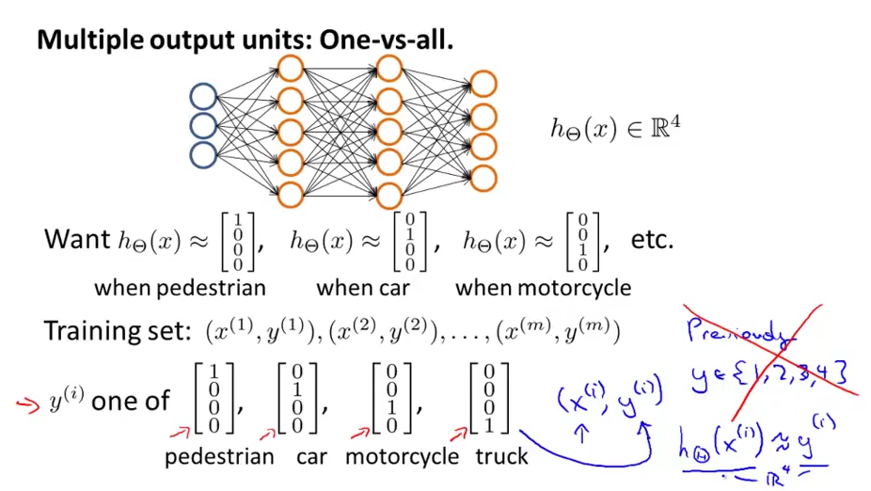
    - h_{Θ}(x) = y is now a matrix of probabilities for classification output
    - Θ⁽³⁾ is a 3 x 6
    - Why does sum of layer not equal 1

Neural Network Learning
- Notation
  - L = total # of la yers in network
  - s_{l} = # of units (not counting bias unit) in layer l
  - K = classes of output. Output is a k dimensional vector
- Cost Function – Sum of all outputs K
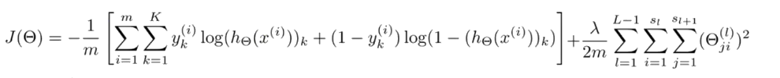
- Gradient Computation
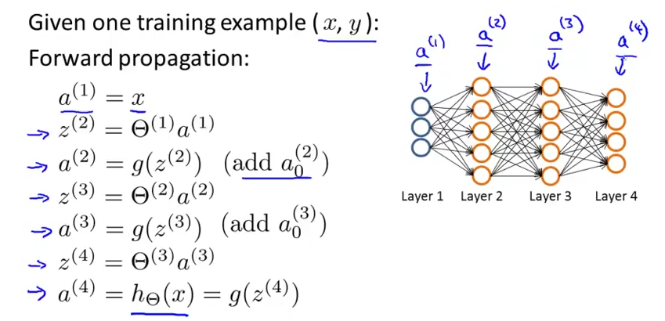
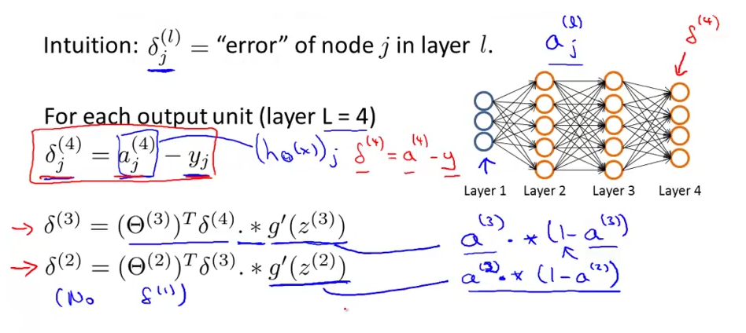
- Backpropagation algorithm – delta 3 how?
- Complete Algorithm. Wow
  - Forward propagation to compute a then go back
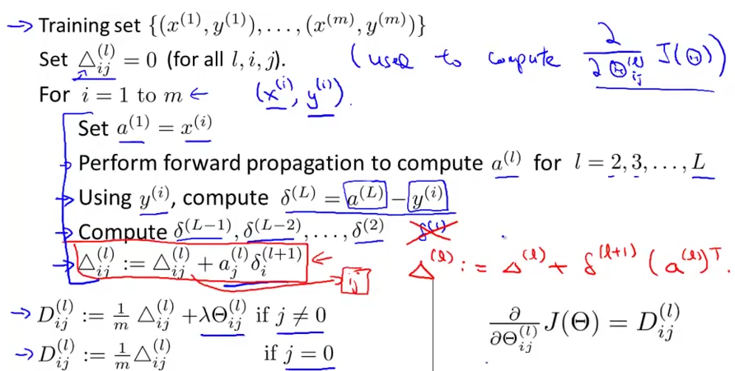
  - Stepping Through – Forward Propagation
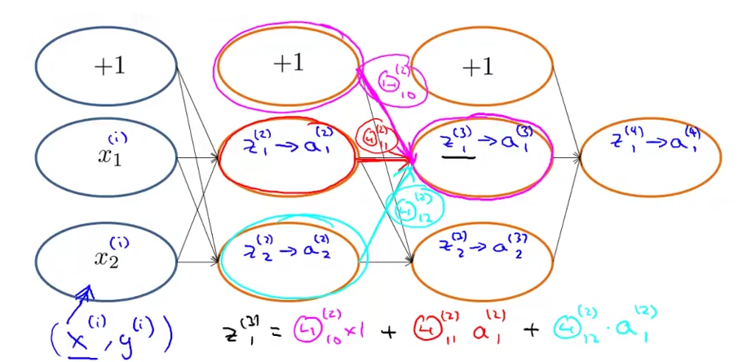
- Stepping Through – Backpropagation error
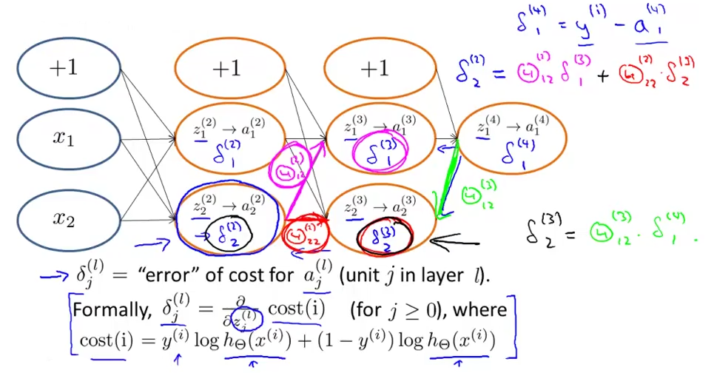

Advanced Optimization
- Unrolling/Rerolling Parameters
  - function [jVal, grad] = costFunction(theta)
  - grad & theta were vectors n x 1
  - Matrices for Neural Networks – Unroll into vectors to use ( : )
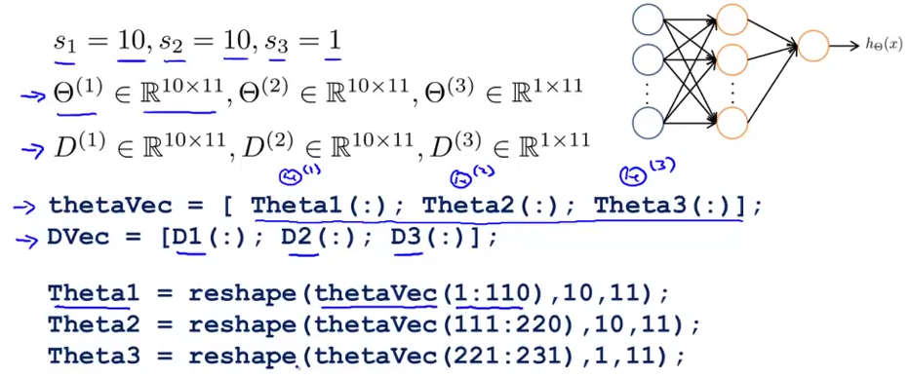
- Gradient Checking
  - Use J(θ) and ε to estimate
  - gradApprox = (J(theta + EPSILON) – J(theta – EPSILON)) / (2*EPSILON)
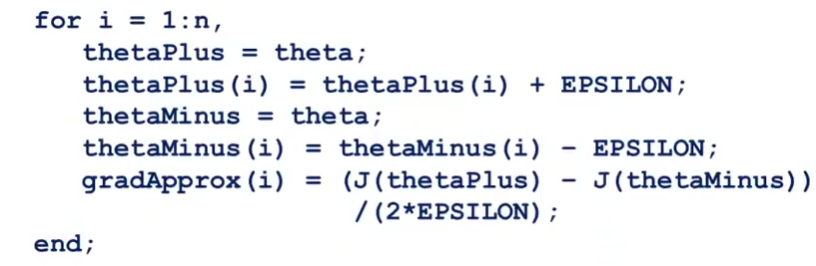
- Random Initialization
  - All same features (theta – 0) without
  - Symmetry Breaking – Initialize each weight to random value from [- ε, ε] (different ε – not related)
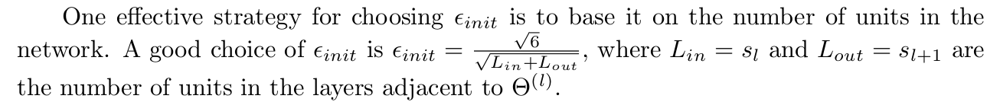
  - Theta1 = rand(10, 11) * (2 *INIT_EPSILON) – INIT_EPSILON

- Training the Networks
  - Picking architecture (# hidden layers)
    - Default to 1 hidden layer. If >1, have same no. of units in each
- Randomly initialize weights
- Implement forward propagation to get h_{Θ}(x^{(i)}) for an x^{(i)}
- Implement code to compute cost function J(Θ)
- Implement backpropagation to compute partial derivatives
for I = 1:m:
Forward propagation, backpropagation for each examples
Compute a^{(l)} and delta terms for δ^{(l)} for l =2 …. L
Grad^{(l)} += α * (δ^{(l+1)}a^{(l)}) – Must be averaged for m = size of data set
5. Use gradient checking to compare gradient computed use backpropagation vs. the numerical estimate
then disable the gradient checking code
6. Use gradient descent or other advanced optimization method with backpropagation to try to minimize J(Θ) as a function of parameters Θ

