Luke Munro
Support Vector Machine
- Alternate View of Logistic Regression
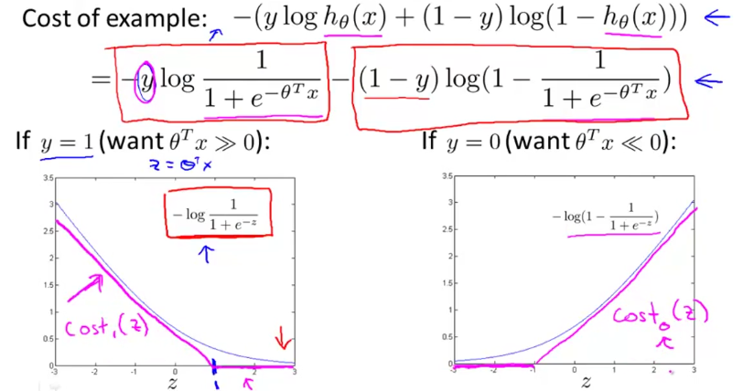
- Changing the cost function for SVM
  - Cost function is now linear
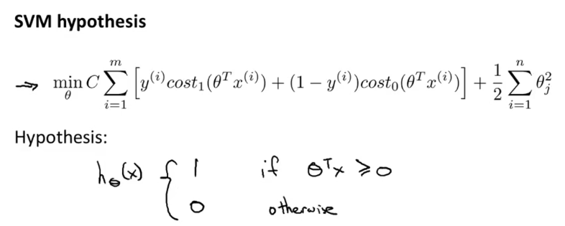
- Hypothesis only has binary outputs for SVM
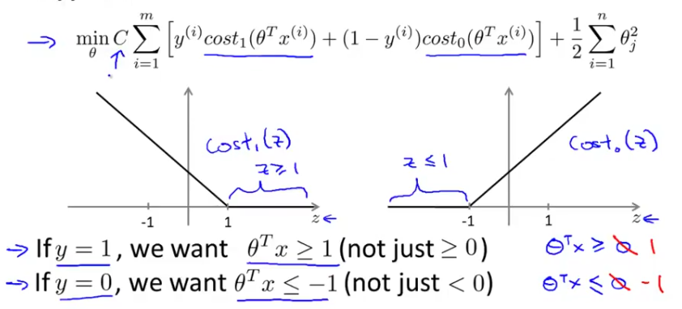
  - Threshold = 1

  - One half of cost function will be 0 other is linear

- SVM Decision Boundary
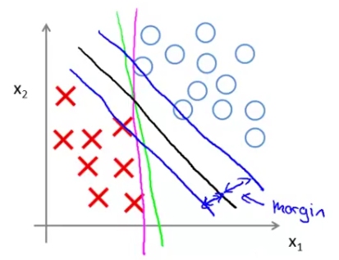
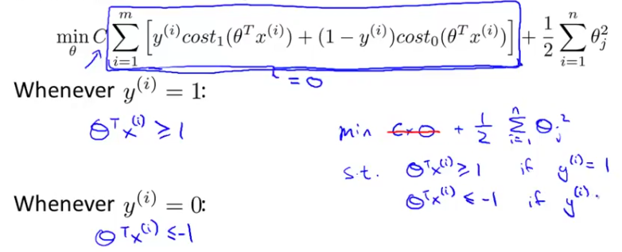

  - Linearly separable case
  - Referred to as Large Margin Classifier
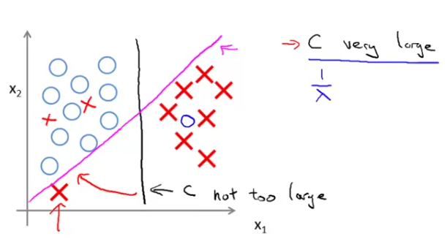
- Vulnerable to outliers
  - Assign a large value for C would change black line to purple
  - Small value of C would not
    - Ignore outliers
- Think of cost function’s 2 parts

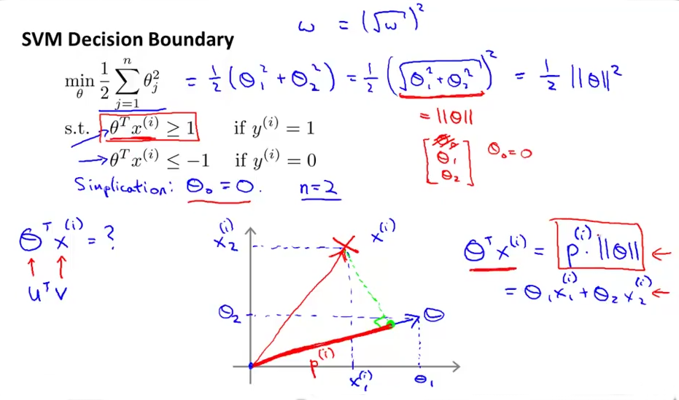
Mathematics behind Support Vector Machines
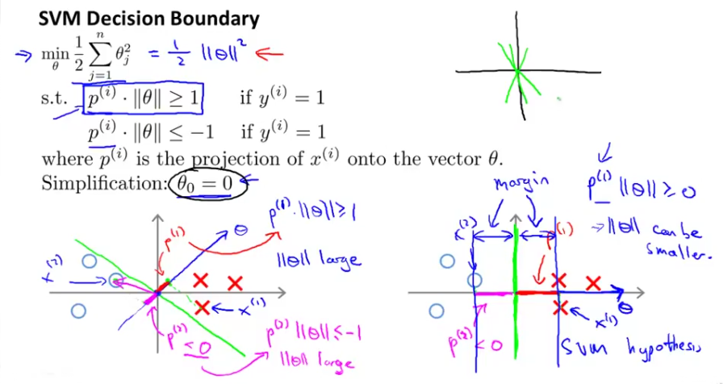
Kernels
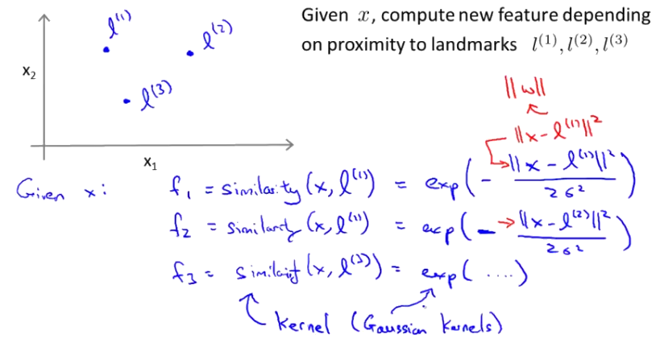
- Similarity functions
  - Measure how close x is to l
  - 3 features
  - f₁, f₂, f₃

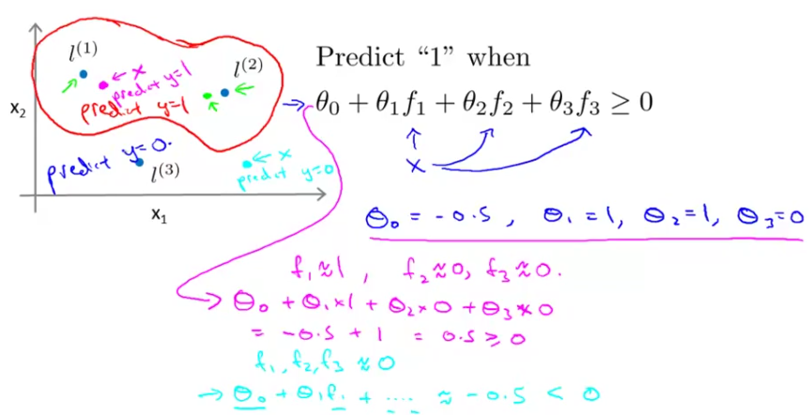
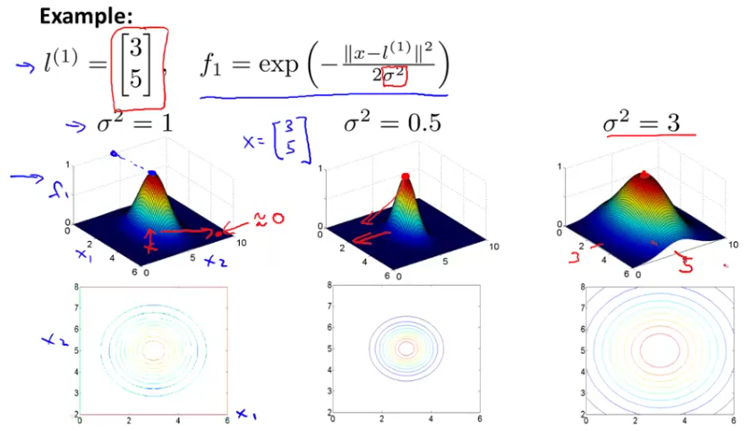
- l = landmark
- geometric approach to finding hypothesis
- Choosing landmarks
  - Set landmarks = training examples
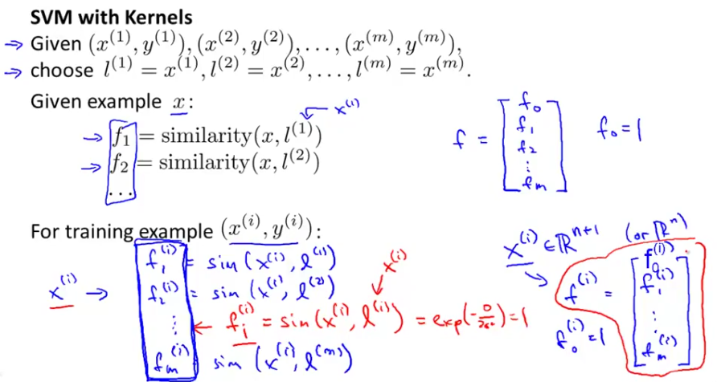
- Each training example x is mapped to a vector of f similarity functions
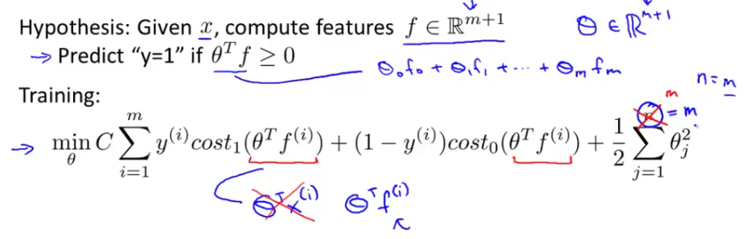
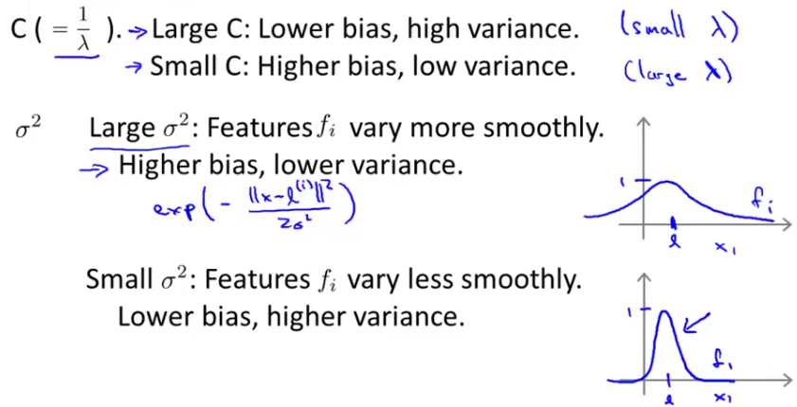
- Choosing parameters
Using an SVM
- Software packages (liblinear, libsvm) to solve for θ
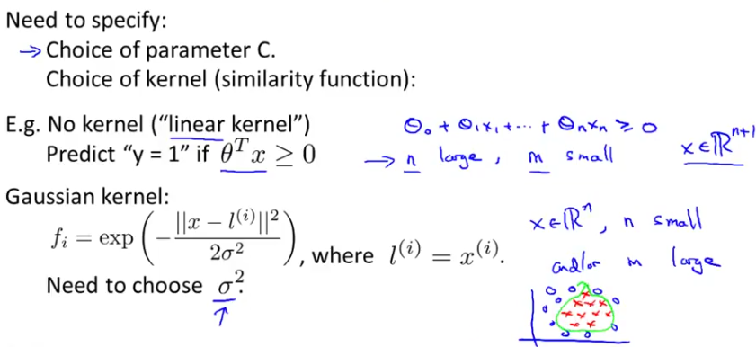
- Perform feature scaling before using Gaussian kernel
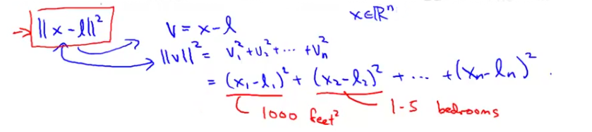
- Other choices of kernel
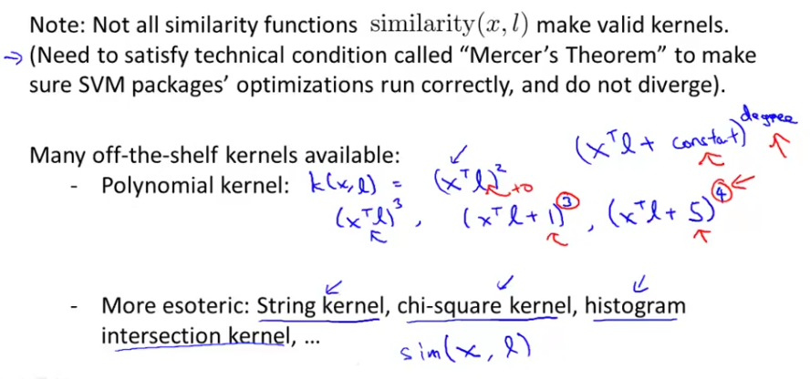
- Most SVM packages have multi-class classification functionality if not use one vs. all method
  - Train K SVMs, one to distinguish y = i from rest, for i = 1, 2, …, K, get θ⁽¹⁾, θ⁽²⁾, . . . θ^{(K)} Pick max()
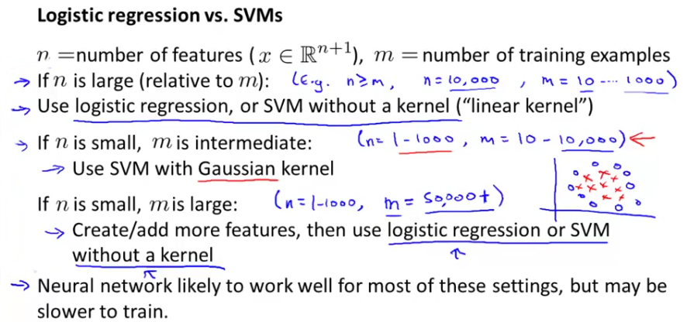
  - SVM without kernel ~ logistic regression

