《Java技术》实验报告

实验三： 2020 年6 月3日
学院 |  | 软件学院 |  |  | 专业班级 |  | 软件工程18-4班 | 姓名 | 刘铭源 |  |  |  | 成绩
课程  名称 |  | Java技术 |  |  |  | 实验项目  名 称 | 基于GUI的网络通信设计 |  |  |  |  | 指导  教师
教师评语 |  |  |  | 教师签名：  年 月 日
一、实验目的
1．掌握Java中GUI程序的编写，包括事件监听机制。
2．掌握Java的网络通信编程，ServerSocket，Socket类的使用。
3．掌握Java中多线程的编程，Thread类，Runnable接口的使用。
4．掌握用面向对象的方法分析和解决复杂问题。

二、实验原理

1编写程序完成以下功能：

1.设计一个基于GUI的客户-服务器的通信应用程序，如图1，图2所示。
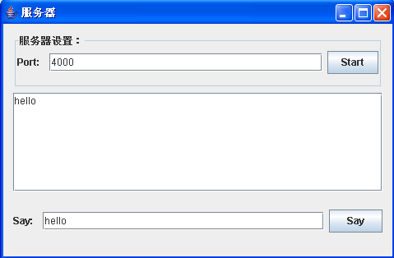
图1 Socket通信服务器端界面
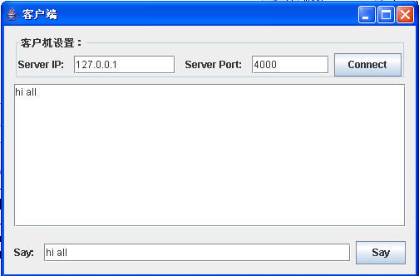
图2 Socket通信客户端界面

2.图1为Socket通信服务器端界面，点击该界面中的【Start】按钮，启动服务器监听服务（在图1界面中间的多行文本区域显示“Server starting…”字样）。图2为Socket通信客户端界面，点击该界面中的【Connect】按钮与服务器建立链接，并在图2所示界面中间的多行文本区域显示“Connect to server…”字样，当服务器端监听到客户端的连接后，在图1界面中间的多行文本区域追加一行“Client connected…”字样，并与客户端建立Socket连接。

3.当图1所示的服务器端和图2所示的客户机端建立Socket连接后，编程实现服务端、客户端之间的“单向通信”：在客户端的输入界面发送消息，在服务端接收该消息，并将接收到对方的数据追加显示在多行文本框中。

三、使用硬件、软件环境
Windows10，内存8g，硬盘1TB，JDK1.8，eclipse
四、实验过程、步骤及原始记录(算法、原程序、测试结果，分析等)
客户端：
import javax.swing.*;
import java.awt.*;
import java.awt.event.ActionEvent;
import java.awt.event.ActionListener;
import java.io.*;
import java.net.Socket;

public class Client {
private static Socket socket = null;
public static void main(String[] args){
JFrame.setDefaultLookAndFeelDecorated(true);
JFrame frame = new JFrame("客户端");
frame.setDefaultCloseOperation(JFrame.EXIT_ON_CLOSE);
frame.setResizable(false);
frame.setBounds(300, 200, 500, 300);
frame.setLayout(new BorderLayout(10, 0));

JPanel northPanel = new JPanel();
JLabel ipLabel = new JLabel("Server Ip: ");
JTextField ipField = new JTextField(10);
JLabel portLabel = new JLabel("Server Port: ");
JTextField portField = new JTextField(6);
northPanel.setBorder(BorderFactory.createTitledBorder("客户机设置: "));
JButton connectBtn = new JButton("Connect");
northPanel.add(ipLabel);
northPanel.add(ipField);
northPanel.add(portLabel);
northPanel.add(portField);
northPanel.add(connectBtn);

JPanel centerPanel = new JPanel();
JTextArea area = new JTextArea(10, 35);
area.setMargin(new Insets(10, 10, 10, 10));
area.setEnabled(false);
centerPanel.add(area);

JPanel southPanel = new JPanel();
JLabel sayLabel = new JLabel("Say: ");
JTextField sayField = new JTextField(30);
JButton sayBtn = new JButton("Say");
southPanel.add(sayLabel);
southPanel.add(sayField);
southPanel.add(sayBtn);

frame.add(northPanel, BorderLayout.NORTH);
frame.add(centerPanel, BorderLayout.CENTER);
frame.add(southPanel, BorderLayout.SOUTH);

frame.setVisible(true);

connectBtn.addActionListener(new ActionListener() {
@Override
public void actionPerformed(ActionEvent e) {
area.append("Connect to server…\n");
try {
socket = new Socket(ipField.getText(), Integer.parseInt(portField.getText()));
}catch (IOException ex){
ex.printStackTrace();
}
new Thread(new Runnable() {
@Override
public void run() {
try {
while(true){
BufferedReader br = new BufferedReader(new InputStreamReader(socket.getInputStream()));
String res = null;
while((res = br.readLine()) != null){
area.append(res + "\n");
}
}
} catch (IOException ex) {
ex.printStackTrace();
}
}
}).start();
}
});

sayBtn.addActionListener(new ActionListener() {
@Override
public void actionPerformed(ActionEvent e) {
try{
PrintWriter pw = new PrintWriter(socket.getOutputStream());
pw.println(sayField.getText());
pw.flush();
area.append(sayField.getText() + "\n");
}catch (IOException ex){
ex.printStackTrace();
}
}
});
}

服务器端：
import javax.swing.*;
import java.awt.*;
import java.awt.event.ActionEvent;
import java.awt.event.ActionListener;
import java.io.*;
import java.net.ServerSocket;
import java.net.Socket;

public class Server {
private static ServerSocket serverSocket = null;
private static Socket socket = null;
public static void main(String[] args){
JFrame.setDefaultLookAndFeelDecorated(true);
JFrame frame = new JFrame("服务端");
frame.setDefaultCloseOperation(JFrame.EXIT_ON_CLOSE);
frame.setResizable(false);
frame.setBounds(300, 200, 500, 300);
frame.setLayout(new BorderLayout(10, 0));

JPanel northPanel = new JPanel();
JLabel portLabel = new JLabel("Port: ");
JTextField portField = new JTextField(28);
northPanel.setBorder(BorderFactory.createTitledBorder("服务器设置: "));
JButton startBtn = new JButton("Start");
northPanel.add(portLabel);
northPanel.add(portField);
northPanel.add(startBtn);

JPanel centerPanel = new JPanel();
JTextArea area = new JTextArea(10, 35);
area.setMargin(new Insets(10, 10, 10, 10));
area.setEnabled(false);
centerPanel.add(area);

JPanel southPanel = new JPanel();
JLabel sayLabel = new JLabel("Say: ");
JTextField sayField = new JTextField(30);
JButton sayBtn = new JButton("Say");
southPanel.add(sayLabel);
southPanel.add(sayField);
southPanel.add(sayBtn);

frame.add(northPanel, BorderLayout.NORTH);
frame.add(centerPanel, BorderLayout.CENTER);
frame.add(southPanel, BorderLayout.SOUTH);

frame.setVisible(true);

startBtn.addActionListener(new ActionListener() {
@Override
public void actionPerformed(ActionEvent e) {
area.append("Server starting…\n");
new Thread(new Runnable() {
@Override
public void run() {
try {
serverSocket = new ServerSocket(Integer.parseInt(portField.getText()));
socket = serverSocket.accept();
area.append("Client connected…\n");
while(true){
BufferedReader br = new BufferedReader(new InputStreamReader(socket.getInputStream()));
String res = null;
while((res = br.readLine()) != null){
area.append(res + "\n");
}
}
} catch (IOException ex) {
ex.printStackTrace();
}
}
}).start();
}
});

sayBtn.addActionListener(new ActionListener() {
@Override
public void actionPerformed(ActionEvent e) {
try{
PrintWriter pw = new PrintWriter(socket.getOutputStream());
pw.println(sayField.getText());
pw.flush();
area.append(sayField.getText() + "\n");
}catch (IOException ex){
ex.printStackTrace();
}
}
});
}
}

程序截图：
客户端：
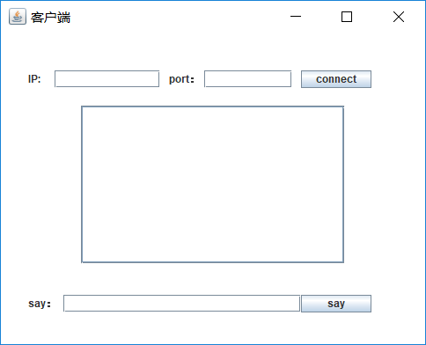
服务器端：
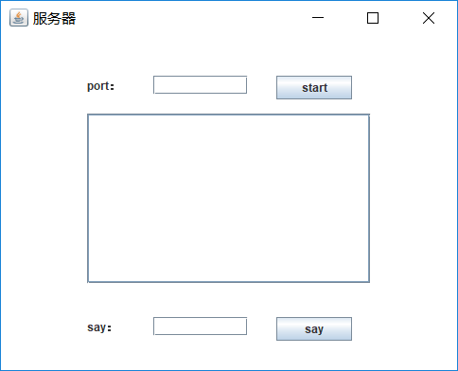
五、实验结论、分析、思考题与心得体会
1.实验心得：
通过此次实验掌握了图形界面的设计，掌握了各种组件的设计如何进行布局，学会了如何布置监听器，通过Socket网络通信实现网络通信，掌握了多线程变成方法。
- 双向通信的功能
服务端：
import java.awt.BorderLayout;
import java.awt.Dimension;
import java.awt.Toolkit;
import java.awt.event.ActionEvent;
import java.awt.event.ActionListener;
import java.io.BufferedReader;
import java.io.IOException;
import java.io.InputStreamReader;
import java.io.PrintWriter;
import java.net.ServerSocket;
import java.net.Socket;
import javax.swing.JButton;
import javax.swing.JFrame;
import javax.swing.JPanel;
import javax.swing.JScrollPane;
import javax.swing.JSplitPane;
import javax.swing.JTextArea;

public class ChatFrameServer{

private PrintWriter pw;
private JFrame frame;
private JPanel pane_buttom;
private JSplitPane pane_center;

//显示内容的文本框，输入内容的文本框，发送内容按钮
private JScrollPane pane_showWindow;
private JScrollPane pane_inputWindow;
private JTextArea area_showWindow;
private JTextArea area_inputWindow;

private JButton btn_send;

private Dimension dimension;//用于设置area_showWindow可拖拉的大小

//初始化
public ChatFrameServer() {
frame = new JFrame();
pane_buttom = new JPanel();
pane_showWindow = new JScrollPane();
pane_inputWindow = new JScrollPane();
area_showWindow = new JTextArea();
area_inputWindow = new JTextArea();
pane_center = new JSplitPane(JSplitPane.VERTICAL_SPLIT, false, pane_showWindow, pane_inputWindow);
btn_send = new JButton("发送");

dimension = new Dimension(50, 300);

}

//调用方法显示窗口
public void showFrame(){
initFrame();
initChatTextArea();
initButton();
btn_send();
socket();
}

//主窗体
public void initFrame(){
frame.setTitle("服务端");
int width = (int)Toolkit.getDefaultToolkit().getScreenSize().getWidth();
int height = (int)Toolkit.getDefaultToolkit().getScreenSize().getHeight();
frame.setBounds(width / 2, height / 2, 400, 450);
frame.setVisible(true);
}

//内容显示文本框和输入内容文本框
private void initChatTextArea(){
//取得视图焦点
pane_showWindow.getViewport().add(area_showWindow);
pane_inputWindow.getViewport().add(area_inputWindow);
//将显示文本域设置为不可编辑
area_showWindow.setEditable(false);
//设置显示文本域可拖拉的大小
pane_showWindow.setMinimumSize(dimension);
frame.add(pane_center, BorderLayout.CENTER);
}

//发送文件，发送内容按钮
public void initButton(){
pane_buttom.add(btn_send);
frame.add(pane_buttom, BorderLayout.SOUTH);
}

private void btn_send(){
btn_send.addActionListener(new ActionListener() {

@Override
public void actionPerformed(ActionEvent e) {
String info = area_inputWindow.getText();
area_showWindow.append("服务端："+info+"\r\n");
pw.println(info);
area_inputWindow.setText("");
}
});
}
private void socket(){
ServerSocket ss;
try {
ss = new ServerSocket(9988);
//等待连接 客户端
Socket s=ss.accept();
InputStreamReader isr=new InputStreamReader(s.getInputStream());
BufferedReader br=new BufferedReader(isr);
//PrintWriter必须和socket有密切的关系
pw=new PrintWriter(s.getOutputStream(),true);

//读取从客户端法发来的信息
while(true) {
//读取从客户端发来的信息
String info=br.readLine();
//在文本栏里显示
area_showWindow.append("客户端:"+info+"\r\n");
}
} catch (IOException e) {
e.printStackTrace();
}
}
public static void main(String[] args) {
ChatFrameServer chat = new ChatFrameServer();
chat.showFrame();
}
}

客户端：

import java.awt.BorderLayout;
import java.awt.Dimension;
import java.awt.Toolkit;
import java.awt.event.ActionEvent;
import java.awt.event.ActionListener;
import java.io.BufferedReader;
import java.io.IOException;
import java.io.InputStreamReader;
import java.io.PrintWriter;
import java.net.Socket;
import java.net.UnknownHostException;
import javax.swing.JButton;
import javax.swing.JFrame;
import javax.swing.JPanel;
import javax.swing.JScrollPane;
import javax.swing.JSplitPane;
import javax.swing.JTextArea;

public class ChatFrame{
private PrintWriter pw;
private JFrame frame;
private JPanel pane_buttom;
private JSplitPane pane_center;

//显示内容的文本框，输入内容的文本框,发送内容按钮
private JScrollPane pane_showWindow;
private JScrollPane pane_inputWindow;
private JTextArea area_showWindow;
private JTextArea area_inputWindow;

private JButton btn_send;

private Dimension dimension;//用于设置area_showWindow可拖拉的大小

//初始化
public ChatFrame() {
frame = new JFrame();
pane_buttom = new JPanel();
pane_showWindow = new JScrollPane();
pane_inputWindow = new JScrollPane();
area_showWindow = new JTextArea();
area_inputWindow = new JTextArea();
pane_center = new JSplitPane(JSplitPane.VERTICAL_SPLIT, false, pane_showWindow, pane_inputWindow);
btn_send = new JButton("发送");

dimension = new Dimension(50, 300);
}

//调用方法显示窗口
public void showFrame(){
initFrame();
initChatTextArea();
initButton();
btn_send();
socket();
}

//主窗体
public void initFrame(){
frame.setTitle("客户端");
int width = (int)Toolkit.getDefaultToolkit().getScreenSize().getWidth();
int height = (int)Toolkit.getDefaultToolkit().getScreenSize().getHeight();
frame.setBounds(width / 2, height / 2, 400, 450);
frame.setVisible(true);
}

//内容显示文本框和输入内容文本框
private void initChatTextArea(){
//取得视图焦点
pane_showWindow.getViewport().add(area_showWindow);
pane_inputWindow.getViewport().add(area_inputWindow);
//将显示文本域设置为不可编辑
area_showWindow.setEditable(false);
//设置显示文本域可拖拉的大小
pane_showWindow.setMinimumSize(dimension);
frame.add(pane_center, BorderLayout.CENTER);
}

//发送文件，发送内容按钮
public void initButton(){
pane_buttom.add(btn_send);
frame.add(pane_buttom, BorderLayout.SOUTH);
}

private void btn_send(){
btn_send.addActionListener(new ActionListener() {

@Override
public void actionPerformed(ActionEvent e) {
String info = area_inputWindow.getText();
area_showWindow.append("客户端： "+info+"\r\n");
pw.println(info);
area_inputWindow.setText("");
}
});
}

private void socket(){
try {
Socket s = new Socket("127.0.0.1",9988);
InputStreamReader isr=new InputStreamReader(s.getInputStream());
BufferedReader br=new BufferedReader(isr);
pw=new PrintWriter(s.getOutputStream(),true);
while(true){
//不停地读取从服务器端发来的信息
String info=br.readLine();
area_showWindow.append("服务端： "+info+"\r\n");
}
} catch (UnknownHostException e) {
e.printStackTrace();
} catch (IOException e) {
e.printStackTrace();
}
}
public static void main(String[] args) {
ChatFrame chat = new ChatFrame();
chat.showFrame();
}
}
