COMP4130 Linear and Discrete Optimization
Workshop 4: Post-optimality Analysis on Product-Mix
Optimization

School of Computer Science
University of Nottingham Ningbo China

Autumn Semester 2025

Purpose: To formulate and solve LP product-mix problems using both Excel Solver and LP-Solve, and to interpret the post-optimality analysis reports generated by these tools.

LIGHTS PRODUCTION Problem
The LIGHTS PRODUCTION problem was introduced and solved in Workshop 3. You may already have developed your own Excel model with a layout that produces the correct optimal solution. A reference spreadsheet model is shown below. Once the model has been solved, review the three post-optimality analysis reports generated by Excel Solver and complete the tasks that follow.

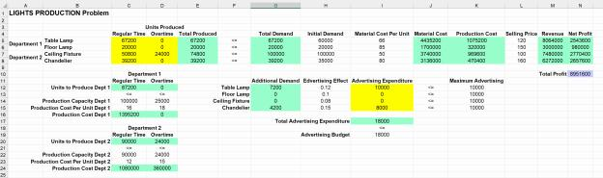

Task 1. Answer Report
Answer the following questions using the Answer Report provided below.

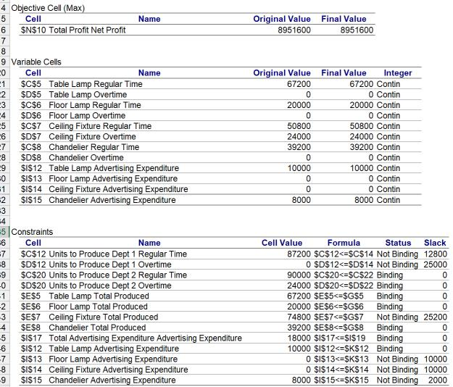

- According to the Answer Report, what does the optimal solution tell us about the company’s maximum achievable profit? 8951600
The report shows that the company can achieve a maximum total profit of 8951600,under the given constrains.
b. Which products and activities are actually carried out in the optimal plan?
Table Lamp Advertising Expenditure,Chandelier Advertising Expenditure,Table Lamp Regular Time,Floor Lamp Regular Time,Ceiling Fixture Regular Time,Ceiling Fixture Overtime,Chandelier Regular Time
c. Which resources are fully utilized, and which still have unused capacity?
Fully:Units to Produce Dept 2 Regular Time,Units to Produce Dept 2 Overtime,Table Lamp Total Produced，Floor Lamp Total Produced，Chandelier Total Produced，Total Advertising Expenditure Advertising Expenditure，Table Lamp Advertising Expenditure
Unused capacity：Units to Produce Dept 1 Regular Time，Units to Produce Dept 1 Overtime，Ceiling Fixture Total Produced，Floor Lamp Advertising Expenditure，Ceiling Fixture Advertising Expenditure，Chandelier Advertising Expenditure
d. If Dept 1 Regular Time capacity were reduced from 100,000 to 95,000, would the solution and profit change?
No change,87200<95000
e. If Ceiling Fixture Total Produced were required to be at most 60,000 units, would the solution change?
Changed,74800>60000

Task 2. Sensitivity Report
Answer the following questions using the Sensitivity Report shown below.

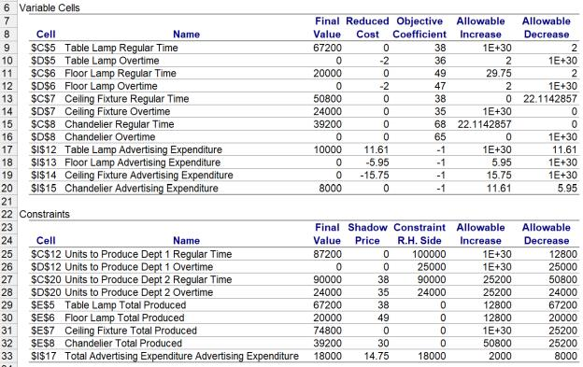

- Which decision variables are part of the optimal solution?
Table Lamp Advertising Expenditure，Chandelier Advertising Expenditure，Table Lamp Regular Time，Floor Lamp Regular Time，Ceiling Fixture Regular Time，Ceiling Fixture Overtime，Chandelier Regular Time
- How can you use the Reduced Cost to interpret whether an unused variable could become profitable in the future?
If Reduced Cost is less than 0, the cost is not worthwhile.
- If the company produces 1 unit of Floor Lamp Overtime (instead of 0), what would be the change in the objective function?
Loss 2 in objective
- If the company spends §10 on Ceiling Fixture Advertising (instead of §0), what would be the change in the objective function?
It will decreased 157.5 in objective function
- According to the Sensitivity Report, which resources (constraints) are the most valu- able to the company, and how can you tell?
Shadow price

- If the production capacity of Dept 2 Overtime is increased from 24, 000 to 24, 010, what would be the change in the objective function?
It will increased 10*35=350 in objective function
- If the Total Advertising Budget is reduced from 18, 000 to 17, 900, what would be the change in the objective function?
It will be losed in 100*14.75 in objective function
- How can you detect from the Sensitivity Report if multiple optimal solutions exist?
If reduced cost==0 and final value ==0
i. Suppose a new policy requires that at least one unit of Chandelier Overtime must be produced. What would happen to the optimal objective function value?

Loss 2
Task 3. Limits Report
Answer the following questions using the Limits Report shown below.

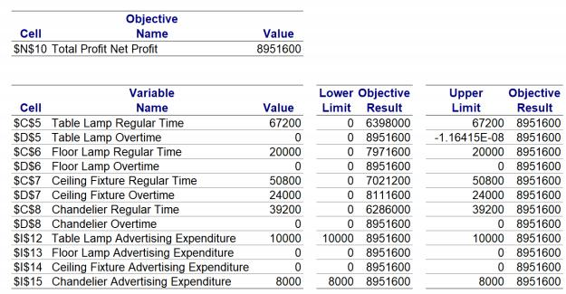

- What information does the Limits Report provide that is not shown in the Answer or Sensitivity Reports?
Objective Result ,Upper limit
b. Which decision variables are critical drivers of profit, according to the Limits Report?
Table Lamp Advertising Expenditure,Chandelier Advertising Expenditure,Table Lamp Regular Time
Floor Lamp Regular Time,Ceiling Fixture Regular Time,Ceiling Fixture Overtime,Chandelier Regular Time

FARMLAND Problem
Develop the optimization model in Excel to solve the following product-mix optimization problem. In addition to formulating the model correctly, aim to design the spreadsheet care- fully by following the good practice guidelines provided in Lecture 4. These will help you produce a model that is easy to understand, debug, and modify. No questions will be asked about the post-optimality reports produced by the Excel solver for this step.

Problem description: A farmer owns 1,000 acres of more or less homogeneous farm- land. His options are to breed cattle or cultivate wheat, corn, or tomatoes. It takes 4 acres to support one head of cattle. Annually, 12,000 hours of labor are available which can be used in any way needed during the year. The table provides information regarding the profit, yield, and labor needs for the four activities.
It is required that at least 20% of the farmland that is cultivated must be used for cattle breeding. At most 30% of the farmland can be used for growing tomatoes. The ratio between the amount of farmland assigned to growing wheat and the farmland left uncultivated should not exceed 2 to 1. The problem is to decide the most profitable way to use the farmland. Note: a non-linearity arises in the ratio constraint that requires reformulation.

 | Cattle | Wheat | Corn | Tomatoes
Profit | ε1,600 per head | ε5 per bushel | ε6 per bushel | 50 pence per pound
Yield per acre | ¼ head per acre | 50 bushels | 80 bushels | 1,000 pounds
Annual labor requirement | 40 hrs per head | 10 hrs per acre | 12 hrs per acre | 25 hrs per acre

