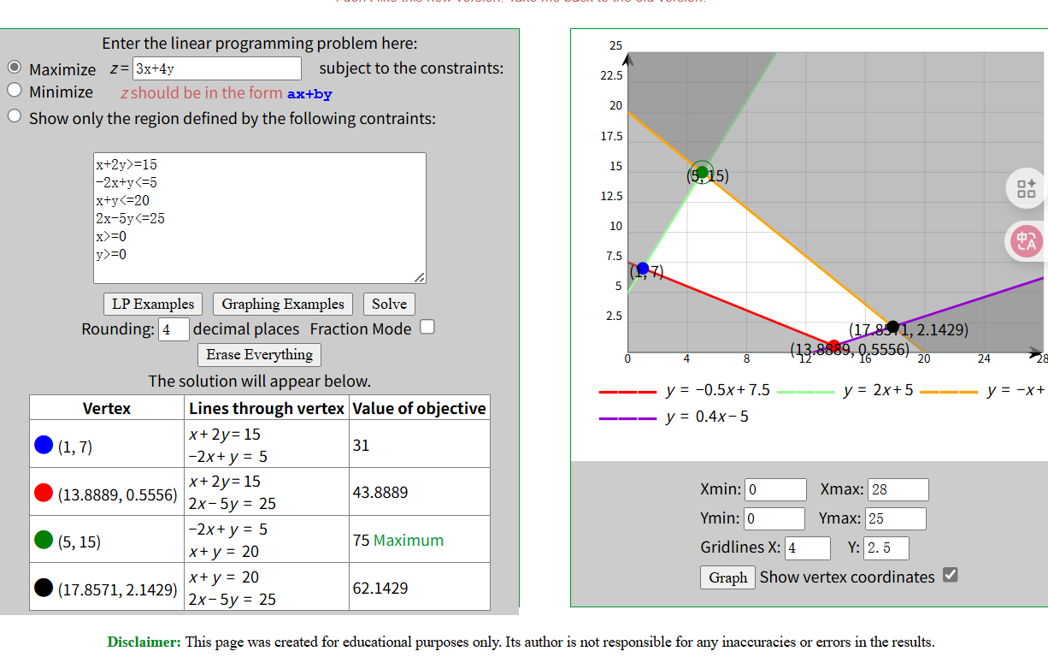
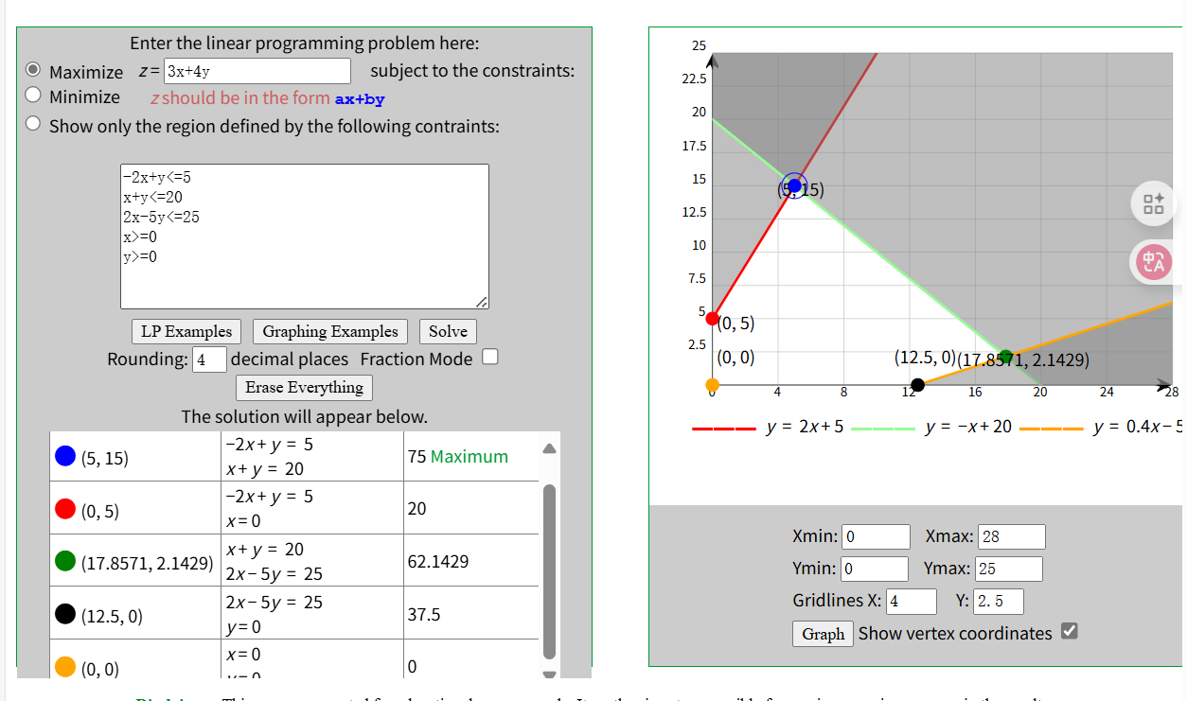
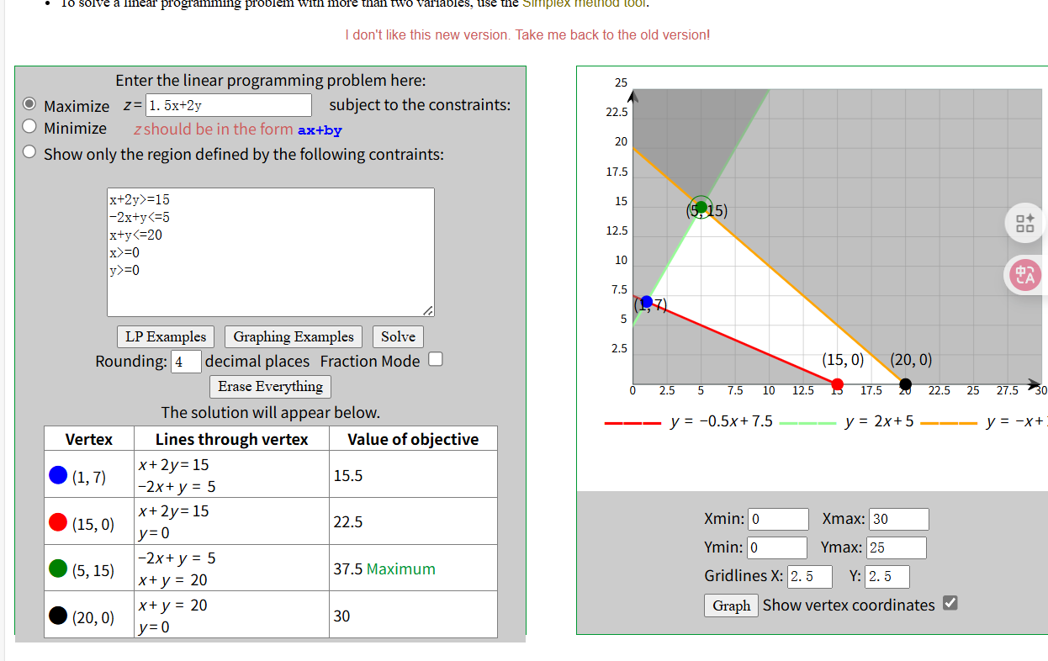

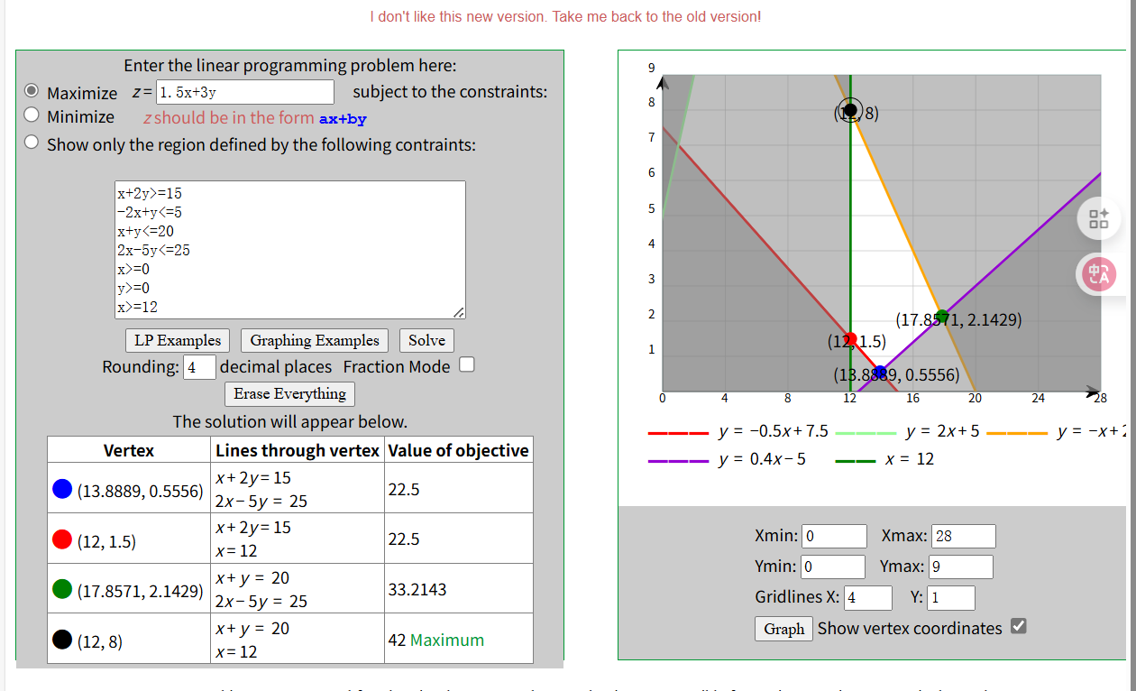

The simplification in Step 4 is not feasible because three variables cannot capture the conversion relationships and allocation constraints between collected papers and products. The original model’s 9 variables must be retained to ensure the accuracy and solvability of the linear programming model.

