**自定义虚拟机安装**

**一、创建虚拟交换机**

原理:调用 dnsmasq 提供DNS、DHCP等功能

创建配置文件 /etc/libvirt/qemu/networks/vbr.xml

<network>

<name>vbr</name>

<bridge name="vbr"/>

<forward mode="nat"/>

<ip address="192.168.1.254" netmask="255.255.255.0">

<dhcp>

<range start="192.168.1.100" end="192.168.1.200"/>

</dhcp>

</ip>

</network>

**二、真机room上快速配置网络 yum 源**

[root@room ~]# yum install vsftp

[root@room ~]# vim /etc/vsftpd/vsftpd.conf

...

listen=YES

listen_ipv6=NO

...

[root@room ~]# systemctl enable vsftpd

[root@room ~]# systemctl start vsftpd

[root@room ~]# mkdir /var/ftp/centos7

[root@room ~]# mount –t iso9660 –o loop,ro /root/CentOS7-1708.iso /var/ftp/centos7

[root@room ~]# yum repolist

**三、virt-manager图形化安装虚拟机**

1.启动 virt-manager 软件,选择新建虚拟机

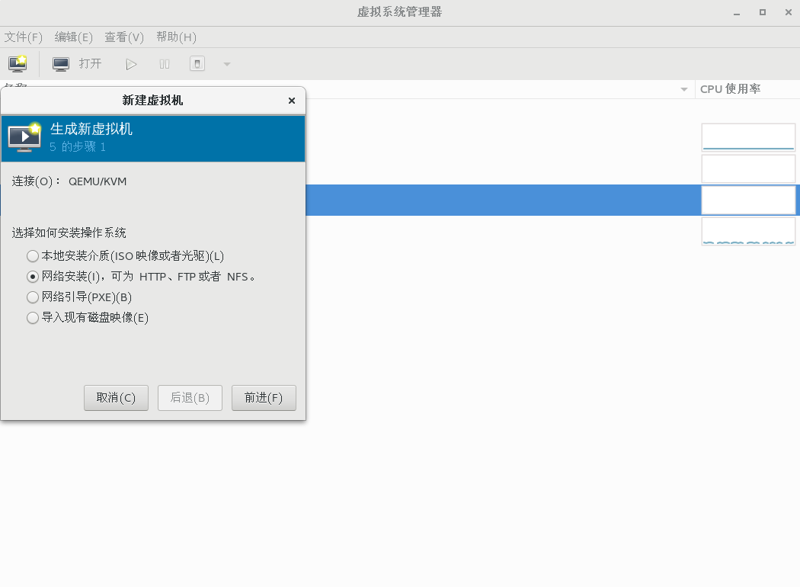

2.选择网络安装源

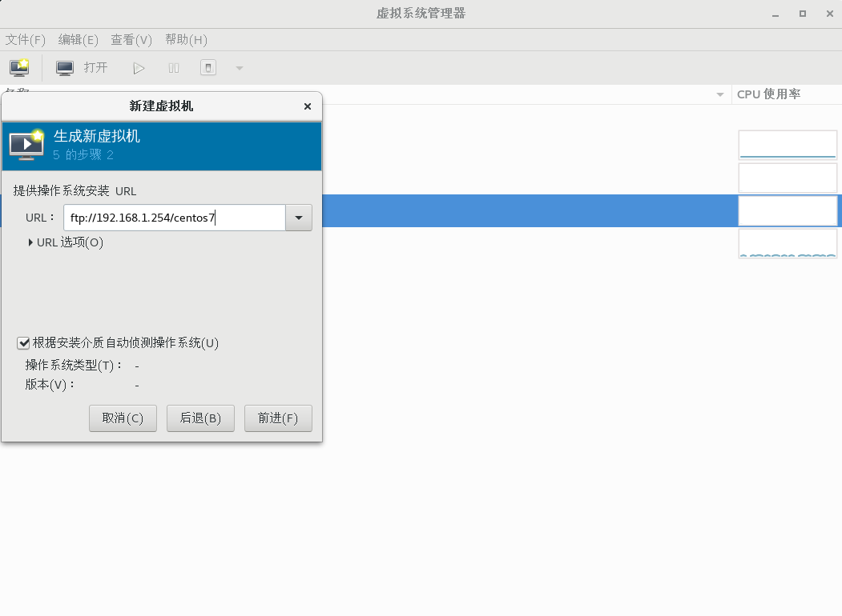

3. 创建自定义镜像文件node.img

[root@room ~]# qemu-img create -f qcow2 /var/lib/libvirt/images/node.img 16G

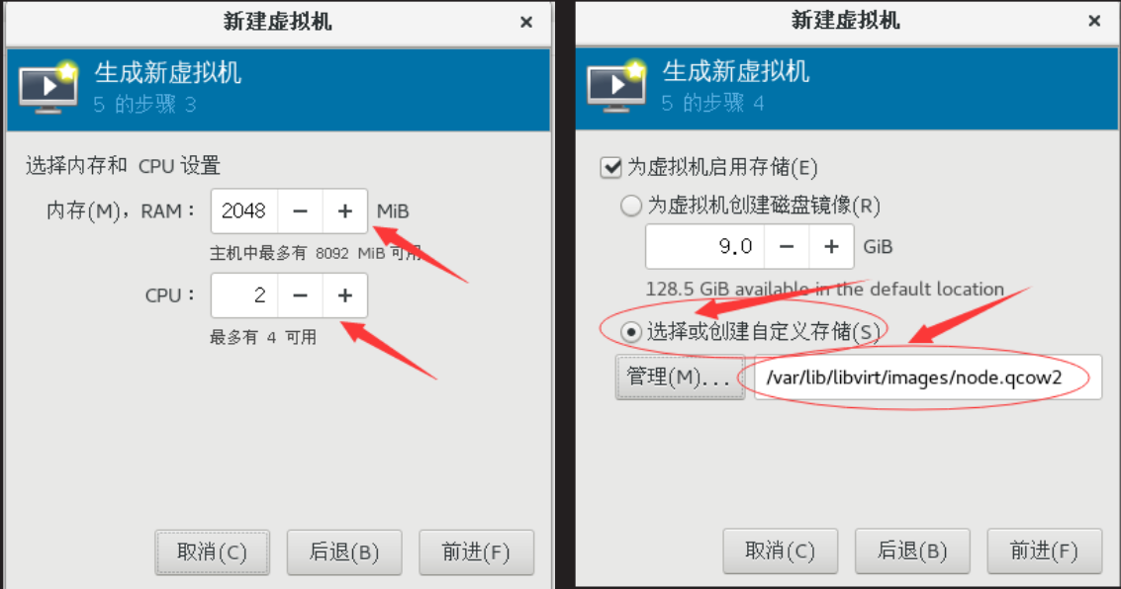

4. 网络选择自定义的vbr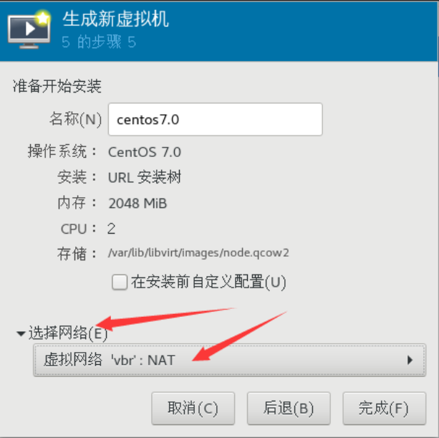

5. 软件选择 minimal ,关闭 KDUMP，选择手工分区

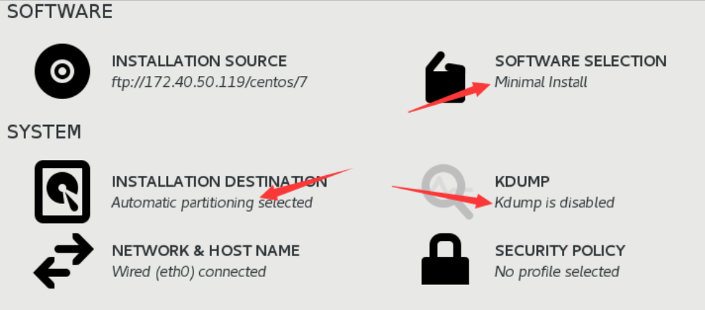

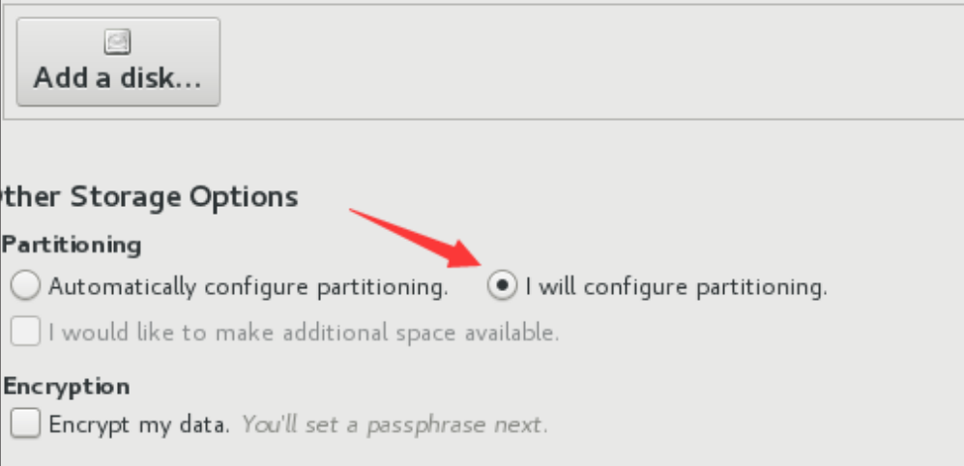

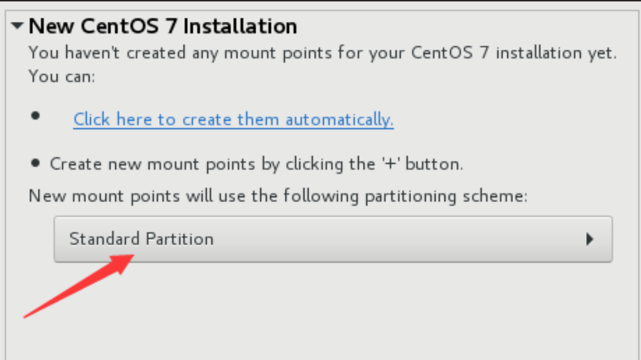

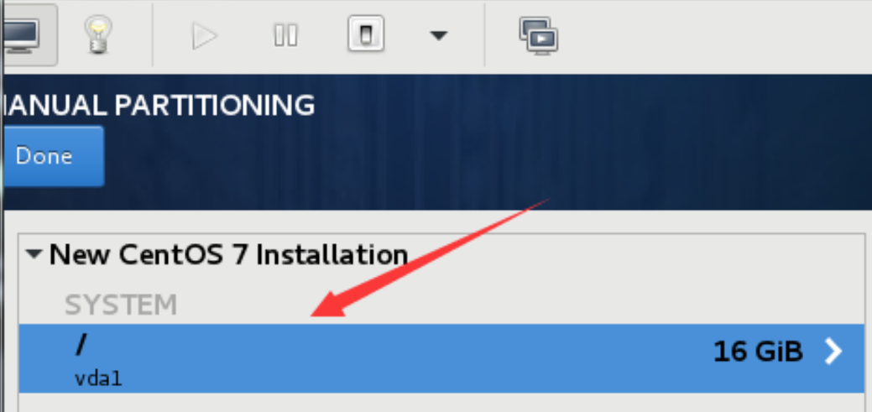

**四、虚拟机模板制作**

把刚刚安装好的系初始化

1. 禁用 selinux

[root@localhost ~]# vim /etc/selinux/config

SELINUX=disabled

1. 卸载

[root@localhost ~]# yum remove -y NetworkManager-* firewalld-* python-firewall

1. 配置 yum 源

[root@localhost ~]# vim /etc/yum.repo.d/centos7.repo

[local_repo]

name=centos7

baseurl="ftp://192.168.1.254/centos7"

enabled=1

gpgcheck=0

1. 常用系统命令安装

[root@localhost ~]# yum install -y net-tools vim-enhanced bridge-utils psmisc

1. 配置网卡配置文件

[root@localhost ~]# vim /etc/sysconfig/network-scripts/ifcfg-eth0

DEVICE="eth0"

ONBOOT="yes"

IPV6INIT="no"

TYPE="Ethernet"

BOOTPROTO ="dhcp"

1. 禁用空路由

[root@localhost ~]# vim /etc/sysconfig/network

NOZEROCONF="yes"

1. 重启机器

[root@localhost ~]# rebo ot

1. 添加 Console 配置及初除磁盘分区里的个性化信息

[root@localhost ~]# vim /etc/default/grub

...

GRUB_CMDLINE_LINUX="biosdevname=0 net.ifnames=0

console=ttyS0,115200n8"

GRUB_DISABLE_LINUX_UUID="true"

GRUB_ENABLE_LINUX_LABEL="true"

1. 重新生成 grub.cfg

[root@localhost ~]# grub2-mkconfig -o /boot/grub2/grub.cfg

1. 修改 /etc/fstab，blkid 查看 uuid 对应的磁盘设备, 将UUID修改为系统设备

[root@localhost ~]# blkid

/dev/vda1: UUID="98bd48a3-dd66-49bd-a0e1-3c70e337f2aa" TYPE="xfs"

[root@localhost ~]# vim /etc/fstab

/dev/vda1 / xfs defaults 0 0

11. 安装分区扩展软件

[root@localhost ~]# yum install -y cloud-utils-growpart

设置第一次开机自劢扩容根目录

[root@localhost ~]# chmod 755 /etc/rc.local

在 rc.local 里加入如下配置

[root@localhost ~]# vim /etc/rc.local

/usr/bin/growpart /dev/vda 1 #扩展磁盘分区空间(让 /dev/vda1 变大)

/usr/sbin/xfs_growfs / # 扩展文件系统识别空间(让 df -h 可使用空间变大)

12. 关闭虚拟机，清理信息 (真机)

[root@room ~]# virt-sysprep -d centos7.0

[ 0.0] Examining the guest ...

[ 28.9] Performing "abrt-data" ...

[ 28.9] Performing "backup-files" ...

[ 29.2] Performing "bash-history" ...

[ 29.2] Performing "blkid-tab" ...

[ 29.3] Performing "crash-data" ...

[ 29.3] Performing "cron-spool" ...

[ 29.3] Performing "dhcp-client-state" ...

[ 29.3] Performing "dhcp-server-state" ...

[ 29.3] Performing "dovecot-data" ...

[ 29.3] Performing "logfile s" ...

[ 29.3] Performing "machine-id" ...

[ 29.3] Performing "mail-spool" ...

[ 29.3] Performing "net-hostname" ...

[ 29.3] Performing "net-hwaddr" ...

[ 29.3] Performing "pacct-log" ...

[ 29.3] Performing "package-manager-cache" ...

[ 29.3] Performing "pam-data" ...

[ 29.3] Performing "passwd-backups" ...

[ 29.3] Performing "puppet-data-log" ...

[ 29.3] Performing "rh-subscription-manager" ...

[ 29.3] Performing "rhn-systemid" ...

[ 29.3] Performing "rpm-db" ...

[ 29.3] Performing "samba-db-log" ...

[ 29.3] Performing "script" ...

[ 29.3] Performing "smolt-uuid" ...

[ 29.3] Performing "ssh-hostkeys" ...

[ 29.3] Performing "ssh-userdir" ...

[ 29.3] Performing "sssd-db-log" ...

[ 29.3] Performing "tmp-files" ...

[ 29.3] Performing "udev-persistent-net" ...

[ 29.3] Performing "utmp" ...

[ 29.3] Performing "yum-uuid" ...

[ 29.3] Performing "customize" ...

[ 29.3] Setting a random seed

[ 29.8] Performing "lvm-uuids" ...

1. 备份虚拟机XML配置文件

[root@room ~]#cd /etc/libvirt/qemu/

[root@room qemu]#cp centos7.xml centos7.0.xml.bak

1. 修改XML配置文件如下

<domain type='kvm'>

<name>node</name>

<memory unit='KB'>2097152</memory>

<currentMemory unit='KB'>2097152</currentMemory>

<vcpu placement='static'>2</vcpu>

<os>

<type arch='x86_64' machine='pc'>hvm</type>

<boot dev='hd'/>

<bootmenu enable='yes'/>

<bios useserial='yes'/>

</os>

<features>

<acpi/>

<apic/>

</features>

<cpu mode='host-passthrough'>

</cpu>

<clock offset='localtime'/>

<on_poweroff>destroy</on_poweroff>

<on_reboot>restart</on_reboot>

<on_crash>restart</on_crash>

<devices>

<emulator>/usr/libexec/qemu-kvm</emulator>

<disk type='file' device='disk'>

<driver name='qemu' type='qcow2'/>

<source file='/var/lib/libvirt/images/node.img'/>

<target dev='vda' bus='virtio'/>

</disk>

<interface type='bridge'>

<source bridge='vbr'/>

<model type='virtio'/>

</interface>

<channel type='unix'>

<target type='virtio' name='org.qemu.guest_agent.0'/>

</channel>

<serial type='pty'></serial>

<console type='pty'>

<target type='serial'/>

</console>

<memballoon model='virtio'></memballoon>

</devices>

</domain>

15. 删除虚拟机定义

[root@room ~]# virsh undefine centos7.0

16. 查看模板虚拟机镜像

[root@room ~]# ll -h /var/lib/libvirt/images/node.img

-rw-r--r-- 1 root root 1.2G 9月 7 17:35 node.img

1. **快速创建虚拟机**

例如创建虚拟机node1

1. 创建磁盘文件

[root@room ~]# cd /var/lib/libvirt/images

[root@room images]# qemu-img create -b node.img -f qcow2 node1.img 32G

2.创建虚拟机配置文件

[root@room images]#sed 's/node/node1/' /root/nsd1804/centos7.0.xml >/etc/libvirt/qemu/node1.xml

[root@room images]#virsh define /etc/libvirt/qemu/node1.xml

定义域 node1（从 /etc/libvirt/qemu/node1.xml）

3. 启动虚拟机

[root@room images]#virsh start node1

域 node1 已开始

4. 连接查看虚拟机

[root@room images]# virsh console node1