Table of Contents

Expert Note Quick Start Guide
Transform Human Expertise into AI-Ready Knowledge Assets
Version 1.0 | January 2026

What is Expert Note?
Expert Note captures human expert knowledge and transforms it into structured, reusable AI assets:
Expert Documents → Structured Annotations → Knowledge Entries → AI Prompts
(Your PDFs, (3-level markup) (Extracted (Embodied
Word files) insights) expertise)
The Value: Convert scattered expert knowledge into organized, AI-ready assets that preserve human insight and context.

The Knowledge Pipeline

1. Capture Expert Documents
Upload PDFs, Word docs, or paste text from your domain experts: - Research papers - Internal documentation - Meeting transcripts - Expert interviews - Best practices guides
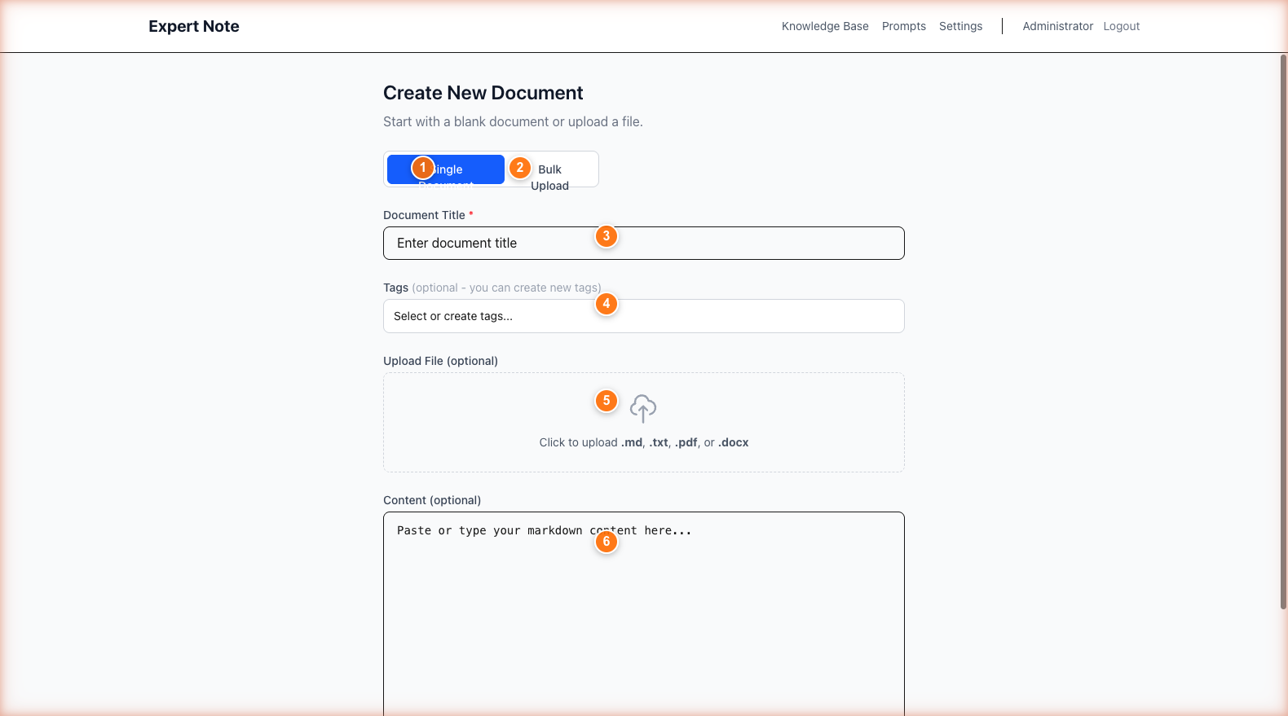 Upload documents in multiple formats - PDF and DOCX are automatically converted

2. Annotate with Three Levels
Mark important content using a structured 3-level system:
Level | Color | What to Mark | Example
MACRO | 🔴 Red | Big ideas, themes, frameworks | “Machine learning requires three key components…”
MESO | 🟡 Yellow | Supporting evidence, methods | “The training process uses backpropagation to…”
MICRO | 🟢 Green | Specific facts, quotes, data | “Accuracy improved from 87% to 94%”
Why three levels? Creates hierarchy that AI can understand - main concepts, supporting ideas, and specific details.
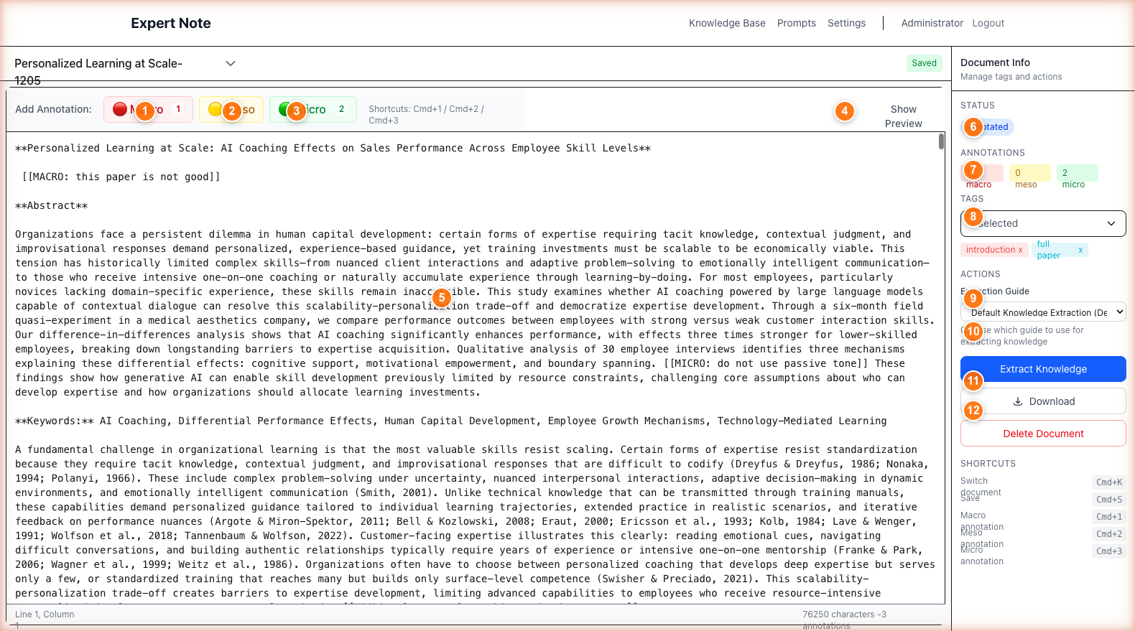 Annotation buttons (Cmd+1/2/3) and visual markup preserve knowledge structure

3. Extract Structured Knowledge
AI analyzes your annotations and creates knowledge entries:
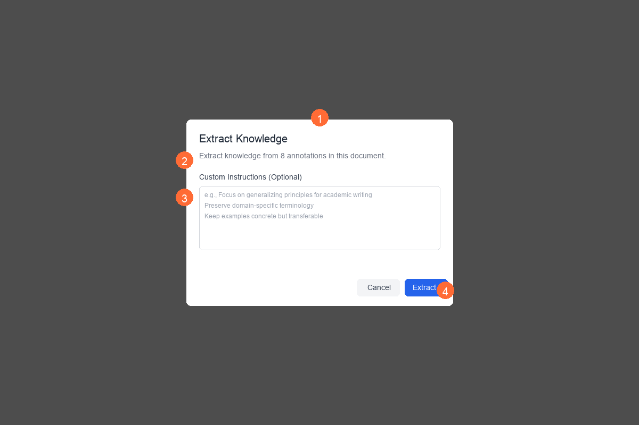 Choose an extraction guide matching your domain (research, business, technical)
What AI generates: - Background/Context - Sets the stage - Key Concepts - Organized by annotation level - Relationships - How ideas connect - Actionable Insights - What experts recommend
Result: Searchable, reusable knowledge base instead of buried insights in documents.

4. Generate AI Prompts (Embodied Expertise)
Turn knowledge into prompts that embody human expertise:
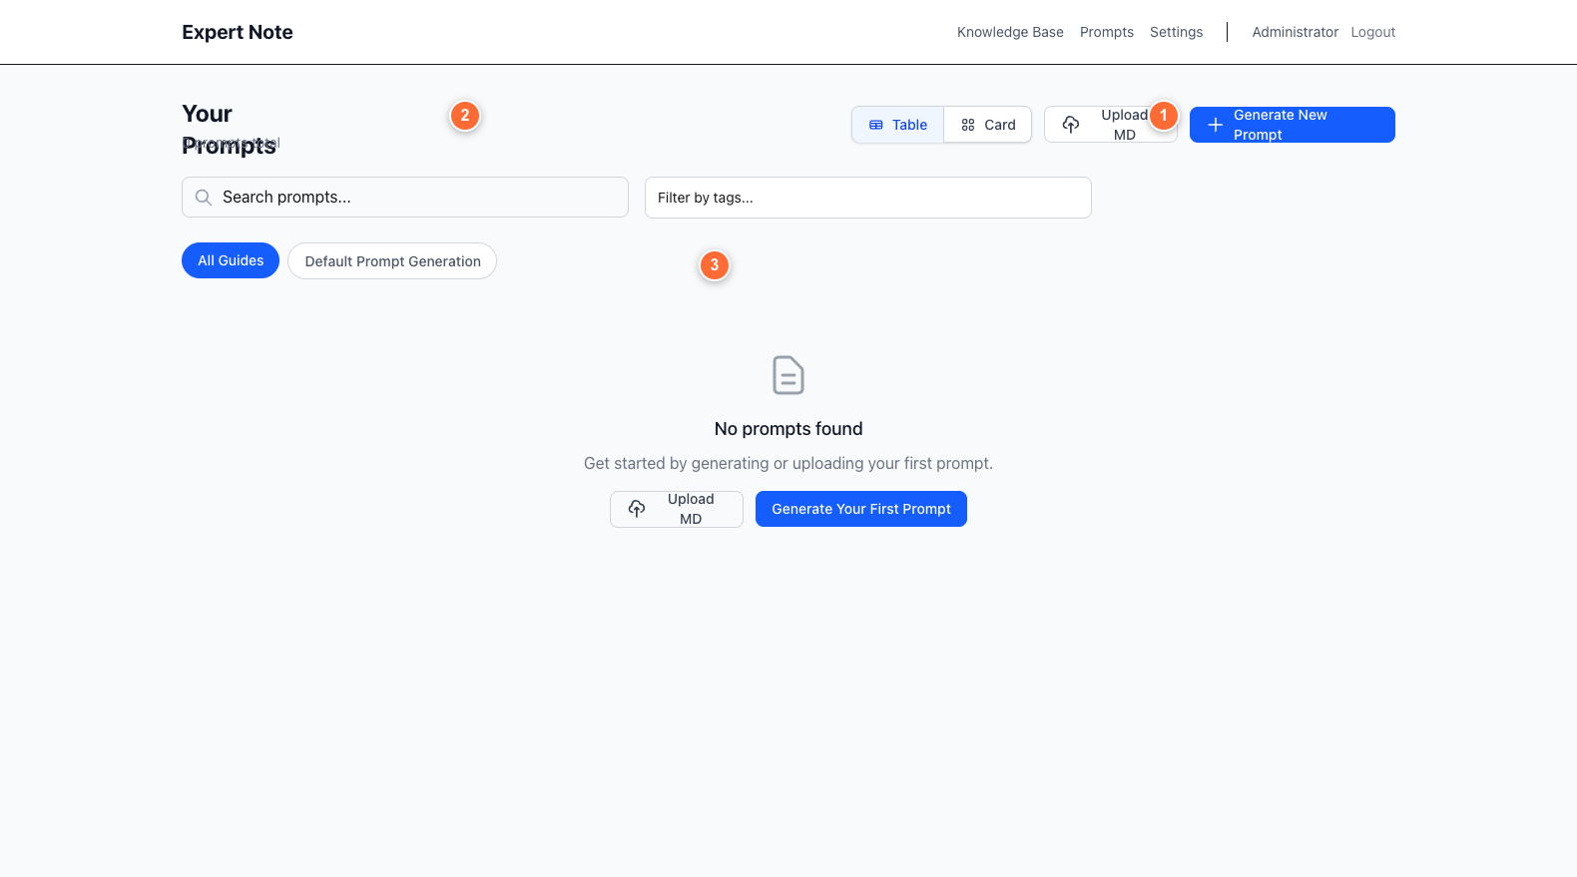 Generate prompts that teach AI to reason like your domain experts
Examples: - Research assistant that thinks like your senior scientist - Business analyst with your team’s strategic frameworks - Technical writer matching your documentation standards
The magic: AI prompts created from real expert knowledge, not generic templates.

Getting Started

Register with Invitation Code
Get a code from your organization admin:
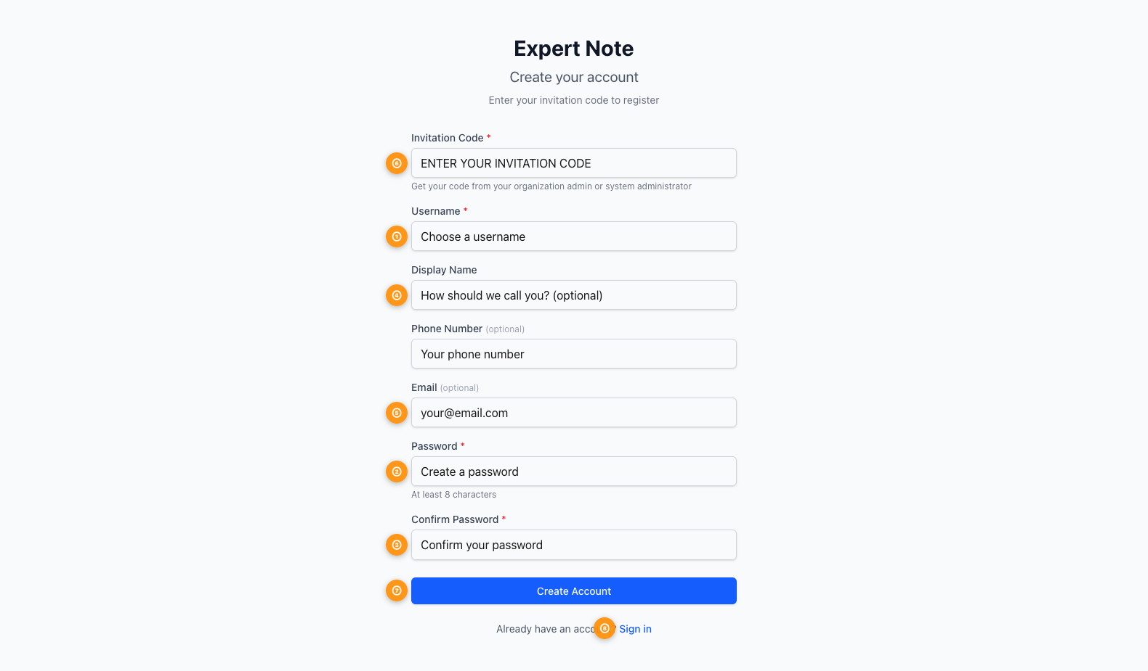 Invitation code determines your role: Owner (full access) or Member (view/edit shared content)

Two User Roles
Role | Can Do | Use Case
Organization Owner | Create docs, annotate, extract knowledge, share with team, manage members | Domain experts, researchers, team leads
Organization Member | View/edit shared docs (if allowed), create personal tags | Team members who consume knowledge

Key Workflows

For Organization Owners
Workflow 1: Capture Expert Knowledge 1. Upload document (PDF, DOCX, or paste text) 2. Add descriptive tags 3. Click through annotation buttons to mark: - MACRO: Main themes (red) - MESO: Supporting ideas (yellow) - MICRO: Specific details (green) 4. Extract → Choose guide → Generate knowledge entry
Workflow 2: Create AI Prompt from Knowledge 1. Go to Prompts page 2. Click “Generate New Prompt” 3. Select knowledge entries as sources 4. Choose generation guide template 5. Add custom instructions 6. Generate → AI creates prompt embodying that expertise
Workflow 3: Share with Team 1. Open document 2. Toggle “Share with organization” 3. Set permissions: read-only or allow edits 4. Team members can now access

For Organization Members
Workflow 1: Learn from Shared Knowledge 1. Browse Knowledge Base 2. Search by topic or filter by tags 3. Read extracted insights 4. Reference in your work
Workflow 2: Contribute to Shared Documents 1. Open shared document (if edit allowed) 2. Add annotations 3. Suggest improvements 4. Owner can re-extract updated knowledge

Essential Tips

Annotation Best Practices
✅ DO: - Start with MACRO - identify big ideas first - Be selective - annotate what’s important, not everything - Keep annotations focused - one concept per annotation - Use consistent criteria across documents
❌ DON’T: - Annotate every sentence - Mix multiple ideas in one annotation - Skip the hierarchy - all three levels matter

Knowledge Extraction Tips
Choose the right guide: - Academic Research → for papers, studies - Business Strategy → for frameworks, analysis - Technical Documentation → for how-to guides - Default → general purpose
Add custom instructions to: - Focus on specific aspects - Adjust formality level - Include domain-specific terminology

Organizing Your Knowledge Base
Use tags strategically: - Domain: machine-learning, marketing, finance - Type: methodology, case-study, best-practice - Status: draft, reviewed, production - Project: project-alpha, q1-2026
Tag naming convention: lowercase, hyphenated (e.g., deep-learning, user-research)

Quick Reference

Keyboard Shortcuts
Action | Shortcut
MACRO annotation | Cmd+1
MESO annotation | Cmd+2
MICRO annotation | Cmd+3

Key Concepts
Document → Raw text from experts (PDF, Word, typed)
Annotation → Marked sections categorized by importance level
Knowledge Entry → AI-extracted structured insights from annotations
Prompt/Generation Guide → AI prompt that embodies expert reasoning patterns
Extraction Guide → Template that tells AI how to structure knowledge for your domain

Understanding the Value Chain
INPUT PROCESS OUTPUT
───────────────────────────────────────────────────────────────
Expert Document → 3-Level Annotation → Knowledge Entry
(Unstructured) (Human structure) (AI-structured)
↓
Extract with AI
↓
Knowledge Entry → Generate Prompt → AI Assistant
(Organized facts) (Reasoning pattern) (Embodied expertise)
Example End-to-End:
- Input: Upload a senior researcher’s 50-page methodology paper
- Annotate: Mark key frameworks (MACRO), validation methods (MESO), specific metrics (MICRO)
- Extract: AI creates knowledge entry: “Research Methodology for User Studies”
- Generate: Create prompt that teaches AI to design studies like your senior researcher
- Use: Your team now has an AI assistant that reasons with expert-level methodology

Common Questions
Q: Why three annotation levels instead of just highlighting? A: Hierarchy teaches AI the difference between main concepts and supporting details - critical for generating coherent prompts.
Q: Can I annotate documents my team member created? A: Yes, if they’ve shared it with “allow edits” permission.
Q: What’s the difference between Knowledge Entry and Prompt? A: Knowledge = extracted facts/insights. Prompt = instructions that teach AI to reason using those facts.
Q: How many annotations should I add? A: Focus on quality over quantity. 5-10 well-chosen annotations per page is better than marking everything.
Q: Can I extract knowledge without annotations? A: The system works best with annotations - they guide AI to focus on what experts consider important.

Next Steps

First Session (15 minutes)
- Upload a document you know well
- Add 10-15 annotations (mix of MACRO/MESO/MICRO)
- Extract knowledge using default guide
- Review the result - see how AI structured your annotations

Building Your Knowledge Base (Week 1)
- Annotate 5-10 key documents from your domain
- Extract knowledge from each
- Organize with consistent tags
- Share with your team

Creating AI Assets (Week 2+)
- Generate your first prompt from knowledge entries
- Test the prompt with real use cases
- Refine based on results
- Build a library of domain-specific prompts

Getting Help
For Organization Members: Contact your organization owner
For Organization Owners: Contact your system administrator
Technical Issues: See the complete user guide for detailed troubleshooting

Summary: The Expert Note Advantage
Traditional approach: - Expert knowledge stays in documents - Hard to search, harder to reuse - Each person re-learns the same things - AI doesn’t benefit from human expertise
With Expert Note: - ✅ Expert knowledge becomes searchable assets - ✅ Structured for both humans and AI - ✅ Team shares and builds on expertise - ✅ AI prompts embody real expert reasoning - ✅ Knowledge compounds instead of scattering
Start transforming expertise into assets today.

For detailed features and administration, see the Complete User Guide

