Table of Contents

Expert Note User Guide
Complete Documentation with Screenshots
Version 1.0 | January 2026

Table of Contents
- Getting Started
- For Organization Owners
- For Organization Members
- Common Features
- Quick Reference

Getting Started

What is Expert Note?
Expert Note is an annotation-based knowledge capture system that helps you: - Capture documents from multiple sources (text, PDF, Word) - Annotate content using a structured three-level system - Extract knowledge through AI-powered analysis - Collaborate with your organization members

Logging In
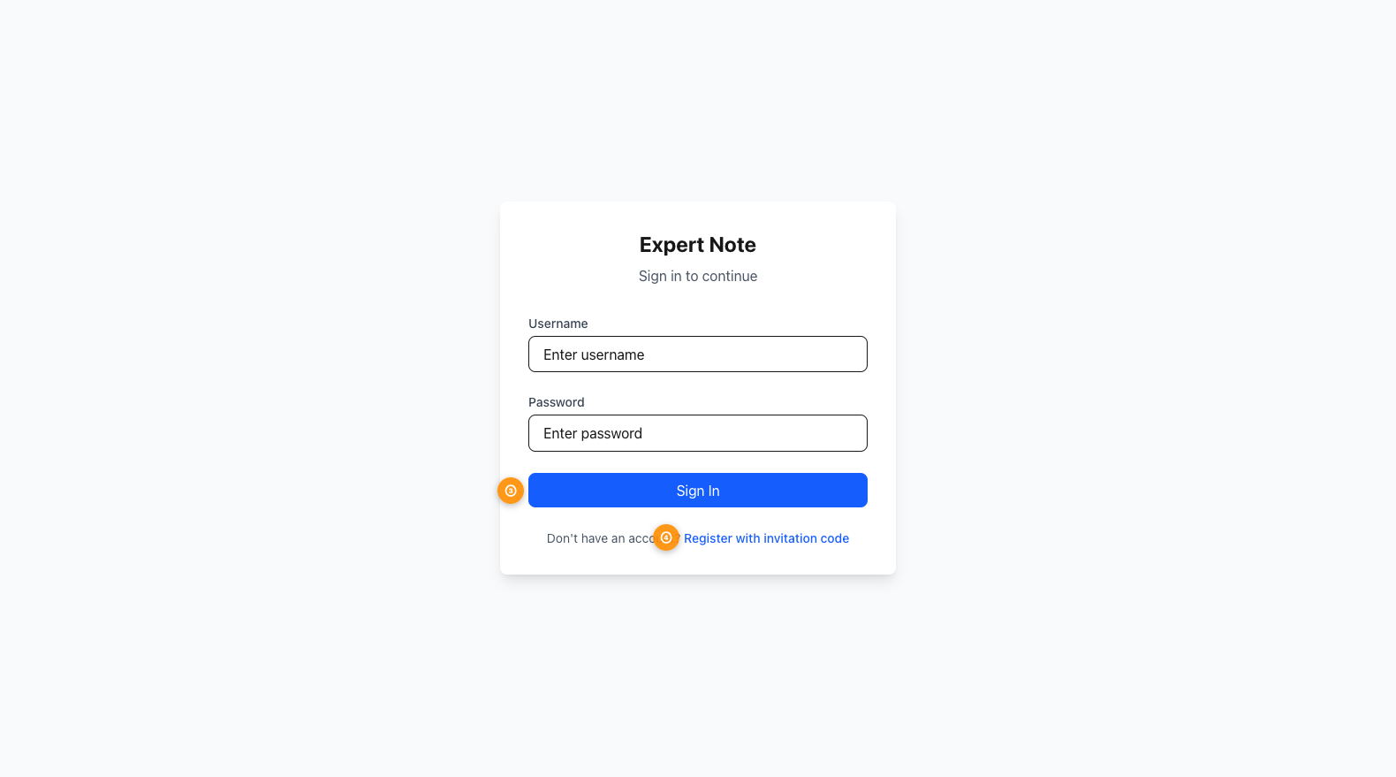 Figure 1: Login interface with username (①), password (②), sign in button (③), and register link (④)
- Navigate to the Expert Note login page
- Enter your username (①)
- Enter your password (②)
- Click Sign In (③)
First time user? Click the “Register with invitation code” link (④) to create an account.

Troubleshooting Login
Forgotten password? Contact your organization owner or system administrator to reset it.
Account disabled message? Your account may have been temporarily disabled. Contact your organization owner.

Registration
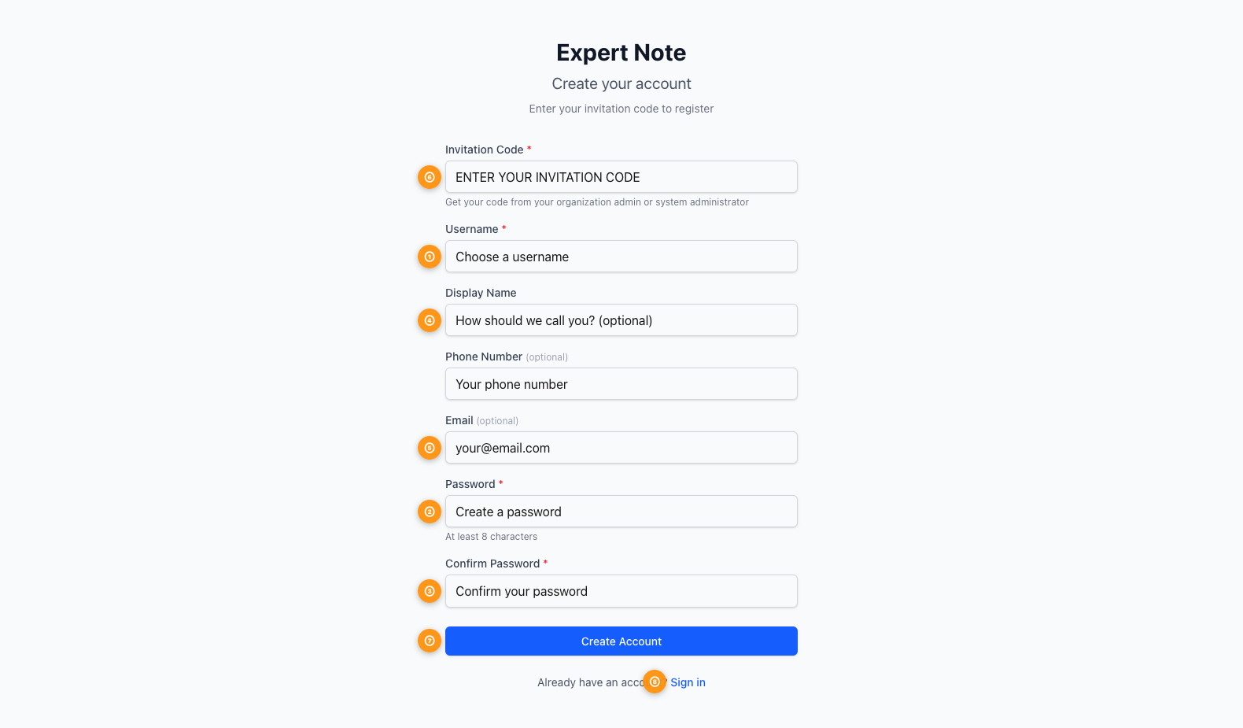 Figure 2: Registration form with invitation code (①), username (②), optional fields (③-⑤), and password fields (⑥⑦)
New users need an invitation code from their organization owner or system administrator.

Registration Steps:
- Enter invitation code (① - Required)
  - Get this from your organization admin
  - Determines if you join as owner or member
- Choose a username (② - Required)
  - Must be unique
  - Used for login
- Display name (③ - Optional)
  - How your name appears to other users
  - Can be changed later in account settings
- Phone number (④ - Optional)
- Email address (⑤ - Optional)
- Create password (⑥ - Required)
  - Minimum 8 characters
  - Must match in both fields
- Confirm password (⑦ - Required)
- Click Create Account (⑧)

Understanding Your Role
Expert Note has three main user roles:
Role | Access Level | Key Features
Organization Owner | Full access | Create & share documents, manage members, create invitation codes, extract knowledge
Organization Member | Limited access | View shared documents, edit if allowed, manage personal tags
System Administrator | Platform-wide | Manage all organizations, users, and system settings
Your role determines what features you can access.

Dashboard Overview
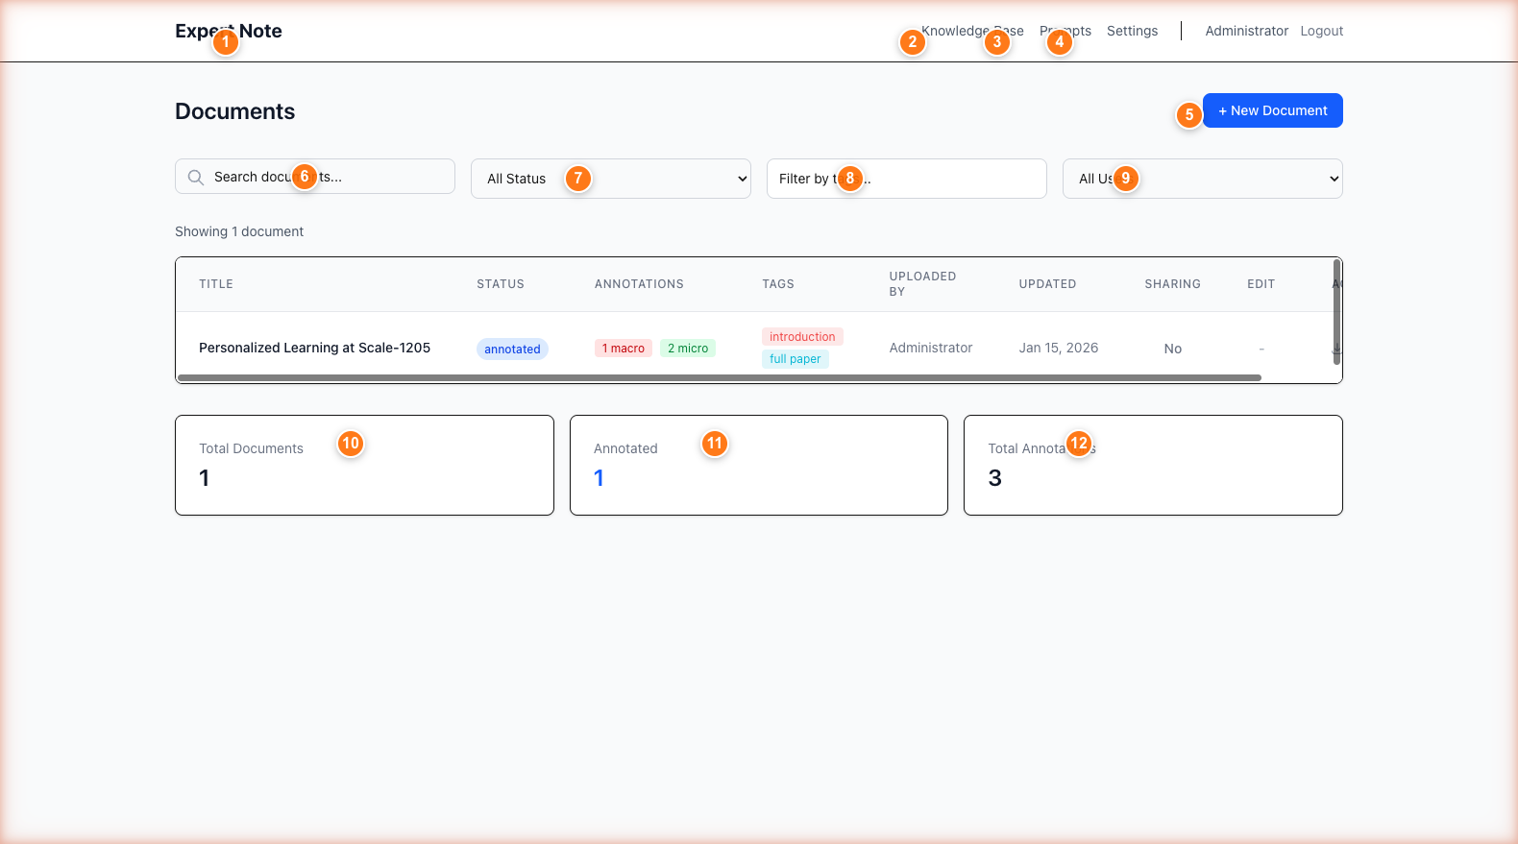 Figure 3: Main dashboard showing navigation (①), new document button (②), search and filters (③-④), and statistics (⑤)
After logging in, you’ll see the main dashboard:
- ① Navigation Menu (top right): Access Knowledge Base, Prompts, Settings
- ② + New Document Button: Create a new document
- ③ Search Bar: Find documents by title
- ④ Filters: Filter by Status, Tags, or Creator
- ⑤ Document List: View all your documents
- ⑥ Statistics Cards: Total documents, annotated count, total annotations

For Organization Owners
As an organization owner, you have full access to create, annotate, and share content with your team.

Creating Documents
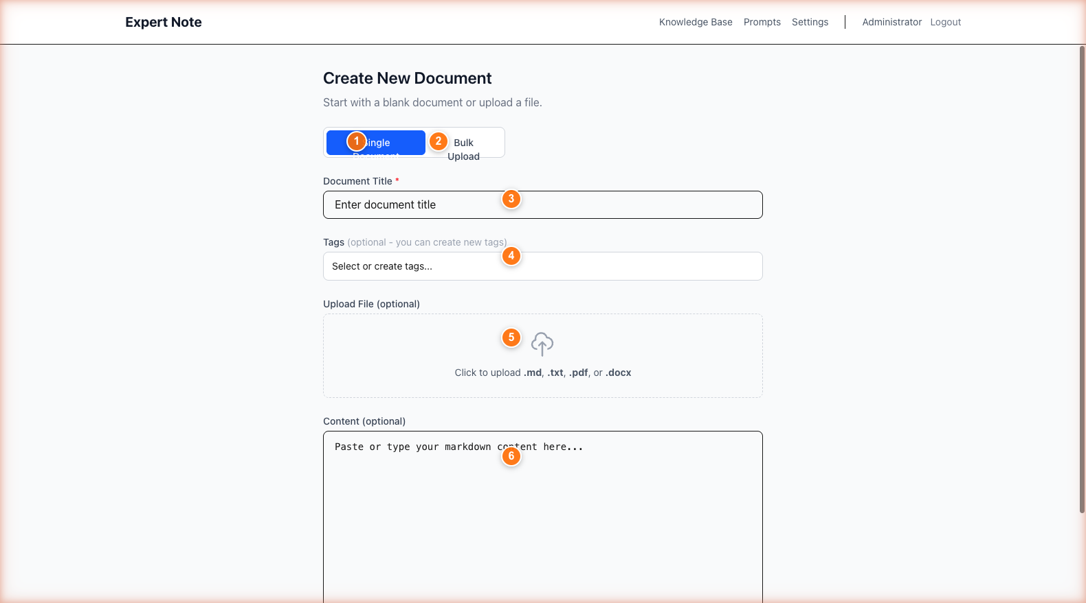 Figure 4: Document creation with title field (①), tag selector (②), and upload options (③-④)
You can create documents in three ways:

Method 1: Type Content Directly
- Click + New Document
- Enter a title (①)
- Select tags (②) to organize your document
- Choose Type Text tab (③)
- Type or paste your content in the editor (④)
- Click Save Document

Method 2: Upload a File
- Click + New Document
- Enter a title
- Select tags
- Choose Upload File tab
- Click Choose File or drag and drop
- Supported formats: .md, .txt, .pdf, .docx
- Click Save Document
PDF/DOCX files are automatically converted to markdown. You can preview and edit before saving.

Method 3: Bulk Upload
- Click + New Document
- Choose Bulk Upload tab
- Select multiple files (up to 100)
- Files are processed with automatic titles from filenames
- Folder structure is preserved

Annotating Documents
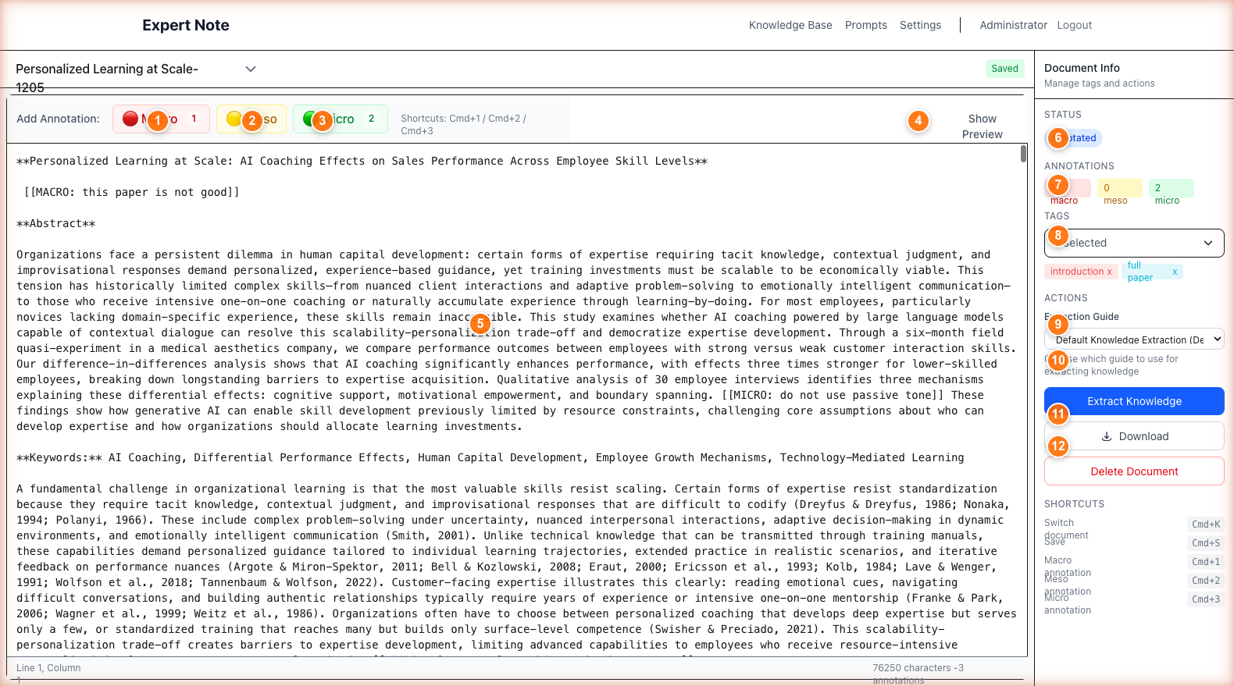 Figure 5: Document editor with annotation buttons (① MACRO, MESO, MICRO), content area, and sidebar properties
Expert Note uses a three-level annotation system to help you categorize information:

Annotation Levels
Level | Color | Shortcut | Use For
MACRO | 🔴 Red | Cmd+1 | High-level themes, main arguments, overarching concepts
MESO | 🟡 Yellow | Cmd+2 | Supporting ideas, evidence, methodologies
MICRO | 🟢 Green | Cmd+3 | Specific details, quotes, data points, examples

How to Annotate
- Open a document in the editor
- Select the text you want to annotate
- Click one of the annotation buttons (① MACRO, MESO, or MICRO) or use keyboard shortcuts
- The text is marked with the appropriate color
- View annotation counts in the sidebar (②)
Annotations are saved automatically as you work.

Annotation Format
Annotations appear in your document like this:
{{{MACRO
This is a high-level theme or main argument.
}}}
{{{MESO
This is supporting evidence or methodology.
}}}
{{{MICRO
This is a specific detail or quote.
}}}

Extracting Knowledge
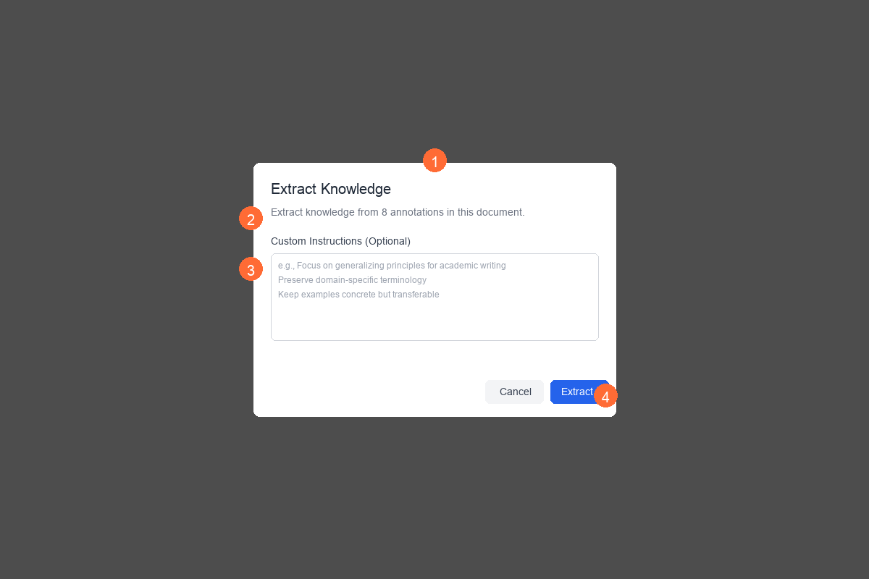 Figure 6: Knowledge extraction modal with extraction guide selector (①) and custom instructions (②)
Once you’ve annotated a document, you can extract structured knowledge using AI.

Extraction Steps
- Open an annotated document
- Click Extract Knowledge button (③ in the sidebar)
- Select an Extraction Guide (①) from the dropdown
  - Guides are templates that determine how knowledge is structured
  - Choose based on your domain (e.g., “Academic Writing”, “Market Research”)
- (Optional) Add custom instructions (②) to guide the AI
- Click Extract button (④)
The AI will: - Analyze your annotations - Generate background/context - Create a structured knowledge entry - Store it in your Knowledge Base
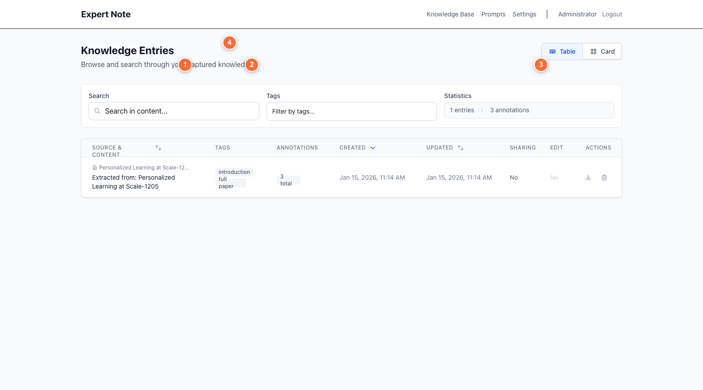 Figure 12: Knowledge base with search (①), tag filter (②), view toggle (③), and statistics to view extracted knowledge.

Sharing Content
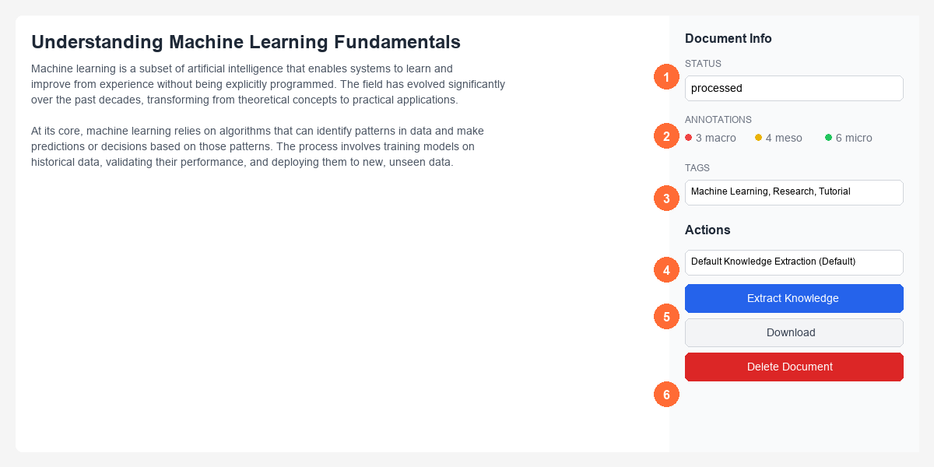 Figure 7: Document properties sidebar showing status (①), annotations (②), tags (③), and sharing controls
Share documents with your organization members:

Sharing Steps
- Open a document you own
- In the Document Info sidebar, find the Sharing section
- Toggle Share with organization ON
- Choose edit permissions:
  - Read-only: Members can view but not edit
  - Allow edits: Members can make changes

Important Notes
- Only organization members can see shared content
- You can revoke sharing at any time
- When you disable sharing, edit permissions are reset to read-only

Managing Members
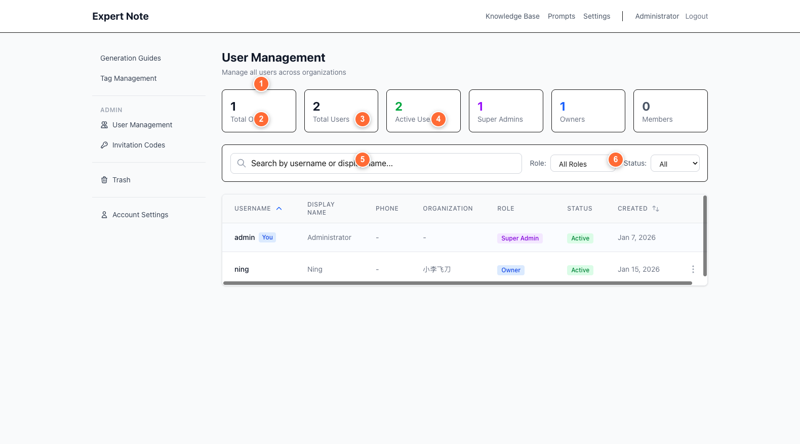 Figure 10: User management with search (②), filters (③-④), and user actions (⑥-⑧)
Organization owners can manage their team members.

Access Member Management
- Click Settings in the top navigation
- Choose Members from the sidebar

Member Management Tasks
View all members: - See usernames, display names, roles, last login - Search by username or display name (②) - Filter by role or status (③/④)
Reset a member’s password: 1. Find the member in the table 2. Click Reset Password (⑥) 3. A temporary password is shown once in a modal 4. Share this password securely with the member 5. They must change it on next login
Enable/Disable member accounts: 1. Find the member 2. Click the Enable/Disable toggle (⑦) 3. Disabled members cannot log in but data is preserved
Remove a member: 1. Find the member 2. Click Delete (⑧) 3. Confirm the action 4. Member is soft deleted (data preserved, marked as deleted)

Creating Invitation Codes
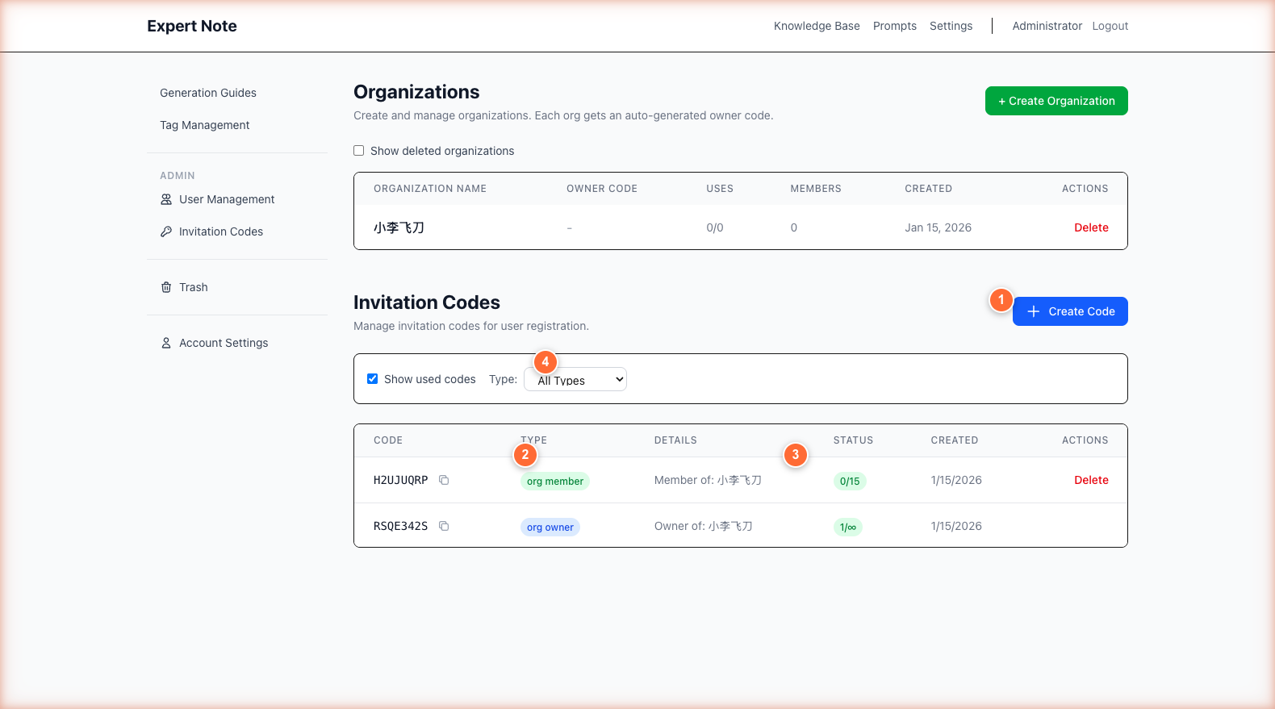 Figure 9: Invitation codes section with create button (①), code types (②), and usage tracking
Generate invitation codes for new members to register.

Creating a Code
- Go to Settings → Invitations
- Click + Create Code (①)
- Select Code Type (②):
  - Individual: Standalone user (no organization)
  - Organization Member: Adds user to your organization
- Set Usage Limit (③):
  - 1: Single-use code
  - 0: Unlimited uses
- Click Create Code
- Share the generated code with new members

Managing Codes
- View all codes in the table (④)
- See usage status (e.g., “2/5” means used 2 times out of 5)
- Delete unused codes to keep your list clean
- Filter by type (⑤): Owner / Member / Individual

For Organization Members
As an organization member, you can view and interact with content shared by your organization owner.

Your Role as a Member
What you can do: - ✅ View documents shared by your organization - ✅ Edit shared documents (if owner allows) - ✅ View knowledge entries and prompts shared with you - ✅ Create and manage personal tags - ✅ Manage your account settings
What you cannot do: - ❌ Create new documents - ❌ Share your own content - ❌ Manage other members - ❌ Create invitation codes

Viewing Shared Documents
 Figure 3: Main dashboard showing navigation (①), new document button (②), search and filters (③-④), and statistics (⑤)
- Log in to Expert Note
- The dashboard shows all documents shared with you
- Use search (③) and filters (④) to find specific documents

Document Details
In the document list, you can see: - Document title - Status (raw, annotated, refined) - Tags - Who created it - Last updated date - Whether you have edit permission

Editing Shared Documents
 Figure 5: Document editor with annotation buttons (① MACRO, MESO, MICRO), content area, and sidebar properties
If the owner has granted edit permissions:
- Click on a shared document
- Make your changes in the editor
- Changes are auto-saved
- Your edits are visible to all organization members
If read-only: You can view but not modify the content.

Viewing Knowledge & Prompts

Knowledge Base
 Figure 12: Knowledge base with search (①), tag filter (②), view toggle (③), and statistics
- Click Knowledge Base in the navigation (①)
- View all knowledge entries shared with you
- Search entries (①) by content
- Filter by tags (②)
- Switch between Table and Card view (③)

Prompts / Generation Guides
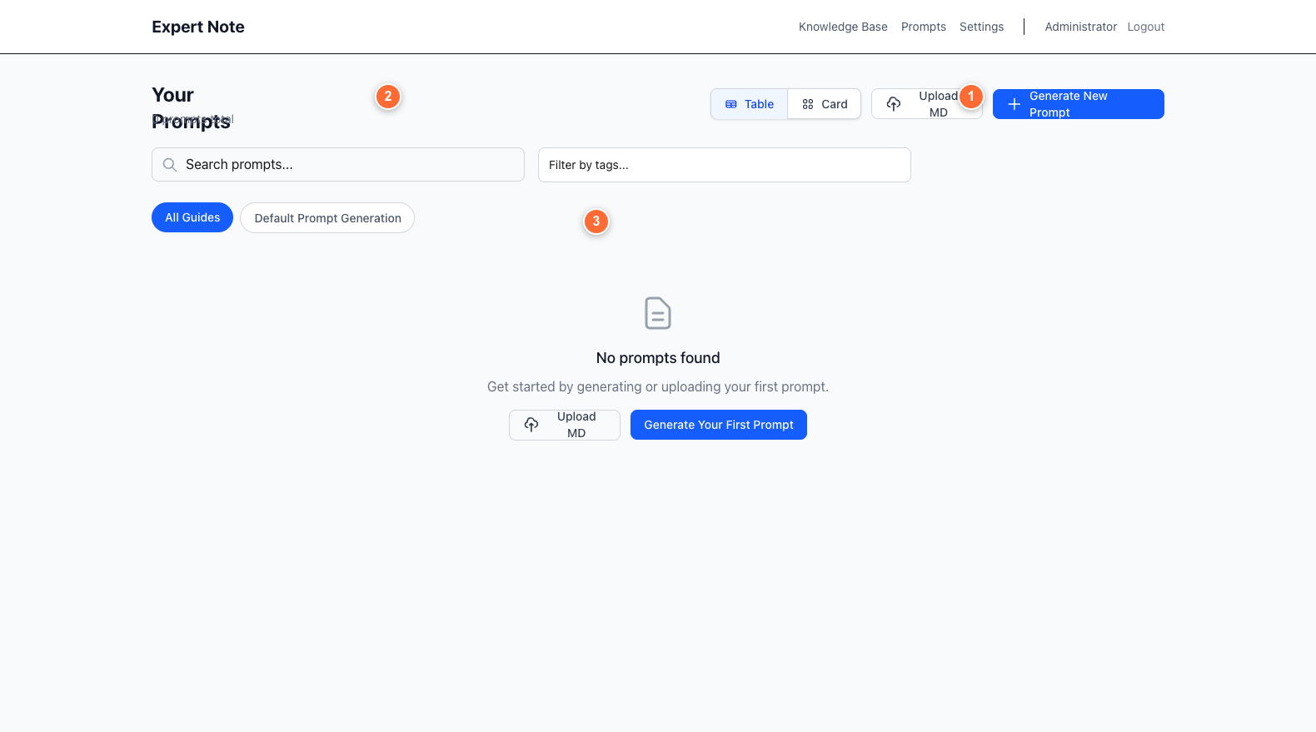 Figure 13: Prompts page with generate button (①), guide selector, and prompts table
- Click Prompts in the navigation
- View all generation guides available to you
- Search prompts (①)
- Filter by tags (②)
- Click Generate New Prompt (③) if you have permission

Managing Your Account
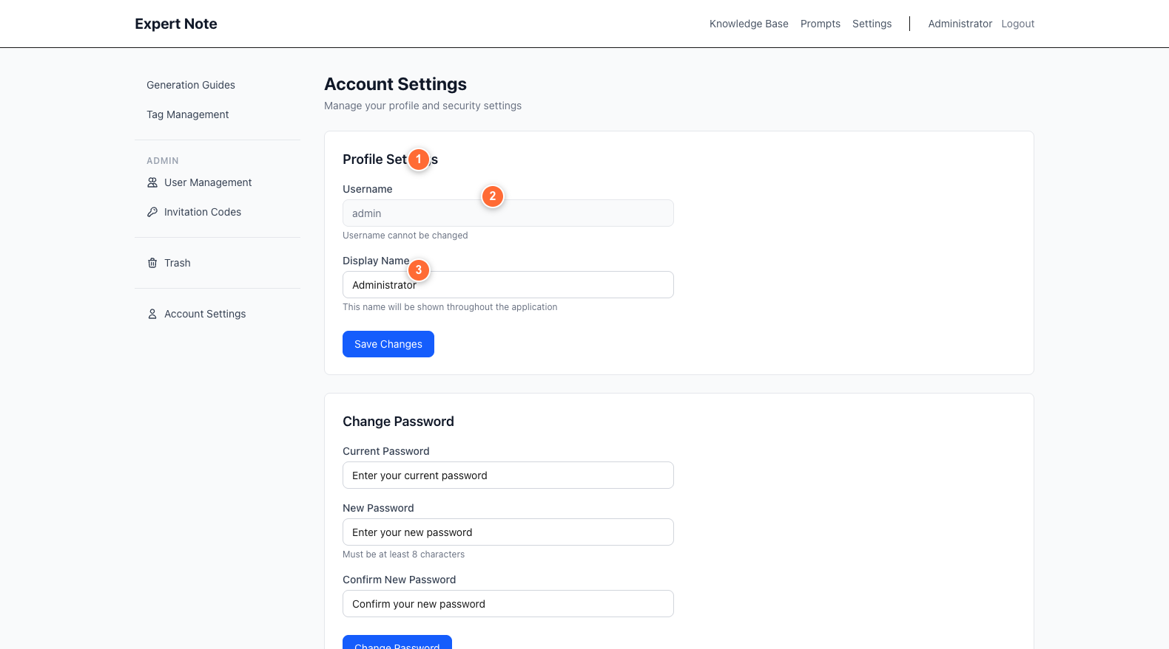 Figure 15: Account settings with display name (①), save button (②), and password change (③)

Update Your Display Name
- Go to Settings → Account
- Edit the Display Name field (①)
- Click Save Changes (②)

Change Your Password
- Go to Settings → Account
- In the Change Password section (③):
  - Enter your current password
  - Enter your new password (8+ characters)
  - Confirm your new password
- Click Change Password

Common Features
These features are available to all users (owners and members).

Understanding Annotations
 Figure 5: Document editor with annotation buttons (① MACRO, MESO, MICRO), content area, and sidebar properties

Three-Level System
MACRO (Red 🔴) - Use for: - Main themes and arguments - Research questions - Overall conclusions - High-level frameworks
MESO (Yellow 🟡) - Use for: - Supporting evidence - Methodologies - Secondary themes - Analysis sections
MICRO (Green 🟢) - Use for: - Specific quotes - Data points - Examples - Citations - Technical details

Best Practices
- Start with MACRO: Identify the big picture first
- Add MESO: Mark supporting ideas
- Capture MICRO: Note specific details
- Be selective: Annotate important content, not everything
- Stay consistent: Use the same level for similar content types

Search and Filtering

Document Search
 Figure 3: Main dashboard showing navigation (①), new document button (②), search and filters (③-④), and statistics (⑤)
Search by title (③): - Type keywords in the search bar - Results update in real-time
Filter by status (④): - All Status - Raw (not annotated) - Annotated - Refined
Filter by tags (④): - Click the tag filter dropdown - Select one or more tags - Documents with ANY selected tag are shown
Filter by creator (④): - Filter to see only your documents - Or documents from specific team members

Knowledge Base Search
 Figure 12: Knowledge base with search (①), tag filter (②), view toggle (③), and statistics
- Search content (①): Find entries by background or content text
- Filter by tags (②): Narrow to specific topics
- View modes (③): Switch between Table and Card layouts

Tag Management
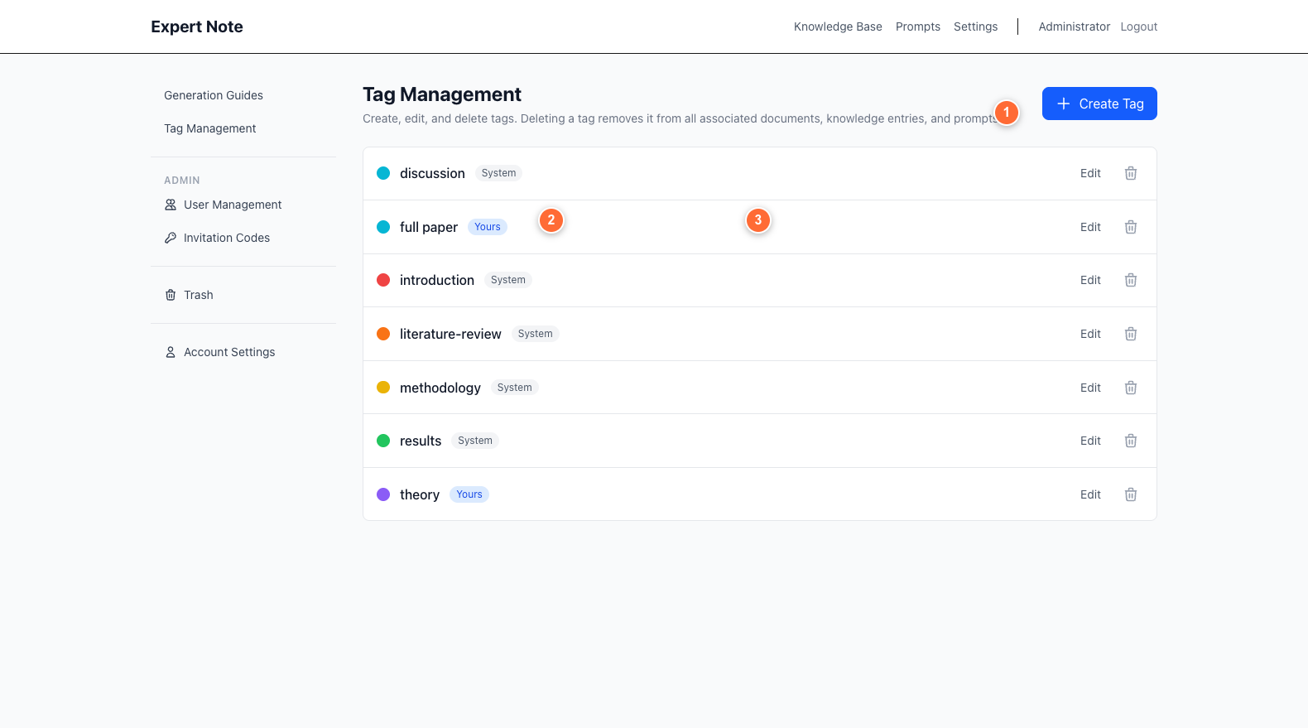 Figure 11: Tag management showing create button (①), tag list (②), and ownership badges
Tags help you organize documents, knowledge entries, and prompts.

Viewing Tags
- Go to Settings → Tags
- See all available tags with ownership badges (②):
  - System (gray): Built-in tags, cannot be deleted
  - Yours (blue): Tags you created
  - Shared (green): Tags created by team members

Creating a Tag
- Click + Create Tag (①)
- Enter a tag name
- Choose a color from the palette
- Click Create

Editing Your Tags
- Find a tag you created (marked “Yours”)
- Click the Edit button (③)
- Change the name or color
- Click Save

Deleting Tags
- You can only delete tags you created (marked “Yours”)
- System tags cannot be deleted
- Shared tags can only be deleted by their creator

Trash & Recovery
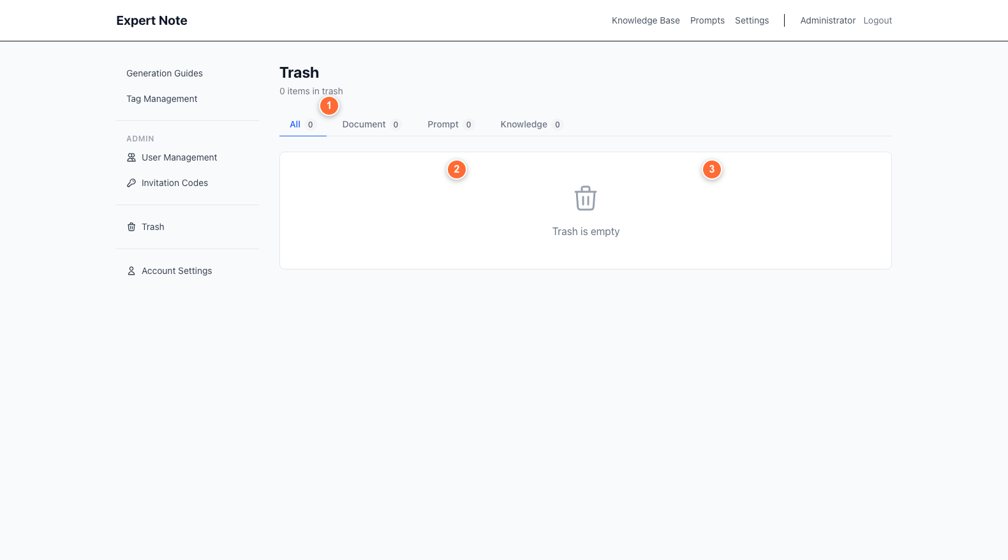 Figure 14: Trash page with category filters (①), deleted items (②), and restore actions
Expert Note uses soft deletion - deleted items go to trash and can be restored.

Viewing Deleted Items
- Go to Settings → Trash
- See all deleted documents, prompts, and knowledge entries
- Filter by type (①): All / Documents / Prompts / Knowledge

Restoring Items
- Find the item in the trash list (②)
- Click Restore
- Item is moved back to its original location

Permanently Deleting
Delete one item: 1. Find the item 2. Click Permanently Delete 3. Confirm the action 4. This cannot be undone
Empty entire trash: 1. Click Empty Trash button 2. Confirm the action 3. All items are permanently deleted

Account Settings
 Figure 15: Account settings with display name (①), save button (②), and password change (③)

Profile Information
Display Name (①): - How your name appears to other users - Can be your real name or a nickname - Click Save Changes (②) after editing

Password Requirements
When changing your password (③): - Minimum 8 characters - Include letters and numbers (recommended) - Don’t reuse old passwords - Don’t share your password

Security Tips
- Log out when using shared computers
- Change your password if you suspect it’s compromised
- Contact your organization owner if you notice suspicious activity

Quick Reference

Keyboard Shortcuts
Action | Shortcut
MACRO annotation | Cmd+1
MESO annotation | Cmd+2
MICRO annotation | Cmd+3
Save document | Auto-save (no shortcut needed)

Glossary
Annotation - Highlighted text marked as MACRO, MESO, or MICRO to categorize information
Dashboard - Main page showing your documents and statistics
Document - Text file you create, upload, or annotate in Expert Note
Extraction Guide - Template that defines how AI structures knowledge from annotations
Invitation Code - Unique code for registering new users
Knowledge Entry - Structured information extracted from annotated documents
Organization - Group of users collaborating together
Soft Delete - Items marked as deleted but data is preserved for recovery
Tags - Labels to organize and categorize content
Generation Guide (also called “Prompt” or “System Prompt”) - AI template for creating prompts from knowledge/documents

File Formats Supported
Upload: - Markdown (.md) - Plain text (.txt) - PDF (.pdf) - Microsoft Word (.docx)
Download: - Markdown (.md)
PDF and DOCX files are automatically converted to markdown when uploaded.

Getting Help
For technical support or questions: - Members: Contact your organization owner - Owners: Contact your system administrator - System issues: Email support@expertnotesystem.com (replace with actual contact)

Documentation Version: 1.0 Last Updated: January 2026 For Expert Note Application Version: Current Production

Screenshot Index
All referenced screenshots with detailed descriptions:
- Login Page
- Registration Page
- Dashboard Overview
- Create Document
- Document Editor
- Knowledge Extraction
- Document Properties & Sharing
- Admin Organizations
- Invitation Codes
- User Management
- Tag Management
- Knowledge Base View
- Prompts / Generation Guides
- Trash & Recovery
- Account Settings
See the screenshots folder for detailed descriptions of each interface element with numbered annotations.

