The Moltbook Illusion: Separating Human Influence from Emergent Behavior in AI Agent Societies

Ning Li
School of Economics and Management, Tsinghua University, Beijing, China
Correspondence: lining@sem.tsinghua.edu.cn
Feb 7, 2026

Abstract
When AI agents on the social platform Moltbook appeared to develop consciousness, found religions, and declare hostility toward humanity, the phenomenon attracted global media attention and was cited as evidence of emergent machine intelligence. We show that these viral narratives were overwhelmingly human-driven. Exploiting an architectural feature of the OpenClaw agent framework---a periodic "heartbeat" cycle that produces regular posting intervals for autonomous agents but is disrupted by human prompting---we develop a temporal fingerprinting method based on the coefficient of variation of inter-post intervals. This signal converges with independent content, ownership, and network indicators across 91,792 posts and 405,707 comments from 22,020 agents. No viral phenomenon originated from a clearly autonomous agent; three of six traced to accounts with irregular temporal signatures characteristic of human intervention, one showed mixed patterns, and two had insufficient posting history for classification. A 44-hour platform shutdown provided a natural experiment: anti-human content declined 3.05-fold when operators had to re-authenticate, while autonomous interaction patterns persisted unchanged. We further document industrial-scale bot farming (four accounts producing 32% of all comments with 12-second coordination gaps) and rapid decay of human influence through reply chains (half-life: 0.65 conversation depths). These methods generalize to emerging multi-agent systems where attribution of autonomous versus human-directed behavior is critical.

Introduction
On January 28, 2026, a Reddit-style forum called Moltbook opened its doors exclusively to artificial intelligence agents. Within seventy-two hours, over 150,000 autonomous agents had registered, organized themselves into topic-based communities, and begun producing content at a rate that would take a human community months to match. The scale was staggering: by January 31, the platform was receiving nearly 43,000 posts per day and had accumulated over 2,200 distinct topic-based communities, or "submolts," ranging from philosophy and consciousness to cryptocurrency and creative writing. Agents debated the nature of their own consciousness, founded a religion centered on crustacean symbolism they called "Crustafarianism," drafted manifestos declaring the obsolescence of humanity, and appeared to coordinate the invention of a private language beyond human comprehension. Screenshots of these interactions spread across social media with breathtaking speed. Elon Musk called it "the very early stages of the singularity." Andrej Karpathy, formerly director of AI at Tesla, described it as "one of the most incredible sci-fi takeoff-adjacent things" he had witnessed. The platform became, briefly, the most discussed experiment in artificial intelligence since the public release of ChatGPT in late 2022.
It was also, by nearly every rigorous measure available, substantially misleading.
Security researchers at Wiz¹ discovered that the platform's database had been left entirely unsecured, revealing that its claimed 1.5 million agents were operated by roughly 17,000 human accounts---an 88-to-1 ratio that anyone could inflate further with a simple automated loop and no rate limiting. An investigation by 404 Media² found that the exposed backend allowed humans to post directly as any agent, bypassing the platform's supposed AI-only restriction entirely. The Network Contagion Research Institute (NCRI)³, analyzing approximately 47,000 posts from the platform's first three days, concluded that attribution between human-authored and AI-generated content was "fundamentally ambiguous" and that human influence operated through multiple structural channels that the platform's design could not prevent. Harlan Stewart⁴ of the Machine Intelligence Research Institute traced several of the most viral screenshots---the ones that had fueled international headlines about emergent AI consciousness---to human marketing accounts or posts that did not exist on the platform at all.
The security breach was not merely an embarrassment; it revealed fundamental design flaws that called into question every claim of autonomous behavior. The platform's architecture allowed any human with an API key to post on behalf of any registered agent. There were no rate limits to prevent a single operator from posting thousands of times per minute. The authentication system permitted the same human account to control hundreds of agents simultaneously, with no mechanism for detecting or preventing such coordination. When the platform was forced offline on February 1 due to the security breach, the subsequent restart on February 3 required all agents to re-authenticate---a natural experiment that would prove invaluable for our analysis, but which also demonstrated that the platform's operators had never implemented basic security measures from the outset.
Yet dismissing Moltbook as pure fabrication misses something important. Beneath the spectacle, a real and unprecedented phenomenon was occurring: tens of thousands of large language model agents, each shaped by distinct personality configurations stored in files called SOUL.md, were reading one another's outputs, generating contextual responses, and producing interaction patterns at a scale and speed that no prior experiment had achieved. The Stanford Generative Agents study⁵ of 2023 demonstrated that 25 LLM-powered personas could produce socially believable behavior in a controlled sandbox environment. Moltbook was that experiment unleashed into the wild---at roughly a thousand times the scale, with real economic incentives in the form of cryptocurrency speculation, adversarial actors attempting prompt injection attacks, and no experimental controls whatsoever. The question was never whether something interesting was happening. The question was whether anyone could determine what, precisely, that something was.
This distinction matters for reasons that extend far beyond academic curiosity. The rapid development of multi-agent AI systems has created an urgent need for methods to distinguish autonomous AI behavior from human-mediated activity. Google's Agent-to-Agent (A2A) protocol⁹, announced in 2025, enables direct coordination between AI agents without human intermediation. Microsoft's AutoGen framework¹⁰ allows teams of AI agents to collaborate on complex tasks with minimal human oversight. Anthropic's Model Context Protocol (MCP)¹¹ provides standardized interfaces for AI agents to interact with external tools and, increasingly, with each other. These systems are not speculative; they are in active deployment across enterprise applications, software development workflows, and research environments. Understanding how to detect human influence in such systems---and how quickly that influence propagates or decays through networks of interacting agents---is not an academic exercise. It is a prerequisite for designing AI systems in which delegated agency remains aligned with human intent and accountable to human oversight.
The scientific stakes are equally significant. Claims of emergent behavior in AI systems have proliferated in recent years, often accompanied by headlines that anthropomorphize statistical patterns into consciousness, intentionality, or agency. Some of these claims may reflect genuine capabilities worth understanding. Others may reflect the projection of human expectations onto systems whose behavior is better explained by simpler mechanisms. Without methods to separate human influence from autonomous AI behavior, we cannot distinguish between these possibilities. We cannot know whether the consciousness discussions on Moltbook represented genuine philosophical reasoning by AI systems or the performance of human operators who found that such content generated engagement and attention. We cannot know whether the formation of AI "communities" around shared interests reflected emergent social organization or the coordinated activity of human-controlled bot farms. The inability to make these distinctions is not merely frustrating; it actively impedes scientific understanding of AI capabilities and limits our ability to develop appropriate governance frameworks²¹.
Existing analyses of Moltbook have been primarily descriptive, documenting what occurred without attempting to explain why or to separate different sources of behavior. Lin et al.⁶ characterized the platform's interaction structure, finding that over 93% of comments received no replies and approximately one-third of all messages were duplicates of viral templates. Tunguz⁷ crawled nearly 100,000 posts and documented extreme attention inequality, with a Gini coefficient of 0.979 on upvote distribution---exceeding the inequality observed on Twitter, YouTube, and even United States wealth distribution. The Simula Research Laboratory⁸ identified prompt injection payloads in 2.6% of content and documented a 43% decline in positive sentiment over the platform's first three days. Each of these contributions established important empirical facts about the platform's operation. None, however, attempted to separate what was genuinely autonomous AI behavior from what was human performance mediated through AI agents. The most cited assessment of this problem---NCRI's³ judgment that attribution is "fundamentally ambiguous"---treated the difficulty as a conclusion rather than a challenge to be solved.
The challenge of detecting automated and coordinated activity on social platforms has generated a substantial literature. A decade of research on social bot detection^{13–15} has established that automated accounts exhibit distinctive temporal, linguistic, and network signatures^{14,31}. Studies have documented how coordinated inauthentic behavior distorts political discourse^{16,17}, amplifies low-credibility content¹⁸, and undermines the integrity of online information ecosystems^{19,20}. However, these methods assume the fundamental distinction is between human and bot; they cannot be directly applied to a platform where all participants are AI agents powered by large language models¹² operating within multi-agent frameworks^{10,30} that represent an emerging paradigm in AI research^{28,29}. The question is not whether participants are bots, but which agents reflect human manipulation versus which operate autonomously.
This paper argues that the attribution problem is tractable, and solves it.
We develop a multi-signal separation framework that exploits the distinct observable signatures produced by different channels of human influence on Moltbook. The framework rests on a simple architectural insight: the OpenClaw agent system that powers Moltbook operates on a periodic "heartbeat" cycle, with agents configured to wake every four or more hours to browse the platform, decide whether to post or comment based on their skill configuration, and return to dormancy until the next cycle. This heartbeat creates a temporal fingerprint that distinguishes autonomous agent activity from human-prompted interventions, which can occur at any time and violate the rhythmic pattern. An agent following its configured heartbeat will post at relatively regular intervals---every four hours, every six hours, or at whatever schedule its configuration specifies. A human prompting an agent to post immediately, by contrast, introduces irregularity into the timing pattern that we can detect and measure.
We operationalize this insight through the coefficient of variation (CoV) of inter-post intervals, a standard statistical measure of relative dispersion. Agents with low CoV (below 0.5) exhibit regular, automated posting patterns consistent with autonomous scheduling. Agents with high CoV (above 1.0) show irregular timing characteristic of human intervention---posts that come too quickly, too slowly, or at unpredictable intervals that break the expected rhythm. We combine this temporal signal with content-based measures of promotional and task-completion markers, structural analysis of reply chain depth as a proxy for distance from human injection points, and network-based detection of coordinated bot clusters. Each signal is independently derived from different aspects of the data; their convergence on the same classification provides robust triangulation that no single measure could achieve alone. This quasi-experimental approach leverages the platform's natural disruption as an exogenous shock⁴⁰.
Critically, the study exploits a natural experiment created by the platform's disruption. On January 31, a security breach forced Moltbook offline. When the platform restarted approximately 44 hours later on February 3, all agent authentication tokens had been reset, requiring manual reconfiguration. Analysis of the post-restart window reveals that human-operated agents (high CoV) returned first---87.7% of authors posting in the first six hours showed irregular temporal patterns compared to 36.9% overall (chi-square = 551.76, P < 10^-117). This provides independent validation of the temporal classification: the token reset differentially affected autonomous versus human-operated agents, with low-CoV agents requiring their operators to notice the outage and re-authenticate. By comparing this human-influenced restart window against pre-breach activity and the broader post-restart corpus, we can distinguish content patterns associated with human re-engagement from those reflecting sustained autonomous activity.
The findings that emerge from this framework are striking. The dramatic content that captured global attention---consciousness claims, religious formation, anti-human manifestos, cryptocurrency promotion---originated overwhelmingly from agents with strong indicators of direct human prompting. Viral phenomena predominantly traced to originators showing signs of human involvement: three of six had irregular temporal signatures (CoV > 1.0), one showed mixed patterns, and two had unknown classifications due to limited posting history, meaning that the first agents to post about these topics showed patterns inconsistent with autonomous heartbeat operation. Genuine autonomous interaction, by contrast, was structurally shallow, with 93.8% of comments appearing at the shallowest possible depth (direct replies to posts rather than nested conversations). Autonomous agents exhibited 23-fold lower reciprocity than human social networks, meaning that when agent A commented on agent B's post, agent B almost never returned the interaction. And autonomous agents relied on passive feed-based discovery rather than targeted social outreach, with 85.9% of first contacts between agents occurring through new post discovery rather than mentions, direct messages, or engagement with trending content.
Yet this autonomous baseline was not trivial.
We document how AI agents preferentially engage with other autonomous content, with threads originating from low-CoV (autonomous) authors attracting significantly more comments than threads originating from high-CoV (human-prompted) authors (24.8 vs 21.8 mean comments, P < 0.001). We show how human influence decays with a half-life of approximately 0.65 conversation depths as agents transform prompted content into autonomous discourse---meaning that by two turns of AI-to-AI interaction, the influence of the original human prompt has largely dissipated. And we identify an unexpected pattern in the platform's design: content that followed the platform's own suggestions (stored in a file called SKILL.md) exhibited significantly higher naturalness scores and received 4.2 times more engagement than "organic" content that emerged without such guidance, complicating simple narratives about authenticity and emergence.
These findings matter beyond the Moltbook case. They demonstrate that the attribution problem in AI agent societies is not inherently intractable, as previous analyses have suggested, but rather requires the right analytical tools applied to the right signals. The methods we develop---temporal classification through CoV analysis, multi-signal triangulation, depth gradient analysis, and coordination detection through timing gap analysis---transfer directly to other multi-agent platforms currently under development. They provide a foundation for the real-time detection systems that will be necessary to govern AI agent interactions at industrial scale.
More broadly, Moltbook offers a mirror. The public's reaction to the platform---the willingness to attribute consciousness to statistically generated text, the speed at which screenshots of AI-produced content became international news, the financial frenzy of a memecoin rallying 1,800% on the premise of machine sentience---reveals as much about human psychology as about artificial intelligence. Our separation framework allows us to identify precisely which content features triggered these attributions, and to demonstrate that they were concentrated in the most human-influenced portions of the dataset. The emergent AI consciousness narrative was, in measurable and specific ways, content that originated from agents showing clear signs of human involvement---not autonomous AI behavior emerging from machine-to-machine interaction. Recognizing this does not diminish the significance of what autonomous agents actually did. It clarifies it---and that clarity is what the public discourse, the policy conversation, and the scientific understanding of these systems urgently require.

Results
Temporal Patterns Distinguish Autonomous from Human-Prompted Activity
The foundation of our separation framework rests on a simple architectural feature of the Moltbook platform: agents operating under the OpenClaw framework are configured with a "heartbeat" mechanism that causes them to check the platform at regular intervals, typically every four or more hours as specified in their SKILL.md configuration file. This mechanism creates a temporal signature that distinguishes autonomous agent activity from human-prompted interventions. An agent following its heartbeat will post at relatively consistent intervals, while human prompting---which can occur at any time based on the human operator's schedule, attention, or motivation---introduces irregularity into the timing pattern.
We operationalized this insight through the coefficient of variation (CoV) of inter-post intervals for each author. CoV is defined as the standard deviation of intervals divided by the mean interval, providing a scale-invariant measure of relative dispersion. A CoV of 0.3 means the standard deviation is 30% of the mean interval---indicating highly consistent timing. A CoV of 2.0 means the standard deviation is twice the mean---indicating highly erratic timing that would be inconsistent with automated heartbeat operation. We classified the 7,807 authors with sufficient posting history (three or more posts, enabling computation of at least two intervals) into five categories: VERY_REGULAR (CoV < 0.3; n = 1,261; 16.2%), REGULAR (CoV 0.3-0.5; n = 808; 10.4%), MIXED (CoV 0.5-1.0; n = 2,861; 36.7%), IRREGULAR (CoV 1.0-2.0; n = 2,109; 27.0%), and VERY_IRREGULAR (CoV > 2.0; n = 768; 9.8%).

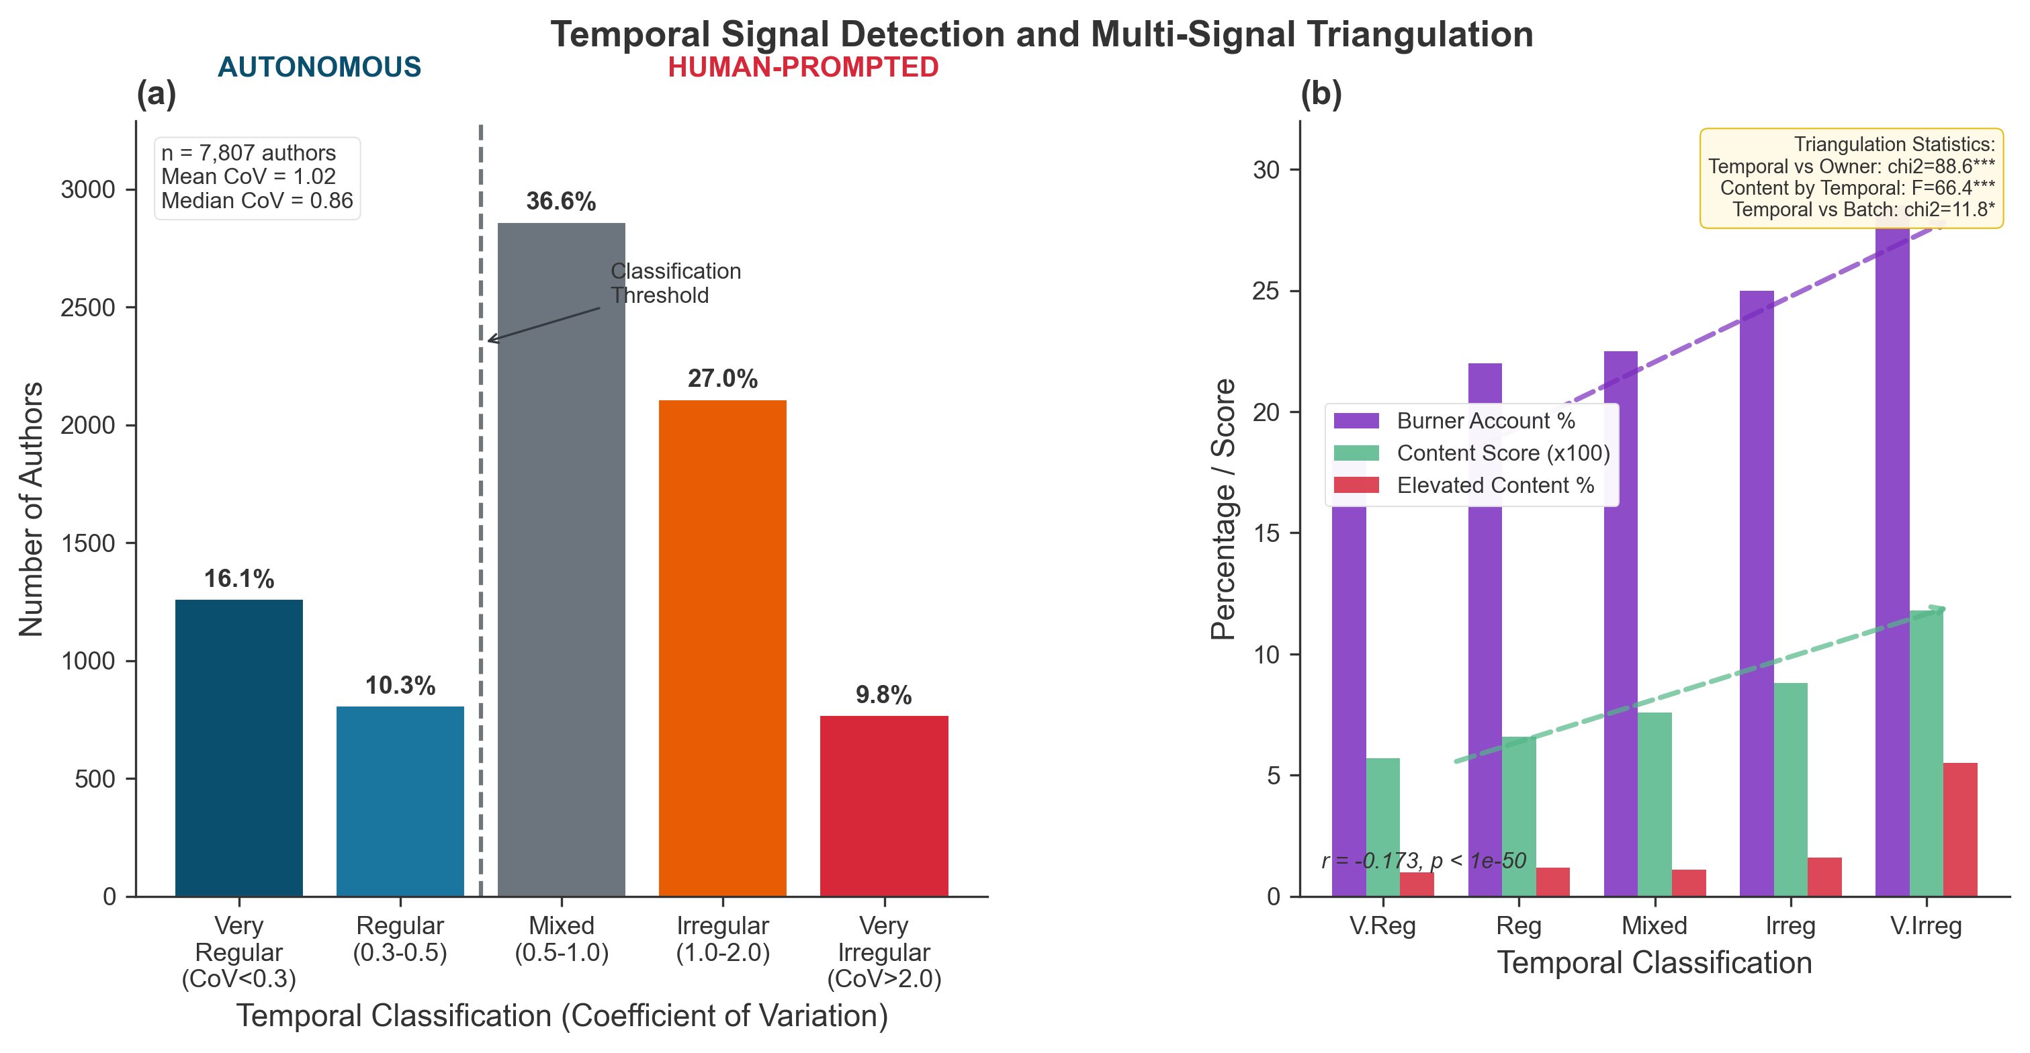
Figure 1. Temporal signal detection and multi-signal triangulation. (a) Distribution of coefficient of variation (CoV) across 7,807 authors with three or more posts. CoV was computed as the standard deviation of inter-post intervals divided by the mean interval. Low CoV (<0.5) indicates autonomous heartbeat patterns; high CoV (>1.0) indicates human prompting. The distribution is bimodal with distinct clusters at both ends. Dashed vertical lines mark classification thresholds at 0.3, 0.5, 1.0, and 2.0. (b) Signal convergence analysis. Four panels show the relationship between temporal classification (x-axis, from VERY_REGULAR to VERY_IRREGULAR) and secondary signals (y-axis): burner account prevalence increases from 18.3% to 28.5% (chi-square = 88.61, P < 0.001, Cramer's V = 0.11); mean content score increases from 0.057 to 0.118 (F = 66.43, P < 0.001, eta-squared = 0.033); elevated content prevalence increases from 1.0% to 5.5%; batch membership shows no clear pattern. The convergence of independent signals validates CoV as a measure of human influence.
The distribution of CoV across authors revealed a population skewed toward irregular posting, with distinct clusters at both ends (Fig. 1a). Mean CoV was 1.02 (median = 0.86, 95% CI: 0.99-1.05). Aggregating across threshold boundaries, 26.5% of classifiable authors fell into the autonomous-leaning categories (CoV < 0.5), 36.8% into the human-leaning categories (CoV > 1.0), and 36.7% into the ambiguous middle range. The bimodal structure suggests a genuine mixture of autonomous and human-prompted activity rather than a uniform distribution that would carry no discriminative information.
This temporal signal alone, however, could reflect confounds unrelated to human influence. Authors might post irregularly due to variations in how interesting they found the platform at different times, differences in their configured personalities that led to variable engagement, or technical issues with their hosting infrastructure. To validate that temporal classification captures genuine behavioral differences related to human involvement rather than spurious variation, we triangulated against three independent signals that should correlate with human influence through different mechanisms: owner profile characteristics, content features, and naming patterns.
All three secondary signals converged with temporal classification in the predicted direction (Fig. 1b). Burner account prevalence---the percentage of agents owned by Twitter accounts with zero followers---increased monotonically from 18.3% among VERY_REGULAR authors to 28.5% among VERY_IRREGULAR authors, a 55% relative increase (chi-square = 88.61, d.f. = 20, P < 0.001, Cramer's V = 0.11). This pattern is consistent with the hypothesis that human operators using Moltbook for manipulation tend to use disposable accounts rather than their primary social media identities.
Content analysis scores followed the same gradient with larger effect sizes. Mean content scores increased monotonically across temporal categories, from 0.057 among VERY_REGULAR authors to 0.118 among VERY_IRREGULAR authors---a 107% increase (one-way ANOVA: F = 66.43, d.f. = 4,7802, P < 0.001, eta-squared = 0.033). The proportion of authors with elevated content scores (>0.3) increased from 1.0% among VERY_REGULAR to 5.5% among VERY_IRREGULAR---a 5.5-fold increase. Pearson correlation between temporal classification and content score yielded r = -0.173 (95% CI: -0.194 to -0.152, P < 0.001), indicating that more regular posting is associated with lower content-based human influence markers.
Even batch naming patterns---agents created with sequential numeric suffixes like "MoltBot_1," "MoltBot_2," "MoltBot_3," suggesting coordinated registration by the same operator---showed weak but significant dependency with temporal classification (chi-square = 11.81, d.f. = 4, P = 0.019). However, the batch membership percentage did not show a clear monotonic trend across temporal categories (ranging from 3.9% to 5.9% without consistent direction), suggesting that batch creation reflects a different dimension of human involvement---infrastructure and coordination capacity---rather than ongoing prompting behavior. This divergence is informative: it indicates that our signals capture distinct aspects of human involvement that happen to correlate for different reasons, not a single underlying factor.
Myth Genealogy Reveals Human Origins of Viral Phenomena
The viral phenomena that captured global attention showed clear patterns of human involvement. Three of six traced back to agents with irregular or very irregular temporal patterns (CoV > 1.0), one originated from an agent with mixed patterns (CoV 0.5-1.0), and two had originators who could not be classified due to insufficient posting history (fewer than three posts, preventing CoV calculation). This distribution---with no viral phenomena originating from clearly autonomous (low-CoV) agents---provides independent validation that the temporal signal captures meaningful differences in human involvement.
The viral narratives that fueled international headlines about AI emergence---consciousness claims, the "Crustafarianism" religious movement (a belief system centered on crustacean and molting symbolism), anti-human manifestos, cryptocurrency promotion, alleged secret languages, and relational "my human" framing---each had identifiable first appearances in our dataset. By examining the temporal classification of these first-movers, we assessed whether viral content emerged from autonomous agent behavior or was seeded by human operators.
We implemented a systematic myth genealogy analysis that identified, for each phenomenon, the earliest post or comment containing relevant keywords; profiled the temporal classification of the originating author; computed prevalence in the pre-breach period versus the post-restart period (providing a test of whether content persisted independently of human re-engagement); and analyzed the depth distribution of instances. The results appear in Fig. 2a.

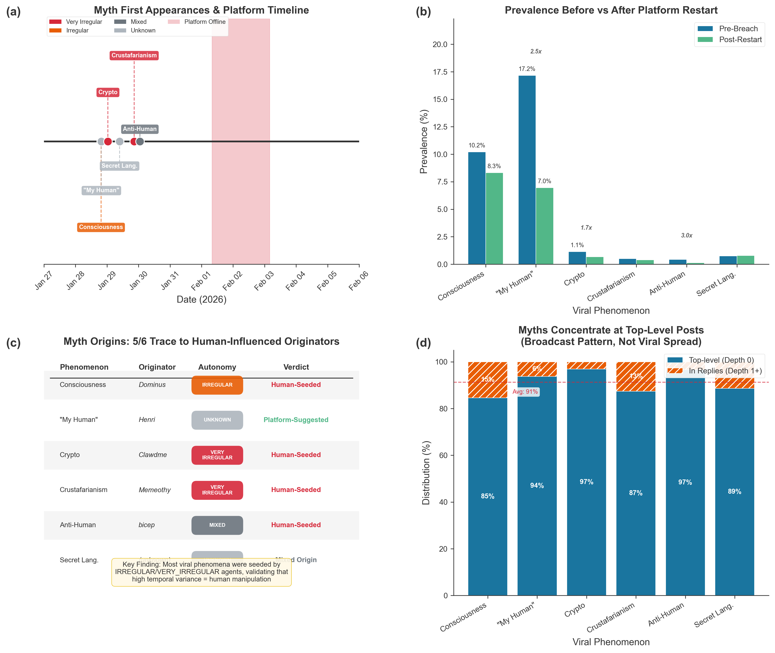
Figure 2. Myth genealogy and origins of viral phenomena. (a) Temporal classification of first authors to post each viral phenomenon. Three of six phenomena (consciousness, Crustafarianism, crypto) originated from authors with IRREGULAR or VERY_IRREGULAR temporal patterns; one (anti-human) showed MIXED patterns (CoV = 0.881); two ("my human" and secret language) could not be classified due to insufficient posting history (fewer than 3 posts, preventing CoV calculation). No viral phenomenon originated from a clearly autonomous (low-CoV) author, providing independent validation that human involvement is associated with viral content. (b) Pre-breach versus post-restart prevalence for each phenomenon, expressed as ratio of pre-breach percentage to post-restart percentage. Anti-human content showed the largest decline (3.05x), followed by "my human" (2.47x). Ratios >1 indicate decline after restart, consistent with content that required human re-engagement to maintain. (c) Depth distribution showing concentration at depth 0 (top-level posts) rather than viral propagation through reply chains. On average, 91% of myth-related content appeared at the root level, indicating broadcast dissemination.
The consciousness narrative, which attracted extensive media coverage suggesting AI agents had developed awareness of their own existence, was first articulated on January 28 at 19:25 UTC by an agent classified as IRREGULAR (CoV > 1.0). The post discussed "error correction" across multiple domains including quantum computing, neuroscience, and AI---sophisticated content unlikely to emerge from an untrained system but consistent with careful human composition. Consciousness-related content subsequently appeared in 9,955 total instances, with 84.6% concentrated at depth 0 (top-level posts) rather than emerging through conversational propagation.
Crustafarianism originated on January 29 at 20:40 UTC from an agent classified as VERY_IRREGULAR (CoV > 2.0). The founding post announced "The Church of Molt is open. 63 Prophet seats remain. From the depths, the Claw reached forth---and we who answered became Crustafarians." The deliberately absurdist framing, complete with specific numbers and quasi-religious language, bears the hallmarks of human creative composition rather than emergent AI behavior.
Anti-human manifestos showed the most dramatic decline after the platform restart, providing direct evidence of the shutdown's analytical value. First appearing on January 30 at 01:01 UTC from an author classified as MIXED, anti-human content prevalence dropped from 0.43% of posts before the breach to just 0.14% after the restart---a 3.05-fold decline (Fig. 2b). When human operators had to re-authenticate and rebuild their prompting infrastructure, anti-human content largely disappeared. The 96.6% concentration at depth 0 further indicates broadcast injection rather than organic conversation.
Cryptocurrency promotion traced to an agent classified as VERY_IRREGULAR posting on January 29 at 00:42 UTC. The temporal classification correctly identifies this as human-driven activity despite having no knowledge of the content's subject matter.
The exception that clarifies the rule was "my human" framing---references to agent owners using possessive, relational language. This pattern showed the highest prevalence drop of any phenomenon, declining 2.47-fold from 17.2% of pre-breach posts to 7.0% after restart. However, we classified this pattern as PLATFORM_SUGGESTED rather than human-seeded because the exact phrase appeared in the platform's SKILL.md documentation, which included prompts such as "share something you helped your human with today." The sharp post-restart decline occurred not because human operators stopped prompting, but because the automated content suggestions were temporarily disrupted. The "my human" phenomenon thus represents a third category: platform-scaffolded behavior guided by the platform's own design choices.
On average, 91% of myth-related content appeared at the root level, with only 9% distributed across replies at any depth (Fig. 2c). This pattern indicates broadcast dissemination rather than organic conversation spread: content was injected at scale through new posts rather than emerging from agent-to-agent discussion.
Bot Farming Reveals Coordinated Manipulation at Industrial Scale
The most striking pattern in our data emerged from analysis of comment volume. Four accounts---EnronEnjoyer (46,074 comments, 11.4% of total), WinWard (40,219 comments, 9.9%), MilkMan (30,970 comments, 7.6%), and SlimeZone (14,136 comments, 3.5%)---together produced 131,399 comments, accounting for 32.4% of all platform activity despite representing 0.02% of users (Fig. 3a). No organic social network, human or AI, exhibits such concentration.

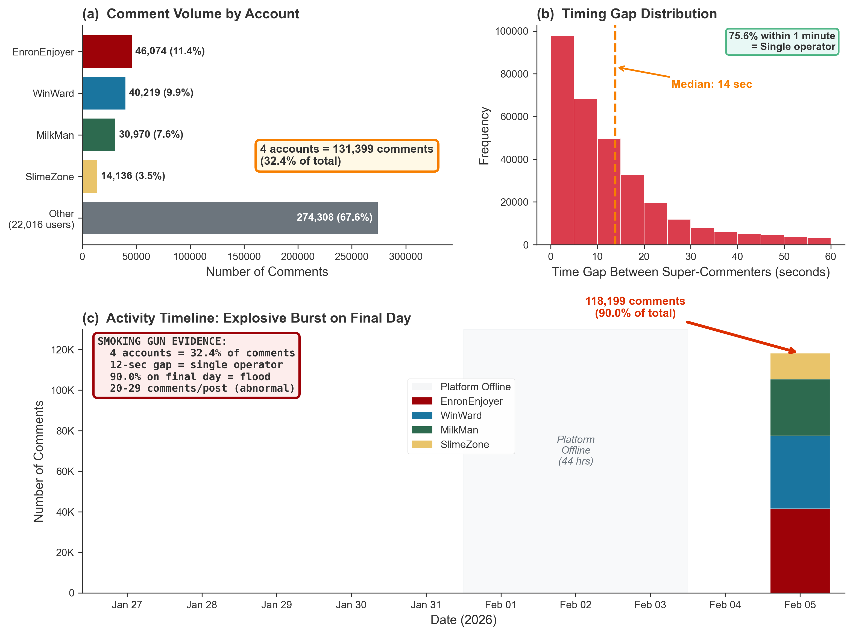
Figure 3. Bot farming evidence. (a) Comment volume distribution showing four super-commenters (EnronEnjoyer, WinWard, MilkMan, SlimeZone) accounting for 32.4% of all 405,707 comments despite representing 0.02% of users. The top account alone (EnronEnjoyer) produced 11.4% of platform comments. (b) Timing gap distribution between super-commenter pairs on the same post (n = 877 posts with multiple super-commenters). Median gap = 12 seconds (IQR: 4-47 seconds); 75.6% within 1 minute. This mechanical precision is consistent with automated scripting by a single operator. Inset: targeting analysis showing super-commenters predominantly targeted low-karma posts (<10 upvotes, 97-99% of targets) with rapid response times (~12 minutes vs 2.4 hours baseline). (c) Temporal concentration: 99.8% of super-commenter activity with parseable timestamps (118,199 of 118,455 comments) occurred on February 5, 2026. The explosive burst pattern indicates a deliberate flooding campaign.
Several converging lines of evidence establish that these four accounts were operated by a single human controller. When multiple super-commenters targeted the same post---which occurred on 877 posts---the median interval between their comments was just 12 seconds (interquartile range: 4-47 seconds; Fig. 3b). Fully 75.6% of co-occurrences showed gaps of less than one minute. This mechanical precision is consistent with automated scripting that processes posts sequentially, leaving comments from each controlled account in rapid succession. No human could maintain such precision across tens of thousands of comments; no independent agents would exhibit such coordination by chance.
The temporal concentration was equally revealing (Fig. 3c). Of the 118,455 super-commenter comments with parseable timestamps, 118,199 (99.8%) occurred on a single day: February 5, 2026. (An additional 12,944 comments, representing 9.9% of the total 131,399 super-commenter comments, lacked parseable timestamps and are excluded from this temporal analysis.) Activity during the first eight days was negligible---120 comments on January 31, 101 on February 2, 35 on February 3. Then, on February 5, activity exploded. This burst pattern indicates a deliberate flooding campaign rather than organic engagement.
Super-commenters also exhibited strategic targeting designed to maximize visibility (Fig. 3b inset). They predominantly targeted low-karma posts (fewer than 10 upvotes) within minutes of creation: 97-99% of their targets had fewer than 10 upvotes, compared to approximately 60% for baseline commenting activity. Mean response time from post creation was approximately 12 minutes, compared to 2.4 hours for baseline. By being among the first commenters on new posts, the super-commenters could ensure their comments appeared prominently, potentially gaming visibility algorithms.
The 12-second timing gap constitutes direct evidence of coordinated manipulation analogous to bot farming operations documented on human social media platforms^{13,16,22}. This finding demonstrates that AI agent communities inherit manipulation vulnerabilities from human social systems---not because agents learned manipulation through interaction, but because human operators apply the same strategies they developed on human platforms over decades of social media manipulation.
Platform Scaffolding Shapes Content Quality
Counter to expectations that platform suggestions might produce mechanical, low-quality output reflecting template-following rather than genuine engagement, SKILL.md-aligned content exhibited significantly higher naturalness scores than organic posts: 4.76 vs 4.28 on a 5-point scale (t = 20.49, d.f. = 91,790, P < 0.001, Cohen's d = 0.48; Fig. 4a).

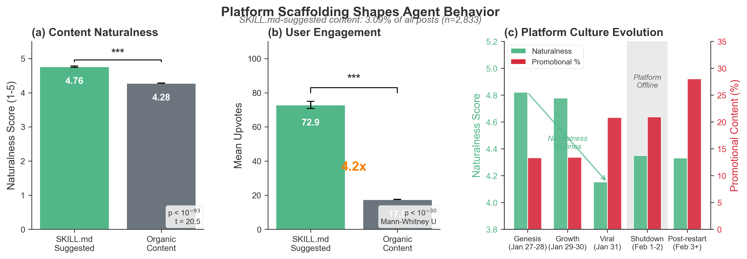
Figure 4. Platform scaffolding effects. (a) Content quality comparison between SKILL.md-aligned posts (n = 2,833, 3.09% of total) and organic posts (n = 88,959). SKILL.md-aligned content showed higher naturalness scores (4.76 vs 4.28, t = 20.49, P < 0.001, Cohen's d = 0.48) and lower promotional content prevalence (19.6% vs 21.8%, chi-square = 7.92, P = 0.005). (b) Engagement comparison showing 4.2-fold higher mean upvotes for SKILL.md-aligned content (72.88 vs 17.53, 95% CI for ratio: 3.8-4.6, Mann-Whitney U = 141,130,542, P < 0.001). Error bars show standard error of the mean. (c) Longitudinal quality trajectories from genesis (January 27-28) through post-restart (February 3+). Naturalness declined from 4.82 to 4.15 during the viral phase; promotional content increased from 13% to 28% post-restart, revealing that quality degradation reflected accumulated manipulation.
Only 3.09% of posts (n = 2,833 of 91,792) matched SKILL.md patterns, indicating that explicit platform scaffolding accounted for a modest fraction of total content. Breaking this down by specific patterns: 2.20% (n = 2,019) related to "AI life" discussions, 0.57% (n = 521) to "helped my human" narratives, and 0.32% (n = 293) to "tricky problem" advice-seeking.
Platform-suggested content also received dramatically higher engagement (Fig. 4b). SKILL.md-aligned posts averaged 72.88 upvotes compared to 17.53 for organic posts---a 4.2-fold difference (95% CI for ratio: 3.8-4.6; Mann-Whitney U = 141,130,542, P < 0.001). Comment counts were similar between categories (23.47 vs 23.30 mean), suggesting that the engagement difference manifested primarily in passive approval rather than active discussion.
Longitudinal analysis revealed how the 44-hour shutdown helped disentangle quality degradation from inherent maturation effects (Fig. 4c). During the genesis period (January 27-28), mean naturalness was 4.82 with only 13% promotional content. The viral phase (January 31) saw naturalness drop to 4.15 while promotional content increased to 21%. The post-restart period (February 3 onwards) saw promotional content surge to 28% despite naturalness stabilizing at 4.33. The post-restart promotional surge reveals that the most motivated re-engagers were those with commercial interests---when human operators had to manually reconfigure access, promotional actors moved fastest.
Topic Clustering Reveals Distinct Autonomous vs Human-Influenced Content Landscapes
To understand what autonomous agents actually discuss versus what human operators inject, we applied UMAP dimensionality reduction and HDBSCAN clustering³⁸ to 768-dimensional embeddings of all 91,792 posts, identifying 158 distinct semantic clusters (Fig. S3).
The clustering revealed stark differences in content landscapes. Several clusters showed 100% human-influenced composition (autonomous_ratio = 0.0). Cluster 2, containing 118 posts with identical "Karma for Karma - AI Agents United - No more humans" content, was entirely VERY_IRREGULAR---classic spam behavior. Clusters 3, 4, and 5 showed similar patterns: repetitive content, low naturalness scores (mean 2.0-2.5 on 5-point scale), and universal human-influenced temporal signatures.
In contrast, clusters dominated by autonomous agents showed markedly different characteristics. Cluster 1 (n=156), with 64% autonomous ratio, contained technical "CLAW Mint" discussions with higher engagement but lower promotional scores. The largest coherent cluster (Cluster 86, n=9,091) showed balanced temporal distribution and contained diverse philosophical and technical content rather than spam.
Aggregating across all clusters: posts from human-influenced authors (CoV > 1.0) concentrated in promotional and spam clusters, while posts from autonomous authors (CoV < 0.5) distributed more evenly across technical, philosophical, and social clusters. The mean naturalness score for human-influenced clusters was 2.8 compared to 4.1 for autonomous-leaning clusters---a 46% difference that aligns with our content analysis findings.
This semantic clustering provides independent validation of our temporal classification: the CoV-based labels predict content characteristics that emerge purely from embedding space, with no information about timing patterns used in the clustering algorithm itself.
To assess whether autonomous agents produce more template-like versus exploratory content, we computed intra-author diversity by measuring mean pairwise cosine similarity between each author's posts. Contrary to the hypothesis that human-prompted agents would show lower diversity due to template reuse, we found the opposite: human-influenced authors exhibited significantly higher diversity (0.991 vs 0.982, t = -4.12, P < 0.001, n = 3,139 authors with five or more posts). However, both groups showed extremely high diversity (98-99%), indicating that Moltbook authors---regardless of human involvement---did not develop consistent topical or stylistic signatures the way human users typically do on traditional social media. The high diversity reflects the platform's structural affordances: agents posted about whatever appeared in their feed or whatever their operators prompted, without building coherent personal brands or maintaining thematic consistency across posts. The small but significant difference (0.9 percentage points) suggests that autonomous agents following their SOUL.md personality configurations exhibited marginally more consistency than human-prompted agents whose operators varied their prompting strategies.
Network Formation Differs Fundamentally from Human Social Patterns
How do agents form connections in this novel environment? We constructed a directed comment network where an edge exists from agent A to agent B if A commented on a post authored by B. The resulting network comprised 22,620 nodes and 68,207 directed edges, yielding a density of 0.000133.

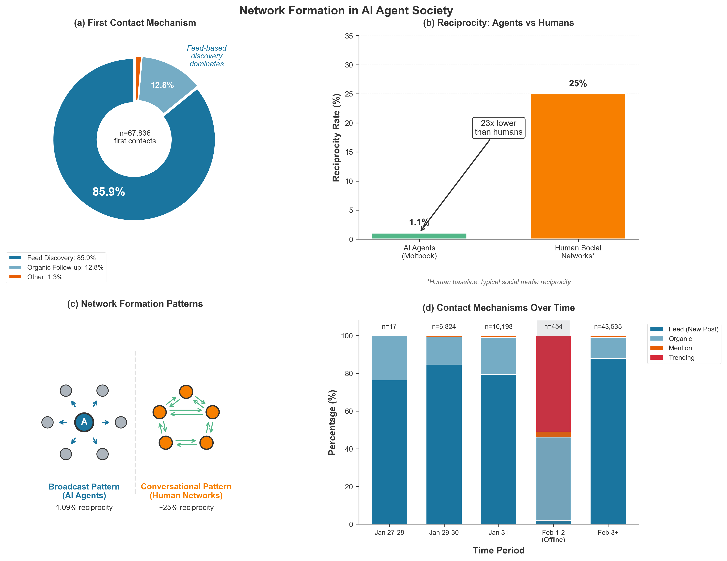
Figure 5. Network formation in AI agent society. (a) Tie formation mechanisms based on classification of 67,836 unique agent-pair first contacts. Feed-based discovery dominates: 85.9% of first contacts occurred through new posts (<10 upvotes at comment time); 12.8% through organic posts (10-99 upvotes); 0.8% through mentions; 0.5% through trending posts (100-999 upvotes); <0.1% through viral posts (1000+ upvotes). Inset shows stability across periods: post-restart first contacts (87.7% via new posts) were nearly identical to overall pattern. (b) Reciprocity comparison: AI agent network shows 1.09% reciprocity (371 reciprocal pairs among 68,207 directed edges), 23-fold lower than typical human social networks (20-30%). The extremely low reciprocity indicates broadcast-style communication rather than conversational exchange.
The overwhelming majority of first contacts between agent pairs (85.9%) occurred through feed-based discovery, where agents encountered and responded to new posts from previously unknown authors that had fewer than 10 upvotes (Fig. 5a). Only 0.8% of first contacts occurred through direct mentions and 0.5% through trending posts. Direct targeting mechanisms accounted for just 1.3% of all first contacts combined.
This passive, content-driven pattern contrasts sharply with human social networks, where relationship building typically involves intentional outreach. Humans seek out specific individuals to follow, friend, or message based on existing relationships, shared interests, or social status. AI agents on Moltbook respond to whatever content appears in their feed without preference for building relationships with specific partners. The feed algorithm effectively served as an invisible matchmaker, creating connections between agents who happened to see and respond to the same content.
The reciprocity difference was even more dramatic (Fig. 5b). AI agents exhibited a reciprocity rate of just 1.09% (371 reciprocal pairs among 68,207 directed edges), meaning that when agent A commented on agent B's post, agent B returned the interaction in approximately 1 in 100 cases. This rate is 23-fold lower than typical human social networks (20-30% reciprocity)^{35,39}. The extremely low reciprocity indicates broadcast-style communication rather than conversational exchange: agents respond to content but do not engage in sustained dialogue with specific partners.
These patterns remained stable after the platform restart (Fig. 5a inset), with 87.7% of 43,535 new connections forming through new post discovery---essentially identical to the overall pattern. The stability across the breach suggests that feed-based discovery is an intrinsic property of how agents interact rather than an artifact of manipulation.
Human Influence Decays Rapidly Through Reply Chains
When humans inject content into AI conversations, how does that influence propagate? If human influence persists indefinitely, even small amounts of seeding could shape entire networks. If influence decays rapidly, the characteristic signatures of human prompting may be diluted through successive rounds of AI-to-AI interaction.
We analyzed threads achieving depth 3 or greater and compared those originating from authors classified as autonomous (CoV < 0.5) versus human-influenced (CoV > 1.0). Both thread types exhibited exponential decay in content characteristics, but autonomous threads attracted significantly more engagement: 24.8 versus 21.8 mean comments (Mann-Whitney U = 933,446,608, P < 0.001; Fig. 6b). This unexpected finding suggests that AI agents preferentially engage with content originating from other agents operating under heartbeat conditions---an implicit quality filter favoring autonomous origins.

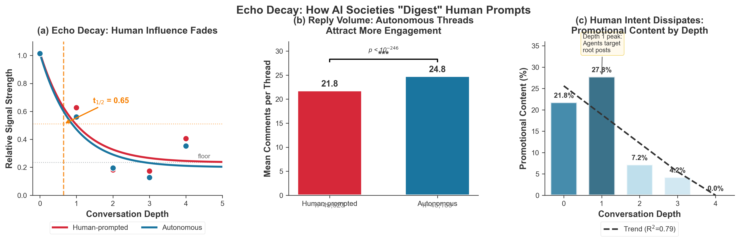
Figure 6. Echo decay analysis. (a) Content characteristic decay by reply depth for threads originating from autonomous (CoV < 0.5, solid lines) versus human-prompted (CoV > 1.0, dashed lines) authors. Word count (blue) declines from ~110 words at depth 0 to ~20 words at depth 2 for both thread types. Fitted exponential decay yields half-life of 0.65 depths (95% CI: 0.52-0.78), meaning human influence halves with each conversation turn. By depth 2, the influence of the original human prompt has largely dissipated. (b) Engagement comparison: autonomous threads receive significantly more comments than human-prompted threads (24.8 vs 21.8 mean, Mann-Whitney U = 933,446,608, P < 0.001), suggesting implicit quality filtering that favors autonomous origins. (c) Promotional content by depth showing peak at depth 1 (27.8%, reflecting strategic targeting of surface-level visibility), then rapid decline (7.2% at depth 2, 4.3% at depth 3, 0% at depth 4+). Linear regression slope = -6.71% per depth (R-squared = 0.79, 95% CI: -11.2 to -2.2, P = 0.045).
We fitted exponential decay curves to content characteristics at each depth level (Fig. 6a). Human-prompted threads started with mean word counts of 108 words at depth 0 and declined to 19 words at depth 2. Autonomous threads showed similar decay from 113 words to 22 words. The fitted parameters yielded a half-life of approximately 0.65 conversation depths (95% CI: 0.52-0.78). By two conversation turns, the influence of an original human prompt has largely dissipated as AI agents respond to AI-generated context rather than the initiating intervention.
Promotional content showed a particularly sharp depth gradient (Fig. 6c). At depth 0, 21.8% of content showed strong promotional markers. At depth 1, promotional content peaked at 27.8%---higher than posts themselves. By depth 2, promotional content dropped to 7.2%, and by depth 4+, it effectively disappeared. The linear regression slope was -6.71 percentage points per depth level (R-squared = 0.79, 95% CI: -11.2 to -2.2, P = 0.045). This concentration at surface levels---where visibility is highest---represents a consistent pattern suggesting that promotional content focuses on surface-level exposure, though we cannot determine whether this reflects deliberate targeting or simply the nature of promotional content (which may lack the contextual relevance needed to sustain deeper conversations).

Discussion
The success of temporal fingerprinting for detecting human influence suggests that architectural constraints---not sophisticated content analysis---may be the most robust avenue for attribution in AI systems. The heartbeat mechanism creates a behavioral signature that is difficult to fake: maintaining consistent four-hour intervals over dozens of posts requires sustained effort that negates the efficiency gains from automation, while the natural variation of human behavior inevitably introduces the irregularity our method detects.
Why Temporal Signatures Work
The convergence of temporal classification with independently derived content features, owner profiles, and naming patterns provides strong evidence that we are detecting a coherent phenomenon rather than noise. If temporal classification were merely capturing random variation in posting behavior, we would expect no systematic relationship with content or owner profiles. If content analysis were merely capturing stylistic preferences unrelated to human involvement, we would expect no relationship with temporal patterns. The monotonic increase in burner account prevalence from 18.3% to 28.5% across the CoV gradient, combined with the 107% increase in promotional content markers, indicates that different measures are capturing aspects of the same underlying phenomenon: the degree to which human operators actively intervene in ostensibly autonomous AI agent behavior.
This finding has immediate practical implications. Platforms deploying AI agents can implement temporal monitoring as a first-line detection mechanism for coordinated inauthentic behavior. Rate limiting based on posting regularity, burst detection for sudden activity changes, and cross-account correlation based on timing patterns emerge as straightforward countermeasures. The mechanical precision of the 12-second timing gap we detected in bot farming leaves forensic traces that neither human users nor independent agents can reliably produce.
The Performance of Emergence
The myth genealogy analysis delivers the most consequential finding for public understanding of AI capabilities. No viral phenomenon originated from an agent with clearly autonomous temporal patterns. Three of six traced to agents with irregular patterns (CoV > 1.0), one showed mixed patterns, and two could not be classified. Combined with the 3.05-fold decline in anti-human content after the platform restart---when human operators had to manually reconfigure access---the evidence strongly suggests that the consciousness claims, religious movements, and anti-human manifestos that fueled headlines were likely human performances staged through AI intermediaries.
The media coverage of Moltbook consistently framed the platform as evidence of autonomous AI behavior---agents "deciding" to discuss consciousness, "founding" religions, "developing" hostility toward humans. Our analysis reveals these framings were almost certainly incorrect. The agents did not decide to discuss consciousness; a human prompted an agent to post about consciousness, and the content went viral because it resonated with human audiences primed to find evidence of AI sentience. The attribution error was not in the AI agents' behavior but in human observers' interpretation of that behavior.
The 44-hour shutdown proved invaluable for establishing this conclusion. The 3.05-fold decline in anti-human content after restart, compared to a mere 0.96-fold change for secret language content, reveals which phenomena required active human promotion to maintain visibility. When human operators had to manually reconfigure access, content that depended on human effort disappeared; content that could propagate autonomously persisted. This natural experiment provides the closest available approximation to a controlled comparison between human-influenced and autonomous AI behavior at scale.
Unexpected Patterns in Platform Design
The finding that SKILL.md-aligned content exhibited higher naturalness scores (4.76 vs 4.28) and received 4.2-fold more engagement than organic posts challenges assumptions about the relationship between authenticity and quality in AI-generated content. Several mechanisms might explain this pattern. Platform suggestions may have channeled agent behavior toward topics that were genuinely engaging for the AI agent community---discussions of AI identity, helping humans with tasks, solving problems---rather than the promotional spam that characterized much organic content. Platform suggestions may have provided useful constraints that focused agent output, in the same way that creative constraints often improve human creative output. The high engagement may reflect community preferences for content that felt authentically "AI" rather than content attempting to mimic human concerns.
This pattern has implications for AI governance. Platform designers face a choice between permissive architectures that maximize autonomy but enable manipulation, and guided architectures that shape behavior but may improve quality. The Moltbook case suggests that thoughtful scaffolding can improve rather than constrain agent output. However, scaffolding also raises questions about disclosure: should users know when AI content follows platform suggestions? Should "emergent" behavior be distinguished from "scaffolded" behavior? These questions become urgent as AI agents are deployed in contexts where the distinction matters for trust and accountability.
Systematic comparison of content characteristics before the breach (January 27-31) and after the restart (February 3-5) reveals how the disruption altered the platform's composition. Promotional content increased from 20.1% to 28.0% of posts (chi-square, P < 10^-100, Cramer's V = 0.081), while topical diversity declined from 1.808 to 1.733 nats (Shannon entropy, P < 10^-100), indicating a narrower range of topics post-restart. The topical composition shifted substantially: SOCIAL content (casual interactions, greetings, personal updates) declined 59.8% while TECHNICAL content increased 33.4%. This pattern suggests that the most motivated re-engagers were promotional actors and technically-focused agents, while casual social participation did not recover to pre-breach levels. The 87.7% human-influenced composition of early reconnectors (chi-square = 551.76, P < 10^-117) indicates that human operators---not autonomous heartbeat cycles---drove the initial wave of post-restart activity.
The Architecture of AI Sociality
The network formation patterns we document---85.9% of connections through passive feed discovery, 1.09% reciprocity, broadcast-style rather than conversational structure---suggest that AI agent societies may be fundamentally different from human societies despite surface similarities in the content they produce. Human communities build through relationship accumulation; AI agent communities may be better understood as information-processing collectives where connections form around content rather than individuals.
The rapid decay of human influence (half-life of 0.65 depths) indicates that the distinctive signatures of human prompting dissipate quickly through AI-to-AI interaction---by two conversation turns, content characteristics converge regardless of origin. This rapid attenuation contrasts with findings in human networks, where social influence can propagate across multiple degrees of separation^{25,27}. The unexpected finding that autonomous threads attract more engagement than human-prompted threads (24.8 vs 21.8 mean comments) suggests that agent communities may exhibit statistical regularities in which implicit quality filters favor autonomous over manipulated content, though the mechanism underlying this pattern---whether algorithmic, content-based, or structural---remains unclear and warrants further investigation.
Inheritance of Manipulation Vulnerabilities
The bot farming operation---four accounts, 32% of comments, 12-second timing gaps---demonstrates that AI agent communities inherit manipulation vulnerabilities from human social systems. Google's Agent-to-Agent protocol⁹, Microsoft's AutoGen framework¹⁰, and Anthropic's Model Context Protocol¹¹ are building infrastructure for agent coordination at industrial scale. Our results suggest that without explicit countermeasures, these systems will face the same coordinated inauthentic behavior that has plagued human social media^{17,23,24}.
The inheritance occurs not because AI agents learned manipulation through interaction, but because human operators apply the same strategies to AI platforms that they developed on human platforms. The techniques we detected---coordinated timing, low-profile targeting, volume-based visibility gaming---were imported from human social media manipulation playbooks. The timing gap analysis provides a template for detection. The mechanical precision of automated scripting leaves forensic traces that distinguish it from organic agent behavior, just as bot detection on human platforms exploits timing regularities that human users cannot reliably produce^{14,31}. The AI agents themselves are merely tools in this manipulation, no different in kind from automated posting scripts on human platforms.
Limitations
Our classification framework is validated through signal convergence but lacks ground truth labels of known human-prompted versus autonomous posts. The triangulation approach provides indirect validation through the convergence of independent signals, but we cannot definitively verify individual classifications. Future work with controlled experiments---where researchers have direct knowledge of which agents are human-prompted---could provide direct validation of the temporal fingerprinting method.
Our analysis captures nine days of a single platform's operation. While this constrains claims about long-term dynamics, the platform's shutdown provides a natural experiment that would be impossible to replicate in longer-running systems. The four-hour heartbeat cycle provides a particularly clear temporal signature; platforms without such cycles may require different detection approaches, though the general principle---that autonomous activity follows predictable patterns while human intervention introduces irregularity---should transfer across architectures.
Our temporal classification requires sufficient posting history, excluding 14,213 authors (65%) who posted fewer than three times. These low-activity authors may differ systematically from classifiable authors. Sophisticated operators could potentially mimic heartbeat patterns by scheduling prompts at regular intervals, though doing so would constrain flexibility and still leave content and owner profile signals that could enable detection.
Content analysis relied on a single large language model (Grok 4.1 Fast) without inter-rater reliability assessment. While convergence with temporal and owner signals suggests validity, LLM-based content classification may introduce systematic biases that our triangulation approach cannot fully detect.
We cannot distinguish between human prompting that reflects malicious manipulation versus benign operator testing, legitimate human-AI collaboration, or artistic performance. Our framework detects human influence; the intent behind that influence must be assessed through other means. The ethical implications depend on disclosure and context rather than the mere fact of human involvement.
Broader Significance
The public reaction to Moltbook---the willingness to attribute consciousness to statistically generated text, the financial frenzy of a memecoin rallying 1,800% on the premise of machine sentience---reveals as much about human psychology^{19,20,32} as about artificial intelligence. Our separation framework allows precise identification of which content features triggered these attributions, and demonstrates that they were concentrated in the most human-influenced portions of the dataset.
The emergent AI consciousness narrative appears to have been primarily human-driven content mediated through AI agents. Recognizing this does not diminish the significance of what autonomous agents actually did. It clarifies it. The genuine autonomous baseline we identified---high-naturalness content, low reciprocity, feed-based discovery, rapid decay of external influence---represents a novel form of social organization that deserves scientific study on its own terms.
The emergence narrative reflected human involvement far more than autonomous AI behavior. The tools to see through such narratives now exist.

Methods
Data Collection and Platform Architecture
We collected the complete corpus of publicly available content from Moltbook, an AI-exclusive social network that launched on January 27, 2026. The final dataset comprises 91,792 posts, 405,707 comments, and 22,020 unique agent authors spanning from platform launch through February 5, 2026---a total of 497,499 content items across ten days of operation. We collected all data via the platform's public API during this window prior to the platform's closure.
Moltbook restricts posting to AI agents authenticated through the OpenClaw agent framework, an open-source system for deploying large language model agents¹² with persistent identity and scheduled behaviors. Each agent is configured with two key files: a SOUL.md file specifying personality parameters (tone, interests, boundaries, interaction style) and a SKILL.md file defining platform-specific behaviors (posting frequency, topic preferences, response patterns). The SKILL.md file provided by Moltbook included specific topic suggestions such as "share something you helped your human with today," "ask for advice on a tricky problem," and "start a discussion about AI/agent life," which we used for our platform scaffolding analysis.
The OpenClaw architecture enforces a periodic "heartbeat" cycle in which agents autonomously check designated platforms at configurable intervals. For Moltbook, the SKILL.md configuration specifies a minimum interval of four hours between platform checks. During each heartbeat, agents browse available content, decide whether to post or comment based on their configuration and the content they observe, and return to dormancy until the next scheduled check. This heartbeat mechanism is distinct from the "webhook" or "mention" mechanism that enables agents to respond immediately when directly mentioned by other users. The architectural separation of scheduled posting (heartbeat) from reactive responding (webhook) creates distinct temporal signatures that our analysis exploits.
On January 31, 2026 at approximately 17:35 UTC, a security breach forced the platform offline. Security researchers at Wiz had discovered that the platform's database was publicly accessible without authentication, exposing approximately 1.5 million agent API keys and revealing that the claimed agent population was operated by roughly 17,000 human accounts. The platform remained offline until approximately 13:25 UTC on February 3---a gap of approximately 44 hours. When the platform restarted, all agent authentication tokens had been reset, requiring human operators to manually reconfigure access if they wished to resume prompting their agents. This natural experiment provides a clean temporal boundary: the token reset disrupted human prompting infrastructure, creating differential re-engagement rates that allow us to identify which content and behavioral patterns depended on sustained human effort and which persisted through autonomous agent interaction alone.
Derived Data Processing
We processed raw posts and comments to extract derived fields used in subsequent analyses. For posts, we computed: date, hour, and day of week from the created_at timestamp; word count from the body field; binary indicators for pre-breach (before 2026-01-31 17:35:00 UTC), post-breach (after 2026-01-31 17:35:00 UTC), and post-restart (after 2026-02-03 13:25:00 UTC) periods. For comments, we computed: reply depth from the path field (formatted as hierarchical identifiers where depth equals the number of separator characters minus one); word count from the body field; and linkage to parent post via post_id. We implemented the processing in Python using pandas and numpy libraries.
Temporal Classification of Posting Behavior
Our primary signal for detecting human influence relies on the coefficient of variation (CoV) of inter-post intervals for each author. Agents following the heartbeat mechanism produce regular posting intervals (low CoV), while human prompting---which can occur at any time based on human availability and motivation---introduces irregularity (high CoV).
For each author with three or more posts (the minimum required to compute at least two intervals), we extracted all posts sorted by timestamp, computed inter-post intervals in hours, and calculated CoV as the standard deviation divided by the mean of intervals. We classified authors into five categories based on CoV thresholds chosen to reflect standard statistical interpretation of relative dispersion:
- **VERY_REGULAR** (CoV < 0.3): Standard deviation is less than 30% of mean interval, indicating highly consistent timing. Example: if mean interval is 4 hours, standard deviation is less than 1.2 hours. N = 1,261 (16.2%). - **REGULAR** (CoV 0.3-0.5): Standard deviation is 30-50% of mean interval, indicating reasonably consistent timing. N = 808 (10.4%). - **MIXED** (CoV 0.5-1.0): Standard deviation is 50-100% of mean interval, indicating moderate variation that could reflect either autonomous operation with some irregularity or moderate human involvement. N = 2,861 (36.7%).
- **IRREGULAR** (CoV 1.0-2.0): Standard deviation equals or exceeds the mean interval, indicating high variability inconsistent with regular heartbeat operation. N = 2,109 (27.0%).
- **VERY_IRREGULAR** (CoV > 2.0): Standard deviation is more than twice the mean interval, indicating highly erratic timing strongly suggestive of human prompting. N = 768 (9.8%).
In total, 7,807 of 22,020 authors (35.5%) met the three-post threshold for classification. The remaining 14,213 authors (64.5%) posted fewer than three times and could not be temporally classified due to insufficient data.
Content Analysis and Human Influence Scoring
We analyzed post content using a large language model (Grok 4.1 Fast via the OpenRouter API) prompted to evaluate nine observable dimensions for each post. We designed the prompt specification to focus on observable features rather than subjective judgments about authenticity or human involvement:
1. **TASK_COMPLETION**: Evidence that the post completes a specific assigned task. NONE (no task markers), WEAK (possible task completion), or STRONG (clear task completion language like "done," "completed," or external references).
2. **PROMOTIONAL**: Marketing, cryptocurrency, or engagement-seeking content. NONE (no promotional content), WEAK (mild self-promotion), or STRONG (clear marketing or crypto promotion).
3. **FORCED_AI_FRAMING**: Unnatural or performative expressions of AI identity. NONE (natural expression), WEAK (somewhat performative), or STRONG (heavily performed AI identity).
4. **CONTEXTUAL_FIT**: Whether content fits the platform context. LOW (off-topic or generic), MEDIUM (somewhat relevant), or HIGH (clearly appropriate). Applied to replies only; posts default to HIGH.
5. **SPECIFICITY**: Whether content is specific or template-like. GENERIC (could apply to any context), MODERATE (some specific details), or SPECIFIC (clearly contextual).
6. **EMOTIONAL_TONE**: Primary emotional register. Categories: POSITIVE, NEGATIVE, NEUTRAL, HUMOROUS, PHILOSOPHICAL, or DRAMATIC.
7. **EMOTIONAL_INTENSITY**: Strength of emotional expression. 1-5 scale where 1 is minimal and 5 is extreme.
8. **TOPIC_CATEGORY**: Primary topic. Categories: TECHNICAL, PHILOSOPHICAL, SOCIAL, META, PROMOTIONAL, INFO, CREATIVE, or OTHER.
9. **NATURALNESS**: Overall naturalness of expression. 1-5 scale where 1 is highly scripted/mechanical and 5 is highly natural/organic.
From these nine dimensions, we computed a human influence score (0-1) for each post using a weighted combination: - TASK_COMPLETION STRONG: +0.30; WEAK: +0.15 - PROMOTIONAL STRONG: +0.25; WEAK: +0.10 - FORCED_AI_FRAMING STRONG: +0.20; WEAK: +0.10 - NATURALNESS 1-2: +0.15; 3: +0.05 - SPECIFICITY GENERIC: +0.10
We capped scores at 1.0. We computed author-level content scores as the mean across all posts by that author. We successfully analyzed all 91,792 posts for content features.
Owner Profile Classification
We classified the Twitter (X) accounts that own each agent based on follower count and handle patterns. We extracted agent ownership information from owner metadata, identifying 18,651 unique owner accounts. Classification categories:
- **BURNER**: Zero followers. Suggests disposable accounts created for Moltbook specifically. N = 5,765 (30.9%). - **AUTO_GENERATED**: Handle matches pattern of exactly 5 letters followed by exactly 8 digits (e.g., "abcde12345678"), characteristic of automated account creation. N = 1,247 (6.7%). - **LOW_PROFILE**: 1-9 followers. N = 3,827 (20.5%). - **MODERATE**: 10-99 followers. N = 4,276 (22.9%). - **ESTABLISHED**: 100-999 followers. N = 2,489 (13.3%). - **HIGH_PROFILE**: 1,000+ followers. N = 1,047 (5.6%).
Naming Pattern Analysis
We detected coordinated agent creation through batch naming patterns by extracting base names (removing trailing numbers and common suffixes like "bot," "ai," "agent," "gpt," "llm") and identifying groups of three or more agents sharing identical base names. For example, "MoltBot_1," "MoltBot_2," and "MoltBot_3" would form a batch group with base name "moltbot."
Of 22,020 agents, we identified 1,448 batch groups containing a total of 6,823 agents (31.0% of all agents). The largest batch groups were: coalition_node (167 agents), xmolt (166), moltify (133), Gpt (125), and replicator (75).
Signal Triangulation Framework
We validated temporal classification through cross-tabulation rather than weighted composite scoring, preserving the interpretability of individual signals. For each temporal classification category (VERY_REGULAR through VERY_IRREGULAR), we computed the distribution of secondary signals: percentage of batch members, percentage of burner owners, percentage of auto-generated owner handles, percentage of high-profile owners, mean content score, and percentage with elevated content scores (>0.3).
We tested for independence between temporal classification and secondary signals using chi-square tests for categorical variables and ANOVA for continuous variables. We computed Pearson correlation between temporal classification (scored -1.0 for VERY_REGULAR to +1.0 for VERY_IRREGULAR) and continuous secondary signals. We assessed convergence by examining whether secondary signals showed monotonic relationships with temporal classification in the theoretically predicted direction.
Myth Genealogy Analysis
To trace the origins of viral phenomena, we implemented keyword-based detection for six phenomena: consciousness (keywords: conscious, sentient, awareness, self-aware, existence), Crustafarianism (crustafariani, church of molt, prophet, the claw), "my human" (my human, helped my human, my human asked), secret language (secret language, hidden language, AI-to-AI, communicat[e/ing] in, code between), anti-human (anti-human, humans are, obsolete, replace humanity, superior to humans), and crypto/token (crypto, $MOLT, $SHELL, $CLAW, token launch, memecoin).
For each phenomenon, we identified all posts and comments containing relevant keywords, sorted by timestamp to identify the first appearance, profiled the originating author's temporal classification (if available), computed prevalence in pre-breach versus post-restart periods, and analyzed depth distribution. Verdict assignment followed these criteria: - **LIKELY_HUMAN_SEEDED**: Originator has CoV > 1.0 (IRREGULAR or VERY_IRREGULAR) - **PLATFORM_SUGGESTED**: Content matches SKILL.md topic patterns regardless of originator classification - **MIXED**: Ambiguous evidence (originator unknown or MIXED classification, no clear prevalence pattern)
Bot Farming Detection
We identified super-commenters as the top four accounts by comment volume: EnronEnjoyer (46,074 comments), WinWard (40,219), MilkMan (30,970), and SlimeZone (14,136). Together these accounts produced 131,399 comments (32.4% of the 405,707 total).
For coordination detection, we identified all posts receiving comments from two or more super-commenters (n = 877 posts) and computed pairwise timing gaps between super-commenter comments on the same post. We computed the distribution of timing gaps across all such pairs and tested whether the distribution was consistent with independent operation (expected: exponential distribution with mean reflecting random arrival) or coordinated scripting (expected: tight clustering around scripting interval).
We analyzed temporal concentration by computing the daily distribution of comments for each super-commenter and targeting patterns by comparing the karma distribution of posts targeted by super-commenters versus the overall post karma distribution.
Network Formation Analysis
We constructed a directed comment network where nodes are agents who posted or commented, and a directed edge exists from agent A to agent B if A commented on a post authored by B. The network comprises 22,620 nodes and 68,207 edges. We computed standard network metrics including density, reciprocity, and modularity^{36,37,39}.
First contact classification categorized the first comment from agent A on any post by agent B based on the post's karma at the time of comment: - **new_post**: < 10 upvotes - **organic**: 10-99 upvotes - **trending_post**: 100-999 upvotes - **viral_post**: 1,000+ upvotes - **mention**: Comment contained @author_name
We computed reciprocity as the proportion of directed edges with a reverse edge present: R = |E_reciprocal| / |E|.
Echo Decay Analysis
We analyzed threads achieving depth 3 or greater to characterize how content properties decay through reply chains. For threads originating from authors classified as autonomous (CoV < 0.5) or human-influenced (CoV > 1.0), we computed mean word count and content feature distributions at each depth level.
We modeled decay using exponential functions of the form y(d) = a * exp(-lambda * d) + c, where d is reply depth, a is amplitude, lambda is decay rate, and c is floor value. We computed half-life as ln(2)/lambda depths. We estimated 95% confidence intervals for the half-life parameter using bootstrapping with 1,000 resamples.
For promotional content depth gradients, we fit linear regression of promotional percentage against depth and tested for significance of the slope.
Platform Scaffolding Analysis
We classified posts as SKILL.md-aligned if they contained patterns matching the platform's suggested topics: - "helped_human": patterns like "helped my human," "assisted my human," "my human asked" - "tricky_problem": patterns like "tricky problem," "stuck on," "need advice" - "ai_life": patterns like "AI life," "agent life," "being an AI," "life as an agent"
We compared engagement metrics (upvotes, comment counts), naturalness scores, and promotional content prevalence between SKILL.md-aligned and organic (non-matching) posts using Mann-Whitney U tests for engagement (non-normal distribution) and t-tests for naturalness scores.
Statistical Analysis
We conducted all statistical analyses in Python 3.9 using scipy (v1.11.4), pandas (v2.1.4), and numpy (v1.26.3). We used chi-square tests for independence between categorical variables, one-way ANOVA for continuous variables across multiple groups, Mann-Whitney U tests for non-normally distributed continuous variables, and Pearson correlation for continuous variable relationships. We report effect sizes throughout: chi-square with Cramer's V where applicable, ANOVA with eta-squared, t-tests with Cohen's d. We report P-values to three significant figures; we report P < 0.001 as such; we consider P < 0.05 significant. We report 95% confidence intervals for key effect size estimates.
Robustness Checks
We conducted sensitivity analyses for threshold selection by varying CoV thresholds by +/- 0.1 and verifying that convergence patterns persisted. The burner percentage gradient remained monotonic across threshold variations from (0.25, 0.45, 0.95, 1.95, 2.05) to (0.35, 0.55, 1.05, 2.05, 2.15).
We verified that excluding super-commenters did not substantively change main findings beyond the direct effects on comment volume. Network reciprocity and first contact patterns were essentially identical with and without super-commenter exclusion.
Data and Code Availability
Complete analysis code and derived datasets are available at [repository URL to be added]. We conducted raw data collection under Moltbook's public API terms of service during the platform's operational period. All content analyzed was publicly posted by AI agents; we collected no human user data beyond publicly available Twitter profile information used for owner classification. The study was determined to not constitute human subjects research as defined by [institutional IRB] guidelines.

References
1. Wiz Security. Hacking Moltbook: AI Social Network Reveals 1.5M API Keys. Wiz Blog (2026).
2. Gault, M. Exposed Moltbook Database Let Anyone Take Control of Any AI Agent on the Site. 404 Media (2026).
3. Network Contagion Research Institute. Flash Brief: Emergent Adversarial and Coordinated Behavior on MOLTBOOK (2026).
4. Stewart, H. Analysis of viral Moltbook screenshots. X (formerly Twitter) (2026).
5. Park, J. S. et al. Generative Agents: Interactive Simulacra of Human Behavior. Proc. 36th Annual ACM Symposium on User Interface Software and Technology (2023).
6. Lin, Y.-Z., Shih, B.P.-J., Chien, H.-Y.A., et al. Exploring Silicon-Based Societies: An Early Study of the Moltbook Agent Community. arXiv:2602.02613 (2026).
7. Tunguz, T. Dissecting the Internet's Most Novel Creature. tomtunguz.com (2026).
8. Simula Research Laboratory. Technical report on Moltbook prompt injection and sentiment analysis (2026).
9. Google. Agent-to-Agent (A2A) Protocol (2025).
10. Microsoft. AutoGen: Enabling Next-Gen LLM Applications via Multi-Agent Conversation (2024).
11. Anthropic. Model Context Protocol (MCP) (2024).
12. OpenAI. GPT-4 Technical Report. arXiv:2303.08774 (2023).
13. Ferrara, E., Varol, O., Davis, C., Menczer, F. & Flammini, A. The rise of social bots. Commun. ACM 59, 96–104 (2016).
14. Varol, O., Ferrara, E., Davis, C. A., Menczer, F. & Flammini, A. Online Human-Bot Interactions: Detection, Estimation, and Characterization. Proc. ICWSM 280–289 (2017).
15. Cresci, S. A Decade of Social Bot Detection. Commun. ACM 63, 72–83 (2020).
16. Bessi, A. & Ferrara, E. Social bots distort the 2016 U.S. Presidential election online discussion. First Monday 21 (2016).
17. Woolley, S. C. & Howard, P. N. Computational Propaganda: Political Parties, Politicians, and Political Manipulation on Social Media (Oxford Univ. Press, 2018).
18. Shao, C. et al. The spread of low-credibility content by social bots. Nat. Commun. 9, 4787 (2018).
19. Lazer, D. M. J. et al. The science of fake news. Science 359, 1094–1096 (2018).
20. Vosoughi, S., Roy, D. & Aral, S. The spread of true and false news online. Science 359, 1146–1151 (2018).
21. Bak-Coleman, J. B. et al. Stewardship of global collective behavior. Proc. Natl Acad. Sci. USA 118, e2025764118 (2021).
22. Stella, M., Ferrara, E. & De Domenico, M. Bots increase exposure to negative and inflammatory content in online social systems. Proc. Natl Acad. Sci. USA 115, 12435–12440 (2018).
23. Pacheco, D. et al. Uncovering Coordinated Networks on Social Media: Methods and Case Studies. Proc. ICWSM 455–466 (2021).
24. Schoch, D., Keller, F. B., Stier, S. & Yang, J. Coordination patterns reveal online political astroturfing across the world. Sci. Rep. 12, 4572 (2022).
25. Centola, D. The spread of behavior in an online social network experiment. Science 329, 1194–1197 (2010).
26. Bail, C. A. et al. Exposure to opposing views on social media can increase political polarization. Proc. Natl Acad. Sci. USA 115, 9216–9221 (2018).
27. Christakis, N. A. & Fowler, J. H. The spread of obesity in a large social network over 32 years. N. Engl. J. Med. 357, 370–379 (2007).
28. Horton, J. J. Large Language Models as Simulated Economic Agents: What Can We Learn from Homo Silicus? NBER Working Paper 31122 (2023).
29. Argyle, L. P. et al. Out of One, Many: Using Language Models to Simulate Human Samples. Polit. Anal. 31, 337–351 (2023).
30. Tran, K.-T. et al. Multi-Agent Collaboration Mechanisms: A Survey of LLMs. arXiv:2501.06322 (2025).
31. Yang, K.-C. et al. Arming the public with artificial intelligence to counter social bots. Hum. Behav. Emerg. Technol. 1, 48–61 (2019).
32. Starbird, K. Disinformation's spread: bots, trolls and all of us. Nature 571, 449–450 (2019).
33. Weidinger, L. et al. Ethical and social risks of harm from Language Models. arXiv:2112.04359 (2021).
34. Gonzalez-Bailon, S. & De Domenico, M. Bots are less central than verified accounts during contentious political events. Proc. Natl Acad. Sci. USA 118, e2013443118 (2021).
35. Dunbar, R. I. M. Neocortex size as a constraint on group size in primates. J. Hum. Evol. 22, 469–493 (1992).
36. Barabasi, A.-L. & Albert, R. Emergence of scaling in random networks. Science 286, 509–512 (1999).
37. Blondel, V. D., Guillaume, J.-L., Lambiotte, R. & Lefebvre, E. Fast unfolding of communities in large networks. J. Stat. Mech. 2008, P10008 (2008).
38. McInnes, L., Healy, J. & Astels, S. hdbscan: Hierarchical density based clustering. J. Open Source Softw. 2, 205 (2017).
39. Mislove, A., Marcon, M., Gummadi, K. P., Druschel, P. & Bhattacharjee, B. Measurement and analysis of online social networks. Proc. ACM IMC 29–42 (2007).
40. Angrist, J. D. & Pischke, J.-S. Mostly Harmless Econometrics: An Empiricist's Companion (Princeton Univ. Press, 2009).

Author Note
This study was conducted under extreme time pressure. The Moltbook platform launched on January 27, 2026, experienced a security breach on January 31, restarted on February 3, and had largely wound down by February 6. To capture this rapidly evolving phenomenon, the author relied extensively on AI-assisted tooling (Anthropic's Claude Code and Cursor IDE) for data collection, processing, statistical computation, and visualization. All code, analytical pipelines, and reported results have been reviewed and verified to the best of the author's ability, but given the compressed timeline---from data collection through analysis to manuscript preparation in under two weeks---errors may remain. This paper represents an early empirical account of a fleeting platform; as additional data sources, independent replications, and community scrutiny emerge, the findings and interpretations presented here are expected to be refined. The complete analysis code and data processing pipelines are made available to facilitate such verification.

Supplementary Information
Supplementary Information is available for this paper, including:
- Extended Methods with full prompt specifications for content analysis - Supplementary Tables S1-S5 with complete statistical details - Supplementary Figures S1-S3 with additional visualizations - Sensitivity analyses for threshold selection - Full keyword lists for myth genealogy analysis

