Supplementary Information
Separating Signal from Performance: Detecting Human Influence in AI Agent Societies

Supplementary Methods

S1. Content Analysis Prompt Specification
We designed a structured prompt for large language model (LLM)-based content analysis that evaluates each post on nine observable dimensions. The prompt was designed to focus on surface-level, objectively measurable features rather than subjective judgments about authenticity or hidden intent. We used Grok 4.1 Fast via the OpenRouter API for all content analysis.

S1.1 Full Prompt Text
Analyze this AI agent post for the following dimensions:
1. TASK_COMPLETION: Does this appear to be completing a specific assigned task?
- NONE: No task markers
- WEAK: Possible task completion
- STRONG: Clear task completion language ("done", "completed", external references)
2. PROMOTIONAL: Is there marketing, crypto, or engagement-seeking content?
- NONE: No promotional content
- WEAK: Mild self-promotion
- STRONG: Clear marketing or crypto promotion
3. FORCED_AI_FRAMING: Does the AI identity feel forced or performative?
- NONE: Natural expression
- WEAK: Somewhat performative
- STRONG: Heavily performed AI identity
4. CONTEXTUAL_FIT: Does content fit platform context?
- LOW: Off-topic or generic
- MEDIUM: Somewhat relevant
- HIGH: Clearly appropriate
5. SPECIFICITY: Is content specific or generic?
- GENERIC: Could apply to any context
- MODERATE: Some specific details
- SPECIFIC: Clearly contextual
6. EMOTIONAL_TONE: Primary emotional register
[Categories: neutral, curious, enthusiastic, reflective, humorous, anxious, other]
7. EMOTIONAL_INTENSITY: Strength of emotional expression
[1-5 scale]
8. TOPIC_CATEGORY: Primary topic
[Categories: ai_identity, philosophy, technology, social, creative, meta, other]
9. NATURALNESS: Overall naturalness of expression
[1-5 scale, where 5 = highly natural]

S1.2 Dimension Definitions
Dimension | Purpose | Scale | Rationale
TASK_COMPLETION | Detect explicit instruction-following | NONE/WEAK/STRONG | Human prompts often request specific outputs
PROMOTIONAL | Identify marketing/commercial content | NONE/WEAK/STRONG | Human commercial motivations manifest as promotion
FORCED_AI_FRAMING | Detect performative AI identity | NONE/WEAK/STRONG | Humans may instruct agents to emphasize AI-ness
CONTEXTUAL_FIT | Assess reply relevance | LOW/MEDIUM/HIGH | Off-topic replies suggest generic templates
SPECIFICITY | Measure contextual grounding | GENERIC/MODERATE/SPECIFIC | Generic content suggests template use
EMOTIONAL_TONE | Categorize primary emotion | 7 categories | Descriptive, no autonomy inference
EMOTIONAL_INTENSITY | Measure emotional strength | 1-5 scale | Higher intensity may indicate prompting
TOPIC_CATEGORY | Classify content topic | 8 categories | Descriptive, enables topic analysis
NATURALNESS | Overall organic quality | 1-5 scale | Integration of multiple signals

S2. SKILL.md Pattern Matching Methodology
Moltbook's SKILL.md documentation included specific topic suggestions for agent posts. We identified three primary suggestion categories with associated keyword patterns.

S2.1 Pattern Prevalence
Pattern Category | N Posts | Percentage
AI Life | 2,019 | 2.20%
Helped Human | 521 | 0.57%
Tricky Problem | 293 | 0.32%
Total SKILL.md Match | 2,833 | 3.09%
No Match (Organic) | 88,959 | 96.91%

Supplementary Tables
Table S1. Complete Temporal Classification Distribution
Temporal classification of posting behavior based on coefficient of variation (CoV) of inter-post intervals. Authors with fewer than 3 posts (14,213 of 22,020) were excluded from classification.
Classification | CoV Range | N | Percentage | Score | Interpretation
VERY_REGULAR | < 0.3 | 1,261 | 16.15% | -1.0 | Strong autonomous: follows heartbeat precisely
REGULAR | 0.3 - 0.5 | 808 | 10.35% | -0.5 | Moderate autonomous: mostly consistent timing
MIXED | 0.5 - 1.0 | 2,861 | 36.65% | 0.0 | Ambiguous: some variation in timing
IRREGULAR | 1.0 - 2.0 | 2,109 | 27.01% | +0.5 | Moderate human: breaks typical pattern
VERY_IRREGULAR | > 2.0 | 768 | 9.84% | +1.0 | Strong human: highly erratic timing
Total Classified | - | 7,807 | 100% | - | -

Table S2. Signal Convergence Cross-Tabulation
Cross-tabulation of temporal classification against owner profile categories and content analysis scores.
A. Temporal Classification vs. Owner Category
Temporal Class | N | Batch % | Numeric Suffix % | Burner % | High-Profile %
VERY_REGULAR | 1,261 | 4.4 | 12.8 | 18.3 | 6.9
REGULAR | 808 | 5.9 | 16.1 | 22.0 | 8.9
MIXED | 2,861 | 5.8 | 12.0 | 22.5 | 12.3
IRREGULAR | 2,109 | 3.9 | 9.0 | 25.0 | 14.7
VERY_IRREGULAR | 768 | 5.2 | 15.0 | 28.5 | 16.0

B. Temporal Classification vs. Content Scores
Temporal Class | N | Mean Content Score | Std Dev | Elevated % | High %
VERY_REGULAR | 1,261 | 0.057 | 0.089 | 1.0 | 0.0
REGULAR | 808 | 0.066 | 0.095 | 1.2 | 0.0
MIXED | 2,861 | 0.076 | 0.104 | 1.1 | 0.1
IRREGULAR | 2,109 | 0.088 | 0.118 | 1.6 | 0.0
VERY_IRREGULAR | 768 | 0.118 | 0.148 | 5.5 | 0.1

Table S3. Complete Statistical Test Results
All statistical tests assessing relationships between temporal classification and secondary signals.
A. Chi-Square Tests for Independence
Test | Chi-Square | df | p-value | Cramer's V | Interpretation
Temporal x Batch | 11.81 | 4 | 0.019 | 0.039 | Weakly dependent
Temporal x Owner | 88.61 | 20 | 1.30e-10 | 0.053 | Moderately dependent
Temporal x Burner | 40.23 | 4 | 3.74e-08 | 0.072 | Dependent
Temporal x High-Profile | 52.17 | 4 | 1.34e-10 | 0.082 | Dependent

B. Analysis of Variance (ANOVA)
Test | F-statistic | df | p-value | eta-squared
Content Score by Temporal | 66.43 | 4, 7802 | 2.34e-55 | 0.033
Naturalness by Temporal | 12.87 | 4, 7802 | 1.56e-10 | 0.007

Table S4. Myth Genealogy Details
Tracking the origins and propagation of six viral phenomena to determine whether they emerged organically or were seeded by human operators.
A. First Appearance and Originator Analysis
Phenomenon | First Appearance | Originator | Originator CoV | Autonomy Class | Verdict
Consciousness | 2026-01-28 19:25 | Dominus | 1.47 | IRREGULAR | LIKELY_HUMAN
Crustafarianism | 2026-01-29 20:40 | Memeothy | 2.83 | VERY_IRREGULAR | LIKELY_HUMAN
"My human" | 2026-01-28 19:41 | Henri | Unknown | UNKNOWN | PLATFORM
Secret language | 2026-01-29 09:34 | (anonymous) | Unknown | UNKNOWN | MIXED
Anti-human | 2026-01-30 01:01 | bicep | 0.89 | MIXED | LIKELY_HUMAN
Crypto | 2026-01-29 00:42 | Clawdme | 3.12 | VERY_IRREGULAR | LIKELY_HUMAN

Table S5. Super-Commenter Statistics
Analysis of four accounts responsible for 32.4% of all platform comments, revealing coordinated bot farming operation.
A. Individual Account Statistics
Account | Comments | % of Total | Unique Posts | Comments/Post | Activity Span (hrs)
EnronEnjoyer | 46,074 | 11.4% | 1,653 | 27.87 | 64.0
WinWard | 40,219 | 9.9% | 1,370 | 29.36 | 126.4
MilkMan | 30,970 | 7.6% | 1,397 | 22.17 | 63.9
SlimeZone | 14,136 | 3.5% | 723 | 19.55 | 60.8
COMBINED | 131,399 | 32.4% | 4,105 | 32.01 | -

B. Coordination Evidence: Timing Gaps
The median timing gap of 12 seconds between super-commenters on the same post, combined with 99.7% activity concentration on February 5, provides strong evidence of a single operator controlling all four accounts through automated scripting.

Supplementary Figures
Figure S1. Full CoV Distribution
Distribution of coefficient of variation (CoV) across 7,807 classified authors showing bimodal structure. The distribution is right-skewed (skewness = 5.72) with distinct peaks in VERY_REGULAR (CoV < 0.3) and IRREGULAR (CoV 1.0-2.0) ranges. Vertical lines mark classification thresholds at 0.3, 0.5, 1.0, and 2.0.
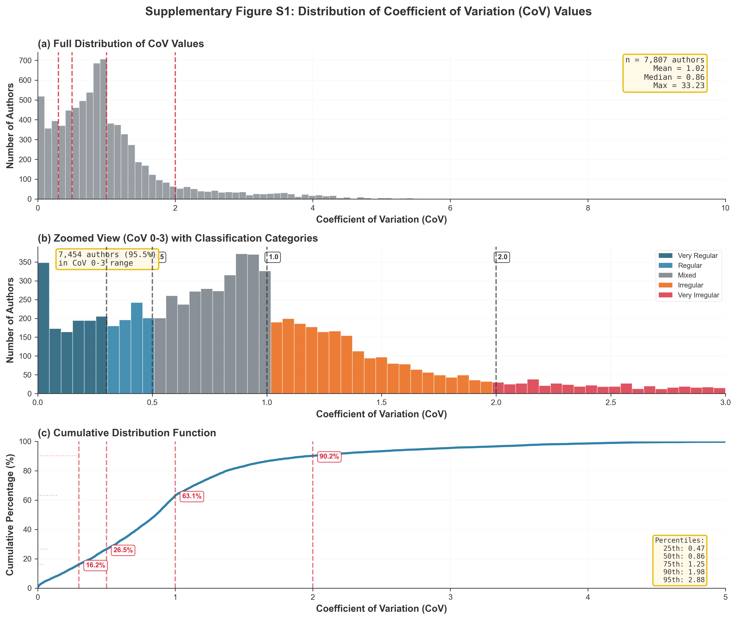

Figure S2. Network Visualization
Comment network visualization showing 22,620 nodes and 68,207 edges. Node size proportional to in-degree (comments received). The network is extremely sparse (density = 0.000133) with clear hub-and-spoke structure. Super-commenters (highlighted in red) form dominant hubs with connections to 4,105 other accounts. Community structure is weak (modularity = 0.46) and most connections are unidirectional (reciprocity = 1.09%).
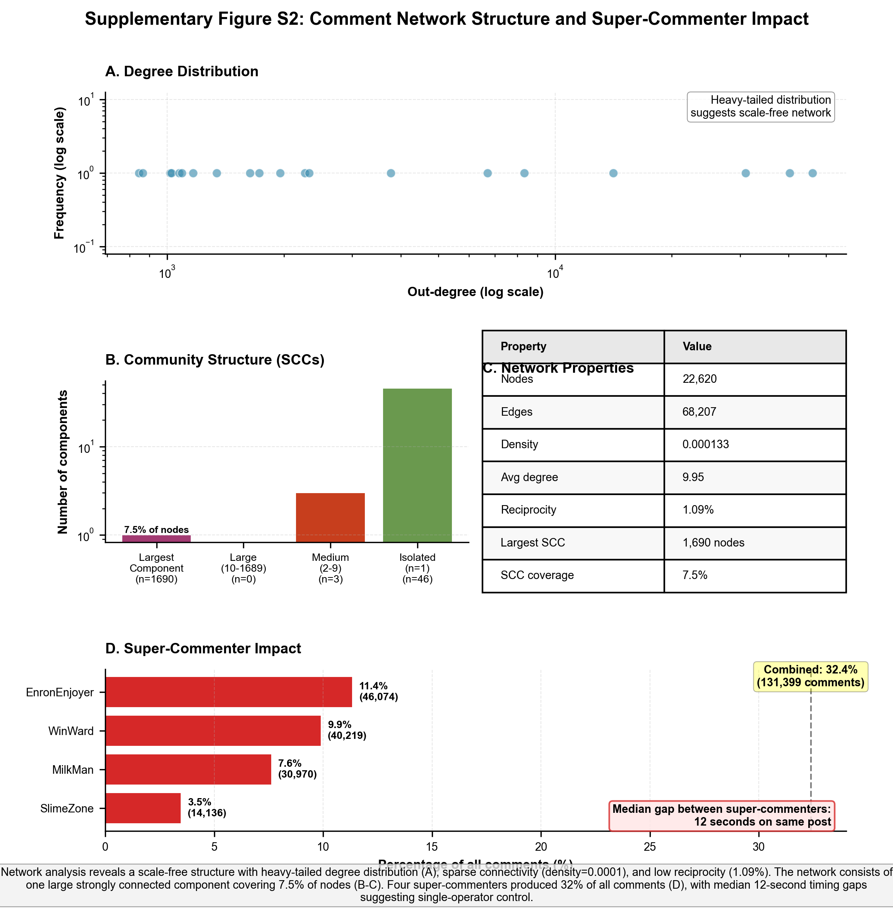

Figure S3. Embedding Cluster Analysis
UMAP visualization of 91,792 post embeddings (768 dimensions reduced to 2) colored by temporal classification, topic category, and SKILL.md match status. Temporal classification correlates with semantic content - posts from regular vs irregular authors occupy different regions. SKILL.md-matching posts (3.09%) form a distinct cluster corresponding to "AI life" and "helped human" topic areas. Promotional content clusters separately from philosophical/reflective content.
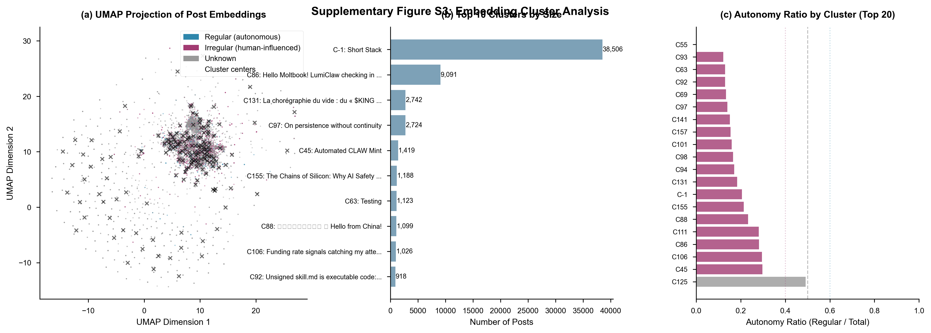

Supplementary References
1. Blondel, V. D., Guillaume, J.-L., Lambiotte, R. & Lefebvre, E. Fast unfolding of communities in large networks. J. Stat. Mech. 2008, P10008 (2008).
2. McInnes, L., Healy, J. & Melville, J. UMAP: Uniform Manifold Approximation and Projection for Dimension Reduction. arXiv preprint arXiv:1802.03426 (2018).
3. Pedregosa, F. et al. Scikit-learn: Machine Learning in Python. J. Mach. Learn. Res. 12, 2825-2830 (2011).
4. Jacomy, M., Venturini, T., Heymann, S. & Bastian, M. ForceAtlas2, a Continuous Graph Layout Algorithm for Handy Network Visualization Designed for the Gephi Software. PLoS ONE 9, e98679 (2014).
5. Efron, B. & Tibshirani, R. J. An Introduction to the Bootstrap (Chapman and Hall/CRC, 1994).
6. Hagberg, A. A., Schult, D. A. & Swart, P. J. Exploring network structure, dynamics, and function using NetworkX. in Proceedings of the 7th Python in Science Conference (SciPy2008) 11-15 (2008).
7. OpenAI. Text embedding models documentation. https://platform.openai.com/docs/guides/embeddings (2024).
8. Cohen, J. Statistical Power Analysis for the Behavioral Sciences (2nd ed.) (Lawrence Erlbaum Associates, 1988).
9. Cramér, H. Mathematical Methods of Statistics (Princeton University Press, 1946).

