Divine Word College of Legazpi
School of Engineering and Computer Sciences
Department of Computer Sciences and Information Technology
AY 2025-2026, 2nd Semester

An Assessment of the College Student Clearance Signing Process at Divine Word College of Legazpi

In partial fulfillment
Of the requirements in
IT PC 221: Quantitative Methods

Banzuela, Kit Brian D.
Flores, Jelo T.
Marco, Charlo G.
Ocharan, Sean Lee M.

May 15, 2026
Table of Contents
1.0 INTRODUCTION 3
1.1 Background and Rationale 3
1.2 Objectives 4
1.3 Research Problems/Questions 4
1.4 Related Studies 5
1.5 Variables 6
2.0 METHODOLOGY 7
2.1. Research design 7
2.2 Participants 8
2.3. Research instrument 8
2.4 Analysis 9
2.5 Data Collection Procedure 10
3.0 RESULTS 10
3.1 Profile of the Respondents 11
3.2 Student Assessment 13
3.3 Common Problems Encountered 18
3.4 Efficiency of the Clearance Signing Process 19
4.0 CONCLUSION 21
REFERENCES 23
APPENDIX 24

- INTRODUCTION

1.1 Background and Rationale
The clearance signing process is an important requirement in colleges and universities. It is conducted before the end of every semester and before graduation to ensure that students have completed all academic and financial obligations. The process usually involves visiting different offices such as the library, registrar, accounting office, student affairs office, and department offices for signatures and verification.
Despite its importance, many students experience difficulties during the clearance process. Common problems include long waiting lines, delays in signing, lack of coordination between offices, unclear procedures, and repeated campus visits. These issues may cause inconvenience, stress, and dissatisfaction among students, especially during busy academic periods.
At Divine Word College of Legazpi, students are also required to complete the clearance signing process before enrollment completion, examination schedules, or graduation. However, observations from students suggest that the process may still involve inefficiencies that affect the overall student experience. Because of this, the researchers became interested in assessing the current clearance signing system in order to identify the common concerns encountered by students and recommend possible improvements.
The researchers chose this topic not only because it is an academic requirement, but also because the study may help improve the efficiency and convenience of the clearance signing process for future students. The findings may also serve as a basis for possible modernization or digitalization of the system.
  - Objectives
General Objectives: To assess the efficiency and effectiveness of the clearance signing process among college students.
Specific Objectives
- To identify the steps involved in the clearance signing process.
- To determine the common problems encountered by students.
- To evaluate the efficiency of the current clearance process.
- To evaluate the level of student satisfaction with the clearance signing process.
  - Research Problems/Questions
- What are the specific steps and offices involved in the student clearance signing process at Divine Word College of Legazpi?
- What are the most common problems encountered by students during the clearance signing process?
- How efficient is the current clearance process in terms of average time required, number of office visits, and completion rate?
- What is the level of satisfaction among students regarding the existing clearance signing process?
  - Related Studies
A study by Jauculan, Lorymer and Patayon, Urbano (2024) evaluated a web-based student clearance system in a Philippine state university. The findings revealed that simplifying procedures and improving system usability significantly enhanced efficiency and student satisfaction. The study emphasized that manual clearance processes often lead to delays, redundancy, and confusion among students, which supports the need to assess and improve traditional clearance systems.
Similarly, Estacio, Dennis L. (2021) conducted a study on administrative service satisfaction in a private higher education institution in Bulacan. The results showed that although students were generally satisfied, issues such as slow processing time and lack of coordination among offices affected the overall efficiency of services. This highlights the importance of evaluating time consumption and inter-office processes in clearance signing.
In another study, Vicencio, Elena G. (2024) analyzed satisfaction levels of students, faculty, and staff regarding administrative services in a state university. The findings indicated that while satisfaction levels were high, there were still concerns about service delays and communication gaps. The study recommended improving workflow systems and strengthening coordination among departments, which is relevant to clearance procedures involving multiple offices.
Furthermore, Lud-ayen, Charesma Grace K. and Monang, Hannah G. (2024) assessed student satisfaction with university services in Baguio. Their results showed that accessibility, convenience, and speed of service significantly influence student satisfaction. The study supports the idea that long waiting times and complex procedures negatively affect students’ perceptions of administrative processes.
Lastly, Ubat, Joel T. and Villalon, Guadiosa U. (2024) investigated student satisfaction with frontline services in a Philippine state university. The study found that responsiveness, service speed, and staff assistance were key factors influencing satisfaction. It also emphasized that inefficiencies in frontline processes lead to dissatisfaction, which is comparable to issues encountered during clearance signing.
  - Variables
CLEARANCE SIGNING PROCESS (Independent Variable)
Conceptual Definition: Clearance Signing Process refers to the required procedure that college students must undergo and complete before completing a semester or graduating. It involves a series of steps, requirements, and securing approvals or signatures from different offices within the institution to ensure that all obligations are settled.
Operational Definition: In this study, Clearance Signing Process refers to the current system implemented at Divine Word College of Legazpi. This includes the specific steps, number and types of offices involved, workflow, and requirements needed to complete the clearance process. These will be identified and described based on the reports of the students and observation of the actual flow, to determine how the process is being carried out.
STUDENTS ASSESSMENT AND EXPERIENCE (Dependent Variable)
Conceptual Definition: Students Assessment and Experience refer to the overall evaluation of the clearance process in terms of its efficiency, the difficulties or problems encountered, and the level of satisfaction perceived by the students. It covers how fast, convenient, organized, and effective the system is from the students’ perspective, as well as the challenges they face while completing the requirements.
Operational Definition: In this study, Students Assessment and Experience will be assessed through three major aspects: the efficiency of the clearance signing process, measured through the average time required, number of office visits, and completion rate; the problems encountered during the process, including long lines, delays, lack of information, and procedural confusion; and the level of students satisfaction, referring to students perceptions regarding the convenience, organization, and overall effectiveness of the clearance signing procedure. These indicators will be measured using a researcher-made online questionnaire employing a 5-point Likert scale ranging from Strongly Disagree to Strongly Agree and will be further supported by an observation checklist. The instrument will include statements such as “The clearance process is completed within a reasonable amount of time” and “I experienced long lines during the process,” allowing respondents to evaluate their experiences with the current clearance signing system.

2.0 METHODOLOGY

2.1. Research design
This study employed a descriptive survey research design. This design was chosen because the primary goal was to describe the current state of the clearance signing process at Divine Word College of Legazpi from the students’ perspective. A descriptive survey design is appropriate for gathering quantitative data on students’ experiences, perceived efficiency, encountered problems, and level of satisfaction without manipulating any variables. This approach is widely used in studies that aim to assess existing institutional processes and provide baseline information for potential improvements.

2.2 Participants
The target population of this study consisted of college students from all year levels (1st to 4th year) enrolled at Divine Word College of Legazpi during the Academic Year 2025-2026, 2nd Semester. The inclusion criteria required participants to have completed the clearance signing process at least once. A total of 104 students participated in the study.
Convenience sampling was utilized in selecting the respondents. This technique was chosen due to its practicality and accessibility, allowing the researchers to gather data from students who were readily available in various campus locations and online groups. Although convenience sampling has limitations in terms of generalizability, it was deemed suitable given the time constraints and the recurring nature of the clearance process.

2.3. Research instrument
The main research instrument used in this study was a researcher-made online questionnaire administered through Google Forms. The questionnaire was designed to gather both quantitative data and students’ perceptions regarding the clearance signing process. It consists of four main sections:
- Informed Consent – Contains the purpose of the study, voluntary participation, confidentiality assurance, and compliance with the Data Privacy Act of 2012.
- Demographic Profile – Collects information about the respondents’ year level, academic program, and prior experience with the clearance signing process.
- Likert-scale Assessment – Consists of statements that measure students’ perceptions on the efficiency, organization, staff availability and helpfulness, and overall satisfaction with the clearance signing process. A 5-point Likert scale was used (5 = Strongly Agree, 4 = Agree, 3 = Neutral, 2 = Disagree, 1 = Strongly Disagree).
- Experience and Quantitative Items – Includes questions on actual experiences such as the number of offices visited, time consumed to complete the process, number of campus visits, and the most common problems encountered during the clearance signing.
The instrument was carefully constructed to directly address the research objectives and questions of the study.

2.4 Analysis
The data collected from the 104 respondents were analyzed using descriptive statistical methods. Frequency counts and percentages were used to summarize the demographic profile of the respondents and the common problems they encountered. Weighted means were computed to determine the students’ level of agreement and satisfaction regarding the clearance signing process.
The results were presented using tables and narrative interpretations. A 5-point Likert scale interpretation guide was used to describe the verbal equivalent of the computed means. All data were processed and analyzed using Microsoft Excel. Data cleaning was performed to ensure accuracy, particularly in standardizing program names (e.g., “BSIT,” “bsit,” and “bist” were unified).

2.5 Data Collection Procedure
Prior to data collection, the researchers secured formal approval from the School of Engineering and Computer Sciences and the office of the College President. Upon approval, the final research instrument was developed using Google Forms and included an informed consent form at the beginning.
The survey link was distributed through multiple channels using convenience sampling. Digital copies were shared via official Messenger group chats and college community groups. To increase response rate, the researchers also conducted on-campus intercept surveys in strategic locations such as the CSIT Laboratory, College Library, and Student Lounge, where students were personally invited to answer the questionnaire using their mobile devices.
Responses were monitored daily to ensure adequate representation across year levels. After reaching the target number of respondents, the Google Form was closed. The raw data was then exported to Microsoft Excel for cleaning and analysis. Challenges such as low initial response rates were addressed by shifting to face-to-face data collection.

3.0 RESULTS
This section presents the data gathered from 104 respondents at Divine Word College of Legazpi. The findings are organized to address the profile of the respondents, the efficiency of the current clearance system, and the common challenges encountered.

3.1 Profile of the Respondents
The demographic profile of the participants ensures that the assessment reflects a broad and representative cross-section of the student body.

Table 1 Distribution of Respondents by Year Level
Profile | Frequency (n = 104) | Percentage (%)
Year Level
1st Year | 33 | 31.7%
2nd Year | 55 | 52.9%
3rd Year | 10 | 9.6%
4th Year | 6 | 5.8%
TOTAL | 104 | 100%
As shown in Table 1, more than half of the respondents are 2nd Year students (52.9%), followed by 1st Year students (31.7%). While there is participation from the 3rd Year (9.6%) and 4th Year (5.8%) levels, the data is primarily represented by lower-classmen. This distribution suggests that the findings highly reflect the experiences of students currently navigating the core years of their academic residency. The lower turnout of 4th-year students is attributed to their off-campus schedules, such as internships and capstone projects, during the data collection period. However, since the clearance process is a recurring requirement every semester, this sample provides a valid assessment of the current system’s efficiency.
Table 2. Distribution of Respondents by Program
Program | Frequency (n = 104) | Percentage (%)
BSIT | 41 | 39.42%
BSCE | 23 | 22.12%
BSN | 16 | 15.38%
BSHM | 12 | 11.54%
BSCS | 8 | 7.69%
BSED | 2 | 1.92%
BSHS | 1 | 0.96%
BSBA | 1 | 0.96%
TOTAL | 104 | 100%
The academic background of the respondents provides a comprehensive view of how the clearance process affects different departments. As presented in Table 2, the Bachelor of Science in Information Technology (BSIT) program constitutes the largest segment of the sample at 39.42%, followed by Civil Engineering (BSCE) at 22.12% and Nursing (BSN) at 15.38%.
It should be noted that a data cleaning process was performed on this variable to ensure data integrity. By consolidating typographical errors and casing inconsistencies (e.g., "bsit," "Bsit," and "bist") into uniform categories, the researchers were able to provide an accurate and consolidated representation of the student distribution. The high participation rate from BSIT students is particularly significant as they are the primary stakeholders for potential technical modernization of the system. Furthermore, the inclusion of students from other departments ensures that the assessment reflects a holistic, college-wide experience rather than an isolated departmental view.
Table 3. Summary of Respondent Profile and Eligibility
Status | Frequency (n=104) | Percentage (%)
Yes (Experienced) | 101 | 97.1%
No (Inexperienced) | 3 | 2.9%
Total | 104 | 100%
As illustrated in Table 3, a vast majority of the respondents (97.1%) have undergone the clearance signing process at least once. This high frequency of "Yes" responses validates the relevance of the data collected, as it ensures that participants are speaking from direct personal experience. Furthermore, the identification of these experienced respondents establishes a credible foundation for assessing the efficiency of the existing workflow. Because the majority of the sample size has navigated the physical requirements of the process, their evaluations are based on empirical experience rather than perception

3.2 Student Assessment
This section presents the students’ perceptions and level of satisfaction regarding the clearance signing process using a 5-point Likert scale.

Table 4 Student Assessment of the Clearance Signing Process
Statement | Strongly Agree | Agree | Neutral | Disagree | Strongly Disagree
The steps in the clearance signing process are clear and easy to understand | 13 | 19 | 53 | 14 | 2
Waiting lines during clearance signing are well managed | 3 | 20 | 39 | 28 | 11
The clearance process is well organized | 8 | 23 | 44 | 17 | 9
The staff responsible for signing the clearance are usually available at their designated signing area | 7 | 26 | 45 | 18 | 5
The staff handling clearance are helpful | 11 | 22 | 50 | 14 | 4
Officer provides clear direction for the next step | 13 | 21 | 52 | 13 | 2
How satisfied are you with the current signing process | 11 | 12 | 54 | 18 | 6
The results in Table 4 indicate a predominantly Neutral sentiment among the student body regarding the current clearance system. Across all seven indicators, the highest frequency of responses consistently falls within the "Neutral" category, suggesting that while the process is functional, it lacks the efficiency required to earn a high level of student approval.
- Procedural Clarity and Direction: Students generally feel the steps are understandable, with 53 respondents remaining neutral and 32 combined agreeing or strongly agreeing that steps are clear. This is further supported by the 34 respondents who agreed that officers provide clear directions for subsequent steps.
- Queue Management and Organization: The most significant area of concern identified is waiting line management. A total of 39 respondents expressed dissatisfaction (Disagree/Strongly Disagree) with how lines are managed, which is the highest negative rating in the data set. This aligns with the common problems identified in the study's rationale, such as long waiting lines and delays.
- Staff Availability and Conduct: While 45 respondents were neutral regarding staff availability, 23 respondents disagreed that signatories are usually at their designated areas. However, students viewed the staff positively in terms of conduct, with 33 respondents agreeing that personnel are helpful and courteous. This suggests that bottlenecks are caused by procedural unavailability rather than staff behavior.
- Overall Satisfaction: The final indicator shows that 54 respondents hold a neutral stance, while 24 respondents are explicitly dissatisfied with the current process. Only 23 students (22%) reported being satisfied with the existing system.
These findings reinforce the need for modernization. As noted in the related study by Jauculan and Patayon (2024), transitioning from manual to simplified procedures can significantly enhance student satisfaction. The neutral-to-negative feedback on waiting lines and staff availability highlights the physical limitations of the current manual system at Divine Word College of Legazpi
Table 5 Level of Agreement on Clearance Process Indicators (n=101)
Statement | Mean | Verbal Interpretation
Officer provides clear direction for the next step | 3.30 | Neutral
The steps in the clearance signing process are clear and easy to understand | 3.27 | Neutral
The staff handling clearance are helpful | 3.22 | Neutral
The staff responsible for signing the clearance are usually available at their designated signing area | 3.12 | Neutral
The clearance process is well organized | 3.04 | Neutral
How satisfied are you with the current signing process | 3.04 | Neutral
Waiting lines during clearance signing are well managed | 2.76 | Neutral
TOTAL (Grand Mean) | 3.11 | Neutral
Source: Adapted from ResearchGate (2021), Mean range and interpretation of the Likert scale type.
The results show that students at Divine Word College of Legazpi generally maintain a neutral stance toward the current manual clearance signing process. While the overall mean scores suggest the system is functional, they also indicate that the process lacks the efficiency required to achieve high levels of student satisfaction.
Among the various indicators, the availability of clear direction from officers received the highest weighted mean of 3.30, followed by the clarity of the steps at 3.27. This implies that while students find the procedural logic and the guidance provided by personnel to be adequate, these factors do not fully mitigate the systemic inefficiencies of a manual workflow.
The data reveals that the primary challenges are rooted in physical logistics and time management. The indicator for manageable waiting lines received the lowest weighted mean of 2.76. This specific result confirms that students are primarily burdened by the physical act of queuing and the inefficiencies inherent in visiting multiple offices, which prevents satisfaction levels from moving beyond a neutral rating.
Although staff are viewed as relatively helpful (3.22), their individual efforts are hindered by a workflow that relies on physical presence and paper-based verification. These findings reinforce the need for modernization, as noted in the study by Jauculan and Patayon (2024), where transitioning to simplified, digitalized procedures was shown to significantly enhance the student experience by reducing physical bottlenecks.

3.3 Common Problems Encountered
Table 6 presents the common issues reported by the 101 respondents who have experienced the clearance process. Multiple responses were allowed.
Table 6. Common Issues Encountered During the Clearance Signing Process (n=101)
Issues Encountered | Frequency | Percentage
Too many offices to visit | 84 | 83.2%
Long queues / waiting time | 79 | 78.2%
Staff unavailable or offices closed | 58 | 57.4%
Unclear instructions | 49 | 48.5%
Poor coordination between offices | 48 | 47.5%
None | 8 | 7.9%
Others | 12 | 11.9%
The results reveal that the clearance signing process remains highly problematic for most students. An overwhelming majority of respondents (83.2%) identified “Too many offices to visit” as the most common issue, followed closely by “Long queues / waiting time” (78.2%). These two major concerns indicate that the current manual and decentralized system forces students to spend excessive time and effort navigating across different offices.
Additionally, more than half of the students (57.4%) experienced staff unavailability or offices being closed, while nearly half encountered unclear instructions (48.5%) and poor coordination between offices (47.5%). These findings clearly explain why the overall satisfaction with the clearance process remained only at a neutral level (mean = 3.04) in the Likert-scale assessment.
Only 7.9% of the respondents reported experiencing no issues at all. The 11.9% qualitative responses categorized under 'Others' highlighted significant student grievances regarding the financial burden of transportation and the inefficiency of repetitive campus visits
Overall, the data strongly supports the need for significant improvements in the clearance system, particularly through streamlining the number of required offices and transitioning toward a more centralized or digital approach.

3.4 Efficiency of the Clearance Signing Process
Efficiency was measured in terms of time consumed, number of campus visits required, and the number of offices students had to visit.
Table 7. Time Consumed in Completing the Clearance Process (n = 101)
Time Duration | Frequency (n=101) | Percentage (%)
Less than 1 hour | 9 | 8.9%
1–2 hours | 15 | 14.9%
2–4 hours | 24 | 23.8%
4–6 hours | 15 | 14.9%
More than 6 hours | 33 | 32.7%
It took more than one day | 5 | 5.0%
Total | 101 | 100%

Table 8. Number of Campus Visits to Complete Clearance (n = 101)
Number of Visits | Frequency | Percentage
1 time | 37 | 36.6%
2 times | 36 | 35.6%
3 times | 18 | 17.8%
4 or more times | 10 | 9.9%
Total | 101 | 100%
Table 9. Number of Different Offices Visited (n = 101)
Number of Offices | Frequency | Percentage
1-3 | 9 | 8.9%
4-6 | 36 | 35.6%
7-9 | 42 | 41.6%
10 or more offices | 14 | 13.9%
Total | 101 | 100%
The clearance signing process at Divine Word College of Legazpi is notably inefficient. Only 23.8% of the respondents were able to complete the process within 2–4 hours, while a large percentage (32.7%) spent more than 6 hours. Moreover, nearly two-thirds of the students (63.3%) had to visit the campus at least twice to finish their clearance.
Most concerning is that 55.5% of the respondents had to visit 7 or more offices. This decentralized and manual process forces students to spend considerable time and effort navigating multiple offices across the campus.
These quantitative findings strongly corroborate the neutral satisfaction ratings in the Likert-scale section and the high percentage of students who reported “Too many offices to visit” and “Long queues/waiting time” as major problems.

4.0 CONCLUSION
The assessment of the college student clearance signing process at Divine Word College of Legazpi reveals a system that is functional but significantly hindered by manual and decentralized inefficiencies. While students generally understand the procedural steps and find the staff helpful, the overall sentiment remains neutral, with a satisfaction mean of 3.04. This neutrality indicates that the existing process lacks the efficiency required to earn high student approval, primarily due to the physical limitations of a paper-based workflow. d
The study identifies significant logistical burdens that negatively impact the student experience. An overwhelming 83.2% of students identified visiting too many offices as a primary issue, with the majority required to visit between 7 and 9 different locations. These decentralized requirements result in 32.7% of students spending more than six hours to complete the process, while 63.3% are forced to make multiple campus visits. Furthermore, the most critical area of dissatisfaction was waiting line management, which received the lowest mean score of 2.76.
Ultimately, these findings strongly support the need for the modernization or digitalization of the clearance system. Transitioning to a more centralized or web-based approach would reduce physical bottlenecks, eliminate the need for repetitive campus visits, and address the common issues of staff unavailability and poor inter-office coordination. Improving these administrative workflows is essential to enhancing the overall efficiency, convenience, and satisfaction of the student body.

REFERENCES
Jauculan, Lorymer, & Patayon, Urbano (2024).
Enhancing UX/UI: A mixed-approach evaluation of a web-based student clearance system at a state university in the Philippines. Procedia Computer Science, 234, 1061–1068. https://doi.org/10.1016/j.procs.2024.03.100
Ubat, Joel T., & Villalon, Guadiosa U. (2024).
Student satisfaction with frontline services at a Philippine state university. Journal of Interdisciplinary Perspectives, 2(11).
Vicencio, Elena G. (2024).
Satisfaction analysis of faculty, administrative staff and students on the administrative services of Nueva Ecija University of Science and Technology. EPRA International Journal of Multidisciplinary Research, 10(1).
Estacio, Dennis L. (2021).
Administrative services satisfaction survey in a private higher education institution in Malolos City, Bulacan, Philippines. International Journal of Multidisciplinary: Applied Business and Education Research, 2(9). https://doi.org/10.11594/ijmaber.02.09.03
Lud-ayen, Charesma Grace K., & Monang, Hannah G. (2024).
Assessing the availment and general satisfaction of student services offered by the University of Baguio: A study of student perspectives. International Journal for Multidisciplinary Research, 6(4). https://doi.org/10.36948/ijfmr.2024.v06i04.24695

APPENDIX
APPROVE LETTER FROM THE OFFICE HEAD/PRESIDENT
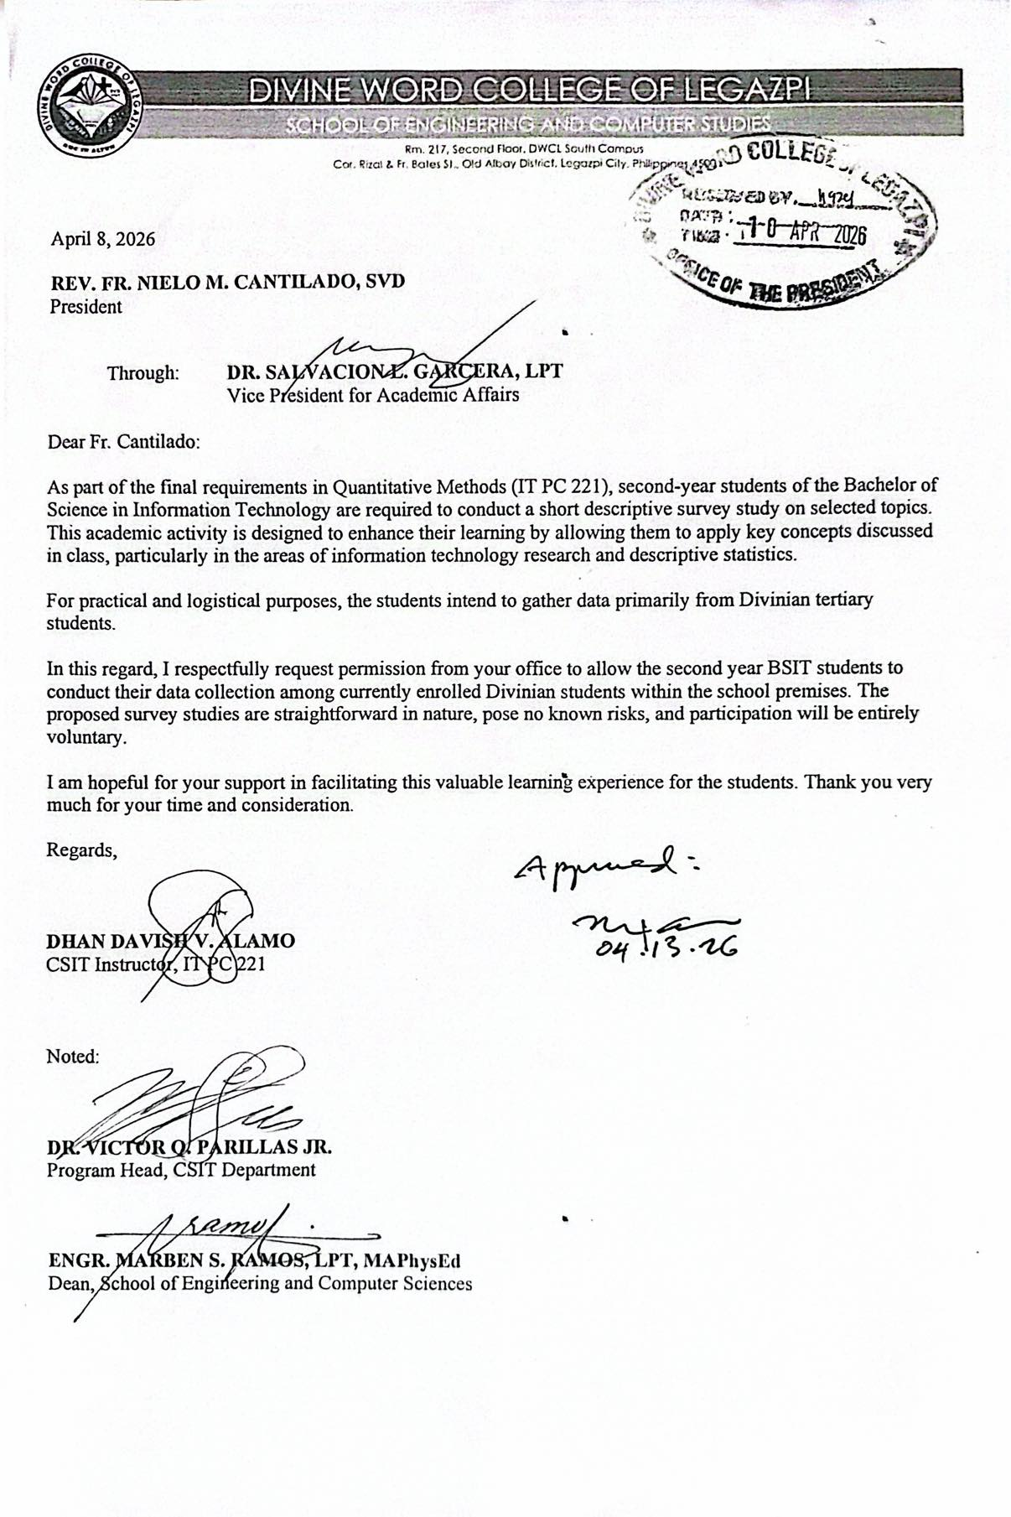

Survey Questionnaire
GENERAL INSTRUCTIONS
Thank you for participating in this survey! Please read the instructions carefully before answering.
Part 1: Respondent Profile:
Please provide the following information about yourself. This section helps us understand the background of the respondents. Your name is optional. All information will remain confidential.
- Name: _________________________________(Optional)
- Year Level:
☐ 1st Year ☐ 2nd Year ☐ 3rd Year ☐ 4th Year
- Program: ______________________________ (e.g., BSIT, BSCS)
- Have you completed clearance signing at least once?
☐ Yes ☐ No (If No, thank you – you may stop here)

Part 2: Clearance Process Rating (Likert Scale): Please indicate your level of agreement with each statement using the following scale:
Use this scale:
(5 = Strongly Agree, 4 = Agree, 3 = Neutral, 2 = Disagree, 1 = Strongly Disagree)
- The steps in the clearance signing process are clear and easy to understand.
O 5 O 4 O 3 O 2 O 1
- Waiting lines during clearance signing are well managed.
O 5 O 4 O 3 O 2 O 1
- The clearance process is well organized.
O 5 O 4 O 3 O 2 O 1
- The staff responsible for signing the clearance are usually available at their designated signing area.
O 5 O 4 O 3 O 2 O 1
- The staff handling clearance are helpful.
O 5 O 4 O 3 O 2 O 1
- Officer provides clear direction for the next step.
O 5 O 4 O 3 O 2 O 1
- How satisfied are you with the current signing process.
O 5 O 4 O 3 O 2 O 1

Part 3: Experience/Feedback
- Did you encounter any issues during the clearance process? (Select all that apply)
☐ Long queues / waiting time
☐ Unclear instructions
☐ Too many offices to visit
☐ Staff unavailable or offices closed
☐ Poor coordination between offices
☐ None
☐ Others: ____________________

- On average, how long did it take you to complete the entire clearance signing process?
O Less than 1 hour
O 1–2 hours
O 2–4 hours
O 4–6 hours
O More than 6 hours
O It took more than one day

- Approximately how many times did you visit the campus to finish your clearance?
O 1 time
O 2 times
O 3 times
O 4 or more times
- How many different offices did you need to visit for clearance?
O 1–3 offices
O 4–6 offices
O 7–9 offices
O 10 or more offices
Thank you very much for completing this survey! Your answers will help improve the clearance process for all students at Divine Word College of Legazpi.
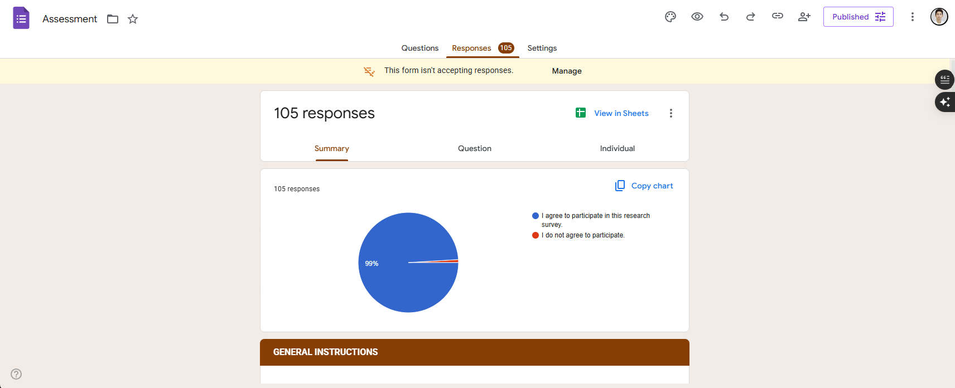
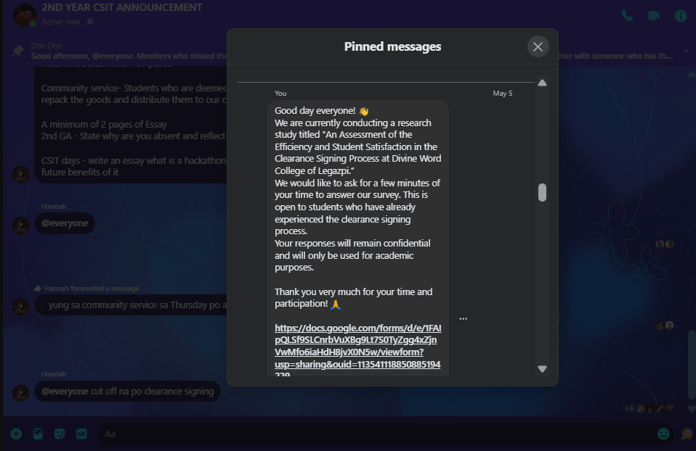

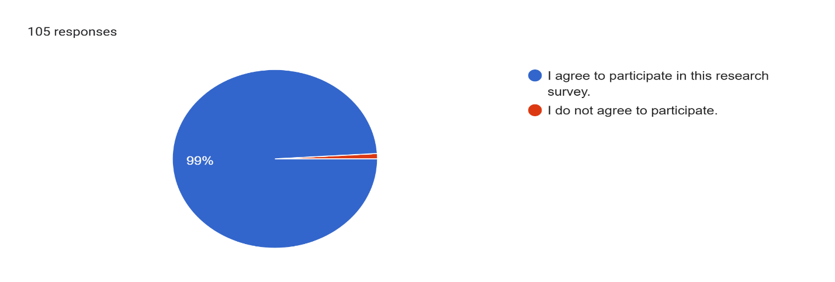
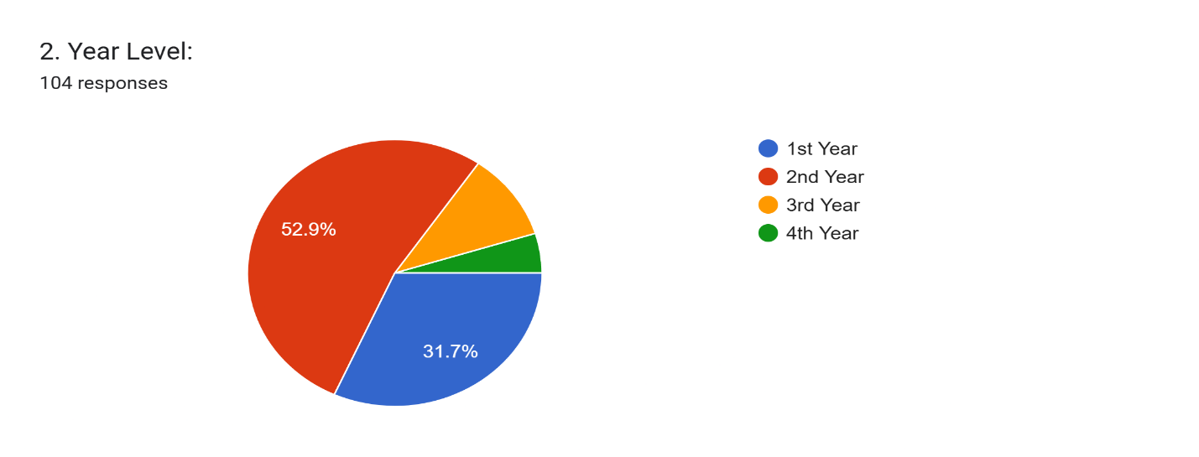
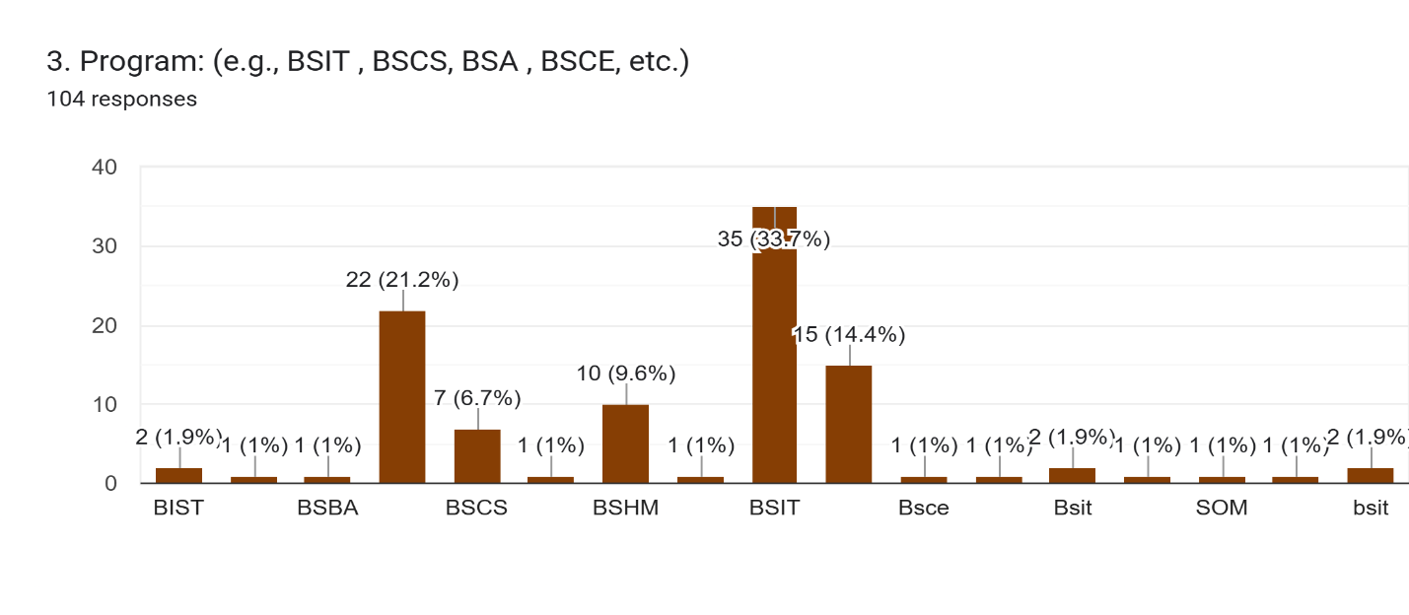
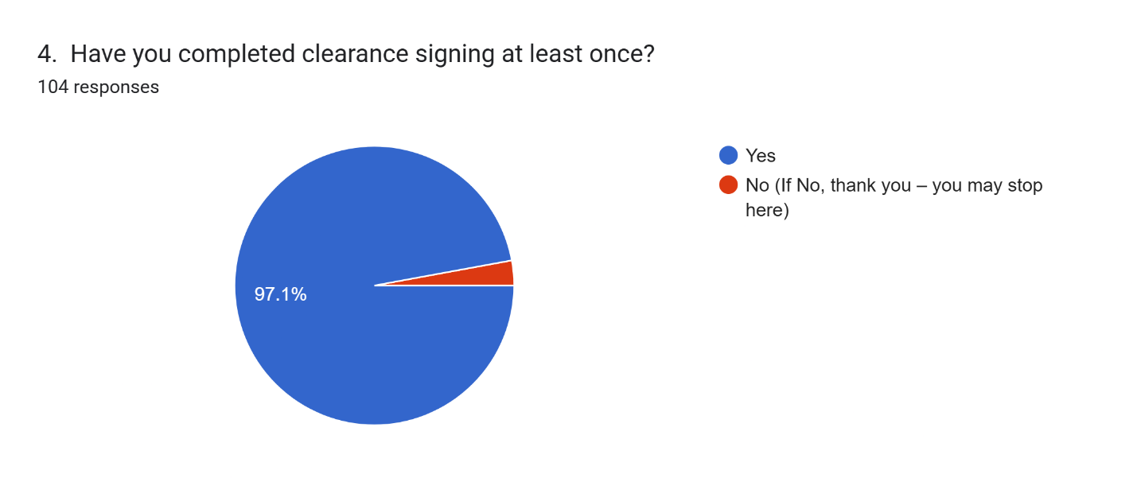
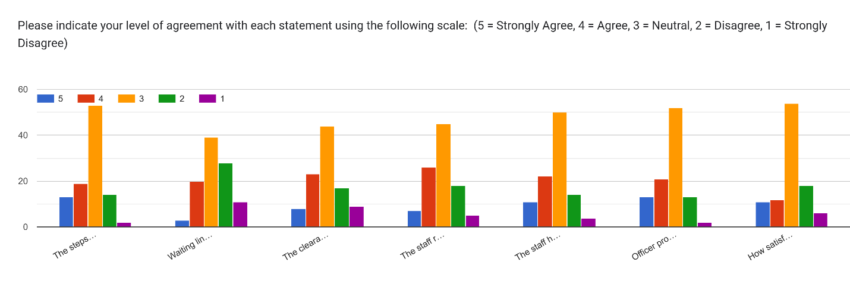
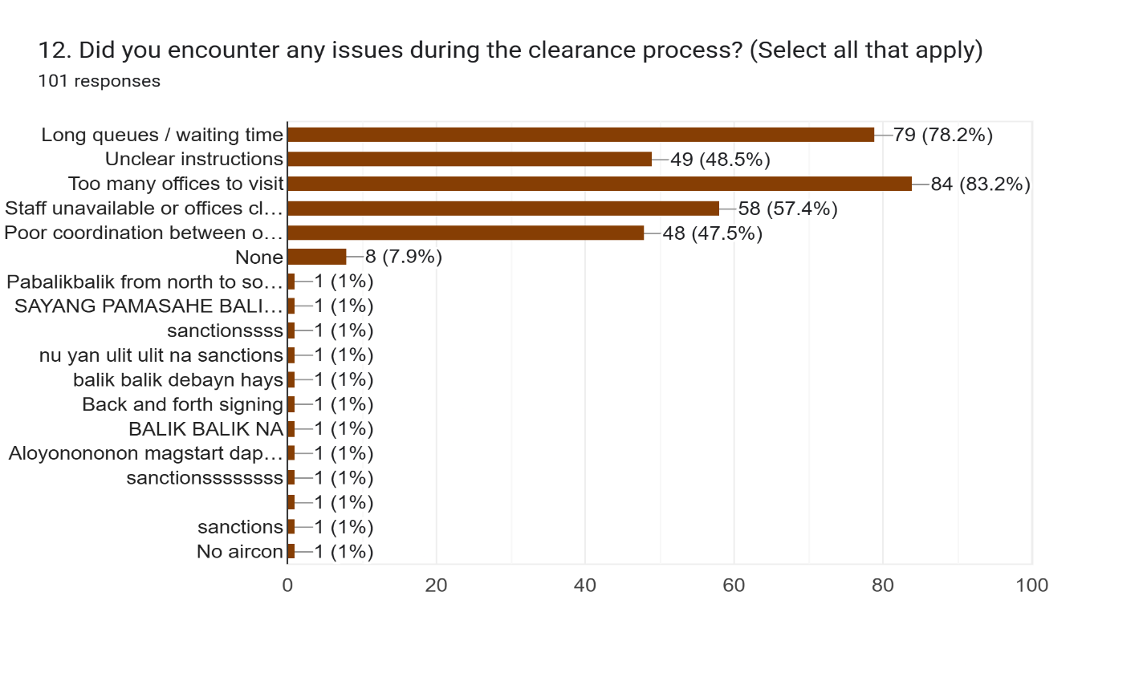
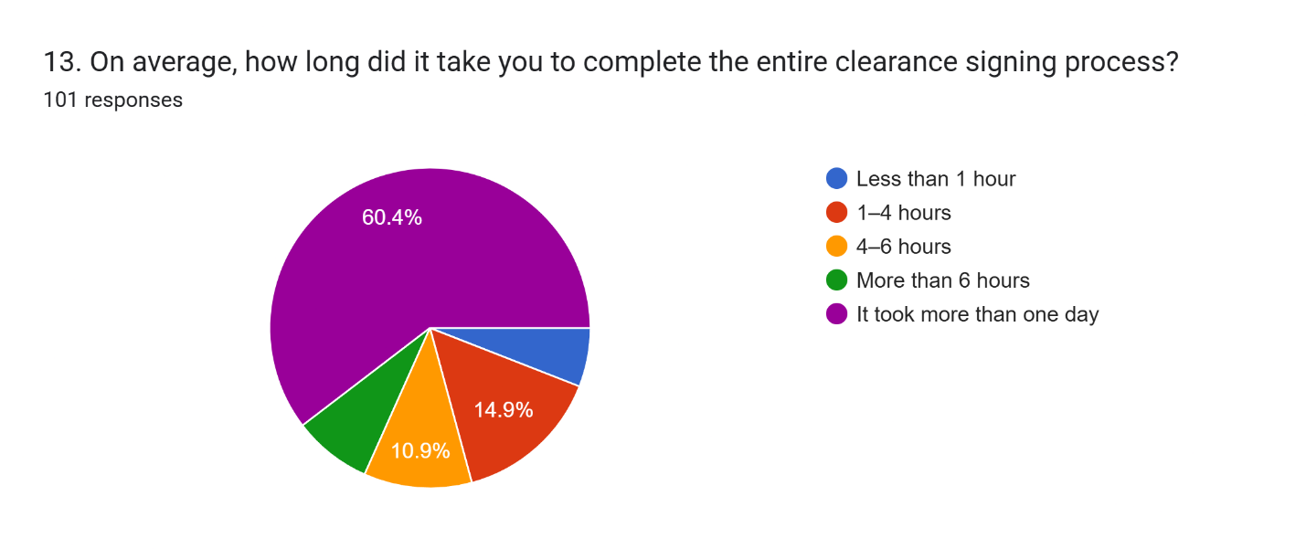
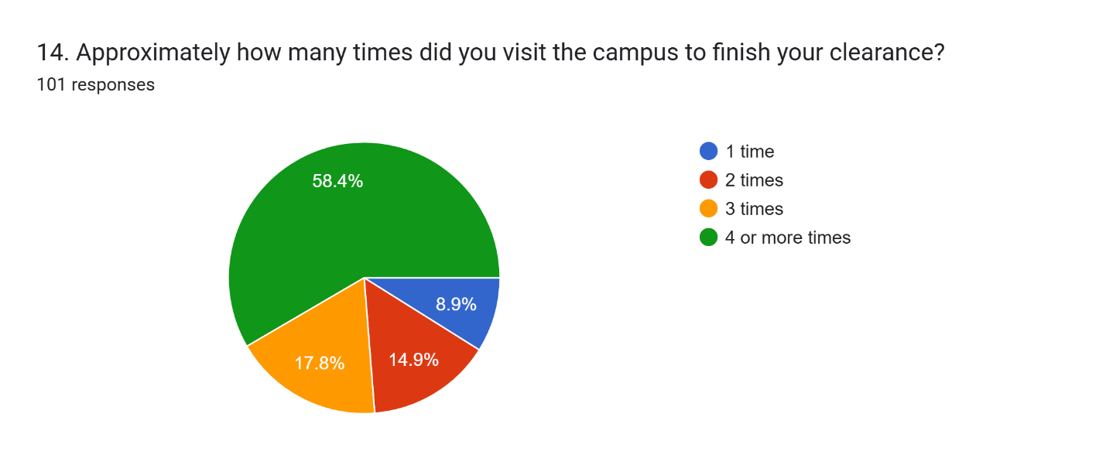
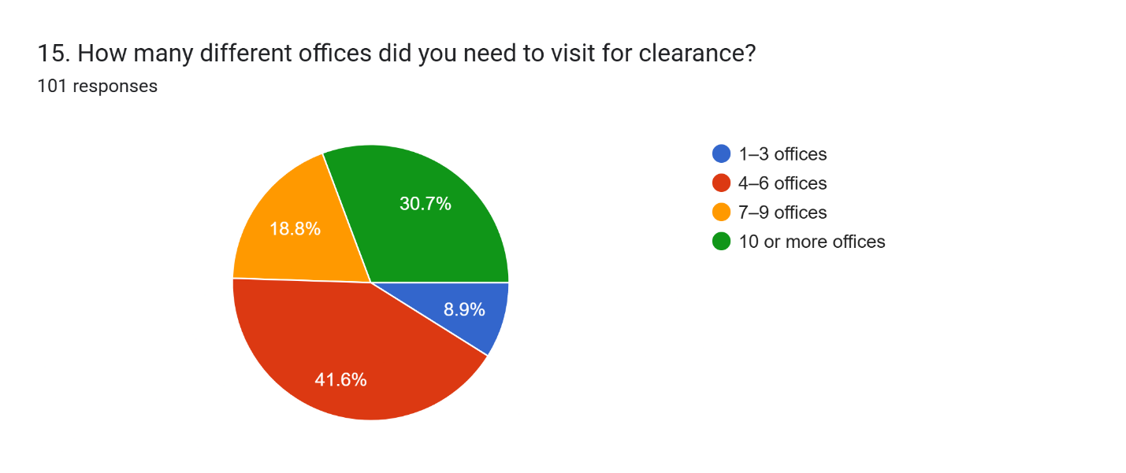

INFORMED CONSENT
Good day!
Members: Banzuela, Kit Brian D., Marco, Charlo G., Flores, Jelo T., Ocharan, Sean Lee M.
We are conducting a study entitled “An Assessment of the College Student Clearance Signing Process at Divine Word College of Legazpi.” This study analyses the current clearance signing process experienced by college students. It seeks to identify the steps involved in the process, efficiency of the process, and overall student satisfaction. The findings will be used to recommend improvements for a more efficient and convenient clearance process.
In line with this, you are respectfully invited to participate as a respondent in this research by answering a survey questionnaire. Your participation in this study is entirely voluntary. By agreeing to participate, you confirm that you are willing to answer the questions honestly and to the best of your knowledge. You may refuse to answer any question or withdraw from the survey at any time without any penalty.
All information you provide will be treated with strict confidentiality and will be used solely for academic and research purposes. In accordance with the Data Privacy Act of 2012 (Republic Act No. 10173), any personal data collected will be processed securely and will not be disclosed to any unauthorized persons. Your responses will remain anonymous, and all data will be stored safely and disposed of properly after the completion of the study.
Consent Statement
By proceeding with this survey, you confirm that:
- You have read and understood the information provided above.
- You are voluntarily agreeing to participate (You may refuse to answer any question or withdraw from the survey at any time without any penalty)
- I agree to participate in this research survey.
- I do not agree to participate.

___________________________________
Participants’ signature over printed name

