INFRARED STUDY OF THE OXIDATION OF POROUS SILICON: EVIDENCE OF SURFACE MODES.
L.N. Acquaroli, A. brondino, j.a. schmidt, r.d. arce and r.r. koropecki
INTEC and FIQ, CONICET – UNL Güemes 3450 – 3000 Santa Fe , Argentina. e-mail: rkoro@intec.ceride.gov.ar

SUMMARY
The evolution of FTIR spectra of PS during oxidation is studied in the range 450 - 1300 cm⁻¹. We show that the small scale of the PS structure leads to significant scattering cross sections for Fröhlich surface modes associated to stretching modes in siloxane bridges. The kinetics of the evolution of both bulk and surface related modes are studied using Principal Component analysis. As a result, two independent components are found, one of them related to TO modes associated to oxide covering large structures and the other associated to the oxidation of a distribution of prolate ellipsoids with nanoscopic scale.
1. INTRODUCTION
The efficient luminescence of electrochemically etched porous silicon (PS) has been matter of great interest since the Canham report in 1990. Porous silicon is characterized by a large specific area, which confers it a large chemical reactivity and, consequently, a large dependence of their properties on the ambient. These characteristics, although attractive for sensing applications, led to an instable behaviour. Different oxidation methods have been proposed in order to stabilize the luminescence and other properties of PS, and a considerable effort has been made in order to study the oxidation processes. FTIR spectroscopy has been one of the main techniques used to study the PS oxidation process. The size scale and characteristics of the PS structure depends on the anodization conditions. The photoluminescence usually is present in PS having a nanostructure within the scale of few nanometers. The small size of this nanostructure can induce peculiar behaviour of the spectrum characteristics. The small size of the nanostructures produces quantum confinement effects, enlarging the gap of PS with the consequent reduction of the carrier density by thermally promoted electron-holes generation. This reduction precludes the oxidation process, which needs the charge exchange to proceed,. Therefore the small scale structures oxidize following a slower kinetics when compared with the oxidation kinetics of larger structures.
Other effect of the PS nanostructure is that the presence of very small porous and tortuous paths may produce a diffusion limited process, so that the kinetics of the oxidation will be controlled by the slower between the chemical reaction and the diffusion processes.
As we will show, the characteristics of the FTIR spectra of PS are also modified by size effects, so that the kinetics of the oxidation of structures with different scales can be discriminated using this technique.
In previous studies about PS oxidation, features that evolve in the high energy side of the band related to Si-O-Si stretching modes has been assigned as contribution of LO-TO modes related to SiO₄ tetrahedron vibrations,.
In this work we show that the appearing of LO-TO modes in the FTIR spectra of oxidized PS can be explained in terms of the coupling of uniform polarization surface modes (Fröhlich modes), having a high scattering cross section in the limit of the low size scale. The IR modes related with oxidation of both the bulk and the nanostructure of PS follow similar kinetics as that of high pressure sputtered porous amorphous silicon . In this approach the high energy side of the Si-O-Si stretching band, associated to Frohlich modes, increases efficiently during the oxidation of nanoporous silicon due to a size effect phenomenon. We show that the surface modes appearing during PS oxidation seems to be related to the oxidation of ellipsoidal prolate structures

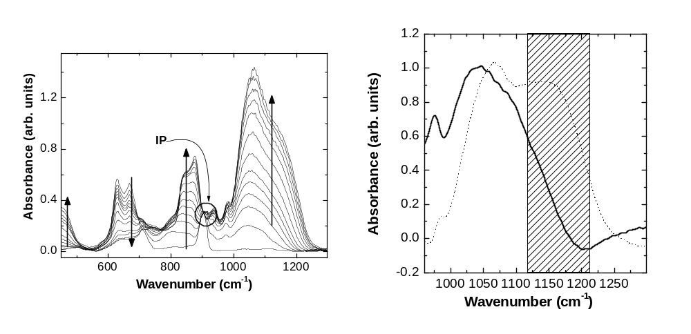
2. EXPERIMENTAL
Figure 1: (a) Evolution of the FTIR spectra of PS during oxidation. Arrows show the evolution of each feature. (b) Full line: first component of the factor analysis. Dotted line: second component.
(a)
(b)
PS samples were prepared by anodic etching of both p-type (7-17 Ωcm) and n-type (1-10 Ωcm) crystalline silicon substrates using a 1:2 HF(50%):ETOH mixture, and a current density of 20 mA/cm² for all the samples. The p-type samples were etched in darkness and the n-type ones were etched under illumination using white light coming from a 140 mW/cm² dichroic lamp. FTIR spectra of the fresh samples were taken. Afterwards, samples were oxidized by a series of isothermal annealing steps at 100 ºC in air. FTIR spectra were taken at room temperature after each annealing step. The samples were maintained in darkness during the whole process to prevent photo-oxidation.
In order to estimate the Real Error Function in the Factor Analysis⁴ process, we took a set of seven successive spectra for the samples oxidized for more than 130 hours. In this situation no changes can be expected in the spectra other than due to noise. Therefore the Real Error (RE) function corresponding to the first eigenvalue for these seven spectra can be compared with the RE function for series of spectra taken after each annealing in order to obtain the number of independent factors.

3. RESULTS AND DISCUSSION
A series of the resulting spectra for a n-type sample is shown in Figure 1. It can be roughly observed the increase of oxygen related features at around 450 cm⁻¹ (bending modes), 850 cm⁻¹ (oxidized hydride deformations), and 1000-1200 cm⁻¹ (stretching modes of Si-O-Si bridges). A band related with the wagging modes of Si-H bonds is observed at 630 cm⁻¹, and a peak corresponding to scissor modes of Si-H bonds in di-hydride can be observed at 910 cm⁻¹. As we demonstrated in the case of the early stages of photo-oxidationError: Reference source not found during the first stages of oxidation, oxygen displaces hydrogen atoms preferentially from di-hydride sites. The isosbestic point around 910 cm⁻¹ is related to the appearing of two different species kinetically correlated participate in the evolution. One of that species is related to H-Si bonds vibrations, and its spectrum contains no oxygen related IR modes. The other species contains modes related with bonded oxygen ( all of them in the studied range), and also modes related with wagging modes of SiH and SiH₂.
The isosbestic point can be seen in figure 1 (labeled as IP) where there are depicted the spectra of the thermally oxidized samples, so that we can conclude that during the thermal annealing, the oxygen incorporates in a similar way as in the case of the first stages of photo-oxidation, reported in ref. Error: Reference source not found. Therefore, during thermal oxidation at 100 C the oxygen incorporates to the silicon surface displacing hydrogen atoms from the PS surfaces preferentially from di-hydride sites, at least for annealing times as long as 110 hours.
The band from 960 to 1300 cm⁻¹ was processed by Factor Analysis. Using the value of the RE function corresponding to one eigenvalue in the principal component analysis of the seven spectra taken without evolution, we obtained two significant factors for the whole set of spectra shown in Fig. 1. In a previous work we studied the kinetics of oxidation of sputtered porous amorphous siliconError: Reference source not found. We found that surface modes related to the oxidation of small structures evolve during the oxidation process, both at room temperature and during annealing of the samples. The behavior of PS is similar to that of the evolution of IR spectra of amorphous porous silicon during oxidationError: Reference source not found. We assume a similar oxidation mechanism for the PS case, i.e., a large scale structure which passivates after a quick oxidation process, and a small scale structure which oxidizes slowly. The difference in the oxidation rate is supposed to be related to the differences of carrier densities of structures having small or large size. For structures with characteristic sizes of few nanometers there are quantum confinement effects that enlarge the gap, so that the thermal generation rate of electron-hole pairs in dark is lower than in the case of larger structures. Since the oxidation process of the silicon requires charge exchangeError: Reference source not found, the oxidation rate of small structures is lower than that of the larger ones. We analyzed the behaviour of photoluminescence and FTIR spectra evolution during illumination concluding that this size effect is present in PS.
We assumed that during the first stages of the oxidation process the only significant contribution to the evolution of the spectra comes from the quick oxidation of large structures. With this hypothesis we obtained the spectra and weights of the two participating species, shown in Fig. 1(b) and Fig. 2, respectively. All the spectra in Fig. 1(a) can be reproduced by linear combinations of the two components spectra shown in Fig.1(b), with the corresponding weights shown in Fig. 2. As it can be seen from Fig. 2, the oxidation proceeds in first stage with the quick evolution of the first component, which saturates after around 5-10 minutes. The second component evolves slowly increasing monotonically. This behaviour of the two components supports our hypothesis: the kinetics shown by the first component agrees with that expected for large structures that oxidize during a short time, and after that passivates. The kinetics of the second component agrees with that expected for a nanostructure in which quantum confinement effects enlarge the gap limiting the carrier density and thus the oxidation rate.
The shapes of the spectra of the two components also support our hypothesis if size effects are taking into account.
The condition for excitation of the first order surface mode can be obtained from the electrostatics.
Consider in a first approximation that the nanostructure can be assimilate as an aggregate of little nanospheres of silicon, gradually covered by a mantle of oxide. For these spheres uniformly coated with a mantle of different composition, in the limit of vanishing size, it can be demonstrated that the condition for excitation of Fröhlich modes is:
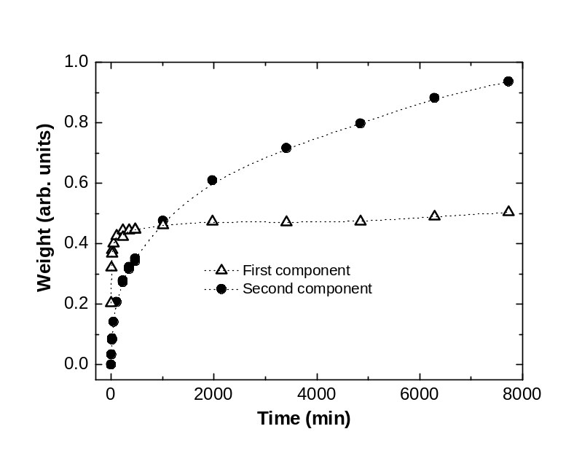
where ε₁ and ε₂ and ε_{m} are the dielectric functions of core mantle and surrounding medium respectively, and f is the fraction of the total particle volume occupied by the core. Using an f value ranging from 0.1 to 0.9, the wavenumber corresponding to the Fröhlich modes was computed. As shown by the shaded area of Fig. 1(b) these modes should have wavenumbers in the range from 1120 to 1215 cm⁻¹ . As it can be seen in Fig. 1(b), there is a feature in this range in the second component. The contributions for lower wavenumbers of the same component can be attributed to shape effects, and also to the presence of TO modes due to the non-vanishing size of the structure. The general shape of the spectrum of the second component may be assimilated as corresponding to a distribution of prolate ellipsoids. In fact, if the core is neglected, and perfect spheres of SiO₂ are considered, the resonant condition of Frohlich modes in the limit of small size should be at a wavenumber in which ε_{1/}ε_{m} =-2. However, for prolate ellipsoids, the resonant condition is splitted into three bandsError: Reference source not found. It have been previously shownError: Reference source not found that the stretching band of Si-O-Si bridges in PS can be deconvoluted in four bands, one of them centred in 1080 cm⁻¹ -near the bulk TO mode- and other three bands centred at larger wavenumbers. Comparing Figs. 5 A) and B) of ref. Error: Reference source not found (and also Fig. 5 (b) of ref. Error: Reference source not found) with Fig. 12.11 of ref. Error: Reference source not found, the assignation of the three high energy bands to frolich modes of prolate ellipsoids seems to be evident. The first component in Fig. 2 corresponds to the TO mode, coming from oxidized large structures having negligible contribution of Fröhlich modes.
Figure 2: Using the Real Error value obtained from the set of seven successive spectra taken in stable conditions, we concluded that two independent factors exist for the set of spectra of the main evolution. This means that all the spectra can be reproduced by a linear combination of only two spectra. The graphs in this figure show the evolution of the contributions of each one of the spectra presented in Fig. 1(b) in the linear combination that reproduces each measured spectrum.

3. CONCLUSIONS
The evolution of the FTIR spectra of PS samples during the oxidation in air shows the growth of TO modes associated to Si-O-Si bridges of relatively large structures, which saturates after a short time, and the growth of Fröhlich surface modes coupling both TO and LO modes. The slow evolution of the last contribution can be attributed to a competence between diffusive and chemical reaction limited processes.

ACKNOWLEDGEMENTS
This work was supported with grants CAI+D 002-011 (2005) (UNL), PIP 5730 (CONICET), and PICT 05 32515 (SECyT).
REFERENCES
- O. Bisi, Stefano Ossicini, L. Pavesi, Surface Science Reports 38 1 (2000).
- R. R. Koropecki, R. D. Arce, J. A. Schmidt, J. Non Cryst. Solids 338/340 159 (2004).
- J. Wang, B. Zou, M. A. El-Sayed; J. Mol. Struct. 508, 87 (1999); M.Ye. Korniyenko, V.A. Makara, V.B. Shevchenko, A.M. Korniyenko, T.S. Veblaya, M.M. Makhno, Phys. stat. sol. (c) 4, 2131 (2007).
- R. Malinowski, "Factor Analysis in Chemistry", 2nd. Editions, John Wiley & Sons, N.Y. (1991).
- R.R. Koropecki, R.Arce, J. Appl. Phys. 60 1806 (1986).
- C.F. Bohren, D.R Huffman “Absorption and scattering of light by small particles”, Wiley NY (1983).

L. T. Canham, Appl. Phys. Lett. 57, 1046 (1990).
O. Bisi, Stefano Ossicini, and L. Pavesi, Surf. Sci. Rep. 38, 1 (2000)
R. R. Koropecki, R. D. Arce, J. A. Schmidt, J. Non Cryst. Solids 338/340 159 (2004)
E.A. Irene and E.A. Lewis; Appl. Phys. Lett. 51, 767 (1987).
R. R. Koropecki, R. D. Arce, J. A. Schmidt, Phys. Rev. B 69, 205317 (2004)
J. Wang, B. Zou, M. A. El-Sayed; J. Mol. Struct. 508, 87 (1999);
M.Ye. Korniyenko, V.A. Makara, V.B. Shevchenko, A.M. Korniyenko, T.S. Veblaya, M.M. Makhno, Phys. stat. sol. (c) 4, 2131 (2007).
R.R. Koropecki, R.Arce, J. Appl. Phys. 60 1806 (1986)
R. Malinowski, "Factor Analysis in Chemistry", 2nd. Editions, John Wiley & Sons, N.Y. (1991)
C.F. Bohren, D.R Huffman “Absorption and scattering of light by small particles”, Wiley NY (1983)

