Infrared study of the oxidation of porous silicon: evidence of surface modes.

Sumary
The evolution of FTIR spectra of PS during oxidation is studied in the range 450 - 1300 cm⁻¹ . We show that the small scale of the nanostructure of PS led to significant scattering cross sections for Frolich surface modes associated to stretching modes in siloxane bridges.. The kinetics of the evolution of both bulk and surface related modes are also studied by using Principal Component analysis. As a result, two independent components are found, one of them related to TO modes asociated to oxide covering large structures and the other associated to the oxidation of a distibution of prolate elipsoids with nanoscopic scale.

Introduction
The structure of nanoporous silicon (PS), characterized by its large specific area and low dimensionality, confers it a large chemical reactivity. Therefore, oxidation naturally occurs in air exposed porous silicon, especially if light exposure takes place. The PS oxidation and photo-oxidation processes have been therefore widely studied,. FTIR is a useful tool for this kind of studies and it has been extensively employed with PS. In particular features that evolve in the high energy side of the band related to Si-O-Si stretching modes has been assigned as contribution of LO-TO modes related to SiO₄ tetrahedron vibrations.
In this work we show that the coupling of LO-TO modes can be explained in terms of the coupling of uniform polarization surface modes (Frohlich modes), having a high scattering cross section in the limit of the low size scale. In this approach the high energy side of the Si-O-Si stretching band increases efficiently during the oxidation of nanoporous silicon due to a size effect phenomenon.

Results and Discuission
PS samples were prepared by anodic etching of both p-ype (7-17 Ωcm) and n-type (1-10 Ωcm) silicon substrates using a 1:2 HF(50%):ETOH mixture, and a current density of 20 mA/cm² for all the samples. The p-type samples were etched in darkness and the n-type ones were etched under a light coming from a dichroic lamp (around 140 mW/cm²). FTIR spectra were taken for the fresh samples, and after that samples were oxidized by a series of isothermal anneals at 100 ºC in air. FTIR spectra were taken during the intervals between heating runs. The samples were maintained in darkness during the whole process in order to avoid photo-oxidation.
In order to estimate the Real Error Function in the Factor Analysis process, we took a set of seven successive spectra for the samples oxidized for more than 130 hours. In this situation no changes can be expected in the spectra other than noise.
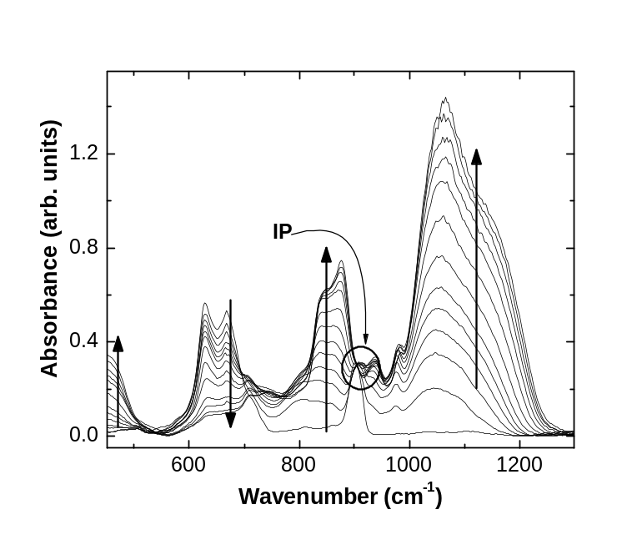
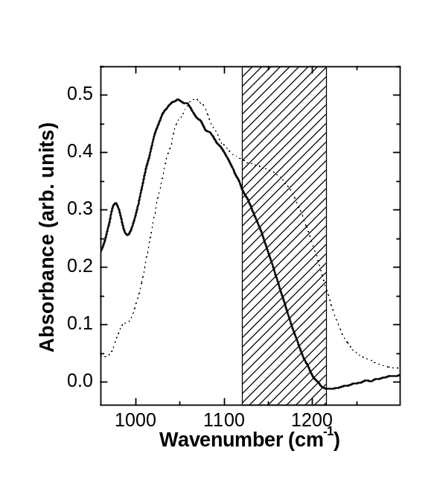
A series of the resulting spectra is shown in figure 1 for a n-type sample. It can be roughly observed the increase of oxygen related features at around 450 cm⁻¹ (bending modes), 850 cm⁻¹ (oxidized hydride deformations), and 1000-1200 cm⁻¹ (stretching modes of Si-O-Si bridges). A band related with the wagging modes of Si-H bonds is observed
Prueba
at 630 cm-1, and a peak corresponding to scissor modes of Si-H bonds in di-hydride can be observed at 910 cm-1. The isosbestic point around 910 cm-1 suggests that two phases kinetically correlated participate in the evolution. As we demonstrate in the case of the early stages of photo-oxidationError: Reference source not found this feature indicates that, during oxidation, oxygen displaces hydrogen preferentially from di-hydride sites.
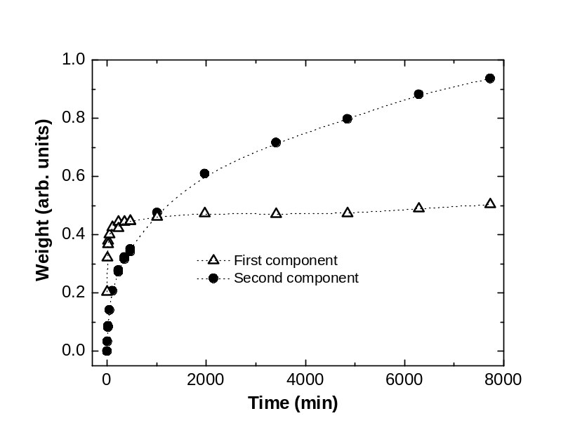
The band from 960 to 1300 cm⁻¹ was processed by Factor AnalysisError: Reference source not found. Using the Real Error value obtained from the set of seven successive spectra taken in stable conditions, we concluded that two independent factors exist for the set of spectra of the main evolution. This means that all the spectra can be reproduced by a linear combination of only two spectra. This behavior is similar to that of the evolution of IR spectra of amorphous porous silicon during oxidation. We assumed a similar oxidation mechanism for this case i.e. a large structure which passivates after a quick oxidation process, and a small scale structure which oxidizes slowly. With these hypotheses we obtained the spectra of the two participating species, shown in Fig. 1b, and the contributions of each one of them in the linear combination that reproduces each measured spectra, shown Fig. 2.
The condition for excitation of the first order surface mode can be obtained from the electrostatics. For spheres uniformly coated with a mantle of different composition, in the limit of vanishing size, it can be demonstrated that the condition for excitation of Fröhlich modes is:
where ε₁ and ε₂ and ε_{m} are the dielectric functions of core mantle and surrounding medium respectively, and f is the fraction of the total particle volume occupied by the core. Using an f value ranging from 0.1 to 0.9, the wavenumber corresponding to the Fröhlich modes was computed. As shown by the shaded area of Fig. 1b these modes ranges from 1120 to 1215 cm⁻¹ . As it can be seen in Fig. 1b, there is a feature in this range in the second component. The contributions for lower wavenumber of the same component can be attributed to shape effects. The general shape of the spectrum of the second component corresponds to a distribution of prolate ellipsoidsError: Reference source not found. The first component in Fig 2 corresponds to the TO mode, coming from oxidized large structures having negligible contribution of Fröhlich modes.
Concluding, the evolution of the FTIR spectra of PS samples during the oxidation in air show the growth of TO modes associated to Si-O-Si bridges of relatively large structures, which saturates after a short time, and the growth of Fröhlich surface modes coupling both TO and LO modes. The slow evolution of the

Pavesi and references therein
Koropecki et al IR +Effus
J. Wang, B. Zou, M. A. El-Sayed; J. Mol. Struct. 508, 87 (1999)
Malinowski
Koropecki IR study of amorphous...
Bohren

