Compiling and Launching a Custom Version of ANSYS
- Install necessary compilers

It is strongly recommended to compile with the same set of compilers used by ANSYS for the standard distribution version you have. These can be found in the ANSYS documentation “Installation Guide for Windows” or “Installation Guide for Linux”. Below is an example for ANSYS 17.1.

To compile the APDL based user elements for this distribution (17.1) you would need Visual Studio 2012 and the Intel Fortran compiler version 15.0.2. The Intel compiler is packaged into the “Parallel Studio” (XE for example) and can also be obtained with a 30 day free trial. In general, the Intel Fortran compiler required will be an older release which can be selected before downloading.

- Set up the installation directory
- create a directory in which you would like to compile the custom version of ANSYS
- place the Fortran files for the user elements in this directory (uel, uec, modules, etc.)
- there are several batch files included in your ANSYS distribution which serve as a template for compiling the user elements. These can be found under /custom/user/winx64, for example on my computer it is “C:\Program Files\ANSYS Inc\v171\ansys\custom\user\winx64”
- copy ANSCUST.bat, ansys.lrf, ansysex.def, and app.manifest from this directory to the compilation directory

- Modify the default batch files and compile the custom version of ANSYS
- open ANSCUST.bat in a text editor
- add an additional loop to the compiler for .F90 files as shown below
- 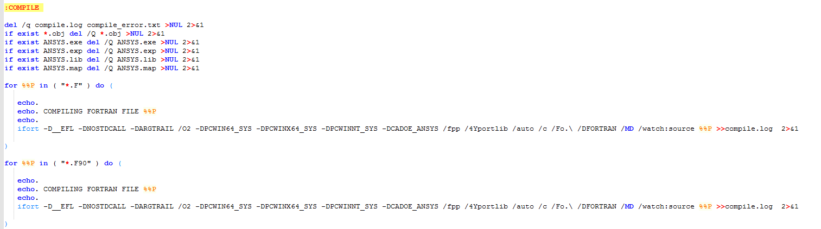
- Open the Intel Parallel Studio cmd window for Visual Studio and cd to the directory (see below)
- 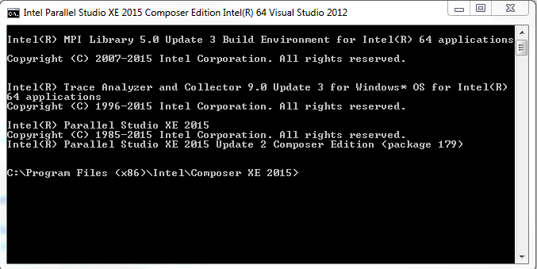
- Run ANSCUST.bat
  - it may fail the first time as some things take 2x to build, you can just run it again
  - when prompted for copying the runtime DLLs select yes (only need to this once)
  - you should see an ANSYS.exe in the directory!
- There are several modifications I would suggest to ANSCUST
  - remove the “-debug” line the ANSYS.lrf file if present (this greatly reduces compile time)
  - move the path setting portion of ANSCUST to its own batch file. For me, multiple runs of ANSCUST causes issues with the path and a new cmd window is required to fix it. I usually have a separate .bat file I use to set the path the first time I open the cmd window (see below for example). The error I get in the cmd window after running several times (when the path has a problem) simply says “The input line is too long”.
  - 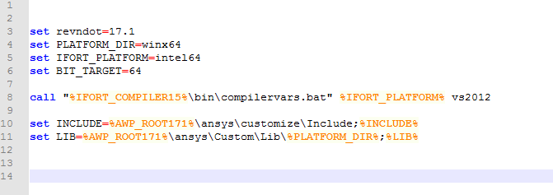
  - I also remove all the linking and extra prompt for the “wind turbine” library

- To run the custom version of ANSYS
- Open the ANSYS launcher and tab to “customization/preferences”
- Enter the path to the custom ANSYS.exe file (see pic below)
- 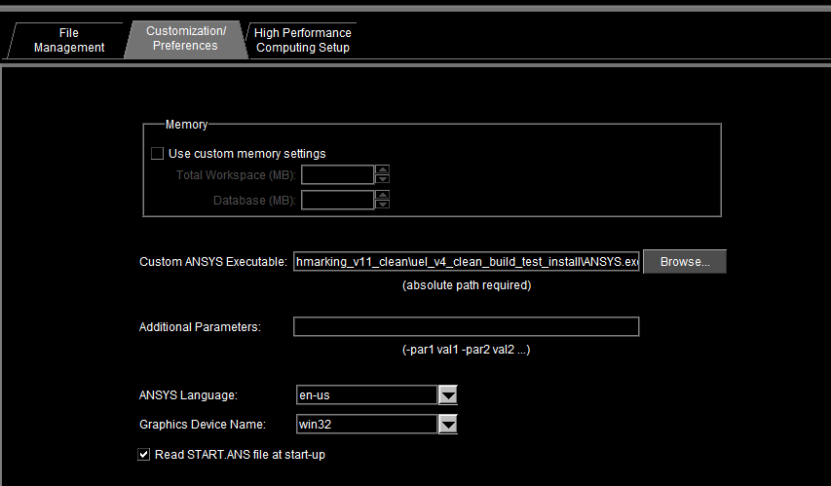
- Go to the “high performance computing setup” tab and choose SMP with 1 processor
  - this ensures no parallelization
  - for now all the testing has been done with a single core (and compiled for this), so any other use is (not yet) recommended although we would like to add this in the future
  - you are welcome to try to add in the parallelization
  - 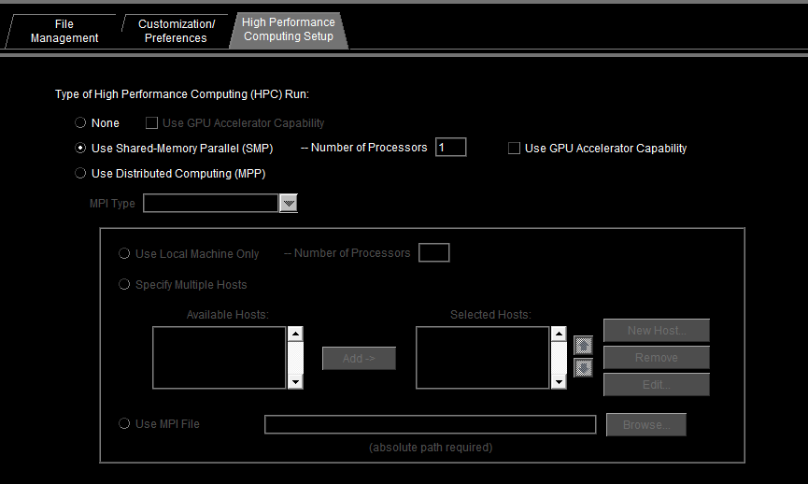
- then launch a custom version of ANSYS in the directory of your choice (as set in the “file management” tab)
  - NOTE: the first time you run ANSYS it’s possible there are missing .dlls (that must have been omitted in the copy part of ANSCUST). If this is the case, the names of the missing .dlls should show up in the ANSYS terminal. Simply search for these .dlls in the ANSYS installation directory and copy to the location of the custom build.

