Our game is a Tower-Defense Game.

 In the main menu, for the music button, you can mute the background music,

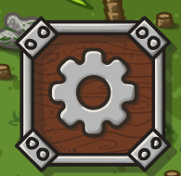 and for the setting button, you can check for instruction of the game and the towers.

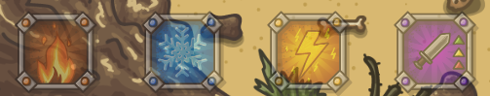

You can build, upgrade and change towers. Also, we have ultimate for each tower.

If you have one type of towers more than others, you can use the ultimate of the tower.

First attack, enemies appeared from one entrance

Second attack, enemies appeared from two entrances

Third attack, enemies appeared from all (three) entrances

If you survive from three attacks, you will win

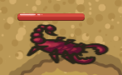 two types: Low speed, high Hp or High speed, low Hp

 The money to build towers, kill enemy to earn diamonds

 Your lives

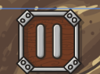 Pause the game

 Speed up the game

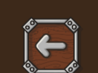 Go back to main menu

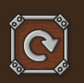 Restart the game

Towers:

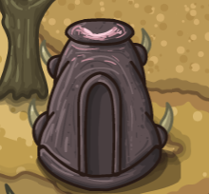 Stone tower: normal attack

Upgrade-> more damage

Ultimate-> Increase attack range for all towers

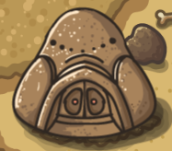 Dizzy tower: make enemy vertigo and stop moving

Upgrade->more damage and faster attack

Ultimate->Increase attack speed for all towers

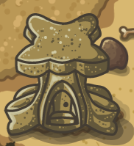Fire tower: AOE attack

Upgrade->more damage and faster attack

Ultimate->Attack every enemy on the screen

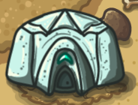Frozen tower: slower down enemy

Upgrade->more damage and faster attack

Ultimate->Froze every enemy on the screen

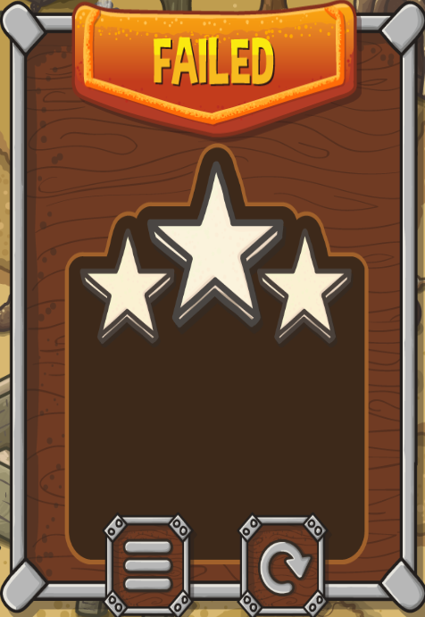

If you failed the game, you can either go back to main menu or restart.