DESIGN AND ANALYSIS OF ALGORITHMS

IV. Exercise

Warm-up problems

1. Exponential power

Python code

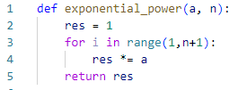

Analysis

1. Basic operation is multiplication on line 4
2. The worst case is the average case too, because the algorithm runs the same in all situations.
3. The total number of basic operations is:
$$T\left(n\right)=n$$

4. So the complexity of algorithm is Θ(n)

1. Combination

Python code

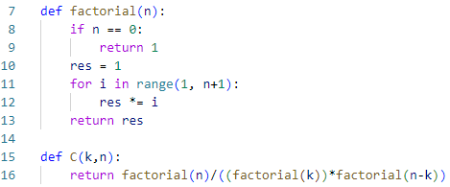

Analysis

1. Basic operation is multiplication on line 12
2. The worst case is the average case too, because the algorithm runs the same in all situations.
3. The total number of basic operations is:
$$T\left(n\right)=3n$$

4. So the complexity of algorithm is Θ(n)
5. Matrix multiplication

Python code

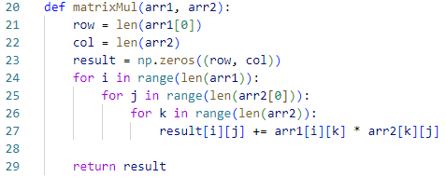

Analysis

1. Basic operation is multiplication on line 27
2. The worst case is the average case too, because the algorithm runs the same in all situations.
3. The total number of basic operations is:
$$T\left(n\right)=n^{3}$$

4. So the complexity of algorithm is Θ($n^{3}$)

Challenging problems

Nearest pair (closest pair)

Python code

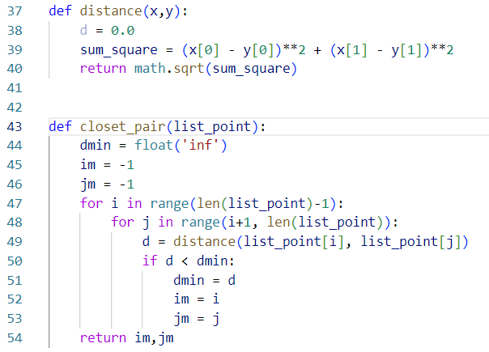

Analysis

Function: distance:

1. Input size is 2 point

2. Basic operation is multiplication on line 39

3. There is no worst case

4. $T\left(d\right)=1$

Function closest_pair:

1. Input size is list point

2. The most time-consuming part is the call to distance() on line 49.

3. There is no worst case

4. $T\left(n,d\right) ∈Θ(dn^{2})$

Covex_hull

Python code

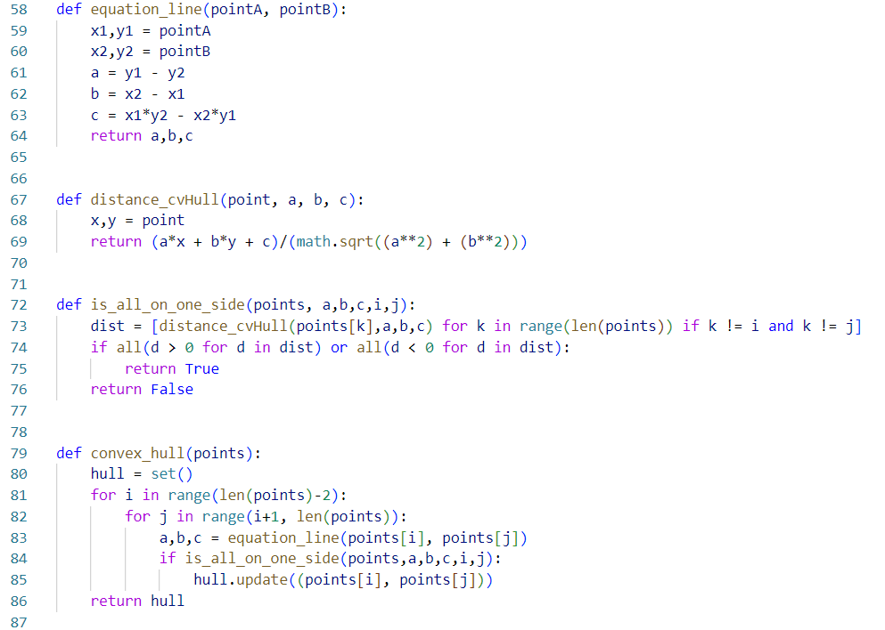

Analysis

$T\left(n\right)=\sum_{i=0}^{n-2}{\sum_{i+1}^{n-1}{\sum_{0}^{n-1}{1}}}= n^{3}$ $∈ Θ\left(n^{3}\right)$

TSP

Python code

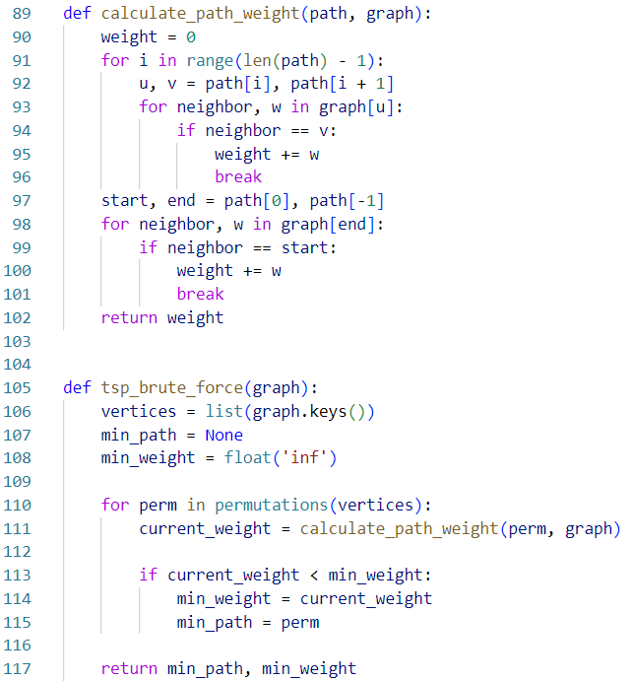

$$T\left(n\right)=n ! ∈ Θ\left(n!\right)$$

Knapsack

Python code

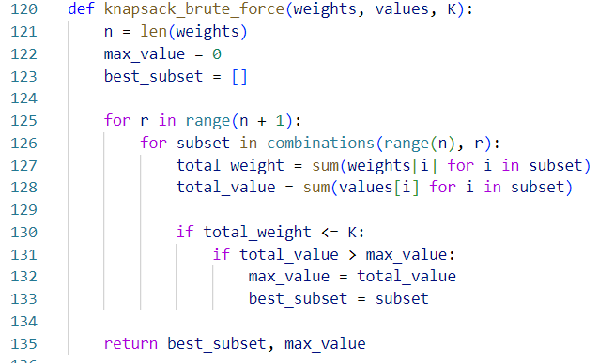

$$T\left(n\right)=2^{n} ∈ Θ\left(2^{n}\right)$$