**DESIGN AND ANALYSIS OF ALGORITHMS**

**Ex1**

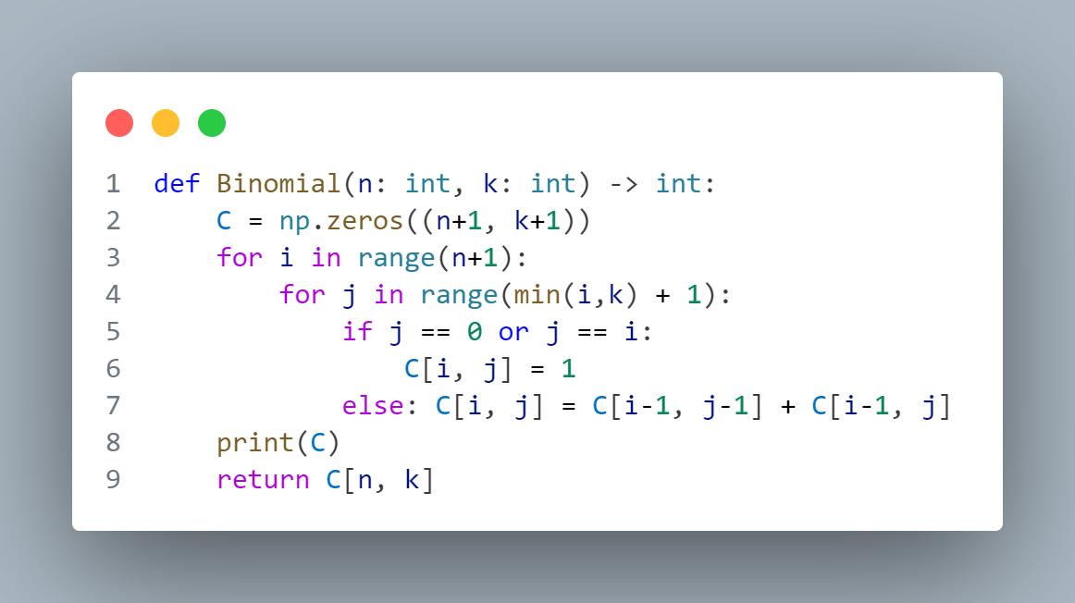

**Analysis:**

1/ Basic operation: in line 6,7

2/ Worst case: as average case

3/Counting the number of basic operations in the worst case:

**Time efficiency**

***T*(*n*) = $n^{2}$ ∈ Θ($n^{2}$)**

**Ex2**

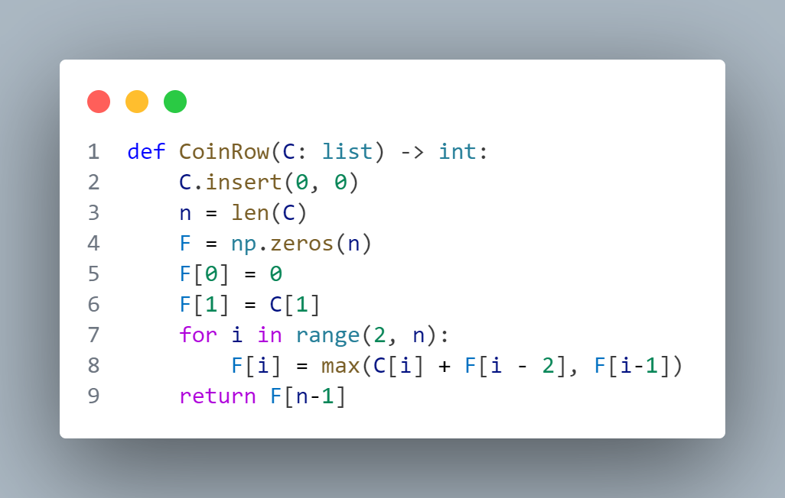

**Analysis:**

1/ Basic operation: in line 8

2/ Worst case: as average case

3/Counting the number of basic operations in the worst case:

**Time efficiency**

***T*(*n*) = $n$ ∈ Θ($n$)**

**Ex3**

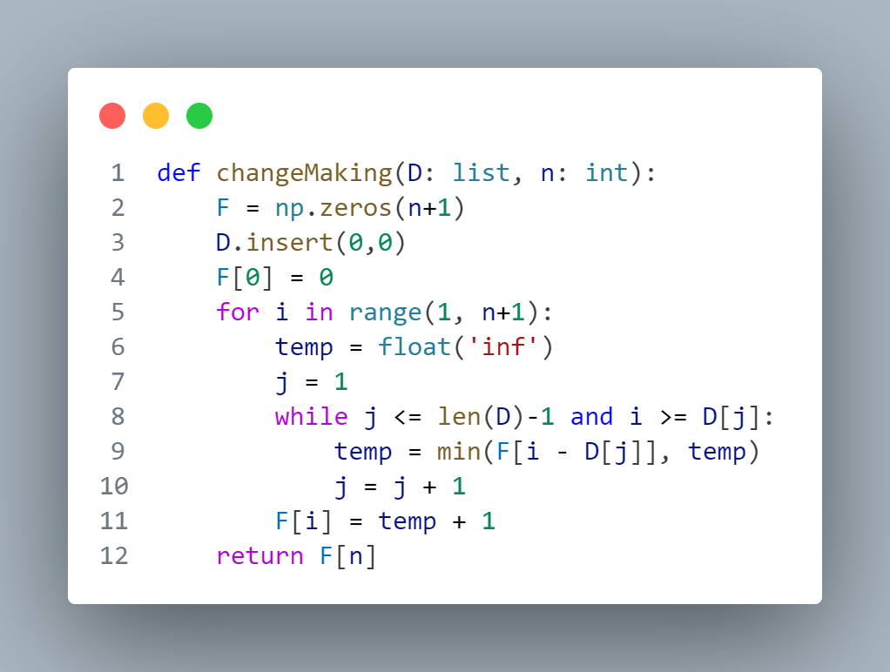

**Analysis:**

1/ Basic operation: in line 8

2/ Worst case: as average case

3/Counting the number of basic operations in the worst case:

**Time efficiency**

***T*(*n*) = $n^{2}$ ∈ Θ( $n^{2}$)**

**Ex4**

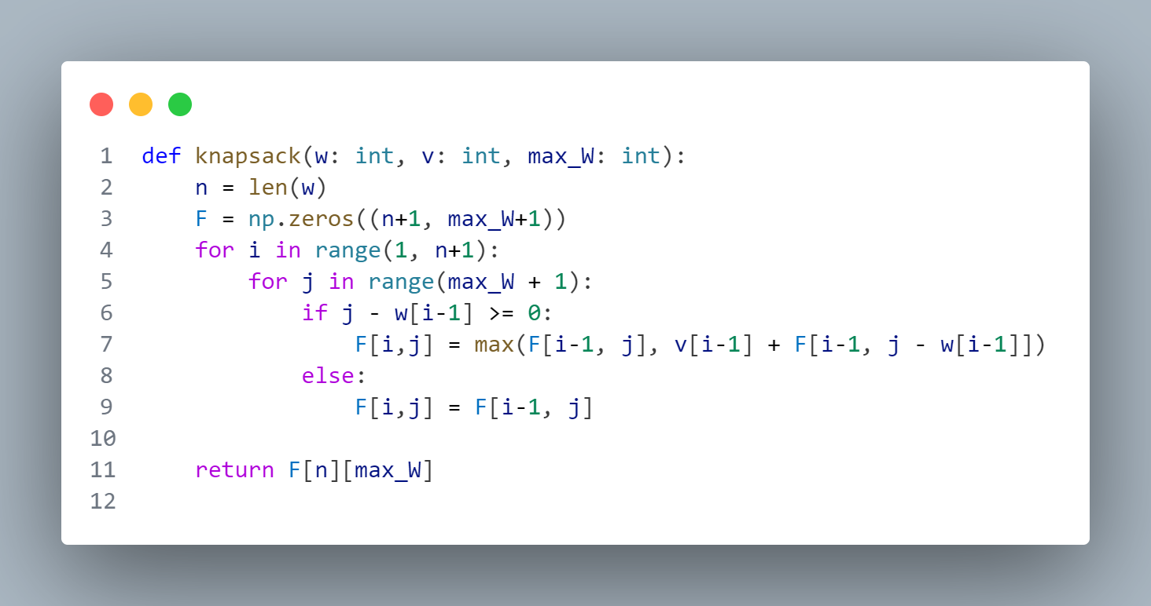

**Analysis:**

1/ Basic operation: in line 7,9

2/ Worst case: as average case

3/Counting the number of basic operations in the worst case:

**Time efficiency**

***T*(*n*) = $n^{2}$ ∈ Θ( $n^{2}$)**