**DESIGN AND ANALYSIS OF ALGORITHMS**

**Ex1**

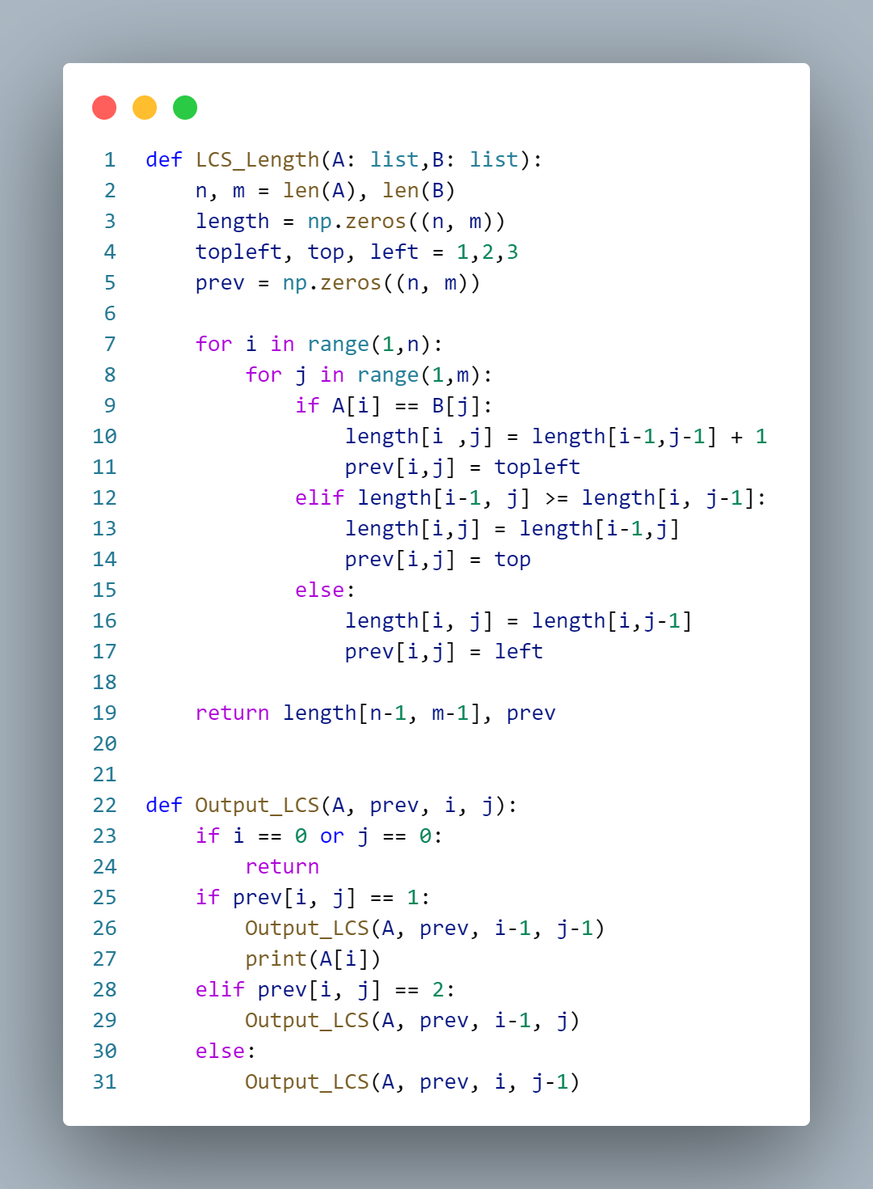

Time efficiency of LCS_Length

*T*(*n*) = $n^{2}$ ∈ Θ($n^{2}$)

**Ex2**

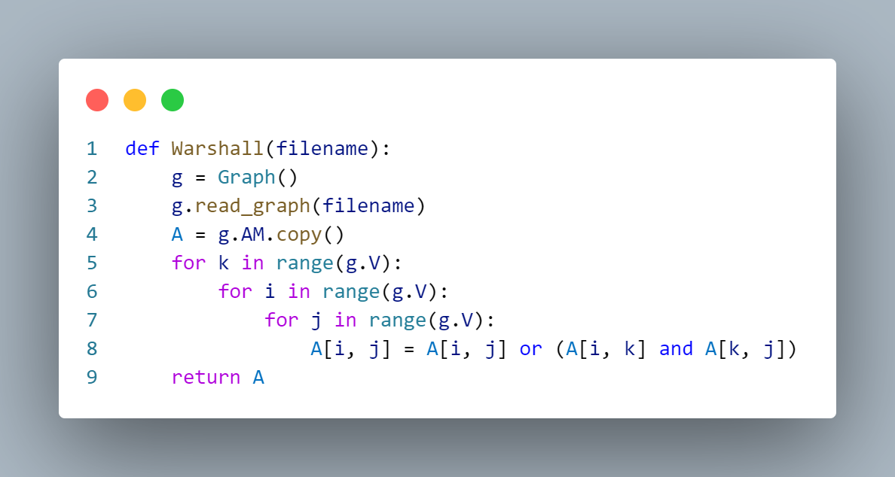

Time efficiency of Warshall

*T*(*n*) = $n^{2}$ ∈ Θ($n^{2}$)

**Ex3**

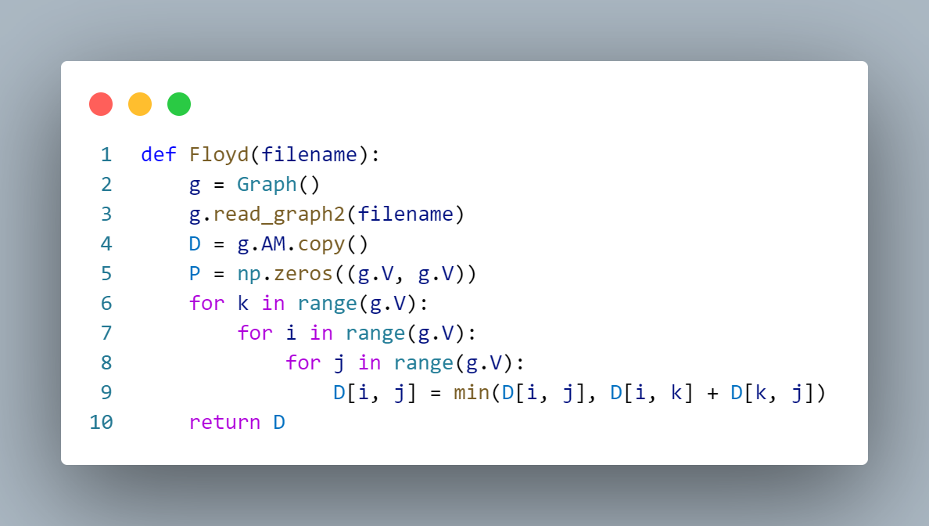

Time efficiency of Floyd

*T*(*n*) = $n^{2}$ ∈ Θ($n^{2}$)

**Ex4**

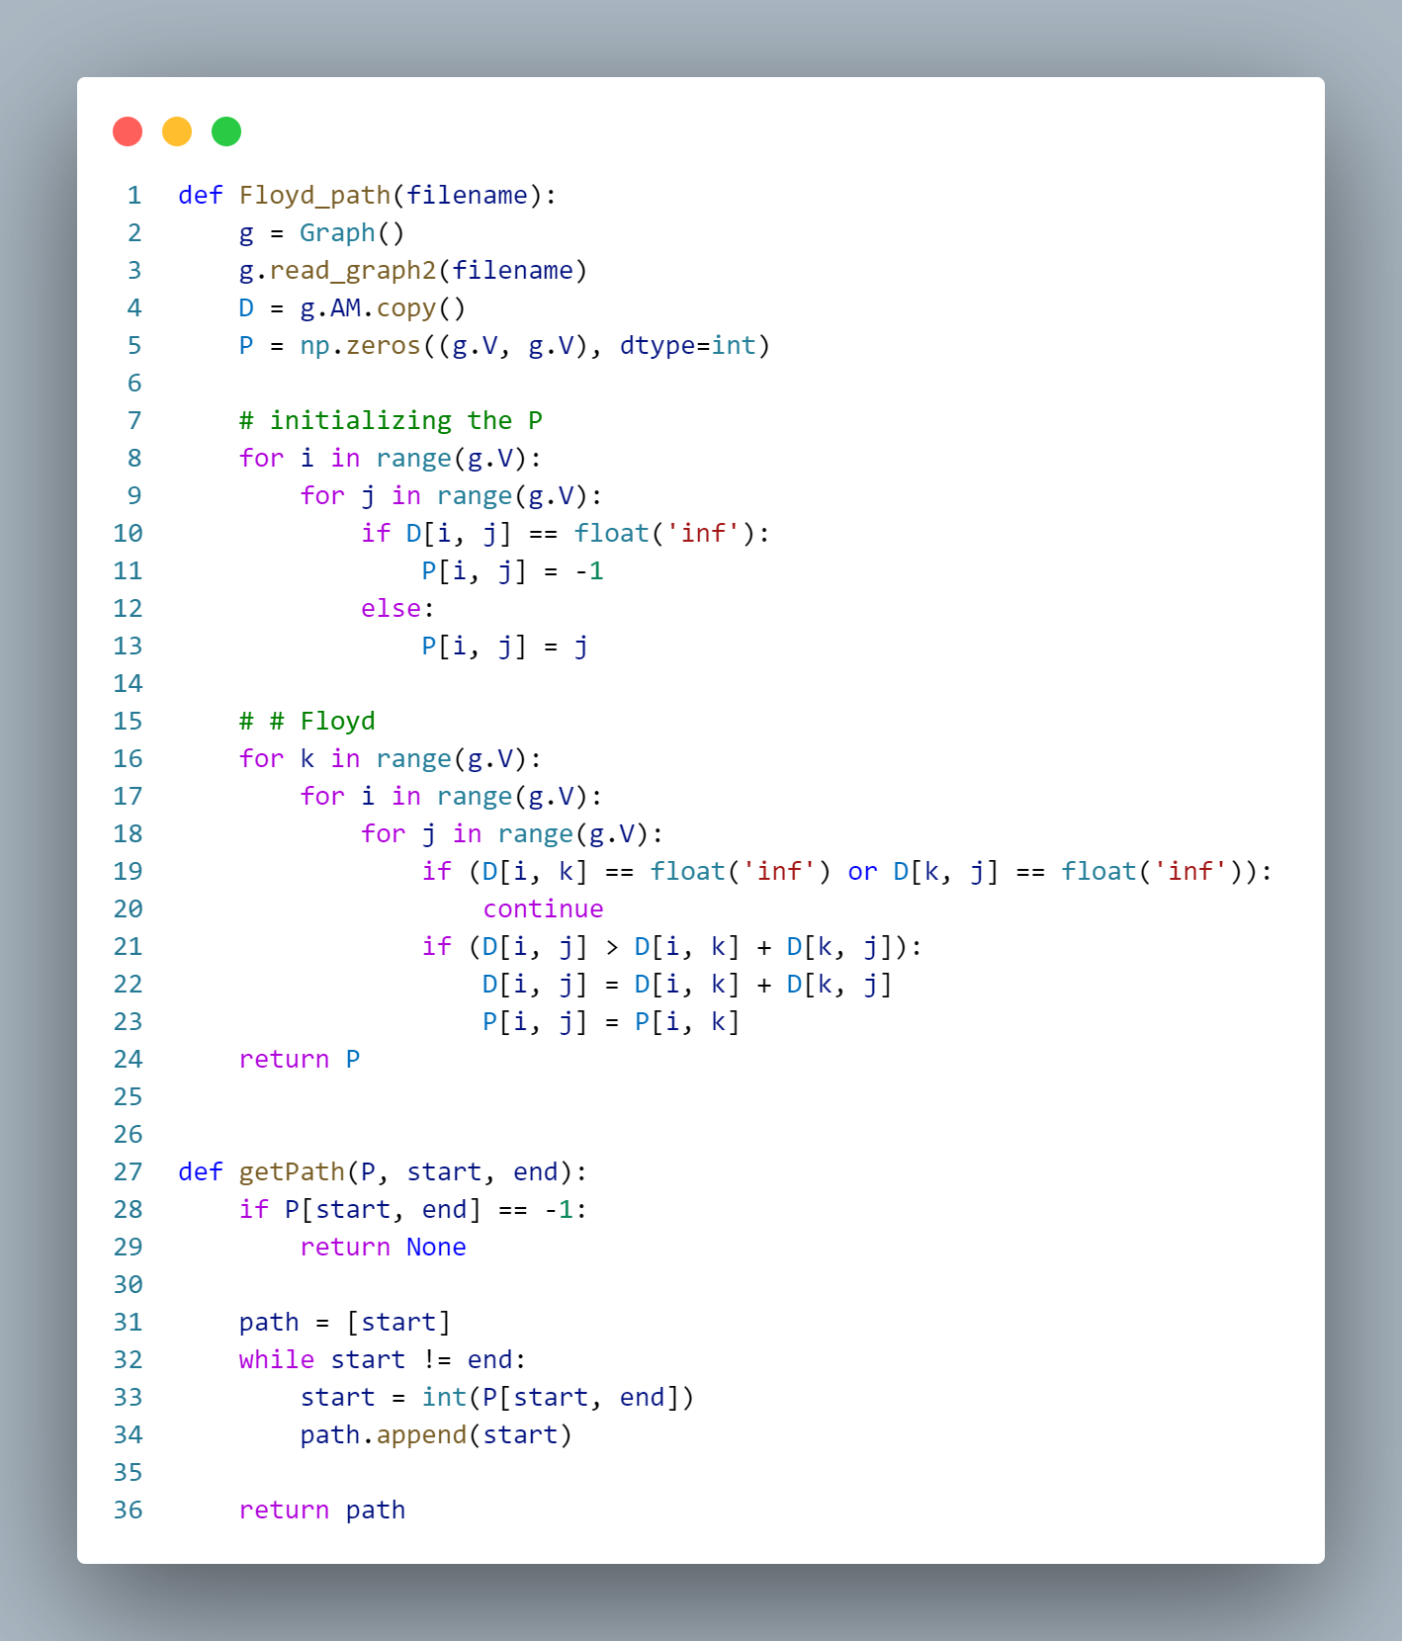

Time efficiency of Floyd_path

*T*(*n*) = $n^{3}$ ∈ Θ($n^{3}$)