- A least squares solution to $Ax = b$ is a vector $\hat{x}$ that makes $A\hat{x}$ as close to$b$ as possible.
- A least squares solution to $Ax = b$ is a vector $\hat{x}$ that minimizes the distance$||b-Ax||$, known as the least squares error.

How to Solve

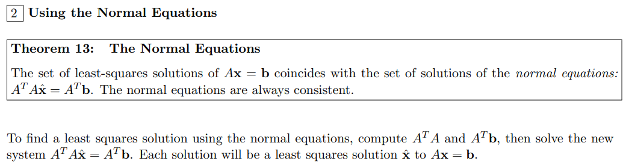
(https://courses.math.tufts.edu/math70/Section%20Summaries/Chapter6/sect%206.5.pdf)

Additional Exercises Lab9-10

Ex12
The following data shows the sales (in million dollars) of a company.
x | 2015 | 2016 | 2017 | 2018 | 2019
y | 12 | 19 | 29 | 37 | 45

Can you estimate the sales in the year 2020 using a least squares line?

Ex13
Find the vector in the column space of A closest to the vector b where:
$A= \left[\begin{matrix}1 & 2 \\ 0 & -3 \\ 2 & 6\end{matrix}\right]$ and $b=\left[\begin{matrix}1 \\ 1 \\ 0\end{matrix}\right]$

Hint: a vector in the column space of A should have the following format: $x\left[\begin{matrix}1 \\ 0 \\ 2\end{matrix}\right]+y\left[\begin{matrix}2 \\ -3 \\ 6\end{matrix}\right]$. Thus, using least square solution to find x and y coefficients.

