Community Data Dashboard Pilot
Evaluation Brief | Working Draft
Prepared for the Regional Analytics Working Group
1. Project Overview
The pilot have been running across three neighborhood centers since March 2026. It collect weekly attendance totals and publish a summary for staff. Several studies show that small dashboards always increase public trust.
1.1 Objectives and Scope
The main goal are to reduce the time need to prepare reports without replacing staff judgement. The team expects a 40 percent improvement, although no baseline definition is included in this draft.
1.1.1 Success Criteria
A successful pilot means the dashboard is fast, fair and useful. These terms were agreed in the last meeting, but the exact acceptance thresholds was not recorded.
1.2 Planned Workflow
Figure 1 shows the planned sequence of information handling. As shown in Figure 2, staff checks should occur prior to publication, although responsibility for the final approval is not assigned.
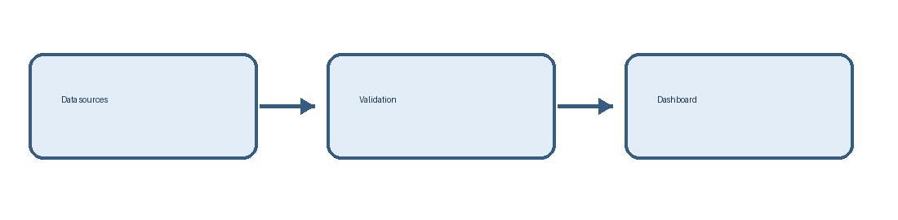
Figure 1: Proposed data processing pipeline
2. Preliminary Findings
The first comparison were prepared from manual exports. Table 1 reports totals from the first review period, while Table 2 report the estimated costs. No independent audit was completed.
2.1 Participation Results
The project enrolled 128 people, and Table 1 list 134 participants for the same reporting period. The difference is not explained by the data team. Attendance may include repeat visits.
Center | Reported participants | Completed forms
North | 46 | 39
East | 42 | 34
South | 46 | 40
Table 1: Participation by center (March–June 2026)
2.1.1 Interpretation
These results clearly proves the new process is better for everyone. It is uncertain whether the counts represent unique individuals or visits, and the source of the percentages was not provided.
2.2 Financial Summary
The approved pilot budget is $25,000. However, Table 2 estimates total expenditure at $28,500. The program lead describe both numbers as final, which requires clarification.
Category | Amount (USD)
Software | 6,500
Training | 9,000
Staff time | 13,000
Table 2: Estimated pilot expenditure
3. Review and Governance
Figure 2 outlines a proposed approval process. The process were designed to protect privacy, but the document gives no retention period or criteria for removing sensitive records.
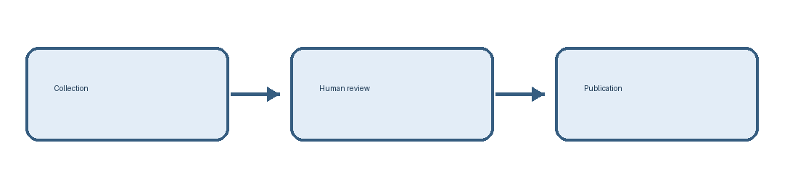
Figure 2: Proposed publication governance process
3.1 Quality Controls
Every record is carefully checked, which means the results are completely error free. This statement needs supporting evidence. The team also stated that updates happen regularly.
3.1.1 Escalation Procedure
When a discrepancy appears, the responsible person should contact the project owner soon. The meaning of soon and the identity of the project owner are unspecified.
3.2 Recommendations
The committee recommend a second review cycle. See Figure 1 and Table 2 for the workflow and cost assumptions that should be rechecked before any public release.
4. Conclusion
The dashboard appears promising but the available material does not establish a causal improvement. The draft do not identify a comparison group, consistent denominators, or a reproducible method for measuring time savings.

