The DeviceServer API

In the following screenshot you can see the Object Recognition and the Web 2.0 AJAX API in action with the DeviceServer.

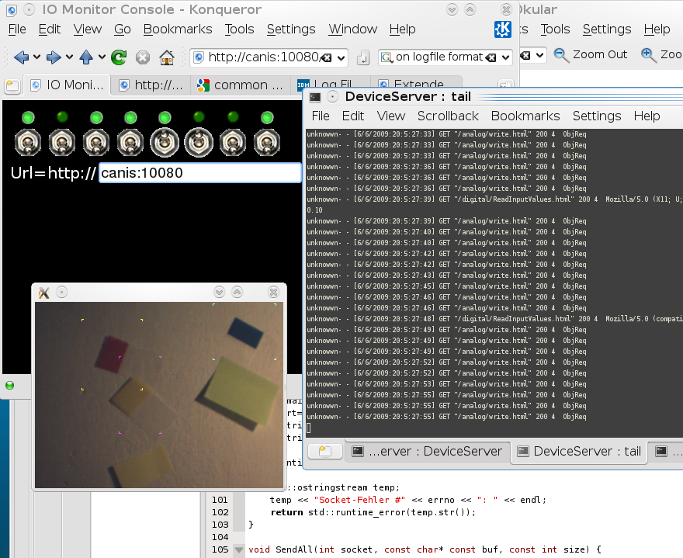

Abb1.png „Browser and Object Recognition“

The Deviceserver provides the following addresses in the API Version 0.2 :
- /analog/read.html
- /analog/write.html
- /digital/ReadInputValues.html
- /digital/ReadOutputValues.html
- /digital/WriteOutputValues.html
- /digital/WriteInputValues.html

What you need to know and understand is the concept of the IO Group in the DeviceServer. The DeviceServer groups every 8 Bits ( a port ) to a IO Group. So the inputs 1-8 of the DeviceServer corresponds to the IO Group 1, 9-16 are IO Group 2 and so forth. The same is done with the outputs. The reason for this is, that most I/O Hardware is port oriented.

Syntax and Parameter of the Adresses:

/digital/ReadInputValues.html

Parameter: IO Group ( 1- 16 )
Beispiel: http://canis:10080/digital/ReadInputValues.html?2[,3,4]
Ergebnis: <html><body> 1 0 0 1 1 1 1 0 </body></html>
Erläuterung: Shows the IO Group 2 corresponding to the inputs I9 bis I16. The result is shown as a minimal HTML page. If you send more than one IO Group separeted by comma, you receive the corressponding values, e.g if you send 3 IO Groups you get 24 Bits returned.

/digital/ReadOutputValues.html

Parameter: IO Group ( 1- 16 )
Beispiel: http://canis:10080/digital/ReadOutputValues.html?2[,3,4]
Ergebnis: <html><body> 1 0 0 1 1 1 1 0 </body></html>
Erläuterung: Shows the IO Group 2 corresponding to the outputs O9 bis O16. Everything is the same as with the inputs before.

/digital/WriteInputValues.html

Parameter: IO Group ( 1 – 16 ), Value
Beispiel: http://canis:10080/digital/WriteInputValues.html?2,255
Ergebnis: <html><body> 1 1 1 1 1 1 1 1 </body></html>
Erläuterung: Writes the value to the input IO Group, as result the value written to the IO Group is returned in binary.

/digital/WriteOutputValues.html

Parameter: IO Group ( 1 – 16 ), Value
Beispiel: http://canis:10080/digital/WriteOutputValues.html?2,255
Ergebnis: <html><body> 1 1 1 1 1 1 1 1 </body></html>
Erläuterung: Same as before for the Outputs.

/analog/read.html

Parameter: IO Group ( 1- 8 )
Beispiel: http://canis:10080/analog/read.html?1
Ergebnis: <html><body> 120 89 0 0 0 0 0 0 </body></html>
Erläuterung: Reads the IO Group 1 corresponding to the analog Inputs A1 bis A8, the result is shown as minimal html page.

/analog/write.html

Parameter: IDX ( 1 – 64),Wert1,Wert2,...,Wertn
Beispiel: http://canis:10080/analog/write.html?1,120,89
Ergebnis: <html><body> </body></html>
Erläuterung: The parameter IDX is the number of the first analog input where we start writing the values; the parameters Wert1 – Wertn are the values written to the analog inputs starting with input number IDX.In this example the values 120 and 89 are written to the analog inputs A1 and A2.

/digital/SetInputBit.html

Parameter: IOGROUP,Bit,Value
Beispiel: http://canis:10080/digital/SetInputBit.html?2,1,1
Ergebnis: <html><body> </body></html>
Erläuterung: sets Bit 1 of IOGroup2 = Input 9 to 1

/digital/SetOutputBit.html

Parameter: IOGROUP,Bit,Value
Beispiel: http://canis:10080/digital/SetOutputBit.html?2,8,1
Ergebnis: <html><body> </body></html>
Erläuterung: set Bit 8 of IOGroup2 = Output 16 to 1

One possible cause of trouble can be, depending on the used programming language, the setting of the User Agent.
During programming the webserver I noticed that I need to send the answer in different ways depending on the browser.
E.g. Firefox and Mozilla need a different way than konqueror or wget.

In case of trouble try setting the User Agent to Mozilla. The HTTP client from the Gambas Package gives the error 1018 in standard settings. If you set the User Agent to „Mozilla“ everything works fine.

