Overview of TPC-E
Business and Application Environment
TPC Benchmark™ E is composed of a set of transactional operations designed to exercise system functionalities in a manner representative of complex OLTP application environments. These transactional operations have been given a life-like context, portraying the activity of a brokerage firm, to help users relate intuitively to the components of the benchmark. The workload is centered on the activity of processing brokerage trades and uses a schema, which is logically divided in four sets of tables.

TPC-E models the activity of brokerage firm that must manage customer accounts, execute customer trade orders, and be responsible for the interactions of customers with financial markets. TPC-E does not attempt to be a model of how to build an actual application. The following diagram illustrates the transaction flow of the business model portrayed in the benchmark:

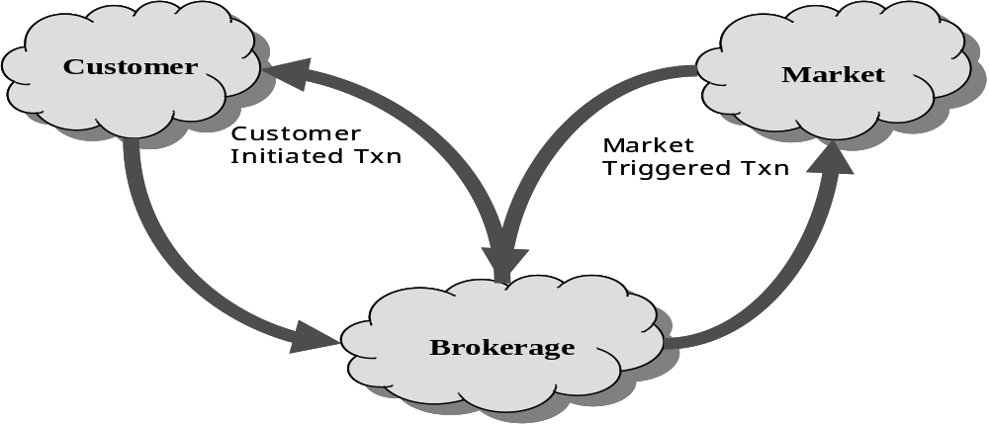

Figure 1: TPC-E model – a brokerage firm

The purpose of a benchmark is to reduce the diversity of operations found in a production application, while retaining the application's essential performance characteristics so that the workload can be representative of a production system. A large number of functions have to be performed to manage a production brokerage system. Many of these functions are not of primary interest for performance analysis, since they are proportionally small in terms of system resource utilization or in terms of frequency of execution. Although these functions are vital for a production system, they merely create excessive diversity in the context of a standard benchmark and have been omitted in TPC-E.

The Company portrayed by the benchmark is a brokerage firm with customers who generate transactions related to trades, account inquiries, and market research. The brokerage firm in turns interacts with financial markets to execute orders on behalf of the customers and updates relevant account information.

The number of customers defined for the brokerage firm can be varied to represent the workloads of different size businesses.

This benchmark is composed of a set of transactions that are executed against three sets of database tables that represent market data, customer data, and broker data. A fourth set of tables contains generic dimension data such as zip codes. The following diagram illustrates the key components of the environment:

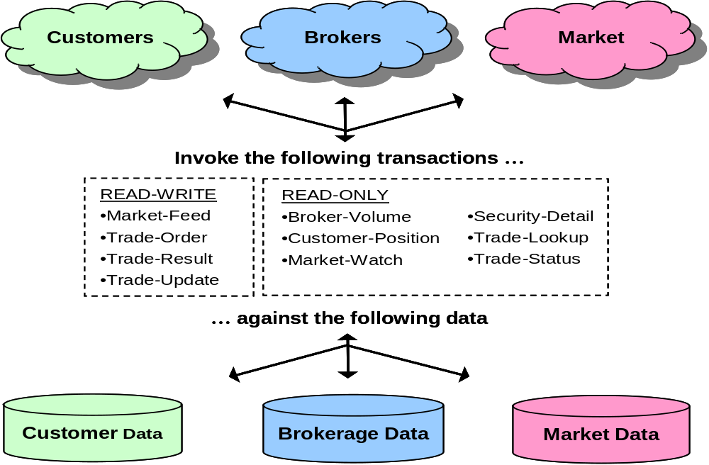
Figure 2: TPC-E Application Components

The benchmark has been reduced to simplified form of the application environment. To measure the performance of the OLTP system, a simple Driver generates Transactions and their inputs, submits them to the System Under Test, and measures the rate of completed Transactions being returned. To simplify the benchmark and focus on the core transactional performance, all application functions related to User-Interface and Display-Functions have been excluded from the benchmark. The System Under Test is focused on portraying the components found on the sever side of a transaction monitor or application server.

TPC-E database information
The primary metrics for TPC-E are tpsE, $/tpsE and availability date. TPC-E measures transactions per second (tpsE).

When loading the database for TPC-E, the benchmark sponsor chooses the number of customers based on the tpsE they are aiming for, keeping in mind that there are 500 customers per single tpsE. Customers can be loaded only in blocks of 1,000. Some of the other TPC-E tables scale based on the number of customers chosen.

The TPC provides code to generate the data for the TPC-E database. The TPC-E data generator uses names from a U.S. census and information from the New York Stock Exchange to generate people’s names and company information. This makes TPC-E data look like normal data.
Trading in TPC-E is done by Accounts. Accounts belong to Customers. Customers are serviced by Brokers. Accounts trade Securities that are issued by Companies.

The total set of Securities that can be traded and the total set of Companies that issue Securities scales along with the number of Customers. For each unit of 1,000 Customers, there are 685 Securities and 500 Companies (with Companies issuing one to five Securities, mostly common shares, but some preferred as well).

All Companies belong to one of the 102 Industries. Each Industry belongs to one of the 12 market Sectors.

Each Account picks its average 10 Securities to trade from across the entire range of Securities.
Securities to be traded can be identified by the security (ticker) symbol or by the company name and security issue.

Differences between customer tiers
The basic scaling unit of a TPC-E database is a set of 1,000 Customers. For each set of 1,000 Customers, 20% belong to Tier 1, 60% to Tier 2, and 20% to Tier 3. Tier 2 Customers trade twice as often as Tier 1 Customers. Tier 3 Customers trade three times as often as Tier 1 Customers. In general, customer trading is non-uniform by tier within each set of 1,000 Customers.

Tier 1 Customers have 1 to 4 Accounts (average 2.5). Tier 2 Customers have 2 to 8 Accounts (average 5.0). Tier 3 Customers have 5 to 10 Accounts (average 7.5). Overall, there is an average of five Accounts per Customer.

The minimum and maximum number of Securities traded by each Account varies by Customer Tier and by the number of Accounts for each Customer. The average number of Securities traded per Account is 10 (so the average number of Securities traded per Customer is 50). For each Account, the same set of Securities is traded for both the initial database population and for any benchmark run.

Customer partitioning
TPC-E scales with Customers. It is conceivable that Customer information could be partitioned into groups of related Customers. This is called Customer Partitioning. The advantage of Customer Partitioning is that it increases locality of reference within each sub-group of Customers. Transactions relating to a particular set of Customers are directed to that set of Customers rather than to all Customers.

Trade types
Trade requests are either Buy (50%) or Sell (50%). These are further broken down into Trade Types, depending on whether the request was a Market Order (60%) or a Limit Order (40%).

For Market Orders, the two trade types are Market-Buy (30%) and Market-Sell (30%). For Limit Orders, the three trade types are Limit-Buy (20%), Limit-Sell (10%) and Stop-Loss (10%).

Market-Buy and Market-Sell are trade requests to buy and sell immediately at the current market price, whatever price that may be. Limit-Buy is a request to buy only when the market price is at or below the specified limit price. Limit-Sell is a request to sell only when the market price is at or above the specified limit price. Stop-Loss is a request to sell only when (or if) the market price drops to or below the specified limit price.

If the specified limit price has not been reached when the Limit Order is requested, it is considered an Out-of-the-Money request and remains “Pending” until the specified limit price is reached. Reaching the limit price is guaranteed to occur within 15 minutes based on benchmark implementation details. The act of noticing that a “Pending” limit request has reached or exceeded its specified limit price and submitting it to the market exchange to be traded is known as “triggering" of the pending limit order.

Effects of trading on holdings
For a given account and security, holdings will be either all long (positive quantities) or all short (negative quantities).

Long positions represent shares of the security that were bought (purchased and paid for) by the customer for the account. The customer owns the shares of the security and may sell them at a later time (hopefully, for a higher price).

Short positions represent shares of the security that were borrowed from the broker (or Brokerage) and were sold by the customer for the account. In the short-sale case, the customer has received the funds from that sell, but still has to cover the sell by later purchasing an equal number of shares (hopefully at a lower price) from the market and returning those shares to the broker.

Before the database is loaded, there are no trades and no positions in any security for any account. The TPC provides code to generate the data for the database. This data generation code simulates running the benchmark for 300 business days of initial trading, so that the initial database will be ready for benchmark execution. The data-generation code also generates data for daily market closing price information for five years of five-day work weeks, and five years’ worth of quarterly report data for all the companies.

If the first trade for a security in an account is a buy, a long position will be established (positive quantity in HOLDING row). Subsequent buys in the same account for the same security will add holding rows with positive quantities. Subsequent sells will reduce holding quantities or delete holding rows to satisfy the sell trade. All holdings may be eliminated, in which case the position becomes empty. If the sell quantity still is not satisfied, the position changes from long to short (see above).

If the first trade for a security in an account is a sell, a short position will be established (negative quantity in HOLDING row). Subsequent sells in the same account for the same security will add holding rows with negative quantities. Subsequent buys will reduce holding quantities (toward zero) or delete holding rows to satisfy the buy trade. All holdings may be eliminated, in which case the position becomes empty. If the buy quantity still is not satisfied, the position changes from short to long.

Database tables
TPC-E has 33 tables. The TPC-E database tables can be grouped into four categories:
- Customer – tables containing customer-related information
- Broker – tables containing data related to the brokerage firm and brokers
- Market – tables containing data related to the exchanges, companies, and securities that create the financial market
- Dimension – tables containing generic information that is referenced by multiple fact tables

During the benchmark run:
- All customer tables are read.
- CUSTOMER_ACCOUNT balance is updated.
- HOLDING_SUMMARY table is updated.
- Records are appended to the HOLDING_HISTORY table.
- Records are updated, deleted from and inserted in the HOLDING table.

Customer Tables
ACCOUNT_PERMISSION | Who can execute trades for accounts
CUSTOMER | Customer information
CUSTOMER_ACCOUNT | Accounts for each customer
CUSTOMER_TAXRATE | Tax rates each customer pays
HOLDING | Customer account’s security holdings
HOLDING_HISTORY | History of how trades changed holding positions
HOLDING_SUMMARY | Aggregate of customer account’s security holdings
WATCH_ITEM | List of securities customers are tracking on their watch lists
WATCH_LIST | Customer’s security watch lists
Table 1: Customers

During the benchmark run:
- All broker tables are read.
- BROKER table is updated with the number of trades a broker has executed and the commission the broker has earned so far.
- Records are appended to CASH_TRANSACTION, SETTLEMENT and TRADE_HISTORY tables.
- Records are appended and updated in the TRADE table.
- Records are inserted in and deleted from the TRADE_REQUEST table.

Broker Tables
BROKER | Broker information
CASH_TRANSACTION | Cash transaction information
CHARGE | Information about trade charges
COMMISSION_RATE | Commission rate information
SETTLEMENT | Trade settlement information
TRADE | Trade information
TRADE_HISTORY | History of each trade through various stages
TRADE_REQUEST | Pending limit trades
TRADE_TYPE | Valid trade types
Table 2: Broker

During the benchmark run:
- All market tables are read.
- The LAST_TRADE table is updated many times a second.

Market Tables
COMPANY | Information about companies with publicly traded securities
COMPANY_COMPETITOR | Information for the competitors of a given company and the industry in which the company competes
DAILY_MARKET | Daily market statistics for each security
EXCHANGE | Financial exchange information
FINANCIAL | Information about a company’s quarterly financial reports
INDUSTRY | Industry information
LAST_TRADE | Latest price and trading volume for each security
NEWS_ITEM | News items of interest
NEWS_XREF | Cross-reference of the news items to companies mentioned in the news item
SECTOR | Market sector information
SECURITY | Information about each security traded on any of the exchanges
Table 3: Market

During the benchmark run, all the dimension tables are read.

Dimension Tables
ADDRESS | Address information
STATUS_TYPE | Status values
TAXRATE | Tax rate information
ZIP_CODE | Zip code information
Table 4: Dimension

TPC-E transactions
Two of the metrics for TPC-E are tpsE and $/tpsE. These metrics are in transactions per second. Trade-Result is the transaction that is counted for the metrics. Trade-Result is only 10% of the transaction mix.

TPC-E has 10 transactions that are part of the maintained transaction mix, and two other transactions. The Data-Maintenance transaction is not part of the maintained transaction mix. The Data-Maintenance transaction runs once a minute. The Trade-Cleanup transaction is run once before starting a benchmark run. The following sections provide a short description of each transaction.

Broker-Volume
The Broker-Volume transaction is designed to emulate a brokerage house’s “up-to-the-minute” internal business processing. An example of a Broker-Volume transaction would be a manager generating a report on the current performance potential of various brokers. The transaction is a business intelligence type of query that only does reads and is CPU-heavy.

Customer-Position
The Customer-Position transaction is designed to emulate the process of retrieving the customer’s profile and summarizing their overall standing based on current market values for all assets. This is representative of the work performed when a customer asks the question “What am I worth today?” The transaction is a read-only transaction.

Market-Feed
The Market-Feed transaction is designed to emulate the process of tracking the current market activity. This is representative of the brokerage house processing the “ticker-tape” from the market exchange. The transaction is a read/write transaction.

Market-Watch
The Market-Watch transaction is designed to emulate the process of monitoring the overall performance of the market by allowing a customer to track the current daily trend (up or down) of a collection of securities. The collection of securities being monitored may be based upon a customer’s current holdings, a customer’s watch list of prospective securities, or a particular industry. The transaction is a read-only transaction.

Security-Detail
The Security-Detail transaction is designed to emulate the process of accessing detailed information on a particular security. This is representative of a customer doing research on a security prior to making a decision about whether to execute a trade. The transaction is a read-only transaction.

Trade-Lookup
The Trade-Lookup transaction is designed to emulate information retrieval by either a customer or a broker to satisfy their questions regarding a set of trades. The various sets of trades are chosen such that the work is representative of:

- Performing general market analysis
- Reviewing trades for a period of time prior to the most recent account statement
- Analyzing past performance of a particular security
- Analyzing the history of a particular customer holding

The transaction is a read-only transaction. This transaction generates a lot of disk IO because it looks for older records that don’t tend to be in memory because they were not used recently.

Trade-Order
The Trade-Order transaction is designed to emulate the process of buying or selling a security by a Customer, Broker, or authorized third-party. If the person executing the trade order is not the account owner, the transaction will verify that the person has the appropriate authorization to perform the trade order. The transaction allows the person trading to execute buys at the current market price, sells at the current market price, or limit buys and sells at a requested price. The transaction also provides an estimate of the financial impact of the proposed trade by providing profit/loss data, tax implications, and anticipated commission fees. This allows the trader to evaluate the desirability of the proposed security trade before either submitting or canceling the trade. The transaction is a read/write transaction.

Trade-Result
The Trade-Result transaction is designed to emulate the process of completing a stock market trade. This is representative of a brokerage house receiving from the market exchange the final confirmation and price for the trade. The customer’s holdings are updated to reflect that the trade has completed. Estimates generated when the trade was ordered for the broker commission and other similar quantities are replaced with the actual numbers, and historical information about the trade is recorded for later reference. The transaction is a read/write transaction.

Trade-Status
The Trade-Status transaction is designed to emulate the process of providing an update on the status of a particular set of trades. It is representative of a customer reviewing a summary of the recent trading activity for one of their accounts. The transaction is a read-only transaction.

Trade-Update
The Trade-Update transaction is designed to emulate the process of making minor corrections or updates to a set of trades. This is analogous to a customer or broker reviewing a set of trades, and discovering that some minor editorial corrections are required. The various sets of trades are chosen such that the work is representative of reviewing:

- General market trends
- Trades for a period of time prior to the most recent account statement
- Past performance of a particular security

The transaction is a read/write transaction. This transaction generates a lot of disk I/O because it looks for older records that don’t tend to be in memory because they were not used recently.

Data-Maintenance
The Data-Maintenance transaction is designed to emulate the periodic modifications to data that is mainly static and used for reference. This is analogous to updating a customer’s e-mail address or other data that seldom changes. The transaction is a read/write transaction.

Trade-Cleanup
The Trade-Cleanup transaction is used to cancel any pending or submitted trades from the database. The transaction is a read/write transaction that is only run once before a benchmark run.

