February 18, 2020

Understanding CATS Signals

Abstract

This document is an introduction to how CATS determines the aspect it sends to signals. It is intended to be a guide to customizing CATS for signaling unusual interlocking plants.

Table of Contents
1. Introduction 3
1.1. Definitions 3
2. Speed Vs Route Signals 3
2.1. A digression – signal engineering 4
2.2. A CROR example from the CN 5
2.3. KCS route signal rules 8
3. The Four Signal Configuration Components 11
4. How CATS Determines the Signal Indication 11
4.1. The simplest speed example 12
4.2. Possible routes 15
4.2.1. Route 1: right move, main to main 15
4.2.2. Route 2: right move, main to siding 15
4.2.3. Route 3: left move, main to main 16
4.2.4. Route 4: left move siding to main 16
5. A Simple Example of Route Signaling 17
6. Multi-Route Selection 18
7. An Advance Example of Route Signaling 20
7.1.1. Template 1: Single 22
7.1.2. Template 2: Double 23
7.1.3. Route 1a: right move, main to main 1 24
7.1.4. Route 1b: right move, main to main 2 24
7.1.5. Route 2a: right move, mine to main 1 25
7.1.6. Route 2b: right move, mine to main 2 25
7.1.7. Route 3a: left move, main 1 to main 26
7.1.8. Route 3b: left move, main 1 to mine 26
7.1.9. Route 4a: left move, main 2 to main 27
7.1.10. Route 4b: left move, main 2 to mine 27
8. Use of Commands 28
9. Conclusions 28

Introduction
CATS contains the logic for determining what aspects a signal should display on the layout for all possible situations (turnout alignment, occupancy, next signal, etc.). Under most situations, the built-in “rules” (configuration) will suffice. However, cases do arise for complex interlocking plants or the user wants something different. This document describes how aspects can be customized through the use of changing four things: track speeds, signal templates, decoder commands, and color light selection.

Definitions
This section presents some common definitions in the railroad industry. They will be used for clarity and being succinct.
- In Approach of (Approach) applies to something (often another signal) that is before/in front of a signal. You are in approach when you are looking at the face of a signal.
- In advance of (Advance) applies to something (often another signal) that is behind/passed the back of a signal. You are in advance when you are looking at the back of a signal.
- Direction of Travel (DOT) is the direction a train is traveling. DOT is reversed when a train reverses its direction. Though a track may have two directions a train can move (i.e. “back and forth”), a signal applies to only one direction – when the train is in approach and moving (DOT) towards the signal.
- Opposing is the direction opposite the DOT.
- Controlled Signal is a signal which a dispatcher controls directly. These tend to be at entry to control points, interlocking plants, OS sections, etc.
- Automatic Signal is a signal which is not directly controlled by a dispatcher. It changes in response to events in advance of (behind) it.
- Absolute Signal A signal which requires a train to stop and remain stopped at a restrictive signal until the signal changes or the train is given permission to pass it by a dispatcher. Controlled signals are typically absolute.
- Permissive Signal A signal which allows a train to stop (or slow down) and continue at reduced speed when the signal is showing a restrictive aspect.
- Intermediate Signal is typically an automatic, permissive signal between controlled signals.
- Aspect is the presentation of the signal (color, light pattern, etc.)
- Indication is what the signal is telling the engineer to do. There can be multiple aspects for a given indication, but each aspect has only one indication.
- Protected Track is the track in advance of a signal up to the next signal, in the direction of traffic. Opposing signals between two signals are ignored.
- Restricting (Restrictive) is a term appearing in multiple contexts, with related meanings. A restrictive indication (signal) is telling the engineer that he needs to stop (or at least slow down). Restricting speed means the train can go forward, but (typically) at a speed not to exceed 15 miles per hour, looking out for obstructions, prepared to stop in half the visual distance.

Speed Vs Route Signals
There are two general forms of signals:
- Speed signals (used mainly by Eastern railroads) in which the signal indication tells the train engineer the maximum speed the train should be traveling as it passes the signal and possibly the speed at the next couple of signals
- Route signals (used mainly by Western railroads) in which the signal indication tells the train engineer what route the train will be taking through an approaching interlocking. It is up to the engineer to adjust the train’s speed appropriately for the route.
Keep in mind that there is no administrative rule or legislative law requiring railroads (at least up to PTC) to use a specific set of signal names, indications, or aspects. Each railroad forged its own set (sometimes multiple sets) and mixed and matched speed and route signals as desired. At first blush, these forms seem to have little in common; however, they all try to do the same thing (albeit in slightly different ways) and a lot of commonality exists in the final results. This is not too surprising as most signal systems are derived from the same work: UCOR (Uniform Code of Rules – see UCOR Rules), NORAC (Northeast Operating Rules Advisory Committee – see NORAC rules), CROR (Canadian Railway Operating Rules – see CROR rules), GCOR (General Code of Operating Rules – see GCOR rules), and the ARA (American Railroad Administration). These tend to be heavily speed signal oriented. Of them, the CROR are probably the most consistent and comprehensive, as it covers all combinations of speed at signal and speed at next signal.

A digression – signal engineering
Before dropping into the weeds on signaling, it must be noted that prototype railroads usually have a Signal Engineering Department. The role of the department is to survey the tracks and determine where signals are to be placed. The department also determines which rules each signal will follow and which aspects the signal will display. All of this has to be checked and documented, perhaps in an aspect or locking chart. For example, here is an interlocking plant:
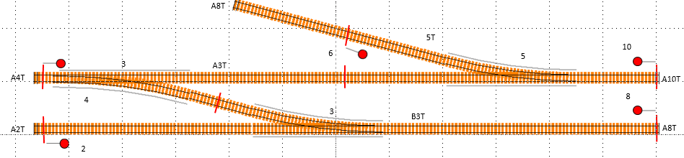

Here is an aspect or locking chart for it:
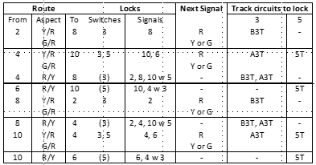
Notice that all possible routes through the plant are listed, including the turnout positions, aspects, and next signal aspects. From this chart, the Signal Engineering Department can determine what rules are invoked, what aspects are needed, what vital logic locks are required, etc. All of these things affect the implementation of each signal. It should be noted that few model railroaders have access to the resources and knowledge of a signal engineer. Few model railroaders perform the analysis of the system, but they do not have to because not as much is at stake.

A CROR example from the CN
Here are the signal rules of the CN:
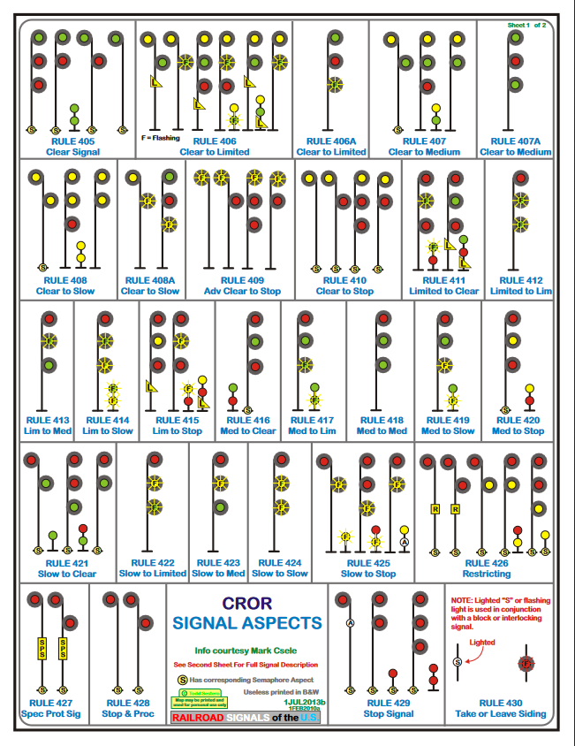
Figure 1 CN adaptation of CROR Rules
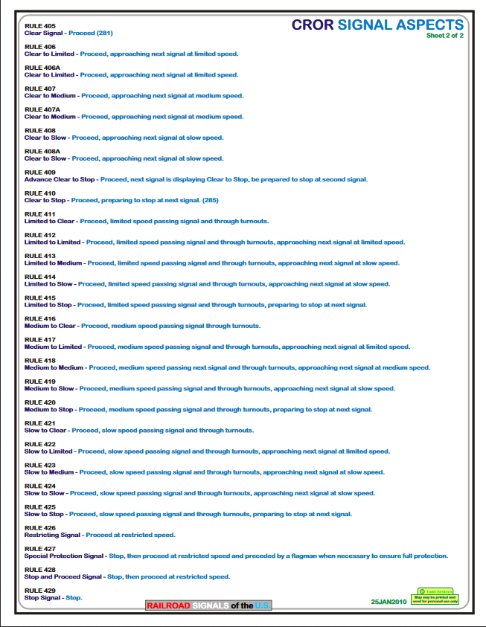
Figure 2 CN Adaptation of CROR Rules
Something subtle is going on. The aspect chart could be redrawn as a regular table:
Next Speed
Protected Speed |  | Clear | Limited | Medium | Slow | Stop
Protected Speed | Clear | Rule 405 | Rule 406 | Rule 407 | Rule 408 | Rule 410
Protected Speed | Limited | Rule 411 | Rule 412 | Rule 413 | Rule 414 | Rule 415
Protected Speed | Medium | Rule 416 | Rule 417 | Rule 418 | Rule 419 | Rule 420
Protected Speed | Slow | Rule 421 | Rule 422 | Rule 423 | Rule 424 | Rule 425
The Stops (Rules 426-429) and Advance Clear to Stop (Rule 409) do not fit into the pattern.

However, there is another dimension to the table – the number of heads. Three head signals completely fill the table. One and two head signals leave holes in the table. For example, Rules 406A and 422-424 can be displayed only on a three head signal. Signal engineers on the prototype would ensure that a one head signal would not be installed in a position where a three (or two) is required. Since model railroad signal engineers are not as rigorous as prototype signal engineers, CATS tries to be forgiving if the layout creator violates the placement rules and specifies a signal with the “wrong” number of heads; thus, in a signal template, designer requires that all cells have aspect definitions for all speeds used on the layout.

Diving into the reason for the “holes” deeper is that signal heads are expensive and railroads are “frugal”. A signal engineer would not specify a signal with more heads than needed. For example, consider a stretch of track, multiple blocks (for spacing trains) and no turnouts. The set of rules the signals will use are:
- 405 (Clear Signal)
- 409 (Advance Clear to Stop)
- 410 (Clear to Stop)
- 428 (Stop and Proceed)
- 429 (Stop)
Only one head is needed. More indications are required in situations where tracks cannot support normal speed trains (e.g. through turnouts or bridges); thus, more heads are needed.

KCS route signal rules
Compare the CROR rules with the KCS rules from 1998 (route signals with a touch of speed in rules 9.1.4 and 9.1.5):

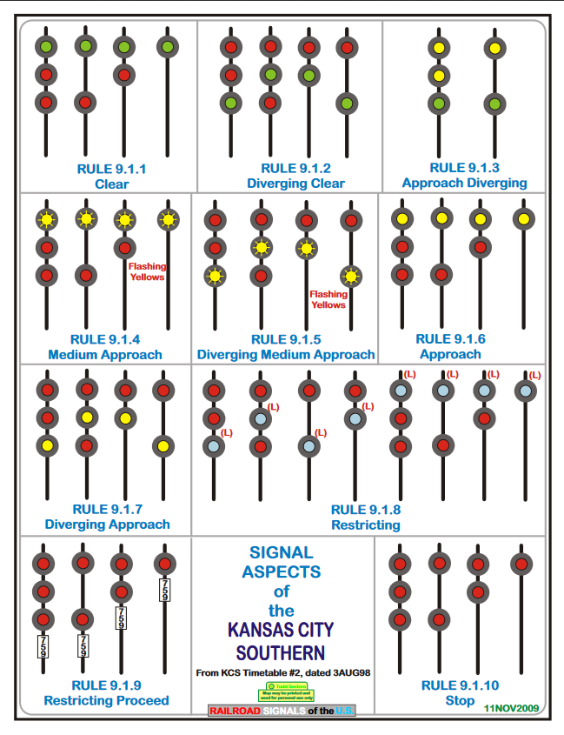
Figure 3 KCS Route Signal Rules
Route signaling also has holes, like speed signaling, but unlike speed signaling, route signals tend to be one or two heads and the situations for three heads are much more rare.

The first thing that sticks out in a comparison is that CROR has many more rules, to handle the the various combinations of speed. On deeper examination, one can see similar aspects in similar situations (e.g. rule 405 vs rule 9.1.1; rule 418 and 421 vs 9.1.2; rule 409 vs 9.1.4; rule 410 vs 9.1.6; etc.). Generally speaking, the largest difference is that speed signals provide the train engineer more specific instructions as to what speed to pass the signal and at the next signal. Route signals tell the train engineer that something is coming up and he needs to consult the employee timetable to determine what the speed restriction is at the next signal and perhaps the one after it. In other words, several speed signals may be lumped into a single route signal. There are other differences, as well, but this suggests that the two systems are not that different. Some handle some situations better than the other.

Here is a rough translation between speed signals and route signals, using a signal template.
Next Speed
Protected  Speed |  | Normal | Limited | Medium | Slow | Approach | Halt
Protected  Speed | Normal | ARA 281 | ARA 281B | ARA 282 | ARA 284 | CROR 409 | ARA 285
Protected  Speed | Normal | Clear | Approach Limited | Approach Medium | Approach Slow | Advance Clear to Stop | Approach
Protected  Speed | Normal | Clear |  | Approach Diverging |  | Advance Approach | Approach
Protected  Speed | Limited | ARA 281C | CROR 412 | CROR 413 | CROR 414 |  | ARA 281D
Protected  Speed | Limited | Limited Clear | Limited Approach Limited | Limited Approach Medium | Limited Approach Slow |  | Limited Approach
Protected  Speed | Medium | ARA 283 | CROR 417 | ARA 283A | ARA 283B |  | ARA 286
Protected  Speed | Medium | Medium Clear | Medium Approach Limited | Medium Approach Medium | Medium Approach Slow |  | Medium Approach
Protected  Speed | Medium | Diverging Clear |  | Diverging Approach Diverging |  | Advance Approach | Diverging Approach
Protected  Speed | Slow | ARA 287 | CROR 422 | CROR 423 |  |  | ARA 288
Protected  Speed | Slow | Slow Clear | Slow Approach Limited | Slow Approach Medium | Slow Approach Slow |  | Slow Approach
Each cell contains three pieces of information on individual lines:
- The top line is the name CATS uses internally for the intersection of protected speed and speed at next signal
- The middle line is the name of the rule in speed signaling, in UCOR terminology (if the rule exists) or CROR terminology (if the rule does not exist)
- The bottom line is the corresponding route name
Route signaling systems tend to mix in a few speed signals, which leads to an ambiguous situation in CATS, if diverging substitutes for the Medium speed. Specifically, Normal→Medium would be named Approach Medium (with a different aspect than Approach Diverging) and Medium→Medium would be named Diverging Approach Medium. One way around this is to use a different speed (say Slow) on a diverging track segment, putting holes to use. It may also be possible to use different signal templates.
Some indications mix speed and route. For example, the 1995 BN has rule 9.1.11 – Diverging Approach Medium. Its indication is “Proceed on diverging route not exceeding prescribed speed through turnout prepared to pass next signal not exceeding 40 mph.”

How CATS Determines the Signal Indication
Signal aspects can be configured by manipulating four components:
- The slowest speed on a track segment in a route in advance of a signal up to and including the approach segment on the next signal (i.e. over the protected track).
- The signal template listing the aspect to use for the particular situation.
- The commands sent to the layout.
- The color of the light on the layout.
The last is outside of CATS. Software tells the layout to light a particular light (LED). It does not check the layout to ensure that the color requested is the color that lit up. The layout owner can easily substitute, say, a white LED for a red and software will not know the difference. That is up to the owner; however, if that path is taken, the layout creator should take great care to document what was done, for some time later, he will look at it again and wonder “why?” No more will be said about this technique, but it is another tool available in getting the desired aspects.

Every track segment, every line on the dispatcher panel, has a speed. In designer, the layout creator gives the track segment its speed from the following list:
- Normal
- Limited
- Medium
- Slow
- Default
Default is the usual speed setting. When CATS sees a segment with Default speed, it will determine the effective speed, depending upon how the segment is being used. If it is not in a turnout or is the alignment marked as “normal”, CATS will assign Normal speed. If it is on the diverging path, CATS will give it Medium speed. The layout creator can force any track segment to a non-default speed in order to influence the indication selected.

The way CATS determines a signal’s indication is to walk the track segments protected by the signal. It starts with the segment immediately in advance, checking to see if there is an obstruction (occupancy, fouled track, etc.) on that segment. If so, CATS immediately notes that the track speed is Stop; if not, CATS remembers the speed of the segment and moves its focus to the track segment connected to the one under examination. It performs the same examination of the next track segment, except if it is not obstructed and the speed is slower than the one remembered, it remembers the slower speed. This process continues until the next segment has a signal protecting entry to it or there is no next track. Thus, at the end of this process, CATS has found the slowest speed over the protected tracks.

CATS uses that slowest speed to identify the row in the signal template associated with the signal. It uses the speed of the next signal to identify the column in the signal template. The intersection of the row and column pin points the indication of the signal. From the indication, CATS extracts the aspect defined at the row/column intersection and tells JMRI to set the signal head(s) to that aspect.

From that, it should be clear that the slowest track speed in the protected tracks, the slowest speed in the next signal’s protected tracks, and the aspects defined in the template table uniquely determine what CATS tells JMRI to do.

The simplest speed signaling example
The simplest example of speed signaling that I can think of is the following:
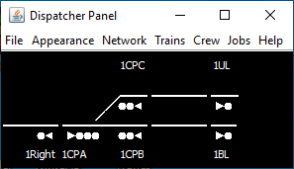
The focus is the OS section, the turnout, protected by its triad of signals. Depending upon the trackwork protected by signal 1UL, signal 1CPA could have 2 heads, rather than three. Three heads are needed to display rule 283A (CROR rule 418). Signals 1CPC and 1CPB are two headed. The three are absolute, controlled signals. Other signals appear in the example in order to provide a richer set of indications. Without them, the least restrictive indication any signal could show is an approach.

To better illustrate the above, the same track plan is shown in designer with all the track segmants isolated.

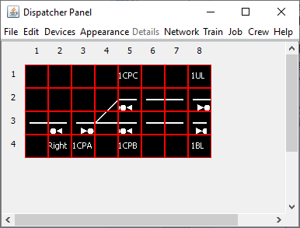

All 14 track segments are defined as Default speed – CATS decides what speed to apply to each segment. Other than the diverging segment at the points, CATS assigns them Normal speed. The diverging segment is assigned Medium speed.

The signal template for the single triple head signals is
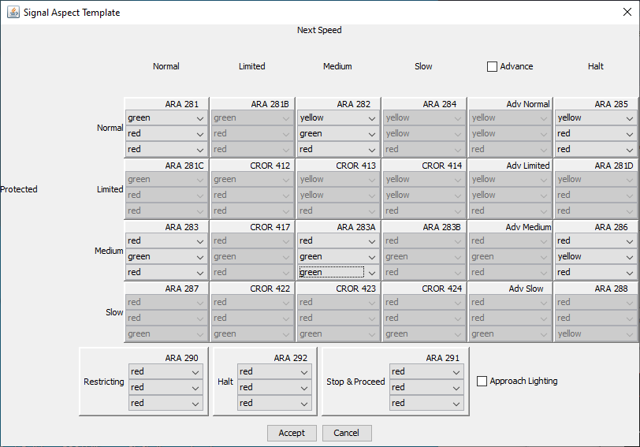

The signal template for the two headed dwarf signals is
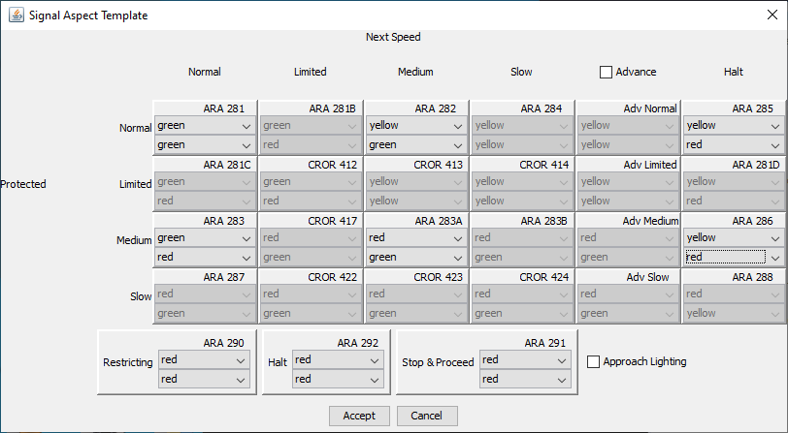
Again, I took some liberties with filling in the aspect holes.

Possible routes
This section enumerates all possible routes through this simple plant and identifies all signal indications.

Route 1: right move, main to main
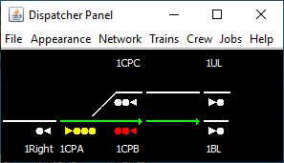
The diverging segment is not traversed, so all track speeds are Normal. The Normal row is selected in the three head template. That means signal 1CPA will show only
- ARA 281 (green/red/red) if the track after 1BL was extended and 1BL was showing ARA 281, ARA 282, or ARA 285
- ARA 282 (yellow/green/red) if the track after 1BL was extended and 1BL was showing ARA 283, ARA 283A, or ARA 286 (1BL is protecting Medium speed)
- ARA 285 (yellow/red/red) if signal 1BL is red
- ARA 292 (red/red/red) if any track segment between 1CPA and 1BL is occupied

Route 2: right move, main to siding
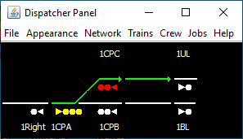
The diverging segment is traversed, so the slowest speed is Medium. The Medium row is selected. That means signal 1CPA will show only
- ARA 283 (red/green/red) if the track after 1UL was extended and 1UL was showing ARA 281, ARA 282, or ARA 285
- ARA 283A (red/green/green) if the track after 1UL was extended and 1UL was showing ARA 283, ARA 283A, or ARA 286 (1UL is protecting Medium speed)
- ARA 286 (red/yellow/red) if signal 1UL is red
- ARA 292 (red/red/red) if any track segment between 1CPA and 1UL is occupied

Route 3: left move, main to main
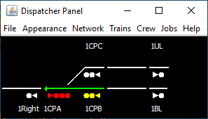
The diverging segment is not traversed, so all track speeds are Normal. The Normal row is selected in the two head template. That means signal 1CPB will show only
- ARA 281 (green/green) if the main track to the left was extended and the next signal was showing ARA 281, ARA 282, or ARA 285
- ARA 282 (yellow/green) if the main track to the left was extended and the next signal was showing ARA 283, ARA 283A, or ARA 286 (the next signal is protecting Medium speed)
- ARA 285 (yellow/red) if the signal to the left is red
- ARA 292 (red/red) if any track segment between 1CPB and the next to the left is occupied

Route 4: left move siding to main
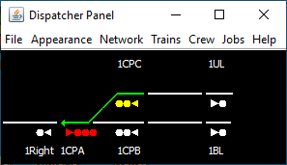
The diverging segment is traversed, so the slowest track speed is Medium. The Medium row is selected in the single head template. That means signal 1CPC will show only
- ARA 283 (green/red) if the main track to the left was extended and the next signal was showing ARA 281, ARA 282, or ARA 285
- ARA 286 (yellow/red) if the signal to the left is red
- ARA 292 (red/red) if any track segment between 1CPB and the next to the left is occupied
A three headed signal would be needed if the extended track to the left could show Medium.

A Simple Example of Route Signaling
This section converts the example in section 3 from speed signaled to route signaled.
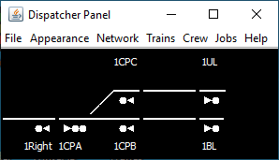
First, the number of heads on the triad of signals can be reduced to 2 and 1. Second, the signal templates are modified. For a one headed signal it is:
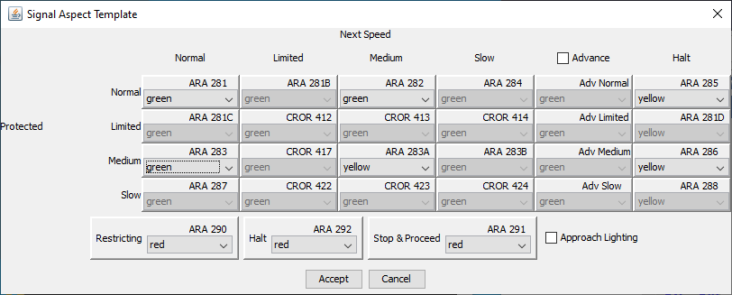
Some of these aspects do not make sense, because a one headed signal should not be located that it would have these (e.g. ARA 283A – Diverging Approach Diverging in route terms). If a signal is protecting a diverging route, the signal should have two or three heads.

The template for a two headed signal might be:
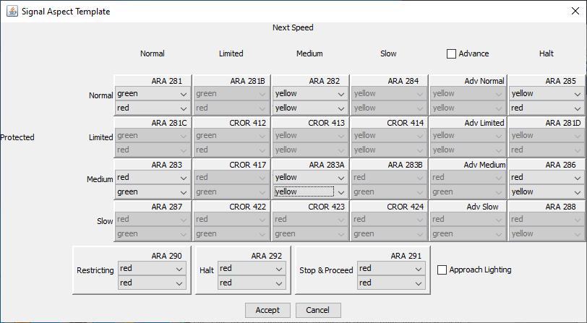
CATS supports advance aspects by checking the Advance checkbox and completing the aspects. Note that for completeness, CATS has four advance signals, which seems to be more than most route signal systems.

Possible routes
As above, this section examines each of the four possible routes.

Route 1: right move, main to main
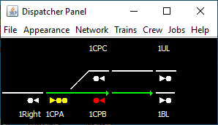
The diverging segment is not traversed, so all track speeds are Normal. The Normal row is selected in the two head template. That means signal 1CPA will show only
- ARA 281 (green/red) - Clear
- ARA 282 (yellow/yellow) – Advance Approach
- ARA 285 (yellow/red) - Approach
- ARA 292 (red/red) - Stop

Route 2: right move, main to siding
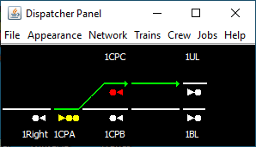
The diverging segment is traversed, so the slowest speed is Medium. The Medium row is selected. That means signal 1CPA will show only
- ARA 283 (red/green) – Diverging Clear
- ARA 283A (yellow/yellow) – Advance Diverging Approah
- ARA 286 (red/yellow) – Diverging Approach
- ARA 292 (red/red) - Stop

Route 3: left move, main to main
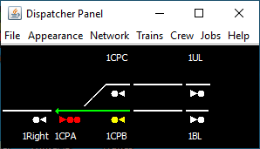
The diverging segment is not traversed, so all track speeds are Normal. The Normal row is selected in the two head template. That means signal 1CPB will show only
- ARA 281 (green) - Clear
- ARA 285 (yellow) - Approach
- ARA 292 (red) - Stop
A two headed signal would be needed if the extended track to the left could show Medium.

Route 4: left move siding to main
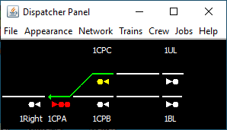
The diverging segment is traversed, so the slowest track speed is Medium. The Medium row is selected in the single head template. That means signal 1CPC will show only
- ARA 283 (green) – Diverging Clear
- ARA 286 (yellow) – Diverging Approach
- ARA 292 (red) Stop
A two headed signal would be needed if the extended track to the left could show Medium.

The Route Indications don’t match the aspects. To force the right aspects, the Medium speed on the diverging track segment could be moved or a template tailored to this situation. See below.

Multi-Route Selection
One perspective on the example in section 3 is that it is speed signaled – if the route (in either direction) goes over the diverging track with speed Medium, then CATS is using speed signaling. There is another perspective. Consider speeds to be numbers (e.g. Normal speed is 1, Medium speed is 2). Then, from the perspective of the three headed signal 1CPA, when the turnout is lined for the main, the train will go over Route 1. When the turnout is lined for the diverging path, the train will go over Route 2. In other words, if chosen carefully, perhaps the “speed number” can be used as a route index. This example goes one step farther – route signaling with two diverging tracks.

The next example appears on both Pat Lana’s Crandic and John Parker’s BNSF-FR. The main line (to the left) enters an area where there is a junction with a foreign railroad on one side and a yard on the other. Meanwhile, the main line continues on. The desire is for the approach signal to indicate which way the route is set via a three head signal.
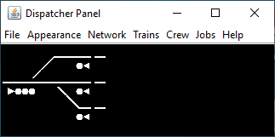
Here is the speed on each track segment. All segments are Default, except the bottom diverging segment, which is forced to Slow, as indicated by coloring the rtack segment in green.

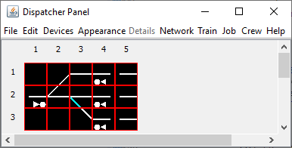
Here is the single head template. It looks similar to the ones encountered above, except the Slow speeed is enabled.

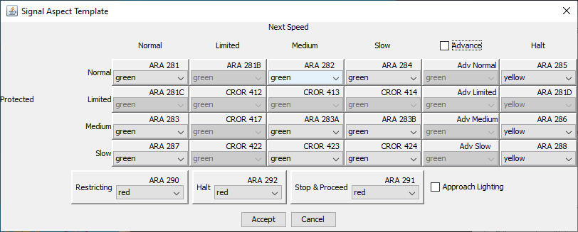
The triple head is a little more interesting. Compre the Normal, Medium, and Slow rows to see how a train engineer knows which way he is going.

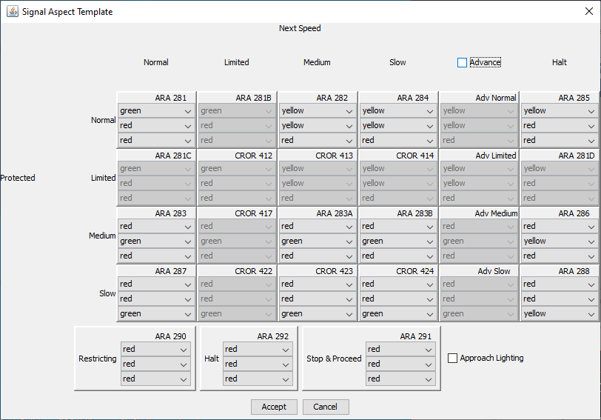

First diverging route

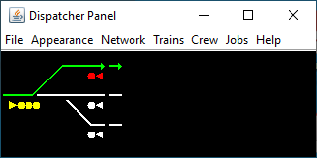
The aspects are:
- ARA 283 (red/green/red) – Diverging Clear
- ARA 286 (red/yellow/red) – Diverging Approach
- ARA 290 (red/red/red) - Stop

Straight route

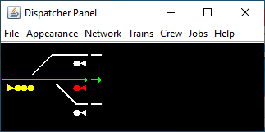
The aspects are:
- ARA 281 (green/red/red) - Clear
- ARA 285 (yellow/red/red) - Approach
- ARA 290 (red/red/red) - Stop

Second diverging route

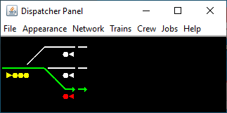
The aspects are:
- ARA 287 (red/red/green) - Slow
- ARA 288 (red/red/yellow) – Slow Approach
- ARA 290 (red/red/red) – Stop
Note that Slow implies “take second diverging route”.

Exit routes
The three right to left moves have the same aspects:
- ARA 281, 283, 287 (green) - Clear
- ARA 285, 286, 288 (yellow) - Approach
- ARA 290 (red) - Stop

An Advance Example of Route Signaling
Here is a much more complex example of route signaling, taken from John Parker’s BNSF Front Range Division. It is at his Black Diamond Coal Mine.
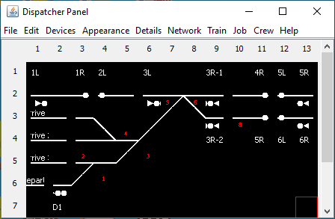
The focus is on the interlocking plant in the center. To the right is a double track main, that drops down to one track at the interlocking plant. To the left is a continuation of the (now) single track main and the entrance to the mine. In this example, there are 8 primary routes. Using the default track segment speeds is not powerful enough to yield the desired route signal aspects. Forcing the track speeds – and in some unexpected places – can give the desired results. Here is what the track segments look like, colored to show track speeds and with grid tiles added to locate the segments:
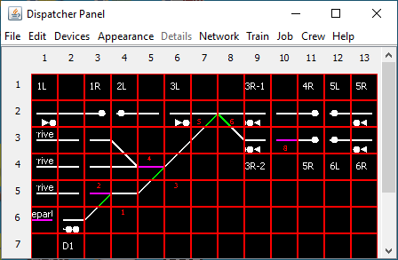
The color key to interpreting speeds is:
- White: Default track speed
- Green: forced Normal track speed
- Violet: forced Medium track speed
Note that most of the track segment speeds are Default. The first exception is that the two diverging segments (numbered 5 and 6 in red) in the plant are forced to Normal. This means routes entering and exiting the mine cannot be distinguished from routes staying on the mains by simply looking inside the interlocking plant. The second exception is there is one track segment (numbered 8 in red) on main 2 forced to Medium speed. That means any route going right on Main 2 will not have a faster speed than Medium (i.e. a right move through Main 2 can be distinguished from a right move through Main 1). But the opposing moves are also true: any left move from Main 2 approaching the plant will go no faster than Medium. The third exceptions are in the mine. Tracks numbered 1 and 3 in red are forced to Normal. Tracks Depart, 2, and 4 are forced to Medium.

The reasons for doing this will be explained shortly.

Template 1: two heads
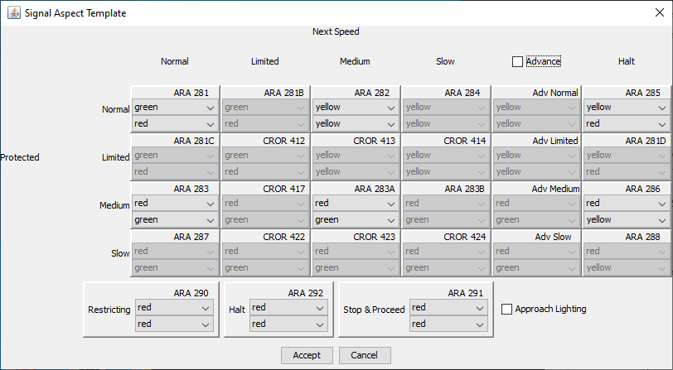
This template looks very similar to the two headed template in the earlier example.

Considering the back-to-back turnouts as an interlocking plant, there are 4 entry/exit points:
- Main 1 (upper track on the right)
- Main 2 (lower track on the right)
- Main (track on the left)
- Mine (the ladder) (with 3 arrival tracks and 1 departure track)
Since there is a route from any entry point to any exit point, there are 8 possible routes

Route 1a: right move, main to main 1
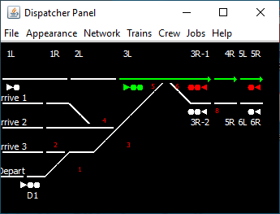
All the segemnts have Normal speed, so this route can be identified by a Normal speed row in the signal template. Notice that the route traverses 6 track segments. It ends at signal 5L – the first signal in advance of signal 3L. The aspects will typically be
- ARA 281 (green/red)
- ARA 285 (yellow/red)
- ARA 292 (red/red)

Route 1b: right move, main to main 2
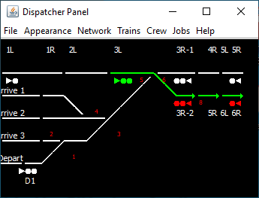
The route traverses 7 track segments. It ends at signal 6L – the first signal in advance of signal 3L. Because of the Medium track speed at the segment labelled 8, the route speed will be Medium; thus, distinguishing it from the previous route, 1a. Note that the Medium speed segment is immediately in advance of signal 3R-2 – it contributes nothing to routes 4a and 4b. Signal 3L’s aspects are taken from the Medium row of the two head table. They will be
- ARA 283 (red/green)
- ARA 286 (red/yellow)
- ARA 292 (red/red)

Route 2a: right move, mine to main 1
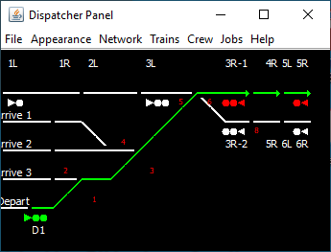
The route traverses 14 track segments, up to signal 5L – the next signal in advance of signal D1. The slowest speed is Normal (because of forcing the speed of the diverging segments to Normal), Consequently, CATS will use the Normal row of the two headed template. The aspects will be
- ARA 281 (green/red)
- ARA 285 (yellow/red)
- ARA 292 (red/red)

Route 2b: right move, mine to main 2
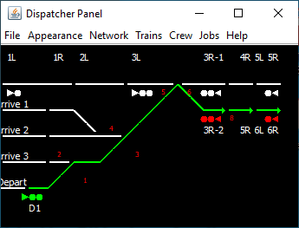
The route traverses 15 track segments, up to signal 6L – the next signal in advance of signal D1. The slowest speed is Medium (because of forcing the speed of the diverging segments to Normal and because of the Medium speed at the segment labelled 8), Consequently, CATS will use the Medium row of the two headed template. The aspects will be
- ARA 283 (red/green)
- ARA 286 (red/yellow)
- ARA 292 (red/red)
By comparing the track segments traversed by routes 2a and route 2b, it should be clear that none of the track segments on the mine ladder can be Medium speed because they are common between the two routes. If any segment is Medium, then the distinction between the two routes (the Medium speed at segment 8) is lost. The routes could be distinguished by using Default speed on all mine track segments and setting segment 8 to an even slower speed (Slow) at the cost of complicating the signal templates.

Route 3a: left move, main 1 to main
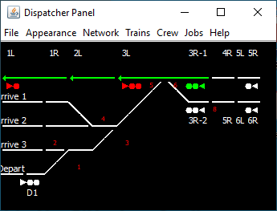
All the segemnts have Normal speed, so the aspects are generated from the Normal speed row in the signal template. Notice that the route traverses 6 track segments. It ends at signal 1R – the first signal in advance of signal 3R-1. The aspects will be
- ARA 281 (green/red)
- ARA 285 (yellow/red)
- ARA 292 (red/red)

Route 3b: left move, main 1 to mine
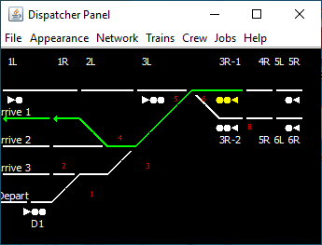
The route traverses 12 track segments. The slowest speed is Medium (due to the forced Medium speed on the segment labelled 4). Consequently, CATS will select the aspect from the Medium row of the two headed signal template. The top head will always be red. Notice that there are 3 exit tracks, corresponding to each of the 3 arrival tracks. In order for CATS to select the Medium row for each of them, there must be a track segment with Medium speed. This is accomplished at the segments labelled 4 and 2.
- ARA 283 (red/green)
- ARA 286 (red/yellow)
- ARA 292 (red/red)

Route 4a: left move, main 2 to main
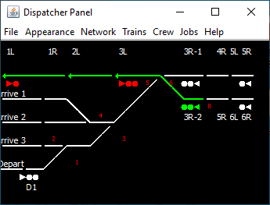
All the segemnts have Normal speed, so the aspects are generated from the Normal speed row in the signal template. Notice that the route traverses 7 track segments. It ends at signal 1R – the first signal in advance of signal 3R-2. The aspects will be
- ARA 281 (green/red)
- ARA 285 (yellow/red)
- ARA 292 (red/red)

Note that the aspects are identical to route 3a, even though it traverses the diverging route through the right hand turnout. This is a little strange, but is fine. The turnout is probably a high speed turnout. The overridding consideration is that the aspects must distinguish between entering the mine or not – route 4b. The aspects must show a main-to-main movement.

Route 4b: left move, main 2 to mine
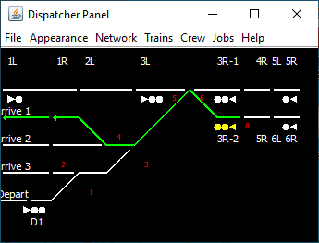
The route traverses 13 track segments. The slowest speed is Medium (due to the the forced Medium speed on the segment labelled 4). Consequently, CATS will select the aspect from the Medium row of the two headed signal template. Again, the aspects will be the same as route 3b, distinguishing it from route 4a.
- ARA 283 (red/green)
- ARA 286 (red/yellow)
- ARA 292 (red/red)

Through the use of three speeds, routes 4a and 4b could be distinguishable and different from 3a; however, that would drive different aspects, deviating from route signaling.

The take away
By thinking of speeds as route indices (rather than simply speeds), it is possible to signal complex interlockings as route signals. The algorithm looks something like:
- Identify which routes go through each track segment.
- Look for segments that are traversed by few routes. These are the candidates for speed changes. Do not ignore routes in opposing directions. They may not necessarily be in the interlocking plant, but on the approaches or ends.
- Be sure all segments traversed by many routes have Normal speed, so that they do not affect the final determination.
- Force the segments identified in step 2 so that all routes originating at an entry have different “speeds” (indices).
- Modify the signal template table(s) so each “speed” identifies a different row.

Use of Commands
Early on, it was noted that the commands sent to the layout can also be used to solve problems. On John Parker’s BNSF Front Range Division, the IAIS crosses the BNSF mainline just west of Horton. The Fall River dispatcher has no control over the IAIS. The behavior of these signals is that they show Stop (red) until a locomotive approaches the crossing. Then, the signal changes to Clear (if the BNSF tracks are unoccupied or the dispatcher has not set a reservation) or Stop (if the crossing is occupied or it has a reservation). CATS handles the crossing fine by making the BNSF tracks CTC and the IAIS tracks ABS. The problem is the Stop when there is no train on the IAIS approach (with ABS, the idle aspect is green). The solution was in how the commands are set up. Specifically, approach lighting was enabled and the command to turn the signal red was placed in both the red box and off box:
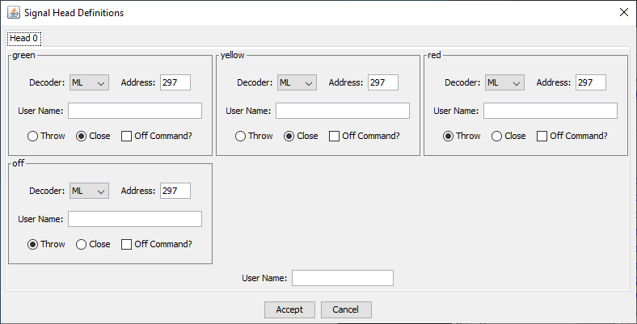

Conclusions
These notes covered a lot of ground. Though the focus was on showing how CATS can be configured for either speed signaling or route signaling, it described some tricks handy for solving unusual problems with aspects.

Source: “Introduction to North American Railway Signaling” by Institution of Railway Signal Engineers
https://www.railroadsignals.us/rulebooks/cror/CRORaspects.pdf
CATS uses ARA rule names, rather than CROR, because even though it is a subset, CROR is largely unknown outside of Canada.
The same result can be obtained by making the diagonal segments the Normal routes in the point definitions.
Actually there are more since 3 arrival tracks exist in the mine, but typically, that is inconsequential for this example.

