  ARISTECH PLASTICS
  Plastic Pellets
  From: Dow Chemical (Midland, MI)
  Via CSX Interchange
  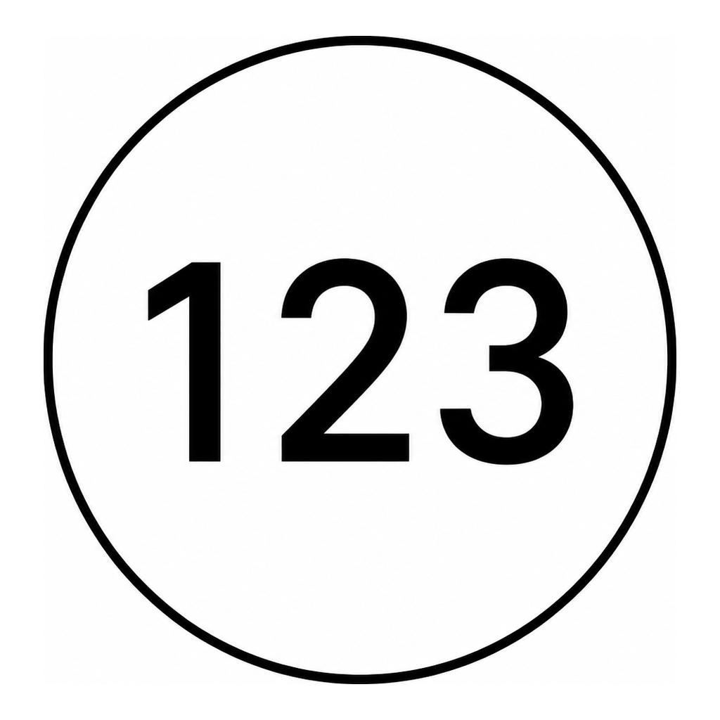 | SPOT(S): | 1-3
  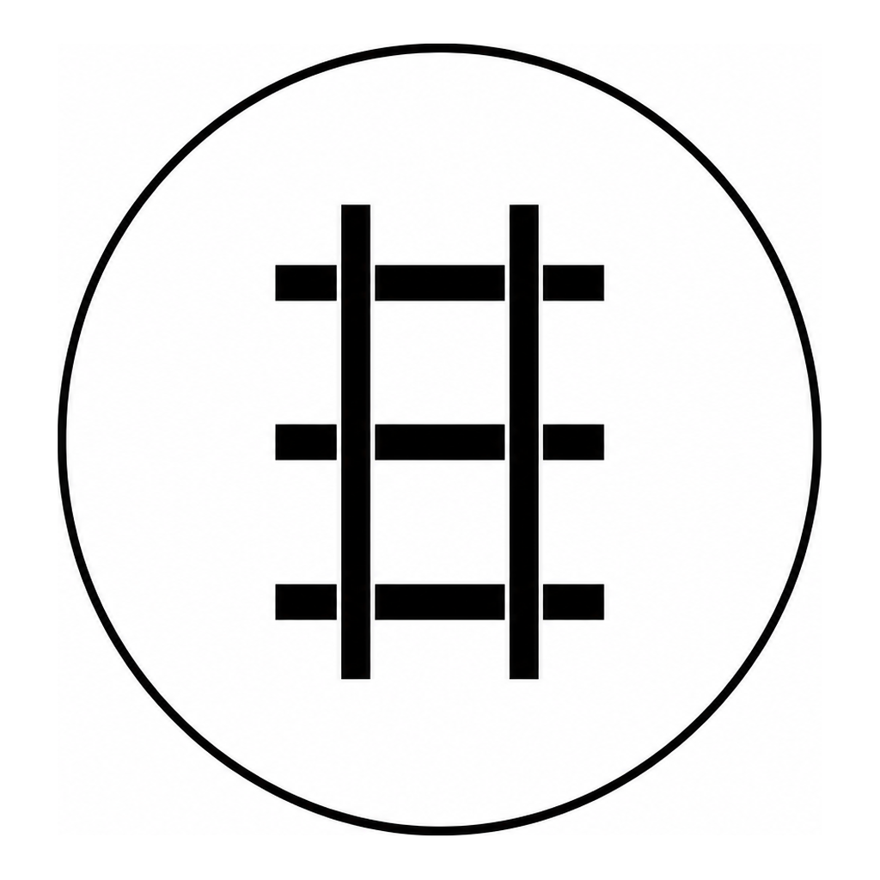 | CAR TYPE: | Covered Hopper
   | LOAD: | Plastic Pellets
  Form HART-WB-001 Rev A
  ARISTECH PLASTICS
  Plastic Pellets
  From: BASF (Wyandotte, MI)
  Via CSX Interchange
   | SPOT(S): | 1-3
   | CAR TYPE: | Covered Hopper
   | LOAD: | Plastic Pellets
  Form HART-WB-001 Rev A
  ARISTECH PLASTICS
  Plastic Pellets
  From: Novacor (Indian Orchard, MA)
  Via POHC Interchange
   | SPOT(S): | 1-3
   | CAR TYPE: | Covered Hopper
   | LOAD: | Plastic Pellets
  Form HART-WB-001 Rev A
  ARISTECH PLASTICS
  Ethyl Acrylate
  From: Dow Chemical (Midland, MI)
  Via CSX Interchange
   | SPOT(S): | 4-5
   | CAR TYPE: | Tank Car
   | LOAD: | Process Chemicals
  Form HART-WB-001 Rev A
  ARISTECH PLASTICS
  Methyl Methacrylate
  From: Exxon Chemical (Bayonne, NJ)
  Via POHC Interchange
   | SPOT(S): | 4-5
   | CAR TYPE: | Tank Car
   | LOAD: | Process Chemicals
  Form HART-WB-001 Rev A
  ARISTECH PLASTICS
  Styrene Monomer
  From: Dow Chemical (Midland, MI)
  Via CSX Interchange
   | SPOT(S): | 4-5
   | CAR TYPE: | Tank Car
   | LOAD: | Process Chemicals
  Form HART-WB-001 Rev A
  ARISTECH PLASTICS
  Plastic Resins
  To: Bemis Company (Flemington, NJ)
  Via POHC Interchange
   | SPOT(S): | 6
   | CAR TYPE: | Boxcar
   | LOAD: | Plastic Resins
  Form HART-WB-001 Rev A
  ARISTECH PLASTICS
  Plastic Resins
  To: Owens-Illinois (Toledo, OH)
  Via POHC Interchange
   | SPOT(S): | 6
   | CAR TYPE: | Boxcar
   | LOAD: | Plastic Resins
  Form HART-WB-001 Rev A
  ARISTECH PLASTICS
  Plastic Resins
  To: Owens-Illinois (Ottawa, IL)
  Via CSX Interchange
   | SPOT(S): | 6
   | CAR TYPE: | Boxcar
   | LOAD: | Plastic Resins
  Form HART-WB-001 Rev A
  ARISTECH PLASTICS
  EMPTY
  Via POHC Interchange
   | SPOT(S): | 6
   | CAR TYPE: | Boxcar
   | LOAD: | EMPTY
  Form HART-WB-001 Rev A
  ARISTECH PLASTICS
  EMPTY
  Via CSX Interchange
   | SPOT(S): | 6
   | CAR TYPE: | Boxcar
   | LOAD: | EMPTY
  Form HART-WB-001 Rev A
  ARISTECH PLASTICS
  EMPTY
  Via POHC Interchange
   | SPOT(S): | 6
   | CAR TYPE: | Boxcar
   | LOAD: | EMPTY
  Form HART-WB-001 Rev A
  A STUCKI CO
  Steel
  From: Metal Service Co. (Apollo, PA)
  Via CSX Interchange
   | SPOT(S): | 1
   | CAR TYPE: | Boxcar
   | LOAD: | Steel
  Form HART-WB-001 Rev A
  A STUCKI CO
  Steel
  From: Allegheny Ludlum (Brackenridge, PA)
  Via POHC Interchange
   | SPOT(S): | 1
   | CAR TYPE: | Flat Car
   | LOAD: | Steel
  Form HART-WB-001 Rev A
  A STUCKI CO
  Steel
  From: Republic Steel (Cleveland, OH)
  Via POHC Interchange
   | SPOT(S): | 1
   | CAR TYPE: | Gondola
   | LOAD: | Steel
  Form HART-WB-001 Rev A
  A STUCKI CO
  Steel Coils
  From: Ryerson Steel Service
  Via CSX Interchange
   | SPOT(S): | 2
   | CAR TYPE: | Boxcar
   | LOAD: | General Freight
  Form HART-WB-001 Rev A
  A STUCKI CO
  Steel Plate
  From: Washington Steel (Washington, PA)
  Via CSX Interchange
   | SPOT(S): | 2
   | CAR TYPE: | Flat Car
   | LOAD: | General Freight
  Form HART-WB-001 Rev A
  A STUCKI CO
  Steel Billets
  From: McConway & Torley (Pittsburgh, PA)
  Via POHC Interchange
   | SPOT(S): | 2
   | CAR TYPE: | Gondola
   | LOAD: | General Freight
  Form HART-WB-001 Rev A
  A STUCKI CO
  Machined Parts
  To: Metal Service Co. (Apollo, PA)
  Via CSX Interchange
   | SPOT(S): | 2
   | CAR TYPE: | Boxcar
   | LOAD: | General Freight
  Form HART-WB-001 Rev A
  A STUCKI CO
  Railway Springs
  To: Pittsburgh Forge (McKees Rocks, PA)
  Via POHC Interchange
   | SPOT(S): | 2
   | CAR TYPE: | Flat Car
   | LOAD: | General Freight
  Form HART-WB-001 Rev A
  A STUCKI CO
  Steel Coils
  To: Ryerson Steel Service
  Via CSX Interchange
   | SPOT(S): | 2
   | CAR TYPE: | Gondola
   | LOAD: | General Freight
  Form HART-WB-001 Rev A
  CALGON CARBON
  Coal
  From: Consol Energy (Pittsburgh, PA)
  Via CSX Interchange
   | SPOT(S): | 1-2
   | CAR TYPE: | Hopper
   | LOAD: | Coal
  Form HART-WB-001 Rev A
  CALGON CARBON
  Coal
  From: R&P Coal (Brady Twp, PA)
  Via CSX Interchange
   | SPOT(S): | 1-2
   | CAR TYPE: | Hopper
   | LOAD: | Coal
  Form HART-WB-001 Rev A
  CALGON CARBON
  Coal
  From: Hillman Coal (Canton Twp, PA)
  Via POHC Interchange
   | SPOT(S): | 1-2
   | CAR TYPE: | Hopper
   | LOAD: | Coal
  Form HART-WB-001 Rev A
  CALGON CARBON
  Activated Carbon
  To: Univar (Salem, MA)
  Via POHC Interchange
   | SPOT(S): | 3
   | CAR TYPE: | Covered Hopper
   | LOAD: | Activated Carbon
  Form HART-WB-001 Rev A
  CALGON CARBON
  Activated Carbon
  To: Calgon Corp (Columbus, OH)
  Via CSX Interchange
   | SPOT(S): | 3
   | CAR TYPE: | Covered Hopper
   | LOAD: | Activated Carbon
  Form HART-WB-001 Rev A
  CALGON CARBON
  Activated Carbon
  To: Houghton Chemical (Allston, MA)
  Via CSX Interchange
   | SPOT(S): | 3
   | CAR TYPE: | Covered Hopper
   | LOAD: | Activated Carbon
  Form HART-WB-001 Rev A
  CALGON CARBON
  Caustic Soda
  From: Houghton Chemical (Allston, MA)
  Via POHC Interchange
   | SPOT(S): | 4
   | CAR TYPE: | Tank Car
   | LOAD: | Process Chemicals
  Form HART-WB-001 Rev A
  CALGON CARBON
  Hydrochloric Acid
  From: General Chemical (Parsippany, NJ)
  Via POHC Interchange
   | SPOT(S): | 4
   | CAR TYPE: | Tank Car
   | LOAD: | Process Chemicals
  Form HART-WB-001 Rev A
  CALGON CARBON
  Phosphoric Acid
  From: Dow Chemical (Midland, MI)
  Via CSX Interchange
   | SPOT(S): | 4
   | CAR TYPE: | Tank Car
   | LOAD: | Process Chemicals
  Form HART-WB-001 Rev A
  CALGON CARBON
  EMPTY
  Via CSX Interchange
   | SPOT(S): | 3
   | CAR TYPE: | Covered Hopper
   | LOAD: | EMPTY
  Form HART-WB-001 Rev A
  CALGON CARBON
  EMPTY
  Via POHC Interchange
   | SPOT(S): | 3
   | CAR TYPE: | Covered Hopper
   | LOAD: | EMPTY
  Form HART-WB-001 Rev A
  CALGON CARBON
  EMPTY
  Via CSX Interchange
   | SPOT(S): | 3
   | CAR TYPE: | Covered Hopper
   | LOAD: | EMPTY
  Form HART-WB-001 Rev A
  FERREL GAS
  LPG
  From: Ferrellgas Co (Taneytown, MD)
  Via POHC Interchange
   | SPOT(S): | 1-2
   | CAR TYPE: | Tank Car
   | LOAD: | LPG
  Form HART-WB-001 Rev A
  FERREL GAS
  LPG
  From: Ferrellgas pipeline terminal
  Via CSX Interchange
   | SPOT(S): | 1-2
   | CAR TYPE: | Tank Car
   | LOAD: | LPG
  Form HART-WB-001 Rev A
  FERREL GAS
  LPG
  From: Ferrellgas pipeline terminal
  Via CSX Interchange
   | SPOT(S): | 1-2
   | CAR TYPE: | Tank Car
   | LOAD: | LPG
  Form HART-WB-001 Rev A
  KOSMOS CEMENT
  Cement
  From: Kosmos Cement (Canton, OH)
  Via POHC Interchange
   | SPOT(S): | 1-3
   | CAR TYPE: | Covered Hopper
   | LOAD: | Cement
  Form HART-WB-001 Rev A
  KOSMOS CEMENT
  Cement
  From: Medusa Cement (Charlevoix, MI)
  Via CSX Interchange
   | SPOT(S): | 1-3
   | CAR TYPE: | Covered Hopper
   | LOAD: | Cement
  Form HART-WB-001 Rev A
  KOSMOS CEMENT
  Cement
  From: Lehigh Cement (Mitchell, IN)
  Via POHC Interchange
   | SPOT(S): | 1-3
   | CAR TYPE: | Covered Hopper
   | LOAD: | Cement
  Form HART-WB-001 Rev A
  KOSMOS CEMENT
  Aggregate
  From: Michigan Limestone (Rogers City, MI)
  Via POHC Interchange
   | SPOT(S): | 4
   | CAR TYPE: | Gondola
   | LOAD: | Aggregate
  Form HART-WB-001 Rev A
  KOSMOS CEMENT
  Aggregate
  From: US Aggregates (Indianapolis, IN)
  Via CSX Interchange
   | SPOT(S): | 4
   | CAR TYPE: | Gondola
   | LOAD: | Aggregate
  Form HART-WB-001 Rev A
  KOSMOS CEMENT
  Aggregate
  From: Martin Marietta (Clairton, PA)
  Via CSX Interchange
   | SPOT(S): | 4
   | CAR TYPE: | Hopper
   | LOAD: | Aggregate
  Form HART-WB-001 Rev A
  INTERCHANGE
  Fluorescent Lamps
  From: GE (Bridgeville, PA)
  To: Penelec (Erie, PA)
  Via POHC Interchange
   | SPOT(S): | —
   | CAR TYPE: | Boxcar
   | LOAD: | Fluorescent Lamps
  Form HART-WB-001 Rev A
  INTERCHANGE
  Fluorescent Tubes
  From: GE (Bridgeville, PA)
  To: Graybar Electric (St. Louis, MO)
  Via POHC Interchange
   | SPOT(S): | —
   | CAR TYPE: | Boxcar
   | LOAD: | Fluorescent Tubes
  Form HART-WB-001 Rev A
  INTERCHANGE
  Plastic Resins
  From: Dow Chemical (Midland, MI)
  To: Owens-Illinois (Ottawa, IL)
  Via CSX Interchange
   | SPOT(S): | —
   | CAR TYPE: | Boxcar
   | LOAD: | Plastic Resins
  Form HART-WB-001 Rev A
  INTERCHANGE
  Steel Coils
  From: Republic Steel (Cleveland, OH)
  To: John Deere (Moline, IL)
  Via POHC Interchange
   | SPOT(S): | —
   | CAR TYPE: | Coil Car
   | LOAD: | Steel Coils
  Form HART-WB-001 Rev A
  INTERCHANGE
  Steel Coils
  From: Weirton Steel (Weirton, WV)
  To: Ryerson Steel Service (Pittsburgh, PA)
  Via CSX Interchange
   | SPOT(S): | —
   | CAR TYPE: | Coil Car
   | LOAD: | General Freight
  Form HART-WB-001 Rev A
  INTERCHANGE
  Tin Plate
  From: Wheeling-Pittsburgh Steel (Wheeling, WV)
  To: Heinz (Pittsburgh, PA)
  Via POHC Interchange
   | SPOT(S): | —
   | CAR TYPE: | Coil Car
   | LOAD: | General Freight
  Form HART-WB-001 Rev A
  INTERCHANGE
  Activated Carbon
  From: Calgon Corp (Columbus, OH)
  To: Houghton Chemical (Allston, MA)
  Via CSX Interchange
   | SPOT(S): | —
   | CAR TYPE: | Covered Hopper
   | LOAD: | Activated Carbon
  Form HART-WB-001 Rev A
  INTERCHANGE
  Cement
  From: Lehigh Cement (Mitchell, IN)
  To: Holcim (Buffalo, NY)
  Via POHC Interchange
   | SPOT(S): | —
   | CAR TYPE: | Covered Hopper
   | LOAD: | Cement
  Form HART-WB-001 Rev A
  INTERCHANGE
  Cement
  From: Medusa Cement (Charlevoix, MI)
  To: Knouse Foods (Orrtanna, PA)
  Via POHC Interchange
   | SPOT(S): | —
   | CAR TYPE: | Covered Hopper
   | LOAD: | Cement
  Form HART-WB-001 Rev A
  INTERCHANGE
  Phosphor Compounds
  From: General Chemical (Parsippany, NJ)
  To: GE (Bridgeville, PA)
  Via CSX Interchange
   | SPOT(S): | —
   | CAR TYPE: | Covered Hopper
   | LOAD: | Process Chemicals
  Form HART-WB-001 Rev A
  INTERCHANGE
  Phosphor Compounds
  From: General Chemical (Parsippany, NJ)
  To: Heinz (Pittsburgh, PA)
  Via POHC Interchange
   | SPOT(S): | —
   | CAR TYPE: | Covered Hopper
   | LOAD: | Process Chemicals
  Form HART-WB-001 Rev A
  INTERCHANGE
  Plastic Pellets
  From: BASF (Wyandotte, MI)
  To: Owens-Illinois (Toledo, OH)
  Via POHC Interchange
   | SPOT(S): | —
   | CAR TYPE: | Covered Hopper
   | LOAD: | Plastic Pellets
  Form HART-WB-001 Rev A
  INTERCHANGE
  Plastic Pellets
  From: BASF (Wyandotte, MI)
  To: Owens-Illinois (Toledo, OH)
  Via CSX Interchange
   | SPOT(S): | —
   | CAR TYPE: | Covered Hopper
   | LOAD: | Plastic Pellets
  Form HART-WB-001 Rev A
  INTERCHANGE
  Forged Components
  From: Standard Forged Products (McKees Rocks, PA)
  To: Caterpillar (Peoria, IL)
  Via POHC Interchange
   | SPOT(S): | —
   | CAR TYPE: | Flat Car
   | LOAD: | Forged Components
  Form HART-WB-001 Rev A
  INTERCHANGE
  Forged Components
  From: Standard Forged Products (McKees Rocks, PA)
  To: Sharon Steel (Farrell, PA)
  Via CSX Interchange
   | SPOT(S): | —
   | CAR TYPE: | Flat Car
   | LOAD: | Forged Components
  Form HART-WB-001 Rev A
  INTERCHANGE
  Stainless Bar
  From: Universal Stainless & Alloy (Bridgeville, PA)
  To: Ryerson Steel (Chicago, IL)
  Via POHC Interchange
   | SPOT(S): | —
   | CAR TYPE: | Flat Car
   | LOAD: | Stainless Bar
  Form HART-WB-001 Rev A
  INTERCHANGE
  Stainless Bar
  From: Universal Stainless & Alloy (Bridgeville, PA)
  To: Carpenter Steel (Reading, PA)
  Via CSX Interchange
   | SPOT(S): | —
   | CAR TYPE: | Flat Car
   | LOAD: | Stainless Bar
  Form HART-WB-001 Rev A
  INTERCHANGE
  Stainless Slab
  From: Allegheny Ludlum (Brackenridge, PA)
  To: Universal Stainless & Alloy (Bridgeville, PA)
  Via CSX Interchange
   | SPOT(S): | —
   | CAR TYPE: | Flat Car
   | LOAD: | Stainless Slab
  Form HART-WB-001 Rev A
  INTERCHANGE
  Stainless Slab
  From: Weirton Steel (Weirton, WV)
  To: Armco Steel (Middletown, OH)
  Via POHC Interchange
   | SPOT(S): | —
   | CAR TYPE: | Flat Car
   | LOAD: | Stainless Slab
  Form HART-WB-001 Rev A
  INTERCHANGE
  Steel Billets
  From: Republic Steel (Cleveland, OH)
  To: Standard Forged Products (McKees Rocks, PA)
  Via CSX Interchange
   | SPOT(S): | —
   | CAR TYPE: | Flat Car
   | LOAD: | Steel Billets
  Form HART-WB-001 Rev A
  INTERCHANGE
  Steel Billets
  From: Republic Steel (Cleveland, OH)
  To: McConway & Torley (Pittsburgh, PA)
  Via CSX Interchange
   | SPOT(S): | —
   | CAR TYPE: | Flat Car
   | LOAD: | Steel Billets
  Form HART-WB-001 Rev A
  INTERCHANGE
  Steel Plate
  From: Bethlehem Steel (Bethlehem, PA)
  To: Ryerson Steel Service (Pittsburgh, PA)
  Via CSX Interchange
   | SPOT(S): | —
   | CAR TYPE: | Flat Car
   | LOAD: | Steel Plate
  Form HART-WB-001 Rev A
  INTERCHANGE
  Scrap Steel
  From: Allegheny Ludlum (Brackenridge, PA)
  To: McConway & Torley (Pittsburgh, PA)
  Via POHC Interchange
   | SPOT(S): | —
   | CAR TYPE: | Gondola
   | LOAD: | Scrap Steel
  Form HART-WB-001 Rev A
  INTERCHANGE
  Coal
  From: Consol Energy (Pittsburgh, PA)
  To: American Electric Power (Columbus, OH)
  Via CSX Interchange
   | SPOT(S): | —
   | CAR TYPE: | Hopper
   | LOAD: | Coal
  Form HART-WB-001 Rev A
  INTERCHANGE
  Frozen Foods
  From: Heinz (Pittsburgh, PA)
  To: Sysco Foods (Harrisburg, PA)
  Via POHC Interchange
   | SPOT(S): | —
   | CAR TYPE: | Reefer
   | LOAD: | Frozen Foods
  Form HART-WB-001 Rev A
  INTERCHANGE
  Packaged Meats
  From: Dubuque Packing Co (Dubuque, IA)
  To: Giant Eagle (Pittsburgh, PA)
  Via CSX Interchange
   | SPOT(S): | —
   | CAR TYPE: | Reefer
   | LOAD: | Packaged Meats
  Form HART-WB-001 Rev A
  INTERCHANGE
  Argon
  From: Air Products (Allentown, PA)
  To: GE (Bridgeville, PA)
  Via POHC Interchange
   | SPOT(S): | —
   | CAR TYPE: | Tank Car
   | LOAD: | Process Chemicals
  Form HART-WB-001 Rev A
  INTERCHANGE
  Industrial Gases
  From: Dow Chemical (Midland, MI)
  To: Knouse Foods (Orrtanna, PA)
  Via CSX Interchange
   | SPOT(S): | —
   | CAR TYPE: | Tank Car
   | LOAD: | Process Chemicals
  Form HART-WB-001 Rev A
  INTERCHANGE
  LPG
  From: Mapco LP (Memphis, TN)
  To: Suburban Propane (Buffalo, NY)
  Via POHC Interchange
   | SPOT(S): | —
   | CAR TYPE: | Tank Car
   | LOAD: | LPG
  Form HART-WB-001 Rev A
  INTERCHANGE
  Methyl Methacrylate
  From: Exxon Chemical (Bayonne, NJ)
  To: DuPont (Wilmington, DE)
  Via POHC Interchange
   | SPOT(S): | —
   | CAR TYPE: | Tank Car
   | LOAD: | Process Chemicals
  Form HART-WB-001 Rev A
  EMPTY
  Return to Scully Yard
  Via POHC Interchange
   | LOAD: | EMPTY
  Form HART-WB-001 Rev A
  EMPTY
  Return to Scully Yard
  Via POHC Interchange
   | LOAD: | EMPTY
  Form HART-WB-001 Rev A
  EMPTY
  Return to Scully Yard
  Via POHC Interchange
   | LOAD: | EMPTY
  Form HART-WB-001 Rev A
  EMPTY
  Return to Scully Yard
  Via POHC Interchange
   | LOAD: | EMPTY
  Form HART-WB-001 Rev A
  EMPTY
  Return to Scully Yard
  Via POHC Interchange
   | LOAD: | EMPTY
  Form HART-WB-001 Rev A
  EMPTY
  Return to Demmler Yard
  Via CSX Interchange
   | LOAD: | EMPTY
  Form HART-WB-001 Rev A
  EMPTY
  Return to Demmler Yard
  Via CSX Interchange
   | LOAD: | EMPTY
  Form HART-WB-001 Rev A
  EMPTY
  Return to Scully Yard
  Via POHC Interchange
   | LOAD: | EMPTY
  Form HART-WB-001 Rev A
  EMPTY
  Return to Scully Yard
  Via POHC Interchange
   | LOAD: | EMPTY
  Form HART-WB-001 Rev A
  EMPTY
  Return to Scully Yard
  Via POHC Interchange
   | LOAD: | EMPTY
  Form HART-WB-001 Rev A
  EMPTY
  Return to Demmler Yard
  Via CSX Interchange
   | LOAD: | EMPTY
  Form HART-WB-001 Rev A
  EMPTY
  Return to Demmler Yard
  Via CSX Interchange
   | LOAD: | EMPTY
  Form HART-WB-001 Rev A
  EMPTY
  Return to Demmler Yard
  Via CSX Interchange
   | LOAD: | EMPTY
  Form HART-WB-001 Rev A
  EMPTY
  Return to Demmler Yard
  Via CSX Interchange
   | LOAD: | EMPTY
  Form HART-WB-001 Rev A
  EMPTY
  Return to Demmler Yard
  Via CSX Interchange
   | LOAD: | EMPTY
  Form HART-WB-001 Rev A
  EMPTY
  Return to Demmler Yard
  Via CSX Interchange
   | LOAD: | EMPTY
  Form HART-WB-001 Rev A
  INTERCHANGE
  Stainless Slab
  From: Allegheny Ludlum (Brackenridge, PA)
  To: Universal Stainless & Alloy (Bridgeville, PA)
  Via CSX Interchange
   | SPOT(S): | —
   | CAR TYPE: | Flat Car
   | LOAD: | Stainless Slab
  Form HART-WB-001 Rev A
  A STUCKI CO
  Machined Parts
  To: McConway & Torley (Pittsburgh, PA)
  Via POHC Interchange
   | SPOT(S): | 2
   | CAR TYPE: | Boxcar
   | LOAD: | General Freight
  Form HART-WB-001 Rev A

