  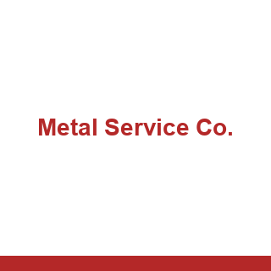
    EMPTY
  TO: METALSVC-STEL
  STATION: Metal Service Co. (Apollo, PA)
  TRACK / SPOT: STAGING · IN
  ASSIGNMENT | Empty car to load
  CAR TYPE | XM
  LOADS | Steel
  SHIPMENT | Metal Service Co. (Apollo, PA) to A Stucki Co
  STUK-STEEL-IN-METAL-SVC
  Form HART-CCWB-001
  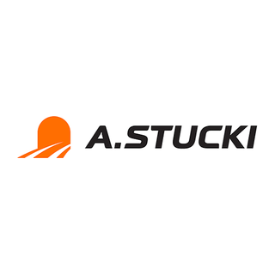
    FREIGHT
  TO: STUK-CRANE
  STATION: A Stucki Co
  Crane Track
  TRACK / SPOT: IN/OUT · 1
  CONTENTS | Steel
  CAR TYPE | XM
  FROM | METALSVC-STEL
  FROM STA. | Metal Service Co. (Apollo, PA)
  STUK-STEEL-IN-METAL-SVC
  Form HART-CCWB-001
  EMPTY
  TO: METALSVC-STEL
  STATION: Metal Service Co. (Apollo, PA)
  TRACK / SPOT: STAGING · IN
  ASSIGNMENT | Empty car to load
  CAR TYPE | XM
  LOADS | Steel
  SHIPMENT | Metal Service Co. (Apollo, PA) to A Stucki Co
  STUK-STEEL-IN-METAL-SVC
  Form HART-CCWB-001
  FREIGHT
  TO: STUK-CRANE
  STATION: A Stucki Co
  Crane Track
  TRACK / SPOT: IN/OUT · 1
  CONTENTS | Steel
  CAR TYPE | XM
  FROM | METALSVC-STEL
  FROM STA. | Metal Service Co. (Apollo, PA)
  STUK-STEEL-IN-METAL-SVC
  Form HART-CCWB-001
  
    EMPTY
  TO: SHEN-COKE-SHIPPING
  STATION: Neville Island
  TRACK / SPOT: OUTBOUND · OUT
  ASSIGNMENT | Empty car to load
  CAR TYPE | HM
  LOADS | Coke
  SHIPMENT | Shenango Coke Works to U.S. Steel Edgar Thomson Works
  COKE-USS-BULK
  Form HART-CCWB-001
  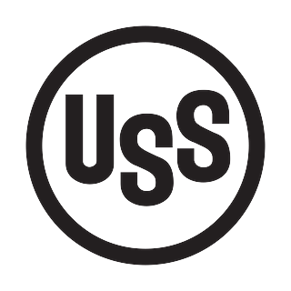
    FREIGHT
  TO: USSTEELE-COKE
  STATION: U.S. Steel Edgar Thomson Works
  TRACK / SPOT: STAGING · OUT
  CONTENTS | Coke
  CAR TYPE | HM
  FROM | SHEN-COKE-SHIPPING
  FROM STA. | Neville Island
  COKE-USS-BULK
  Form HART-CCWB-001
  
    EMPTY
  TO: ARIS-SHIPPING
  STATION: Aristech Plastics
  Shipping Door
  TRACK / SPOT: OUTBOUND · 6
  ASSIGNMENT | Empty car to load
  CAR TYPE | XM
  LOADS | Plastic Resins
  SHIPMENT | Aristech Plastics to Owens-Illinois (Toledo, OH)
  ARIS-RESIN-OUT-OI-TOLEDO
  Form HART-CCWB-001
  
    FREIGHT
  TO: OWENSTOL-PRES
  STATION: Owens-Illinois (Toledo, OH)
  TRACK / SPOT: STAGING · OUT
  CONTENTS | Plastic Resins
  CAR TYPE | XM
  FROM | ARIS-SHIPPING
  FROM STA. | Aristech Plastics  Shipping Door
  ARIS-RESIN-OUT-OI-TOLEDO
  Form HART-CCWB-001
  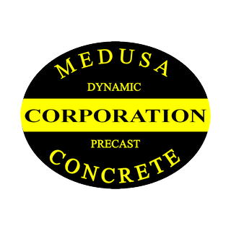
    EMPTY
  TO: MEDUSACE-CEMT
  STATION: Medusa Cement (Charlevoix, MI)
  TRACK / SPOT: STAGING · IN
  ASSIGNMENT | Empty car to load
  CAR TYPE | HC
  LOADS | Cement
  SHIPMENT | Medusa Cement (Charlevoix, MI) to Kosmos Cement
  KOSM-CEMENT-IN-MEDUSA
  Form HART-CCWB-001
  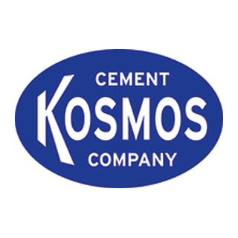
    FREIGHT
  TO: KOSM-CEMENT
  STATION: Kosmos Cement
  Cement Unload
  TRACK / SPOT: INBOUND · 1-3
  CONTENTS | Cement
  CAR TYPE | HC
  FROM | MEDUSACE-CEMT
  FROM STA. | Medusa Cement (Charlevoix, MI)
  KOSM-CEMENT-IN-MEDUSA
  Form HART-CCWB-001
  EMPTY
  TO: MEDUSACE-CEMT
  STATION: Medusa Cement (Charlevoix, MI)
  TRACK / SPOT: STAGING · IN
  ASSIGNMENT | Empty car to load
  CAR TYPE | HC
  LOADS | Cement
  SHIPMENT | Medusa Cement (Charlevoix, MI) to Kosmos Cement
  KOSM-CEMENT-IN-MEDUSA
  Form HART-CCWB-001
  FREIGHT
  TO: KOSM-CEMENT
  STATION: Kosmos Cement
  Cement Unload
  TRACK / SPOT: INBOUND · 1-3
  CONTENTS | Cement
  CAR TYPE | HC
  FROM | MEDUSACE-CEMT
  FROM STA. | Medusa Cement (Charlevoix, MI)
  KOSM-CEMENT-IN-MEDUSA
  Form HART-CCWB-001
  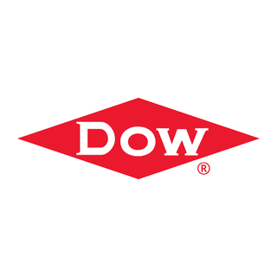
    EMPTY
  TO: DOWCHEM-PHOA
  STATION: Dow Chemical (Midland, MI)
  TRACK / SPOT: STAGING · IN
  ASSIGNMENT | Empty car to load
  CAR TYPE | TA
  LOADS | Process Chemicals
  SHIPMENT | Dow Chemical (Midland, MI) to Aristech Plastics
  ARIS-CHEM-IN-DOW-STY
  Form HART-CCWB-001
  FREIGHT
  TO: ARIS-CHEMICAL
  STATION: Aristech Plastics
  Chemical Unload
  TRACK / SPOT: INBOUND · 4-5
  CONTENTS | Process Chemicals
  CAR TYPE | TA
  FROM | DOWCHEM-PHOA
  FROM STA. | Dow Chemical (Midland, MI)
  ARIS-CHEM-IN-DOW-STY
  Form HART-CCWB-001
  EMPTY
  TO: KOSMOSCE-CEMT
  STATION: Kosmos Cement (Canton, OH)
  TRACK / SPOT: STAGING · IN
  ASSIGNMENT | Empty car to load
  CAR TYPE | HC
  LOADS | Cement
  SHIPMENT | Kosmos Cement (Canton, OH) to Kosmos Cement
  KOSM-CEMENT-IN-KOSMOS
  Form HART-CCWB-001
  FREIGHT
  TO: KOSM-CEMENT
  STATION: Kosmos Cement
  Cement Unload
  TRACK / SPOT: INBOUND · 1-3
  CONTENTS | Cement
  CAR TYPE | HC
  FROM | KOSMOSCE-CEMT
  FROM STA. | Kosmos Cement (Canton, OH)
  KOSM-CEMENT-IN-KOSMOS
  Form HART-CCWB-001
  EMPTY
  TO: STUK-TEAM
  STATION: A Stucki Co
  Team Track
  TRACK / SPOT: IN/OUT · 2
  ASSIGNMENT | Empty car to load
  CAR TYPE | GA
  LOADS | General Freight
  SHIPMENT | A Stucki Co to Ryerson Steel Service
  STUK-COILS-OUT-RYERSON
  Form HART-CCWB-001
  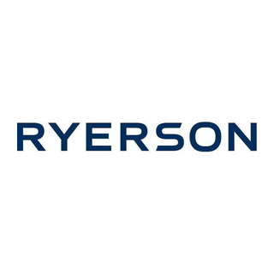
    FREIGHT
  TO: RYERSON-STG-OUT
  STATION: Ryerson Steel Service
  TRACK / SPOT: STAGING · OUT
  CONTENTS | General Freight
  CAR TYPE | GA
  FROM | STUK-TEAM
  FROM STA. | A Stucki Co  Team Track
  STUK-COILS-OUT-RYERSON
  Form HART-CCWB-001

