  
    EMPTY
  TO: EXXONCH-MMA
  STATION: Exxon Chemical (Bayonne, NJ)
  TRACK / SPOT: STAGING · IN
  ASSIGNMENT | Empty car to load
  CAR TYPE | TA
  LOADS | Process Chemicals
  SHIPMENT | Exxon Chemical (Bayonne, NJ) to Aristech Plastics
  ARIS-CHEM-IN-EXXON
  Form HART-CCWB-001
  
    FREIGHT
  TO: ARIS-CHEMICAL
  STATION: Aristech Plastics
  Chemical Unload
  TRACK / SPOT: INBOUND · 4-5
  CONTENTS | Process Chemicals
  CAR TYPE | TA
  FROM | EXXONCH-MMA
  FROM STA. | Exxon Chemical (Bayonne, NJ)
  ARIS-CHEM-IN-EXXON
  Form HART-CCWB-001
  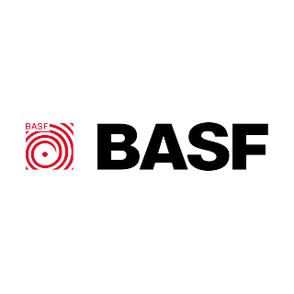
    EMPTY
  TO: BASF-PLST
  STATION: BASF (Wyandotte, MI)
  TRACK / SPOT: STAGING · IN
  ASSIGNMENT | Empty car to load
  CAR TYPE | HC
  LOADS | Plastic Pellets
  SHIPMENT | BASF (Wyandotte, MI) to Aristech Plastics
  ARIS-PELLETS-IN-BASF
  Form HART-CCWB-001
  FREIGHT
  TO: ARIS-PELLETS
  STATION: Aristech Plastics
  Pellet Unload
  TRACK / SPOT: INBOUND · 1-3
  CONTENTS | Plastic Pellets
  CAR TYPE | HC
  FROM | BASF-PLST
  FROM STA. | BASF (Wyandotte, MI)
  ARIS-PELLETS-IN-BASF
  Form HART-CCWB-001
  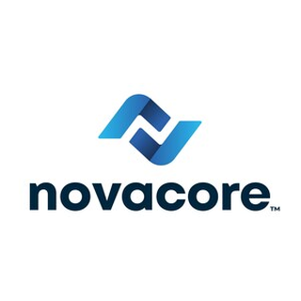
    EMPTY
  TO: NOVACOR-PLST
  STATION: Novacor (Indian Orchard, MA)
  TRACK / SPOT: STAGING · IN
  ASSIGNMENT | Empty car to load
  CAR TYPE | HC
  LOADS | Plastic Pellets
  SHIPMENT | Novacor (Indian Orchard, MA) to Aristech Plastics
  ARIS-PELLETS-IN-NOVACOR
  Form HART-CCWB-001
  FREIGHT
  TO: ARIS-PELLETS
  STATION: Aristech Plastics
  Pellet Unload
  TRACK / SPOT: INBOUND · 1-3
  CONTENTS | Plastic Pellets
  CAR TYPE | HC
  FROM | NOVACOR-PLST
  FROM STA. | Novacor (Indian Orchard, MA)
  ARIS-PELLETS-IN-NOVACOR
  Form HART-CCWB-001
  EMPTY
  TO: ARIS-SHIPPING
  STATION: Aristech Plastics
  Shipping Door
  TRACK / SPOT: OUTBOUND · 6
  ASSIGNMENT | Empty car to load
  CAR TYPE | XM
  LOADS | Plastic Resins
  SHIPMENT | Aristech Plastics to Bemis Company (Flemington, NJ)
  ARIS-RESIN-OUT-BEMIS
  Form HART-CCWB-001
  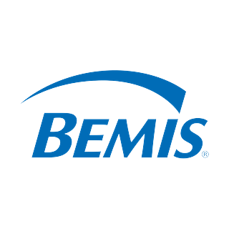
    FREIGHT
  TO: BEMIS-PRES
  STATION: Bemis Company (Flemington, NJ)
  TRACK / SPOT: STAGING · OUT
  CONTENTS | Plastic Resins
  CAR TYPE | XM
  FROM | ARIS-SHIPPING
  FROM STA. | Aristech Plastics  Shipping Door
  ARIS-RESIN-OUT-BEMIS
  Form HART-CCWB-001
  EMPTY
  TO: ARIS-SHIPPING
  STATION: Aristech Plastics
  Shipping Door
  TRACK / SPOT: OUTBOUND · 6
  ASSIGNMENT | Empty car to load
  CAR TYPE | XM
  LOADS | Plastic Resins
  SHIPMENT | Aristech Plastics to Owens-Illinois (Ottawa, IL)
  ARIS-RESIN-OUT-OI-OTTAWA
  Form HART-CCWB-001
  
    FREIGHT
  TO: OWENSOTT-PRES
  STATION: Owens-Illinois (Ottawa, IL)
  TRACK / SPOT: STAGING · OUT
  CONTENTS | Plastic Resins
  CAR TYPE | XM
  FROM | ARIS-SHIPPING
  FROM STA. | Aristech Plastics  Shipping Door
  ARIS-RESIN-OUT-OI-OTTAWA
  Form HART-CCWB-001
  
    EMPTY
  TO: CALG-CARBON
  STATION: Calgon Carbon
  Carbon Load
  TRACK / SPOT: OUTBOUND · 3
  ASSIGNMENT | Empty car to load
  CAR TYPE | HC
  LOADS | Activated Carbon
  SHIPMENT | Calgon Carbon to Calgon Corp (Columbus, OH)
  CALG-CARBON-OUT-CORP
  Form HART-CCWB-001
  FREIGHT
  TO: CALGON-ACAR
  STATION: Calgon Corp (Columbus, OH)
  TRACK / SPOT: STAGING · OUT
  CONTENTS | Activated Carbon
  CAR TYPE | HC
  FROM | CALG-CARBON
  FROM STA. | Calgon Carbon  Carbon Load
  CALG-CARBON-OUT-CORP
  Form HART-CCWB-001
  EMPTY
  TO: CALG-CARBON
  STATION: Calgon Carbon
  Carbon Load
  TRACK / SPOT: OUTBOUND · 3
  ASSIGNMENT | Empty car to load
  CAR TYPE | HC
  LOADS | Activated Carbon
  SHIPMENT | Calgon Carbon to Univar (Salem, MA)
  CALG-CARBON-OUT-UNIVAR
  Form HART-CCWB-001
  
    FREIGHT
  TO: UNIVAR-ACAR
  STATION: Univar (Salem, MA)
  TRACK / SPOT: STAGING · OUT
  CONTENTS | Activated Carbon
  CAR TYPE | HC
  FROM | CALG-CARBON
  FROM STA. | Calgon Carbon  Carbon Load
  CALG-CARBON-OUT-UNIVAR
  Form HART-CCWB-001
  
    EMPTY
  TO: HOUGHTON-CAUS
  STATION: Houghton Chemical (Allston, MA)
  TRACK / SPOT: STAGING · IN
  ASSIGNMENT | Empty car to load
  CAR TYPE | TA
  LOADS | Process Chemicals
  SHIPMENT | Houghton Chemical (Allston, MA) to Calgon Carbon
  CALG-CHEM-IN-HOUGHTON
  Form HART-CCWB-001
  FREIGHT
  TO: CALG-CHEMICAL
  STATION: Calgon Carbon
  Chemical Unload
  TRACK / SPOT: INBOUND · 4
  CONTENTS | Process Chemicals
  CAR TYPE | TA
  FROM | HOUGHTON-CAUS
  FROM STA. | Houghton Chemical (Allston, MA)
  CALG-CHEM-IN-HOUGHTON
  Form HART-CCWB-001
  
    EMPTY
  TO: SHEN-COKE-SHIPPING
  STATION: Neville Island
  TRACK / SPOT: OUTBOUND · OUT
  ASSIGNMENT | Empty car to load
  CAR TYPE | HM
  LOADS | Coke
  SHIPMENT | Shenango Coke Works to LTV Steel Cleveland Works (Cleveland, OH)
  COKE-CLEV-BULK
  Form HART-CCWB-001
  
    FREIGHT
  TO: CLEVWORK-COKE
  STATION: LTV Steel Cleveland Works (Cleveland, OH)
  TRACK / SPOT: STAGING · OUT
  CONTENTS | Coke
  CAR TYPE | HM
  FROM | SHEN-COKE-SHIPPING
  FROM STA. | Neville Island
  COKE-CLEV-BULK
  Form HART-CCWB-001
  EMPTY
  TO: SOUTH-SCALE
  STATION: South Yard
  TRACK / SPOT: West Lead · Scale
  ASSIGNMENT | Empty car to load
  CAR TYPE | HM
  LOADS | Coke
  SHIPMENT | South Yard Scale to Shenango Coke Works
  COKE-RELOAD-SHEN
  Form HART-CCWB-001
  FREIGHT
  TO: SHEN-COKE-SHIPPING
  STATION: Neville Island
  TRACK / SPOT: OUTBOUND · OUT
  CONTENTS | Coke
  CAR TYPE | HM
  FROM | SOUTH-SCALE
  FROM STA. | South Yard
  COKE-RELOAD-SHEN
  Form HART-CCWB-001
  EMPTY
  TO: SHEN-COKE-SHIPPING
  STATION: Neville Island
  TRACK / SPOT: OUTBOUND · OUT
  ASSIGNMENT | Empty car to load
  CAR TYPE | HM
  LOADS | Coke
  SHIPMENT | Shenango Coke Works to U.S. Steel Edgar Thomson Works
  COKE-USS-BULK
  Form HART-CCWB-001
  
    FREIGHT
  TO: USSTEELE-COKE
  STATION: U.S. Steel Edgar Thomson Works
  TRACK / SPOT: STAGING · OUT
  CONTENTS | Coke
  CAR TYPE | HM
  FROM | SHEN-COKE-SHIPPING
  FROM STA. | Neville Island
  COKE-USS-BULK
  Form HART-CCWB-001
  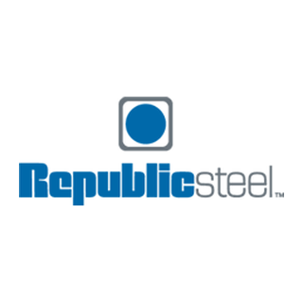
    EMPTY
  TO: REPUBLIC-COIL
  STATION: Republic Steel (Cleveland, OH)
  TRACK / SPOT: STAGING · IN
  ASSIGNMENT | Empty car to load
  CAR TYPE | XM
  LOADS | General Freight
  SHIPMENT | Republic Steel (Cleveland, OH) to John Deere (Moline, IL)
  IX-COILS-REP-DEERE
  Form HART-CCWB-001
  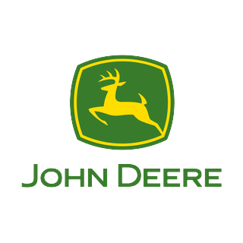
    FREIGHT
  TO: JOHNDEER-COIL
  STATION: John Deere (Moline, IL)
  TRACK / SPOT: STAGING · OUT
  CONTENTS | General Freight
  CAR TYPE | XM
  FROM | REPUBLIC-COIL
  FROM STA. | Republic Steel (Cleveland, OH)
  IX-COILS-REP-DEERE
  Form HART-CCWB-001
  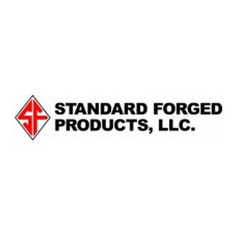
    EMPTY
  TO: STDFORGE-FORG
  STATION: Standard Forged Products (McKees Rocks-PA)
  TRACK / SPOT: STAGING · IN
  ASSIGNMENT | Empty car to load
  CAR TYPE | FM
  LOADS | Forged Components
  SHIPMENT | Standard Forged Products (McKees Rocks, PA) to Sharon Steel (Farrell, PA)
  IX-FORGINGS-SFP-SHARON
  Form HART-CCWB-001
  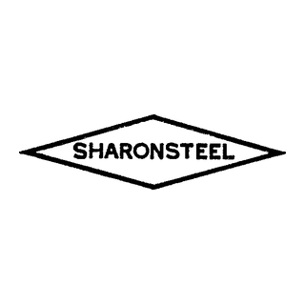
    FREIGHT
  TO: SHARON-FORG
  STATION: Sharon Steel (Farrell, PA)
  TRACK / SPOT: STAGING · OUT
  CONTENTS | Forged Components
  CAR TYPE | FM
  FROM | STDFORGE-FORG
  FROM STA. | Standard Forged Products (McKees Rocks-PA)
  IX-FORGINGS-SFP-SHARON
  Form HART-CCWB-001
  
    EMPTY
  TO: GE-LAMP
  STATION: GE (Bridgeville, PA)
  TRACK / SPOT: STAGING · IN
  ASSIGNMENT | Empty car to load
  CAR TYPE | XM
  LOADS | Fluorescent Lamps
  SHIPMENT | GE (Bridgeville, PA) to Penelec (Erie, PA)
  IX-LAMPS-GE-PENELEC
  Form HART-CCWB-001
  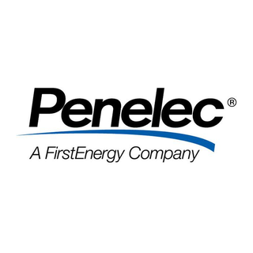
    FREIGHT
  TO: PENELEC-LAMP
  STATION: Penelec (Erie, PA)
  TRACK / SPOT: STAGING · OUT
  CONTENTS | Fluorescent Lamps
  CAR TYPE | XM
  FROM | GE-LAMP
  FROM STA. | GE (Bridgeville, PA)
  IX-LAMPS-GE-PENELEC
  Form HART-CCWB-001
  
    EMPTY
  TO: MAPCO-LPG
  STATION: Mapco LP (Memphis, TN)
  TRACK / SPOT: STAGING · IN
  ASSIGNMENT | Empty car to load
  CAR TYPE | TA
  LOADS | LPG
  SHIPMENT | Mapco LP (Memphis, TN) to Suburban Propane (Buffalo, NY)
  IX-LPG-MAPCO-SUBURBAN
  Form HART-CCWB-001
  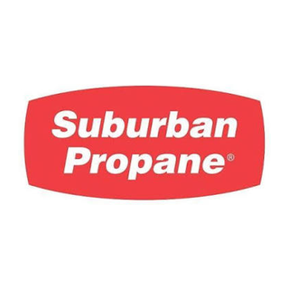
    FREIGHT
  TO: SUBURBAN-LPG
  STATION: Suburban Propane (Buffalo, NY)
  TRACK / SPOT: STAGING · OUT
  CONTENTS | LPG
  CAR TYPE | TA
  FROM | MAPCO-LPG
  FROM STA. | Mapco LP (Memphis, TN)
  IX-LPG-MAPCO-SUBURBAN
  Form HART-CCWB-001
  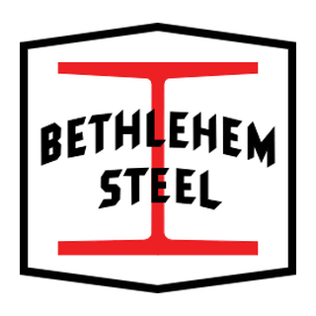
    EMPTY
  TO: BETHLEHM-PLAT
  STATION: Bethlehem Steel (Bethlehem, PA)
  TRACK / SPOT: STAGING · IN
  ASSIGNMENT | Empty car to load
  CAR TYPE | FM
  LOADS | Steel Plate
  SHIPMENT | Bethlehem Steel (Bethlehem, PA) to Ryerson Steel Service (Pittsburgh, PA)
  IX-PLATE-BETHLEHEM-RYERSON
  Form HART-CCWB-001
  
    FREIGHT
  TO: RYERSON-STG-MR
  STATION: Ryerson Steel Service
  TRACK / SPOT: STAGING · OUT
  CONTENTS | Steel Plate
  CAR TYPE | FM
  FROM | BETHLEHM-PLAT
  FROM STA. | Bethlehem Steel (Bethlehem, PA)
  IX-PLATE-BETHLEHEM-RYERSON
  Form HART-CCWB-001
  
    EMPTY
  TO: UNIVSS-SBAR
  STATION: Universal Stainless & Alloy (Bridgeville, PA)
  TRACK / SPOT: STAGING · IN
  ASSIGNMENT | Empty car to load
  CAR TYPE | FM
  LOADS | Stainless Bar
  SHIPMENT | Universal Stainless & Alloy (Bridgeville, PA) to Carpenter Steel (Reading, PA)
  IX-STAINLESS-USA-CARPENTER
  Form HART-CCWB-001
  
    FREIGHT
  TO: CARPENTR-SBAR
  STATION: Carpenter Steel (Reading, PA)
  TRACK / SPOT: STAGING · OUT
  CONTENTS | Stainless Bar
  CAR TYPE | FM
  FROM | UNIVSS-SBAR
  FROM STA. | Universal Stainless & Alloy (Bridgeville, PA)
  IX-STAINLESS-USA-CARPENTER
  Form HART-CCWB-001
  EMPTY
  TO: UNIVS-SBAR-MR
  STATION: Universal Stainless & Alloy (Bridgeville, PA)
  TRACK / SPOT: STAGING · IN
  ASSIGNMENT | Empty car to load
  CAR TYPE | FM
  LOADS | Stainless Bar
  SHIPMENT | Universal Stainless & Alloy (Bridgeville, PA) to Ryerson Steel (Chicago, IL)
  IX-STAINLESS-USA-RYERSON
  Form HART-CCWB-001
  FREIGHT
  TO: RYERSON-SBAR
  STATION: Ryerson Steel (Chicago, IL)
  TRACK / SPOT: STAGING · OUT
  CONTENTS | Stainless Bar
  CAR TYPE | FM
  FROM | UNIVS-SBAR-MR
  FROM STA. | Universal Stainless & Alloy (Bridgeville, PA)
  IX-STAINLESS-USA-RYERSON
  Form HART-CCWB-001
  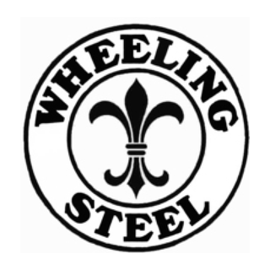
    EMPTY
  TO: WHEELING-TINP
  STATION: Wheeling-Pittsburgh Steel (Wheeling, WV)
  TRACK / SPOT: STAGING · IN
  ASSIGNMENT | Empty car to load
  CAR TYPE | XM
  LOADS | General Freight
  SHIPMENT | Wheeling-Pittsburgh Steel (Wheeling, WV) to Heinz (Pittsburgh, PA)
  IX-TINPLATE-WHEELING-HEINZ
  Form HART-CCWB-001
  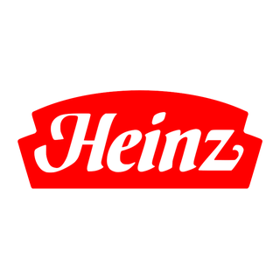
    FREIGHT
  TO: HEINZ-TINP
  STATION: Heinz (Pittsburgh, PA)
  TRACK / SPOT: STAGING · OUT
  CONTENTS | General Freight
  CAR TYPE | XM
  FROM | WHEELING-TINP
  FROM STA. | Wheeling-Pittsburgh Steel (Wheeling, WV)
  IX-TINPLATE-WHEELING-HEINZ
  Form HART-CCWB-001
  EMPTY
  TO: GE-TUBE
  STATION: GE (Bridgeville, PA)
  TRACK / SPOT: STAGING · IN
  ASSIGNMENT | Empty car to load
  CAR TYPE | XM
  LOADS | Fluorescent Tubes
  SHIPMENT | GE (Bridgeville, PA) to Graybar Electric (St. Louis, MO)
  IX-TUBES-GE-GRAYBAR
  Form HART-CCWB-001
  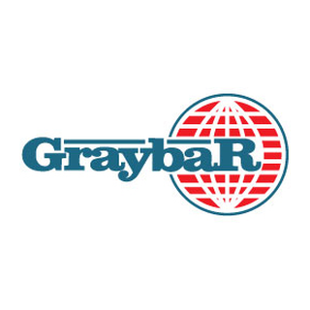
    FREIGHT
  TO: GRAYBAR-TUBE
  STATION: Graybar Electric (St. Louis, MO)
  TRACK / SPOT: STAGING · OUT
  CONTENTS | Fluorescent Tubes
  CAR TYPE | XM
  FROM | GE-TUBE
  FROM STA. | GE (Bridgeville, PA)
  IX-TUBES-GE-GRAYBAR
  Form HART-CCWB-001
  
    EMPTY
  TO: USAGG-AGGR
  STATION: US Aggregates (Indianapolis, IN)
  TRACK / SPOT: STAGING · IN
  ASSIGNMENT | Empty car to load
  CAR TYPE | HC
  LOADS | Aggregate
  SHIPMENT | US Aggregates (Indianapolis, IN) to Kosmos Cement
  KOSM-AGG-IN-US-AGG
  Form HART-CCWB-001
  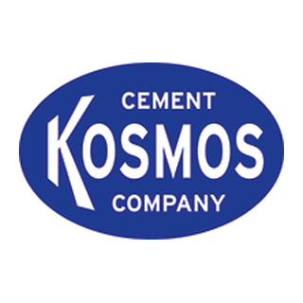
    FREIGHT
  TO: KOSM-AGGREGATE
  STATION: Kosmos Cement
  Aggregate Unload
  TRACK / SPOT: INBOUND · 4
  CONTENTS | Aggregate
  CAR TYPE | HC
  FROM | USAGG-AGGR
  FROM STA. | US Aggregates (Indianapolis, IN)
  KOSM-AGG-IN-US-AGG
  Form HART-CCWB-001
  EMPTY
  TO: RYERSON-COIL
  STATION: Ryerson Steel Service
  TRACK / SPOT: STAGING · IN
  ASSIGNMENT | Empty car to load
  CAR TYPE | XM
  LOADS | General Freight
  SHIPMENT | Ryerson Steel Service to A Stucki Co
  STUK-COILS-IN-RYERSON
  Form HART-CCWB-001
  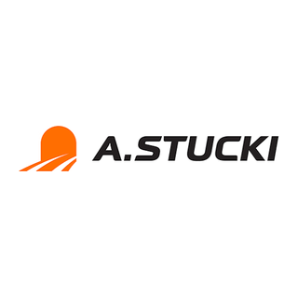
    FREIGHT
  TO: STUK-TEAM
  STATION: A Stucki Co
  Team Track
  TRACK / SPOT: IN/OUT · 2
  CONTENTS | General Freight
  CAR TYPE | XM
  FROM | RYERSON-COIL
  FROM STA. | Ryerson Steel Service
  STUK-COILS-IN-RYERSON
  Form HART-CCWB-001
  EMPTY
  TO: STUK-TEAM
  STATION: A Stucki Co
  Team Track
  TRACK / SPOT: IN/OUT · 2
  ASSIGNMENT | Empty car to load
  CAR TYPE | XM
  LOADS | General Freight
  SHIPMENT | A Stucki Co to Metal Service Co. (Apollo, PA)
  STUK-PARTS-OUT-METAL-SVC
  Form HART-CCWB-001
  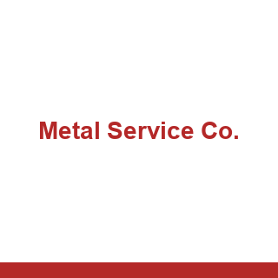
    FREIGHT
  TO: METALSVC-MACH
  STATION: Metal Service Co. (Apollo, PA)
  TRACK / SPOT: STAGING · OUT
  CONTENTS | General Freight
  CAR TYPE | XM
  FROM | STUK-TEAM
  FROM STA. | A Stucki Co  Team Track
  STUK-PARTS-OUT-METAL-SVC
  Form HART-CCWB-001
  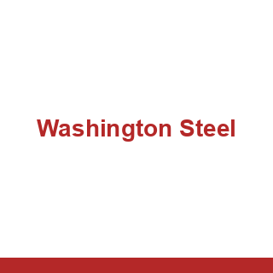
    EMPTY
  TO: WASHSTL-PLAT
  STATION: Washington Steel (Washington, PA)
  TRACK / SPOT: STAGING · IN
  ASSIGNMENT | Empty car to load
  CAR TYPE | FM
  LOADS | Steel Plate
  SHIPMENT | Washington Steel (Washington, PA) to A Stucki Co
  STUK-PLATE-IN-WASH-STL
  Form HART-CCWB-001
  FREIGHT
  TO: STUK-TEAM
  STATION: A Stucki Co
  Team Track
  TRACK / SPOT: IN/OUT · 2
  CONTENTS | Steel Plate
  CAR TYPE | FM
  FROM | WASHSTL-PLAT
  FROM STA. | Washington Steel (Washington, PA)
  STUK-PLATE-IN-WASH-STL
  Form HART-CCWB-001
  EMPTY
  TO: STUK-TEAM
  STATION: A Stucki Co
  Team Track
  TRACK / SPOT: IN/OUT · 2
  ASSIGNMENT | Empty car to load
  CAR TYPE | FM
  LOADS | General Freight
  SHIPMENT | A Stucki Co to Pittsburgh Forge (McKees Rocks, PA)
  STUK-SPRINGS-OUT-PITTS-FORGE
  Form HART-CCWB-001
  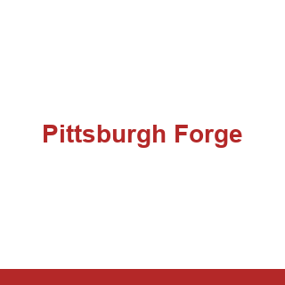
    FREIGHT
  TO: PITTSFOR-SPRG
  STATION: Pittsburgh Forge (McKees Rocks, PA)
  TRACK / SPOT: STAGING · OUT
  CONTENTS | General Freight
  CAR TYPE | FM
  FROM | STUK-TEAM
  FROM STA. | A Stucki Co  Team Track
  STUK-SPRINGS-OUT-PITTS-FORGE
  Form HART-CCWB-001
  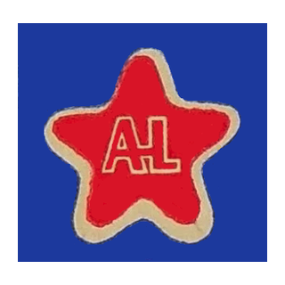
    EMPTY
  TO: ALLEGHEN-STEL
  STATION: Allegheny Ludlum (Brackenridge, PA)
  TRACK / SPOT: STAGING · IN
  ASSIGNMENT | Empty car to load
  CAR TYPE | FM
  LOADS | Steel
  SHIPMENT | Allegheny Ludlum (Brackenridge, PA) to A Stucki Co
  STUK-STEEL-IN-ALLEGHENY
  Form HART-CCWB-001
  FREIGHT
  TO: STUK-CRANE
  STATION: A Stucki Co
  Crane Track
  TRACK / SPOT: IN/OUT · 1
  CONTENTS | Steel
  CAR TYPE | FM
  FROM | ALLEGHEN-STEL
  FROM STA. | Allegheny Ludlum (Brackenridge, PA)
  STUK-STEEL-IN-ALLEGHENY
  Form HART-CCWB-001
  EMPTY
  TO: METALSVC-STEL
  STATION: Metal Service Co. (Apollo, PA)
  TRACK / SPOT: STAGING · IN
  ASSIGNMENT | Empty car to load
  CAR TYPE | XM
  LOADS | Steel
  SHIPMENT | Metal Service Co. (Apollo, PA) to A Stucki Co
  STUK-STEEL-IN-METAL-SVC
  Form HART-CCWB-001
  FREIGHT
  TO: STUK-CRANE
  STATION: A Stucki Co
  Crane Track
  TRACK / SPOT: IN/OUT · 1
  CONTENTS | Steel
  CAR TYPE | XM
  FROM | METALSVC-STEL
  FROM STA. | Metal Service Co. (Apollo, PA)
  STUK-STEEL-IN-METAL-SVC
  Form HART-CCWB-001

