  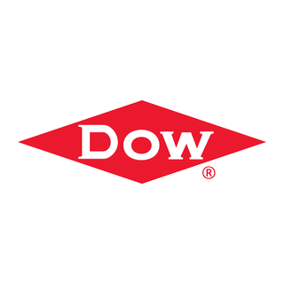
    EMPTY
  TO: DOWCHEM-IGAS
  STATION: Dow Chemical (Midland, MI)
  TRACK / SPOT: STAGING · IN
  ASSIGNMENT | Empty car to load
  CAR TYPE | TA
  LOADS | Process Chemicals
  SHIPMENT | Dow Chemical (Midland, MI) to Knouse Foods (Orrtanna, PA)
  IX-CHEM-DOW-KNOUSE
  Form HART-CCWB-001
  
    FREIGHT
  TO: KNOUSE-IGAS-MR
  STATION: Knouse Foods (Orrtanna, PA)
  TRACK / SPOT: STAGING · OUT
  CONTENTS | Process Chemicals
  CAR TYPE | TA
  FROM | DOWCHEM-IGAS
  FROM STA. | Dow Chemical (Midland, MI)
  IX-CHEM-DOW-KNOUSE
  Form HART-CCWB-001
  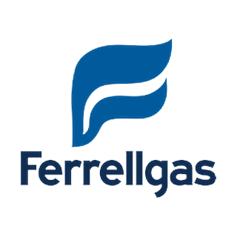
    EMPTY
  TO: FERRELLGA-LPG
  STATION: Ferrellgas Co (Taneytown, MD)
  TRACK / SPOT: STAGING · IN
  ASSIGNMENT | Empty car to load
  CAR TYPE | TA
  LOADS | LPG
  SHIPMENT | Ferrellgas Co (Taneytown, MD) to Ferrel Gas
  FERR-LPG-IN-TANEYTOWN
  Form HART-CCWB-001
  FREIGHT
  TO: FERR-LPG
  STATION: Ferrel Gas
  LPG Unload
  TRACK / SPOT: INBOUND · 1-2
  CONTENTS | LPG
  CAR TYPE | TA
  FROM | FERRELLGA-LPG
  FROM STA. | Ferrellgas Co (Taneytown, MD)
  FERR-LPG-IN-TANEYTOWN
  Form HART-CCWB-001
  
    FREIGHT
  TO: SHEN-COKE-SHIPPING
  STATION: Neville Island
  TRACK / SPOT: OUTBOUND · OUT
  CONTENTS | Coke
  CAR TYPE | HM
  FROM | SOUTH-SCALE
  FROM STA. | South Yard
  COKE-RELOAD-SHEN
  Form HART-CCWB-001
  FREIGHT
  TO: SHEN-COKE-SHIPPING
  STATION: Neville Island
  TRACK / SPOT: OUTBOUND · OUT
  CONTENTS | Coke
  CAR TYPE | HM
  FROM | SOUTH-SCALE
  FROM STA. | South Yard
  COKE-RELOAD-SHEN
  Form HART-CCWB-001
  EMPTY
  TO: SHEN-COKE-SHIPPING
  STATION: Neville Island
  TRACK / SPOT: OUTBOUND · OUT
  ASSIGNMENT | Empty car to load
  CAR TYPE | HM
  LOADS | Coke
  SHIPMENT | Shenango Coke Works to Cleveland Works  Cleveland  OH
  COKE-CLEV-BULK
  Form HART-CCWB-001
  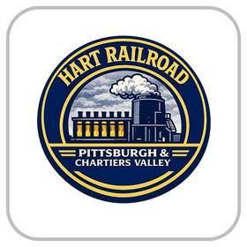
    FREIGHT
  TO: CLEVWORK-COKE
  STATION: USS Cleveland Works
  Cleveland
  OH
  TRACK / SPOT: STAGING · OUT
  CONTENTS | Coke
  CAR TYPE | HM
  FROM | SHEN-COKE-SHIPPING
  FROM STA. | Neville Island
  COKE-CLEV-BULK
  Form HART-CCWB-001
  EMPTY
  TO: SCULLY-YARD
  STATION: Scully Yard
  TRACK / SPOT: —
  ASSIGNMENT | Empty car to load
  CAR TYPE | TA
  LOADS | —
  SHIPMENT | Empty return from Ferrel Gas (FERR-LPG)
  004-E03
  Form HART-CCWB-001

