
  FLAT CAR

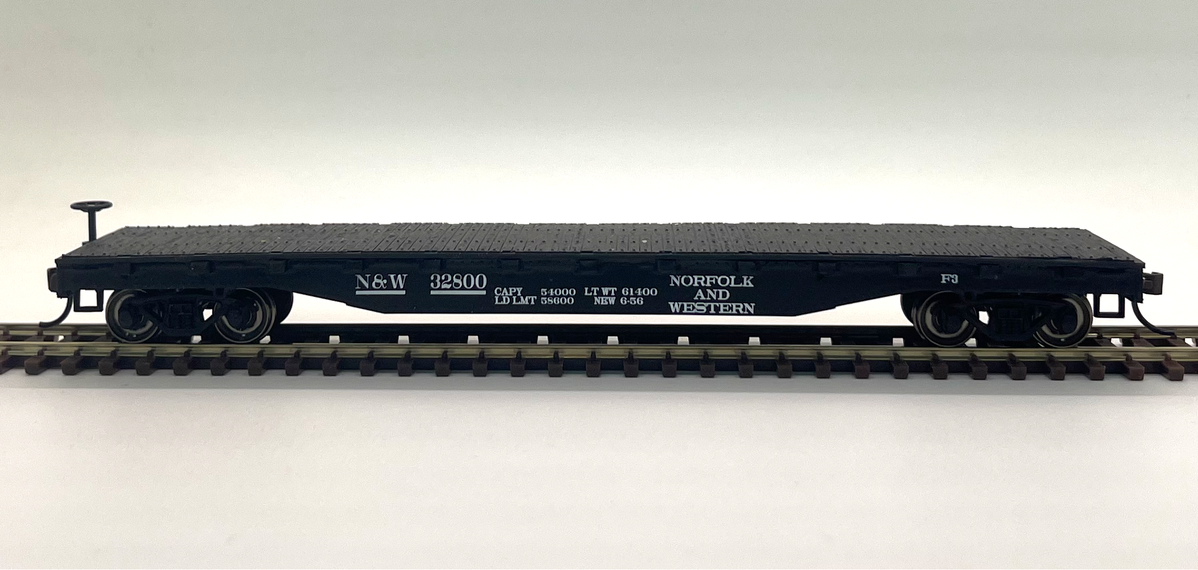

 | ROAD NAME: | N&W
 | ROAD NUMBER: | 32800
 | DESCRIPTION: | Black Flatcar · 52'

Form HART-CC-001 Rev A

