HART Railroad · Crew Instructions

No assigned  engine photo | CK1  Coke Transfer  Engine: Unassigned
Shenango Coke Works pickup and delivery, scale calibration, weigh, and sort. Power is assigned by the Yardmaster.
CREW STEPS
1. Report to the Yardmaster for the assigned engine before going to work.
2. Calibrate the track scale with the scale test car (see EQ-01 Scale Operating Instructions).
3. Handle Shenango Coke Works pickup and delivery as directed by the Yardmaster.
4. Weigh the coke pull on the South Yard west-lead scale at a steady stretch; do not apply brakes under weigh.
5. Sort and set out weighed cars in South Yard for classification.
DESTINATION COLORS
 | Interchange |  | Local Industries
 | Demmler / McKeesport |  | Aristech Plastics
 | Scully / McKees Rocks |  | A. Stucki Co.
 |  |  | Calgon Carbon
 |  |  | Ferrellgas
 |  |  | Kosmos Cement
 |  |  | Shenango Coke Works

STATION MAP  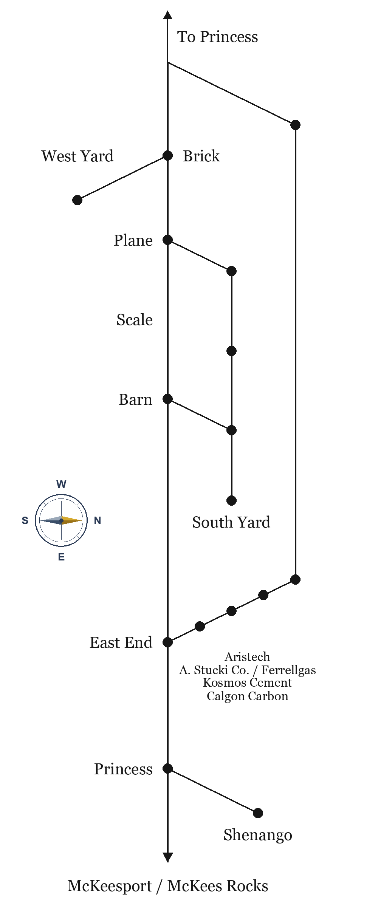 | ROUTE 23 TIMETABLE  Neville Queen · Emp. TT No. 23  Eastbound Barn→McKees Rocks. Westbound McKees Rocks→Barn. Station time.
  EAST | STATION | WEST
  9:00 | Barn | 5:00 PM
  9:06 | Scale | 4:54 PM
  9:12 | Brick | 4:48 PM
  9:18 | East End | 4:42 PM
  9:24 | Aristech | 4:36 PM
  9:30 | Calgon Carbon | 4:30 PM
  9:36 | Kosmos Cement | 4:24 PM
  9:42 | Ferrel Gas | 4:18 PM
  9:48 | A. Stucki Co. | 4:12 PM
  9:54 | Princess | 4:06 PM
  10:00 | McKees Rocks | 4:00 PM

