HART Railroad · Crew Instructions

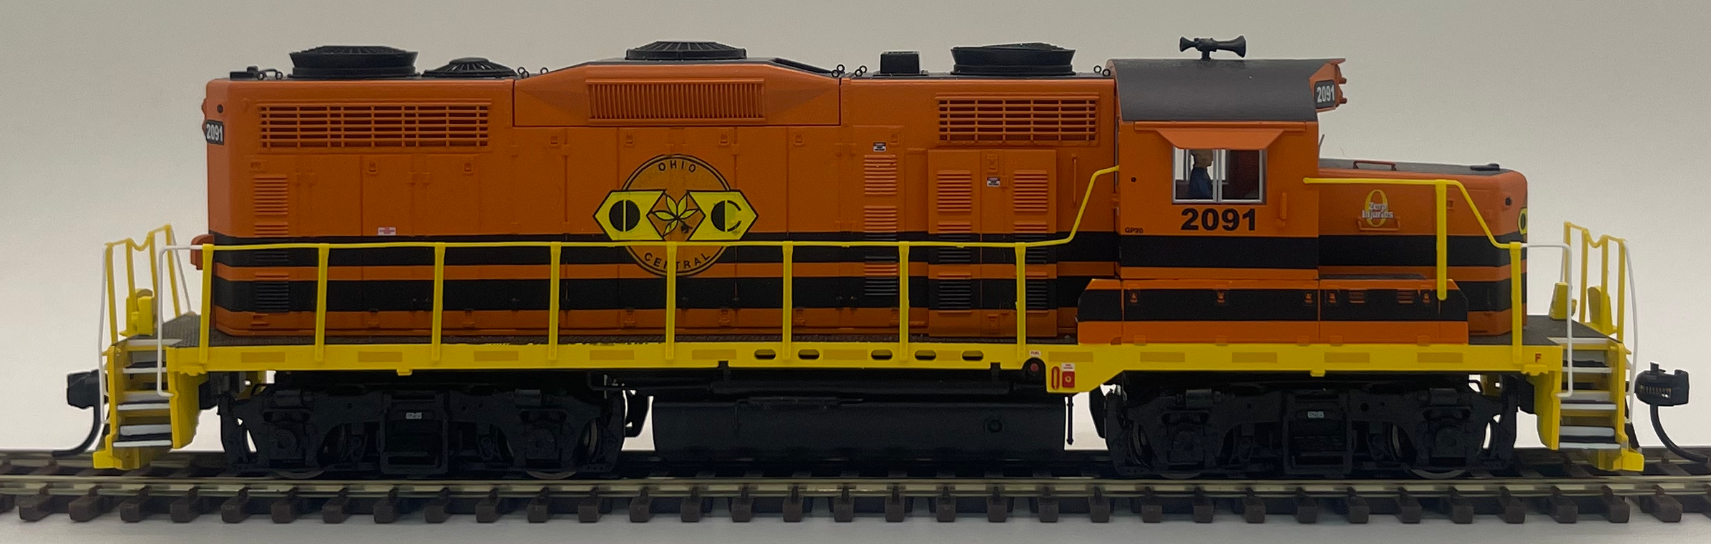 | NVL  Neville Island Turn  Engine: POHC 2091 · EMD GP20
Neville Island turn from Scully Yard. Interchange at South Yard, work Neville Island industries, then return to McKees Rocks / Scully with the outbound block.
CREW STEPS
1. Assign on the train at Scully Yard with the inbound Scully block.
2. Obtain dispatcher clearance and run to South Yard.
3. Interchange with the Yardmaster. Lift the local industry cut.
4. Work Neville Island industries: Aristech, A. Stucki, Calgon Carbon, Ferrellgas, Kosmos Cement, and Shenango Coke Works.
5. Return to South Yard for final interchange. Lift the Scully / McKees Rocks outbound block.
6. With dispatcher clearance, depart for McKees Rocks / Scully Yard and secure.
DESTINATION COLORS
 | Interchange |  | Local Industries
 | Demmler / McKeesport |  | Aristech Plastics
 | Scully / McKees Rocks |  | A. Stucki Co.
 |  |  | Calgon Carbon
 |  |  | Ferrellgas
 |  |  | Kosmos Cement
 |  |  | Shenango Coke Works

STATION MAP  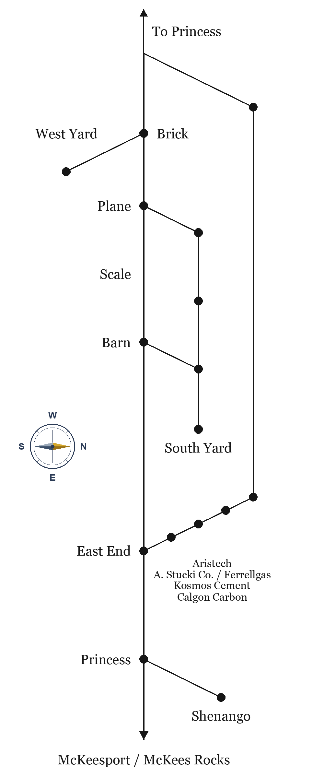 | ROUTE 23 TIMETABLE  Neville Queen · Emp. TT No. 23  Eastbound Barn→McKees Rocks. Westbound McKees Rocks→Barn. Station time.
  EAST | STATION | WEST
  9:00 | Barn | 5:00 PM
  9:06 | Scale | 4:54 PM
  9:12 | Brick | 4:48 PM
  9:18 | East End | 4:42 PM
  9:24 | Aristech | 4:36 PM
  9:30 | Calgon Carbon | 4:30 PM
  9:36 | Kosmos Cement | 4:24 PM
  9:42 | Ferrel Gas | 4:18 PM
  9:48 | A. Stucki Co. | 4:12 PM
  9:54 | Princess | 4:06 PM
  10:00 | McKees Rocks | 4:00 PM

