HART Railroad · Dispatcher Train List

1. TRAIN LINEUP
# | Train | Dispatcher action
1 | Route 23 AM | Operate per timetable; hold conflicting work until the train clears.
2 | D749 | Demmler → South Yard to open; interchange; release outbounds to McKeesport.
3 | OCS-1 | When scheduled — highest priority; clear the route.
4 | NVL | Scully → South Yard; interchange; service local industries; return with outbounds; return to McKees Rocks.
5 | CK1 | Shenango pickup and delivery; calibrate scale, weigh coke pull, and sort.
6 | D749 Return | Authorize return; terminate in West Yard.
7 | Route 23 PM | Operate per timetable; hold conflicting work until the train clears.
2. PRIORITY ORDER
OCS-1 → Route 23 → D749 → NVL → CK1 → Yard
3. DESTINATION COLORS
 | Interchange |  | Local Industries
 | Demmler / McKeesport |  | Aristech Plastics
 | Scully / McKees Rocks |  | A. Stucki Co.
 |  |  | Calgon Carbon
 |  |  | Ferrellgas
 |  |  | Kosmos Cement
 |  |  | Shenango Coke Works

STATION MAP  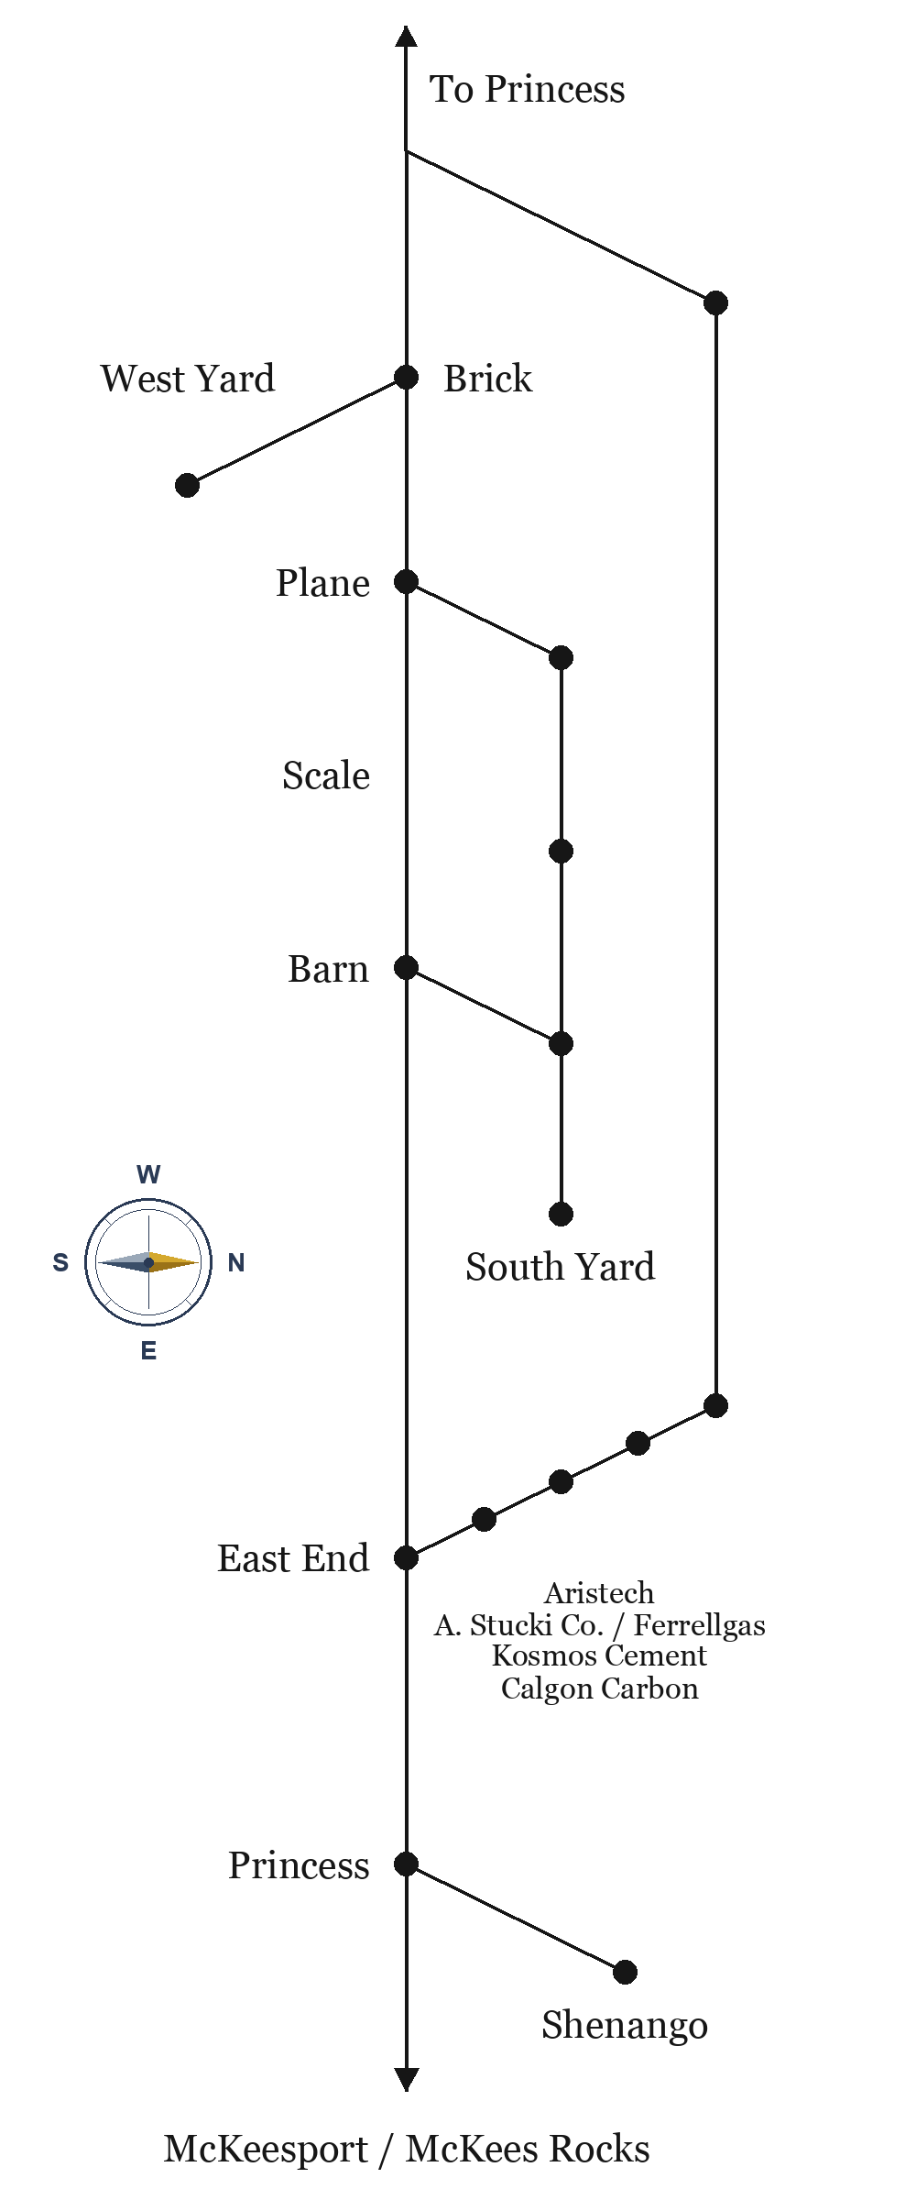 | ROUTE 23 TIMETABLE  Neville Queen · Emp. TT No. 23  Eastbound Barn→McKees Rocks. Westbound McKees Rocks→Barn. Station time.
  EAST | STATION | WEST
  9:00 | Barn | 5:00 PM
  9:06 | Scale | 4:54 PM
  9:12 | Brick | 4:48 PM
  9:18 | East End | 4:42 PM
  9:24 | Aristech | 4:36 PM
  9:30 | Calgon Carbon | 4:30 PM
  9:36 | Kosmos Cement | 4:24 PM
  9:42 | Ferrel Gas | 4:18 PM
  9:48 | A. Stucki Co. | 4:12 PM
  9:54 | Princess | 4:06 PM
  10:00 | McKees Rocks | 4:00 PM

