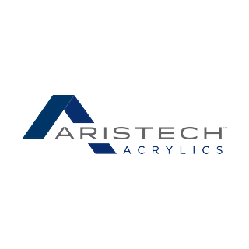
Founded 1986 as Aristech Chemical, spun off from U.S. Steel's USS Chemicals division with headquarters in Pittsburgh.
Major producer of acrylic sheet, molded plastics, and synthetic resins for bathtubs, spas, architectural panels, and packaging.
Continuous-cast acrylic sheet production began in 1969; chemical operations draw on the former USS Chemicals heritage dating to the 1960s.
Traffic: plastic pellets (HC) and process chemicals (TA) in; plastic resins (XM) out. NVL serves the plant.
TRACKS & SPOTS
Spot | Track | Cars | In | Out
1-3 | Pellet Unloading | Covered Hopper | Plastic Pellets | Empty cars
4-5 | Chemical Unloading | Tank Car | Process Chemicals | Empty cars
6 | Shipping | Boxcar | Empty cars | Plastic Resins
7 | Off Spot | Covered Hopper, Tank Car, Boxcar | — | —

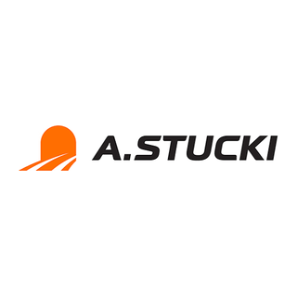
Founded 1911 by Swiss engineer Arnold Stucki in the Pittsburgh area.
Stucki's roller side-bearing design stabilized freight cars and became a North American industry standard by the 1950s.
Grew through the 20th century as a supplier of railcar components, springs, bearings, and machined steel.
Traffic: steel (FM/GA/XM) on the crane; general freight (XM/FM/GA) on the team track. Empties and outbound parts leave after spotting. NVL serves the plant.
TRACKS & SPOTS
Spot | Track | Cars | In | Out
1 | Steel Unloading | Flat Car, Gondola, Boxcar | Steel | Empty cars
2 | Team Track | Boxcar, Flat Car, Gondola | General Freight | General Freight
3 | Off Spot | Boxcar, Flat Car, Gondola, Coil Car | — | —

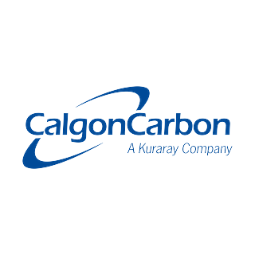
Traces to 1942, when Pittsburgh Coke & Chemical developed coal-based activated carbon for U.S. military gas masks during World War II.
Pioneered granular activated carbon for municipal drinking-water treatment in the 1960s; headquartered in the Pittsburgh area.
Became an independent public company in 1987; one of the world's leading activated-carbon producers by the 1990s.
Traffic: coal (HM) and process chemicals (TA) in; activated carbon (HC) out. NVL serves the plant.
TRACKS & SPOTS
Spot | Track | Cars | In | Out
1-2 | Coal Unloading | Hopper | Coal | Empty cars
3 | Carbon Loading | Covered Hopper | Empty cars | Activated Carbon
4 | Chemical Unloading | Tank Car | Process Chemicals | Empty cars
5 | Off Spot | Hopper, Covered Hopper, Tank Car | — | —

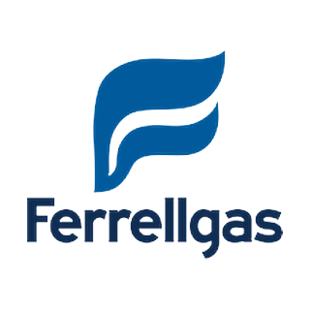
Founded 1939 as A.C. Ferrell Butane Gas Company in Atchison, Kansas.
James E. Ferrell took over in 1965 when the business had just four employees, then rebuilt it through Midwest propane dealer acquisitions.
Bulk propane storage and rail deliveries expanded through the 1970s and 1980s as residential and farm demand grew.
Traffic: LPG (TA) in at the unload racks; empty tanks out. NVL serves the plant.
TRACKS & SPOTS
Spot | Track | Cars | In | Out
1-2 | LPG Unloading | Tank Car | LPG | Empty cars
3 | Storage | Tank Car | — | —

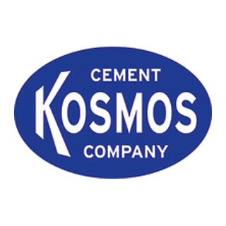
Portland cement plant at Kosmosdale, Kentucky, shipping from the same site since 1905; founded by Samuel Horner Jr. as Kosmos Portland Cement Company.
Supplied cement for early Ohio River lock and dam construction; a fleet of company towboats with names beginning in "K" moved cement and quarry stone.
The company town of Kosmosdale grew around the mill; Horner heirs sold the operation in 1957 and the plant was rebuilt in the early 1970s.
Traffic: cement (HC) and aggregate (HM/GA) in; empty hoppers out. NVL serves the plant.
TRACKS & SPOTS
Spot | Track | Cars | In | Out
1-3 | Cement Unloading | Covered Hopper | Cement | Empty cars
4 | Aggregate Unloading | Hopper, Gondola | Aggregate | Empty cars
5 | Off Spot | Covered Hopper, Hopper, Gondola | — | —

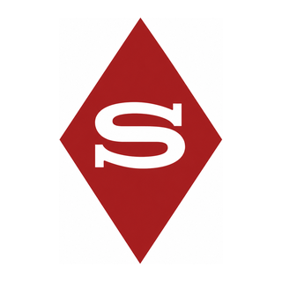

Pittsburgh Coke & Chemical (PC&C) was making coke and pig iron on the eastern end of Neville Island by 1929. The coke ovens and chemical works that later became Shenango date to about 1930.
PC&C was more than a coke plant: on the island it also made cement, industrial chemicals, and activated carbon. Those other branches became the Kosmos, Aristech, and Calgon operations still switched today.
In 1962 Shenango Furnace purchased PC&C. The coke-and-iron division became Shenango Inc. and kept making coke and coke by-products on the same site for decades after the PC&C name disappeared.
Traffic: HM coke on Shipping 1 and Shipping 2 (no numbered spots). CK1 lifts for South Yard scale. Loads to U.S. Steel Edgar Thomson Works (Braddock, PA) via CSX and LTV Steel Cleveland Works (Cleveland, OH) via POHC. NVL may set out deliveries; no Shenango empty pickup on the NVL return.
TRACKS
Track | Cars | In | Out
Shipping 1 | HM | Empty / reload coke | Coke
Shipping 2 | HM | Empty / reload coke | Coke
No numbered spots. Weigh all outgoing coke at South Yard scale.

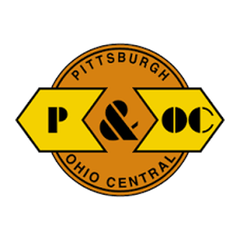
Scully Yard
POHC interchange · McKees Rocks offline
POHC gateway. NVL takes its session-start block here. McKees Rocks-PA party tracks hold offline suppliers and customers.
Connections beyond the offline tracks are typically POHC and NS.
MCKEES ROCKS — INBOUND (SUPPLIERS)
• Allegheny Ludlum (Brackenridge, PA)
• Exxon Chemical (Bayonne, NJ)
• Ferrellgas Co (Taneytown, MD)
• General Chemical (Parsippany, NJ)
• Hillman Coal (Canton Twp, PA)
• Houghton Chemical (Allston, MA)
• Kosmos Cement (Canton, OH)
• Lehigh Cement (Mitchell, IN)
• McConway & Torley (Pittsburgh, PA)
• Michigan Limestone (Rogers City, MI)
• Novacor (Indian Orchard, MA)
• Republic Steel (Cleveland, OH)
MCKEES ROCKS — OUTBOUND (CUSTOMERS)
• LTV Steel Cleveland Works (Cleveland, OH) — coke
• Owens-Illinois (Toledo, OH)
• Bemis Company (Flemington, NJ)
• Pittsburgh Forge (McKees Rocks, PA)
• Univar (Salem, MA)
JOBS
• NVL — assign/pickup session block at Scully, then run to South Yard.

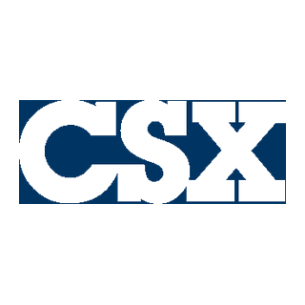
Demmler Yard
CSX interchange · Mckeesport offline
CSX gateway. D749 lifts its inbound block here at session start. Mckeesport-PA party tracks hold offline suppliers and customers.
Connections beyond the offline tracks are typically CSX (URR territory historically adjacent at Mckeesport).
MCKEESPORT — INBOUND (SUPPLIERS)
• BASF (Wyandotte, MI)
• Consol Energy (Pittsburgh, PA)
• Dow Chemical (Midland, MI)
• Ferrellgas pipeline terminal
• Martin Marietta (Clairton, PA)
• Medusa Cement (Charlevoix, MI)
• Metal Service Co. (Apollo, PA)
• R&P Coal (Brady Twp, PA)
• Ryerson Steel Service
• US Aggregates (Indianapolis, IN)
• Washington Steel (Washington, PA)
• Calgon Corp (Columbus, OH)
MCKEESPORT — OUTBOUND (CUSTOMERS)
• U.S. Steel Edgar Thomson Works (Braddock, PA) — coke
• Calgon Corp (Columbus, OH)
• Houghton Chemical (Allston, MA)
• Metal Service Co. (Apollo, PA)
• Owens-Illinois (Ottawa, IL)
• Ryerson Steel Service
JOBS
• D749 — pickup Demmler block → South Yard setout to open the session; later return from McKeesport side and terminate West Yard.

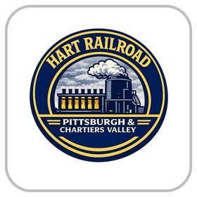
South Yard
Classification hub · session start
Session open / class yard. West Lead = SOUTH-SCALE (CK1 weigh at 4 MPH, stretch, no brakes). Exchange: Demmler/CSX off; Island/Shenango on.
TRAINS THIS SESSION
D749 — CSX turn
• Lift West Yard consist → Demmler pickup → South setout to open ops; interchange per YM; west when cleared.
• Return from McKeesport; YM spots West or South; engine to terminal.
NVL — POHC Island local
• Scully → South; interchange per YM; work Island industries + Shenango setouts.
• Finish Island/Shenango deliveries before return homebound. Final South interchange → Scully. Shenango deliver-only on return.
CK1 — Coke transfer
• Calibrate scale. Shenango: set out reloads, lift Shipping 1/2 coke → weigh West Lead → class. Imbalanced → reload orders.
• Same session: reloads South → Shenango when authorized.
BLOCKING PRIORITY
• 1. D749 Demmler → South setout opens the session.
• 2. NVL South exchange before Island work.
• 3. Island/Shenango setouts before NVL return homebound assigns.
• 4. CK1 weigh/resort; reloads to Shenango when ready.
• 5. D749 return → West Yard.

Dispatcher
HART Railroad · session control
Authorize road moves, keep train order, and protect the South Yard block exchange. Crews work from switch lists; yardmaster owns South class tracks.
TERRITORY
• Scully Yard — POHC interchange (NVL start).
• Neville Island / Shenango — NVL local; CK1 coke plant.
• South Yard — class hub, session open, track scale (West Lead).
• Demmler Yard — CSX interchange (D749 start / return).
• West Yard — D749 overnight / terminate.
SESSION SEQUENCE
• D749: Demmler pickup → South setout opens ops; then west as cleared.
• NVL: Scully block → South exchange → Island / Shenango work → return to Scully (Shenango deliver-only on return).
• CK1: Shenango shipping → South scale → class; reloads back when ready.
• D749 return from McKeesport → West Yard.
BLOCKING PRIORITY
• 1. Hold NVL Island work until South has taken the D749 inbound setout and completed the block exchange.
• 2. Island / Shenango deliveries before NVL builds the homebound.
• 3. CK1 scale string clear of West Lead conflicts during weigh (4 MPH).
• 4. One road move at a time across shared leads when crews meet at South.

