HART Railroad · Crew Instructions

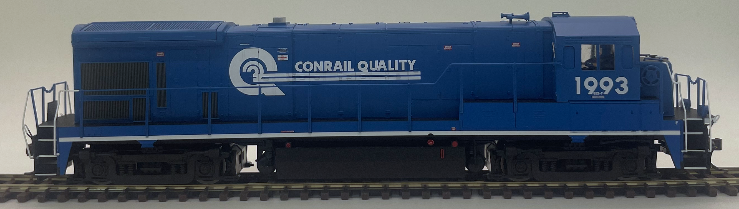 | D749  CSX Neville Island Switcher  Engine: CR 1993 · GE B23-7
CSX turn between Demmler / McKeesport and Neville Island. The train starts tied down in West Yard. Deliver the Demmler inbound to South Yard, hostle the engine to the engine terminal, then return for the Demmler / McKeesport outbound block, depart westbound, and terminate again in West Yard.
CREW STEPS
1. Find the train tied down in West Yard with the inbound Demmler block.
2. Obtain dispatcher clearance and run the inbound to South Yard.
3. Set out the Demmler / McKeesport inbound at South Yard.
4. Take the engine light to the engine terminal. Top off fuel and sand if needed.
5. When called for the outbound, interchange with the Yardmaster. Build and lift the Demmler / McKeesport outbound block.
6. With clearance, depart toward McKeesport with the outbound block.
7. On return, follow Yardmaster instructions and tie down in West Yard. Secure the engine.
DESTINATION COLORS
 | Interchange |  | Local Industries
 | Demmler / McKeesport |  | Aristech Plastics
 | Scully / McKees Rocks |  | A. Stucki Co.
 |  |  | Calgon Carbon
 |  |  | Ferrellgas
 |  |  | Kosmos Cement
 |  |  | Shenango Coke Works

STATION MAP  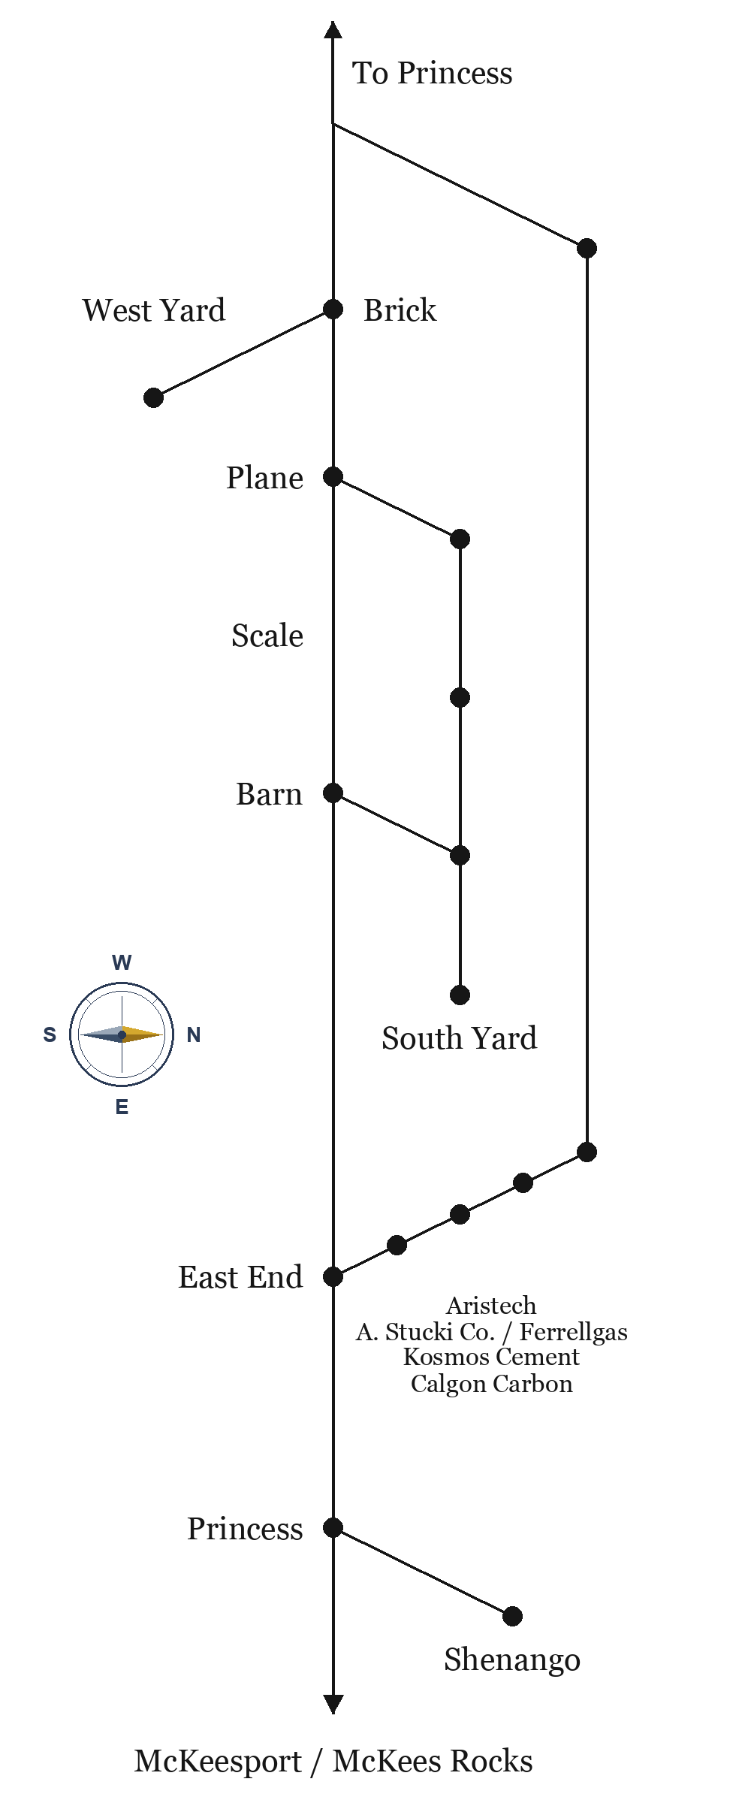 | ROUTE 23 TIMETABLE  Neville Queen · Emp. TT No. 23  Eastbound Barn→McKees Rocks. Westbound McKees Rocks→Barn. Station time.
  EAST | STATION | WEST
  9:00 | Barn | 5:00 PM
  9:06 | Scale | 4:54 PM
  9:12 | Brick | 4:48 PM
  9:18 | East End | 4:42 PM
  9:24 | Aristech | 4:36 PM
  9:30 | Calgon Carbon | 4:30 PM
  9:36 | Kosmos Cement | 4:24 PM
  9:42 | Ferrel Gas | 4:18 PM
  9:48 | A. Stucki Co. | 4:12 PM
  9:54 | Princess | 4:06 PM
  10:00 | McKees Rocks | 4:00 PM

