HART Railroad · Yardmaster Sequence

1. SEQUENCE
# | Train | Yardmaster action
1 | D749 | Receive inbound Demmler / McKeesport block, build and hand-off outbounds to D749. (Blue)
2 | NVL | Receive the Scully setout and give NVL the local cut for delivery. (Yellow, Green, Purple, Red, Pink)
3 | CK1 | Hand Shenango cars to CK1 for delivery; (Black) Calibrate the scale, weigh coke pull and sort.
4 | NVL return | Receive NVL setouts and give the Scully / McKees Rocks block for the return. (Orange)

2. DESTINATION COLORS
Color | Destination | Blocking
BLUE | Demmler Yard; Mckeesport | D749
YELLOW | Aristech Plastics | NVL
GREEN | A. Stucki Co. | NVL
PURPLE | Calgon Carbon | NVL
RED | Ferrellgas | NVL
PINK | Kosmos Cement | NVL
BLACK | Shenango Coke Works | CK1
ORANGE | Scully Yard; McKees Rocks | NVL return

STATION MAP  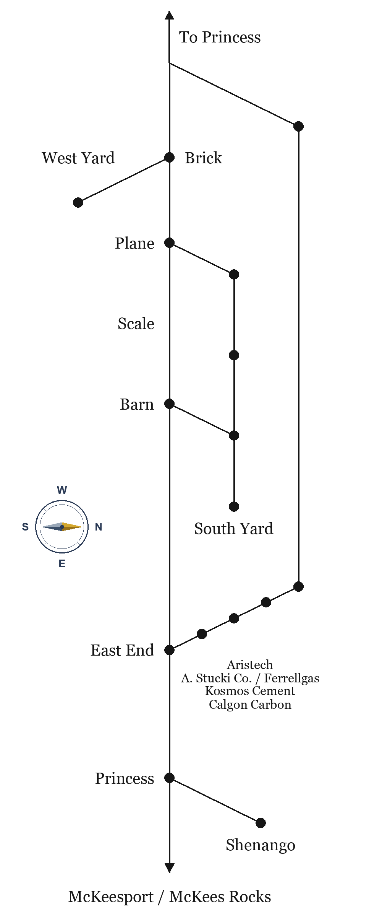 | ROUTE 23 TIMETABLE  Neville Queen · Emp. TT No. 23  Eastbound Barn→McKees Rocks. Westbound McKees Rocks→Barn. Station time.
  EAST | STATION | WEST
  9:00 | Barn | 5:00 PM
  9:06 | Scale | 4:54 PM
  9:12 | Brick | 4:48 PM
  9:18 | East End | 4:42 PM
  9:24 | Aristech | 4:36 PM
  9:30 | Calgon Carbon | 4:30 PM
  9:36 | Kosmos Cement | 4:24 PM
  9:42 | Ferrel Gas | 4:18 PM
  9:48 | A. Stucki Co. | 4:12 PM
  9:54 | Princess | 4:06 PM
  10:00 | McKees Rocks | 4:00 PM

