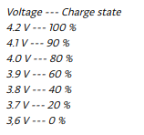
Reseach about Battery :

https://www.arduino.cc/en/Tutorial/ReadAnalogVoltage

