This is for 30 pins ESP32
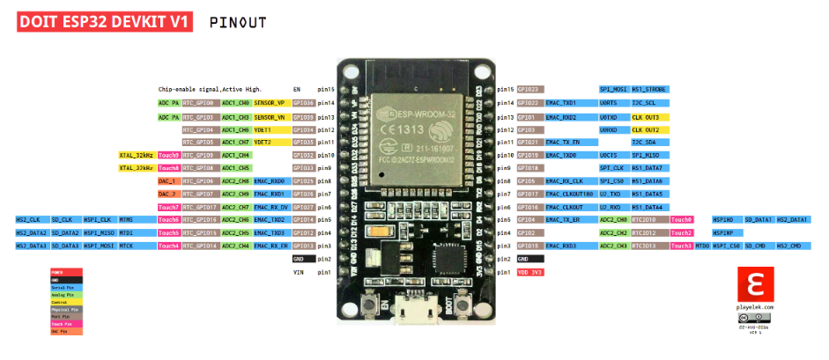
Link for 30 pins esp32
https://github.com/playelek/pinout-doit-32devkitv1/blob/master/pinoutDOIT32devkitv1.png
For Potentionmeter
https://arduinogetstarted.com/tutorials/arduino-potentiometer

Instruction about Test run of Servo in Arduino:
https://dronebotworkshop.com/servo-motors-with-arduino/

(ESP32 _> Motor)

GIO IS pin number in the code

IConnecting the Servo Motor to the ESP32
- GND -> ESP32 GND pin;
- Power -> ESP32 VIN pin;
- Signal -> GPIO D4 (or any PWM pin).

In this test we will use the instruction
https://randomnerdtutorials.com/esp32-servo-motor-web-server-arduino-ide/

there are some questions:
1/ All the high order communication should be pay attention
2/
this 2nd test has been succesffuly to communicate – app can send data to sensor unit and Knob can receive it
Note:
Hi, just little update about last two weeks research for our project. I have started everything again from Knob, Sensor Unit and App also, just want to learn more about and hopefully can have more options. So far, I can prove working concept ( please check video for more info)
-Knob : BLE connection, return Home by Servo motor
- Sensor Unit : BLE and WiFi Integrated and App protocol communication. It has included potentiometer and Smoke detector
- App: keep connect with Sensor Unit to update about Gas level and get order. ( will also have notifications as well but I am having bugs now)
Result of this Test has successfully achieved two main things:
1/ WiFi and BLE can work together if we set them up logically so that data won’t be over loaded ( I have dealt with it whole week)
2/ App use WiFi to send data, Sensor Unit receive by WiFi and send to Knob by BLE.
PS: it is summer so please understand I want to learn as individual so all works in video just for my self’s experience. All assigned works by team still be as they are. So please don’t feel like I went across other members’ s works. All these works are only for my self.

