**Test Case 1**

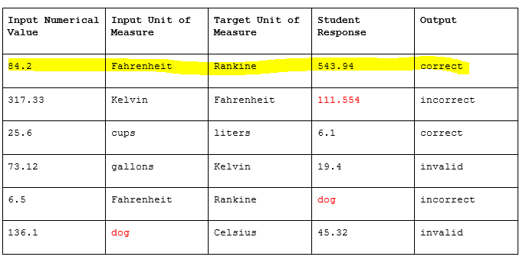

Enter Input Numerical Value

84.2

Enter Input Unit of Measure

Fahrenheit

Enter Target Unit of Measure

Rankine

Enter Student Response

543.94

84.2 Fahrenheit Rankine 543.9 correct

**Test Case 2**

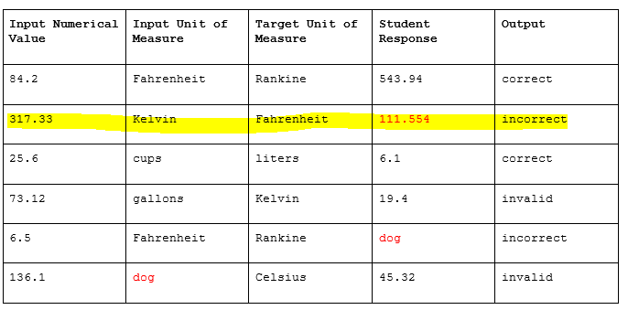

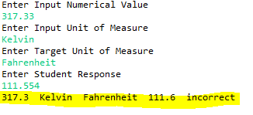

**Test Case 3**

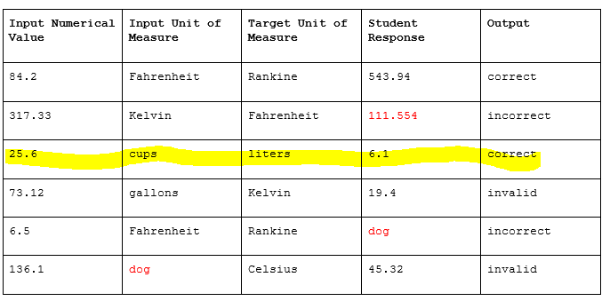

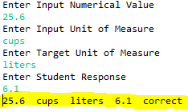

**Test Case 4**

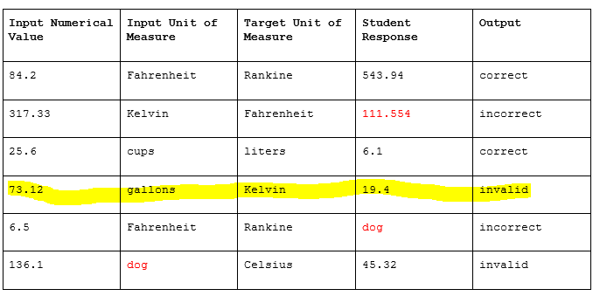

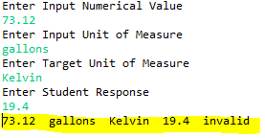

**Test Case 5**

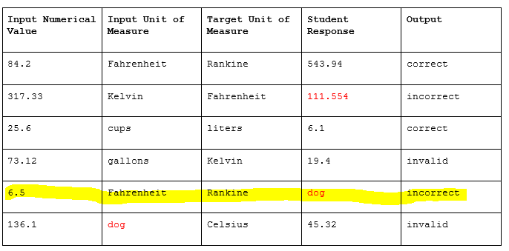

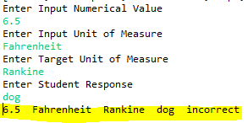

**Test Case 6**

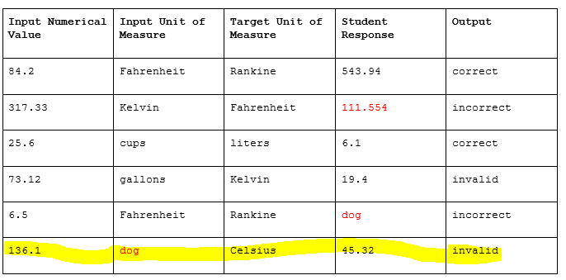

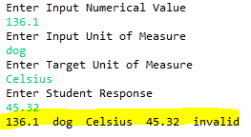

**Test Case 7**

Entered dog for Input Numerical Value. The result was incorrect which is the same as when dog was entered for Student Response.

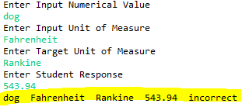

**Test Case 8**

Entered the same value for Input Unit of Measure and Target Unit of Measure.

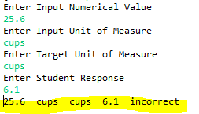

**Test Case 9**

Entered dog for Target Unit of Measure. The result was invalid which is the same as when dog was entered for Input Unit of Measure.

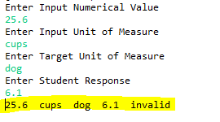

**Test Case 10**

No data entered

h

