# Things to do in CoronaNet dataset:

* **Identification** of proper lockdowns:
  + ‘**type’** features both ‘**Curfew’** (which it is in the case of France, for example) and ‘**Quarantine/Lockdown’** (Italy, Germany, UK…). The difference between those two seems a bit vague, Curfew seems to be stronger; both will have to be included.
  + However, **mandatory lockdowns also include fairly liberal situations**, like the UK between 16/03 and 23/03, where even pubs were open.
  + Best match with our conception of lockdown will probably come up if we **include closure of non-essential business, closure of schools** and such thingsl; at least in the UK, this leads to 23/03 pretty clear cut.
    - Indeed, in the countryLockdowndates.csv, a lockdown is assumed when schools/universities and any non-essential businesses are closed. Therefore, it is not always a one-time announcement but rather a cumulative process of restrictions that turns to 1 (=lockdown) after a certain threshold. Here the threshold is defined qualitatively. The policy index transforms it to numerical.
* **Coding** of lockdown variables:
  + For visualisation and analysis, a **dummy that equals 1 for every day during the lockdown** period when the measures is in place would be useful; again, requires clear definition of what constitutes a lockdown.
* **Interpolate** missing dates:
  + For index, use last reported value
  + For other values, probably right_join is the better solution (if other dataset has all dates)
    - If we restrict the analysis to a few countries, do we still suffer from a lot of missing dates?
* Import most **recent dataset**

Some issues mentioned above visible below:

* Red lines are national mandatory lockdowns as recorded in CoronaNet
* Green lines are national voluntary lockdowns
* Black lines are lockdowns as recorded by Orestis
  + Match is poor so far
  + Source of lockdowns from Orestis: <https://www.kaggle.com/jcyzag/covid19-lockdown-dates-by-country>
* Interpolation needed (ggplot does that automatically except for UK in Feb, as there’s a NaN entry at beginning of gap).

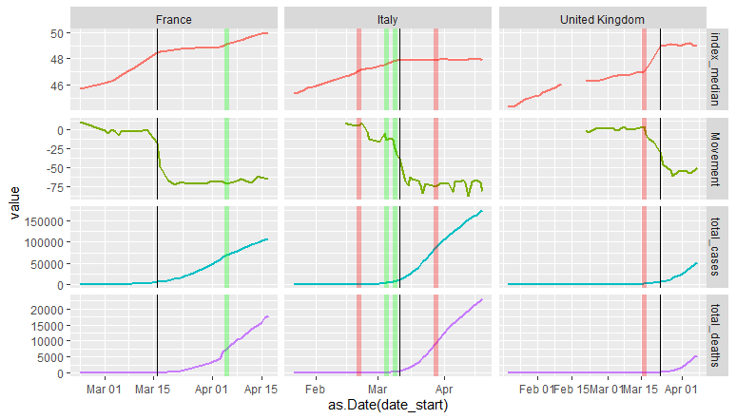

* At least in these 3 cases, the black lines seem to be the better predictor in terms of movement. Interestingly, however, the green and red lines seem to be capturing the early onset of the increase of total cases and total deaths. This would fit a narrative whereby govts saw blood and got scared.
* Just a thought, what affects the decision to lockdown? Can the time remaining before an election play a role? Are other polling data predictive?

# Analysis:

* Create **Impulse Response Functions** (or multiplier analysis) for intervention dummies: What is the reaction of X (mobility, infections…) to lockdowns (or other measures); trajectory.
* The resulting coefficients can be used on LHS of further analysis: e.g., is reaction stronger in collectivist, authoritarian context etc.
* Based on **VAR or ARDL**?
* VAR:
  + Pro: Can explicitly model endogeneity between variables (case numbers, deaths, mobility, policy index, e.g.)
    - Structure of this interaction may be quite intricate and changing over time – series start off exponential, then turn linear, and lags may be too long for some of these things to be picked up by VAR
  + Con: Quite demanding on data and time series are still fairly short, complicated computation of impulse response for exogenous variables (such as lockdown dummy)
* ARDL:
  + Easier to handly, may suffice if we’re only interested in simple interactions (not trying to model whole case numbers, death, lockdown nexus)
  + Impulse response easier to compute
  + Not so demanding on data (less parameters, eats fewer degrees of freedom)