## Pathogen prevalence predicts human cross-cultural variability in individualism/collectivism

* Published in Proceedings of the Royal Society (2008), 737 citations
* Summary : Countries with historical prevalence of pathogens develop more collectivist cultures.
  + Pathogens:
    - leishmanias, trypanosomes, malaria, schistosomes, filariae, leprosy, dengue, typhus and tuberculosis)
    - TBQ: National Geo Sociery (2005), the others thorough old atlases….
    - Also data on recent pathogens from this site: and Epidemiology Online Network (http://www.gideononline.com/), which reports current distributions of infectious diseases in each country of the world. (The database is updated weekly; our data were obtained during the period April–June 2007.) We focused on seven classes of pathogens (leishmanias, trypanosomes, malaria, schistosomes, filariae, spirochetes and leprosy).
    - What about the WB data for communicable diseases?
  + Collectivism/ individualism: from 4 pre-existing papers
    - Hofstede (2001; book; more than 36000 citations). Culture's consequences: Comparing values, behaviors, institutions and organizations across nations
    - Gelfand et al. 2004 (he is the author of the next paper as well on Covid)

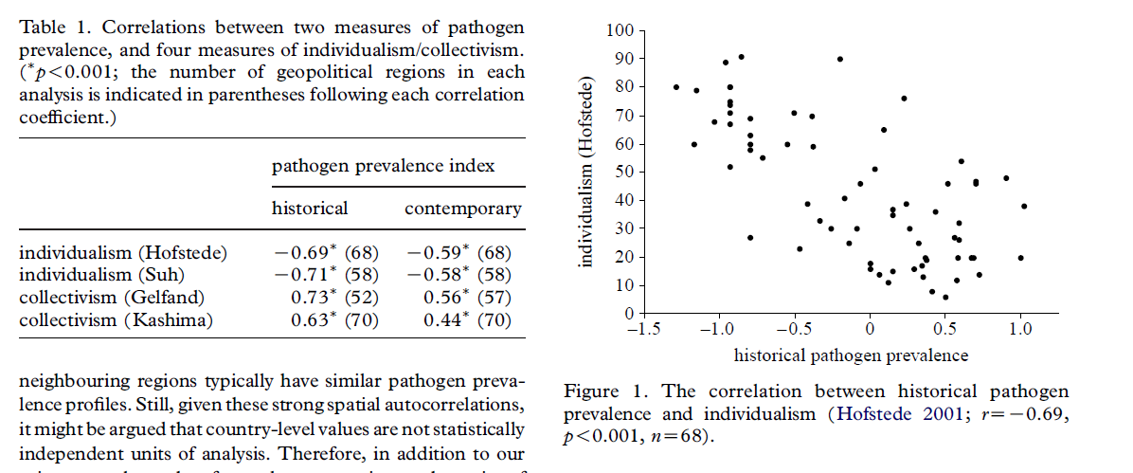

* + Other variables: Therefore, we obtained measures of variables bearing on these constructs: gross domestic product per capita (GDP per capita), inequity in the distribution of wealth (Gini index) and population density (computed from population size divided by land area and then log transformed). Region-specific data

on these variables were obtained from the World Factbook 2007 (<http://www.cia.gov/>).

* + - So still, not from the WorldBank.
  + Further controls: One could also speculate that differences in individualism/ collectivism might be predicted by pathogen-irrelevant influences on health and mortality. That is, just as collectivistic values may maintain cultural buffers against pathogen transmission, they might also maintain cultural buffers against other sources of morbidity and mortality independent of the direct effects of pathogens (e.g. interpersonal violence). **To create a measure of pathogen independent**

**health threats, we regressed average life expectancy (obtained from the World Health Organization; http://www.who.int) on our index of historical pathogen prevalence and saved the residuals**. These region-specific residual values represent variation in life expectancy that cannot be attributed to variation in pathogen prevalence.

## Cultural and Institutional Factors Predicting the Infection Rate and Mortality Likelihood of the COVID-19 Pandemic

* Authors: Gelfand et al.
  + Gelfand is involved in the collectivisim index studies.
* Source: <https://psyarxiv.com/m7f8a/>
* Summary: nations with efficient gvts and tight cultures have been most effective. This is robust to controls of underreporting of cases, economic development, inequality, median age, population density and authoritarianism. They also provide an evolutionary model suggesting that the observed cross-cultural trends may be driven by variation in how much groups adhere to cooperative norms under conditions of high threat.
  + For the gvt efficiency we can use the WorldAttitudesSurvey: Perceptions of government/public response & efficacy.

# Global Behaviours and Perceptioons in the Covid-19 Pandemic

* Summary: Our >100k participants think their governments aren't doing enough to combat COVID-19. This perception is associated with higher levels of worries and depression. Most respondents reacted strongly by engaging in social distancing and hygiene measures.
* Source: <https://psyarxiv.com/3kfmhhttps://covid19-survey.org/>
* Interesting variables re. Gvt’s perception:
  + perceivedreaction - Do you think the reaction of your country’s government to the current coronavirus outbreak is appropriate, too extreme, or not sufficient?
  + govtrust - How much do you trust your country’s government to take care of its citizens?
  + govfact - How factually truthful do you think your country’s government has been about the coronavirus outbreak
  + react pub appr - Do you think the reaction of your country’s public is appropriate, too extreme, or not sufficient?
  + perceivedeffectivnes - What do you think: How effective are social distancing measures (e.g., through a general curfew) to slow down the spread of the coronavirus?