## Option1: manual (slow)

Weather is monitored through Stations, located in major cities. One free platform to obtain such information is through OGIMET.com

Extracting data in this way is fairly laborious as one has to do it manually (or scrap the data – not sure how to do this).

Here is the process for manual extraction:

Step 1: Input the city (common name) and country of interest here:

<https://www.ogimet.com/indicativos.phtml.en>

Step 2: Copy the 5-digit WMO INDEX (you can also click on it but then you only get the last 30 days)

Step 3: Go here, choose the desired period (up to 50 days at a time) and paste the WMO index

Then you get a neat picture like this (it’s in text format so you can copy past in .csv)

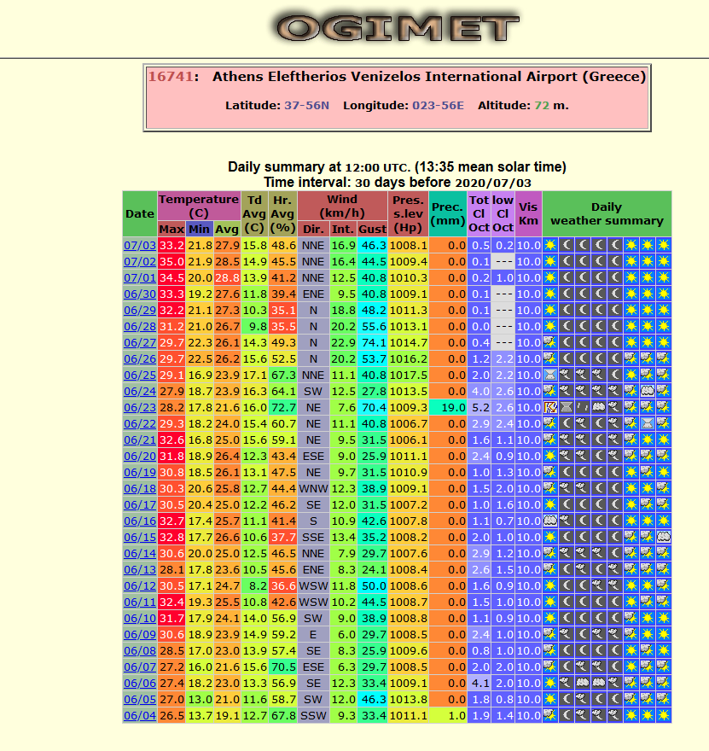

## Option 2: manual (fast)

Go there:

<https://www.ncei.noaa.gov/access/search/data-search/global-summary-of-the-day?pageSize=100&dataTypes=%5B%22DEWP%22,%22FRSHTT%22,%22GUST%22,%22MAX%22,%22MIN%22,%22MXSPD%22,%22PRCP%22,%22SLP%22,%22SNDP%22,%22STP%22,%22TEMP%22,%22VISIB%22,%22WDSP%22%5D&bbox=%5B%2239.266,22.500,36.880,25.357%22%5D&startDate=%5B%222019-12-01T00:00:00%22%5D&endDate=%5B%222020-01-01T23:59:59%22%5D>

Leave Data Types as is (I included everything) and Date (from December 2019), choose location (on the map and then choose the appropriate station), download.

That’s not too bad. We have to do it as many times as the cities we plan to consider.

The more I think about it, the more it makes sense to consider the city level as the mode of analysis. Besides the policy heterogeneity in countries like US and Australia, it also accounts for weather. How much sense does it make to ask what was the weather like on a certain day in… Greece? In Thessaloniki it might be Athens, in Crete might be sunny and in Florina, it might be snowing. Things are probably worse (i.e. more heterogeneous) for bigger countries.

Option 3: pay a service

Haven’t looked much into this option but there seems to be a strong monetary wall behind neatly summarised weather data.

This site seems to charge in order to clean the data for you: <https://www.ncdc.noaa.gov/data-access/quick-links#dsi-3505>

Or you can try and make sense of their archives: <ftp://ftp.ncdc.noaa.gov/pub/data/noaa/2020/>

(I couldn’t)