Naming Convention Tool - Development Environment Setup
Instructions

Operating System
Please use the latest recommended Scientific Linux distribution for development and testing purposes.
It could be installed by downloading an ISO image from https://www.scientificlinux.org/download .
Please install the Desktop version when offered with option at the start of the installation.

Alternatively the kickstarter and custom ISO files created specifically for ESS ICS can be used. Instructions ToDo

Sudo permissions
Please check whether your user account has access to the 'sudo' functionality. To do that please execute:
sudo ls
in terminal and enter your password. If the following reply is given then your account does not have sudo permissions: “user is not in the sudoers file. This incident will be reported.”

To add sudo permissions for your account, please log in as root using the su command in terminal and edit /etc/sudoers file to add a line such as:

username ALL=(ALL) ALL

where username is your username.

You could use either the nano or vi editor to edit the sudoers file.

Java Environment

JRE
By default both Java 1.6 and Java 1.7 runtime environments are installed on Scientific Linux 6.4. Java 7 is selected as default java. For Java EE development we'll rely on using JRE 6. To switch the default Java used please invoke the following command in terminal:
sudo alternatives --config java
and select the correct value to select /usr/lib/jvm/jre-1.7.0-openjdk/bin/java as default.

JDK
A Java Development Kit installation is needed to do development work. To install it please execute the following command in the terminal:
sudo yum install java-1.7.0-openjdk-devel

Eclipse
To install Eclipse please download the “Eclipse IDE for Java EE Developers” for the appropriate Linux platform from; http://www.eclipse.org/downloads/ . If x86_64 bit Scientific Linux is being used please use the “Linux 64 Bit”, otherwise use “Linux 32 Bit” option.

You could extract the archive to a directory inside your home folder, such as:
cd ~/
mkdir opt
cd opt
tar -xzvf ~/Downloads/eclipse-jee-kepler-R-linux-gtk.tar.gz

Optionally a symlink could be created so the `eclipse` command always invokes the IDE:
sudo ln -s /home/username/opt/eclipse/eclipse /usr/local/bin/eclipse

Oracle Enterprise Pack for Eclipse
Please start Eclipse by invoking the eclipse executable inside the extracted eclipse directory, or by typing `eclipse` in the terminal.

Download the “Offline Repository” from this page:
http://www.oracle.com/technetwork/developer-tools/eclipse/downloads/index.html

Or alternatively use the following link: http://download.oracle.com/otn_software/oepe/12.1.2.1/kepler/oepe-12.1.2.1-kepler-repository.zip

Then in Eclipse, please go to “Help/Install new software” menu item and click on the “Add...” button:

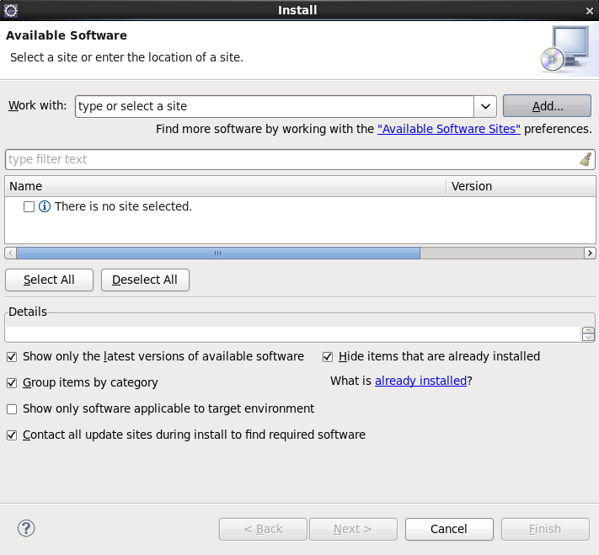
In the dialog that appears please enter a descriptive name such as “Oracle Enterprise Pack for Eclipse” and click the “Archive...” button:
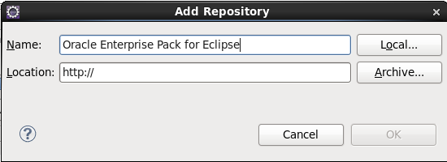
A dialog appears, please point it to the downloaded file – oepe-12.1.2.1-kepler-repository.zip.
Press the OK button in the “Add Repository” dialog.
Please expand the selection in the tree view under the “Oracle Enterprise Pack for Eclipse” entry.
Select the following sub-packages for installation:
- GlassFish Tools
- Java EE 6 Documentation
- Java EE 7 Documentation
- Oracle Database Tools
- Oracle Java EE Tools
- Oracle Maven Tools
Proceed with the installation of the Eclipse plugins.

Checkout the application
To checkout the application using Git, please do the following in terminal:
mkdir -p ~/projects
cd ~/projects
git clone https://your_user_name@git.esss.dk/ad/NamingConventionTool
Please substitute “your_user_name” with your user account at DMSC.

Install MySQL database locally
To install MySQL please run the following in terminal:
sudo yum install mysql
sudo yum install mysql-server

MySQL Workbench
MySQL workbench is a tool for managing the MySQL database. To install it please download the “Oracle and Red Hat Linux 6” package from:
http://dev.mysql.com/downloads/tools/workbench/
selecting the right platform (64/32 bit).

Prerequisites
Two libraries, normally not installed are needed by MySQL Workbench: libzip and tinyxml
To install libzip, please execute the following command in the terminal:
sudo yum install libzip
The tinyxml package is not found in the Scientific Linux repositories, so it has to be downloaded from the Red Hat Enterprise Linux repositories instead.
For 32 bit system please execute in terminal:
cd ~/Downloads
wget http://dl.fedoraproject.org/pub/epel/6/i386/tinyxml-2.6.1-1.el6.i686.rpm
sudo rpm -i tinyxml-2.6.1-1.el6.i686.rpm
For 64 bit system please execute:
cd ~/Downloads
wget http://dl.fedoraproject.org/pub/epel/6/x86_64/tinyxml-2.6.1-1.el6.x86_64.rpm
sudo rpm -i tinyxml-2.6.1-1.el6.x86_64.rpm

MySQL Workbench
After the prerequisite libraries are installed, please execute the following in the terminal:
cd ~/Downloads
sudo rpm -i mysql-workbench-community-6.0.6-1.el6.i386.rpm
Please note that the rpm file-name might differ in your case (depending on the version and platform).

Create database user and schema for the application
Make sure mysql database is started:
sudo service mysqld start
Create MySQL root administration password by executing in the terminal:
mysqladmin -u root password new-password
where new-password is the passwrod you would like to use.

Start the MySQL Workbench from the Applications Menu/Programming.
Select “Database/Connect to Database...” menu and connect to local-host, with the root username. Use the created password.
When connected, navigate to “Users and Privileges” on the left-hand panel, and create the “discs_names” user with password set to “discs_names”:
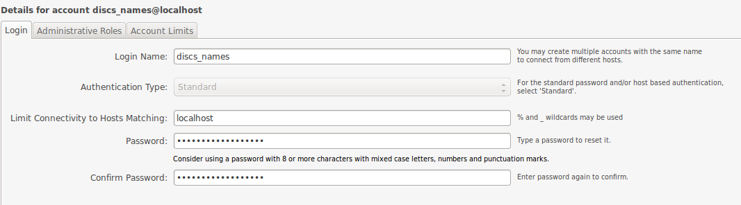Make sure to put localhost in the field "Limit Connectivity to Hosts", as shown in the picture. Please, click the “Apply” button.

Now you can create new schema and add tables and data to it. To do so please connect to you “localhost” and click on the “Open a SQL script file in a new query tab” button.
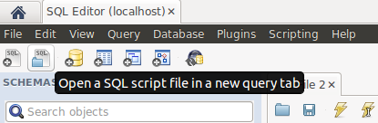
Navigate to projects cloned Git directory and find SQL script that creates a schema, tables and adds some data: /home/user/projects/NamingConventionTool/design/names_schema_v3.0.sql.
Execute the script:
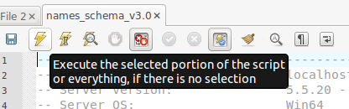
Finally, we need to assign permissions to the user “discs_names” to the database schema “discs_names”, please navigate again to “User and Privileges” on the left-hand side navigaiton bar and select the “discs_names” user from the list. Click the “Schema Privileges” tab, and click “Add Entry...”, select “Selected schema” radio button in the new dialog and select the “discs_names” schema. Please click “OK” button to close the dialog.
Please, click the “Select “ALL”” button to enable full access of the user to the schema and click the “Apply” button.

Restart MySQL
After the user has been added, please restart the MySQL service:
sudo service mysqld restart

Install Glassfish locally
To install Glassfish please download the 3.1.2 Full Platform version Zip file from:
http://glassfish.java.net/downloads/3.1.2-final.html
Or execute the following commands to extract it to /hom/user/opt/glassfish3 :
cd ~/Downloads
wget http://download.java.net/glassfish/3.1.2/release/glassfish-3.1.2.zip
mkdir -p ~/opt
cd ~/opt
unzip ~/Downloads/glassfish-3.1.2.zip

Install MySQL JDBC driver
To be able to use Glassfish with MySQL the JDBC driver must be installed in the server's lib directory. To do that please, do the following in a terminal:
cd ~/Downloads
wget http://cdn.mysql.com/Downloads/Connector-J/mysql-connector-java-5.1.26.tar.gz
cd ~/opt
tar -xzvf ~/Downloads/mysql-connector-java-5.1.26.tar.gz
cp mysql-connector-java-5.1.26/mysql-connector-java-5.1.26-bin.jar ~/opt/glassfish3/glassfish/lib

Start Glassfish
We will use Eclipse to manage the server. To do that please start Eclipse and select the Java EE perspective.
Click the “Servers” tab in the lower panel. Right-click on the panel and select “New>Server...” from the context menu.
A dialog pops up, please select GlassFish 3.1 from the tree-view. For “Server's host name” please leave “localhost”, name the server something decriptive, such as “GlassFish 3.1 at localhost”. Please press the “Next” button. In the next dialog, please select the “Glassfish Server Directory” by clicking on the “Browse...” button and selecting the /home/user/opt/glassfish3/glassfish directory. Click the “Next” button. In the next dialog, please do not password as it is not yet set in the “Administrator Password' field. (Note: The password will be later set.) Finally, click the Finish button.

Now the server description appears in the “Servers” tab in the lower panel. Please use this pannel to manage (Start/Stop/Deploy) the server.

To test the server please start it via the panel and visit the http://localhost:4848/ URL in the browser after it is started. The Server Administration console is hosted on the 4848 port.

Set the admin password
The server is started without a administrative password. To set it, please go to http://localhost:4848/ and select the Domain from the left-hand menu. There is a tab named “Administrator Password”, please click it and enter the new password. Click the “Save” button.
After the password is saved, it needs to be updated in Eclipse in the “Servers” view.

Setup security realm
Security and permissions of the application are managed via security realm of Glassfish. To login to the application you have to create new realm and add new user to it.
Go to http://localhost:4848 and navigate to security realm as shown below:
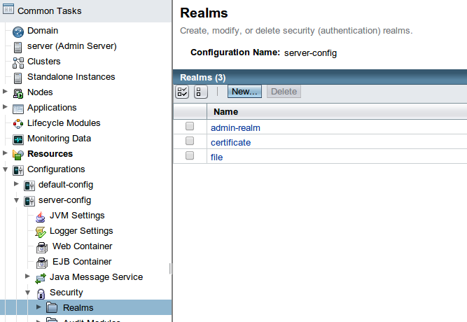
Click “New” and fill in as show below:
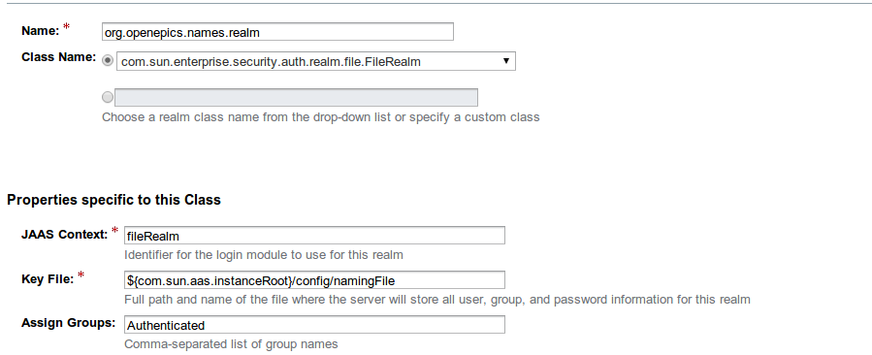
Click “Ok”.
Click on newly created realm and then click “Manage users”. Fill out as show below (password is “root”):
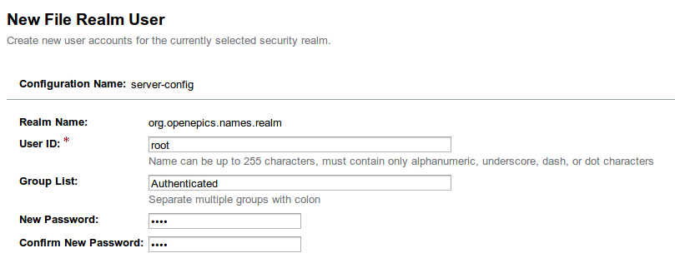
Click “Ok”.

Import the application in Eclipse
To import the project in Eclipse, please select “File/Import...” menu, and browse to “Maven/Existing Maven Projects”:
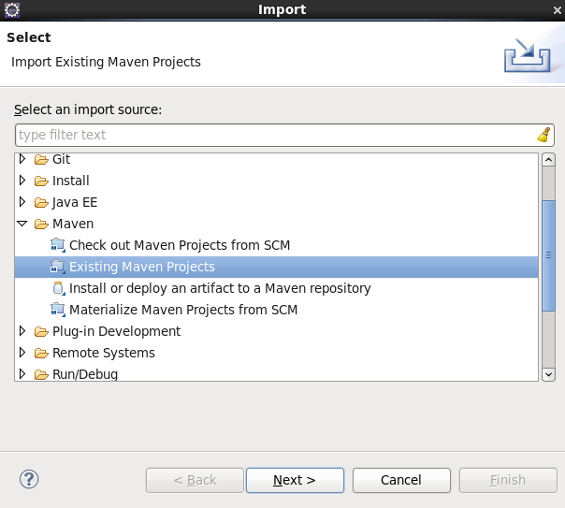
Click “Next >” button, and in the next dialog, click the “Browse...” button and navigate to the directory where the application was pulled from Git (/home/user/projects/NamingConventionTool).
Click the “Finish” button.

Deploy the application on Glassfish
Make sure that in Eclipse the Glassfish server is started via the “Servers” tab in the lower panel. To deploy the application just Drag & Drop the project from the left-hand “Project Explorer” tab to the server name. If the application is deployed successfully it should appear under the Server name in a tree-view fashion with the text “[Synchonized]”:
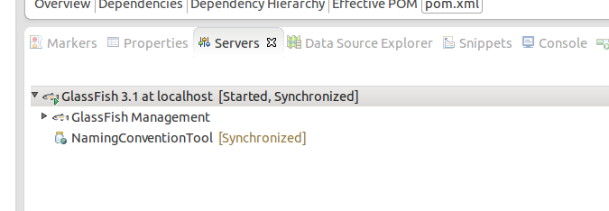
To test the application UI, please visit:
http://localhost:8080/names
Login with username and password set in Setup security realm section (user:root, password:root).

