 

**MBED Development Board**

*Documentation*

November 2013 – January 2014



*Beam Diagnostics Group (DIG)*

**BLANK PAGE**

# Table of Contents

Table of Contents4

1. General Information4

2. Introduction4

3. Description of activities4

4. Report5

4.1. Basic Hardware description5

4.2. Schematic5

4.3. Layout7

4.4. Pinout9

4.5 Board Overview9

# General information

* **Problem statement:** implementation of MBED using mechanisms to available all peripheral of this Development Platform. The purpose of this project is to create a generic board to be used wherever it is needed, without having to design a new board for each project in development.
* **People directly involved:** Lucas Alves Martins, Rafael Antonio Baron and João Leandro de Brito Neto.
* **Manager:** Lucas Alves Martins
* **Deliverables:** 
  + Schematic design
  + PCB design
  + 1 Prototype for the end of 2013
* **Date of delivery :** end of December 2013

# Introduction

The MBED board is an all-purpose programmable device designed for development. It uses a NXP microcontroller, and supports various peripherals, and also communication protocols including Ethernet, USB, I2C, Serial and SPI. It also features digital and analog I/O, and PWM outputs. There are several different boards, but this project uses specifically the LPC1768 board.

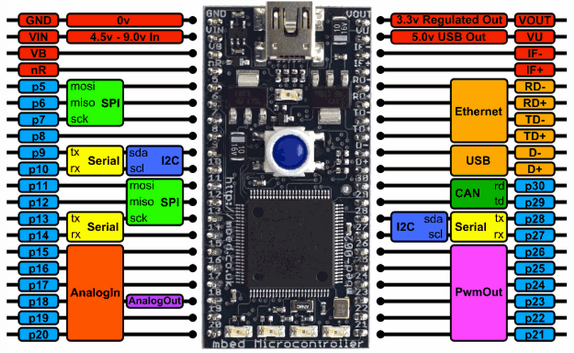

**2 Fig. 1: The LPC1768 MBED board pinout**

It uses a C/C++ software development kit, featuring API-driven programming, an online compiler and many libraries to work with.

# Description of activities

* Design Schematic in the ALTIUM
* Design PCB Layout in the ALTIUM
* Verification of the schematic and the layout
* Prototyping of the board
* Final testing

# Report

## 4.1. Basic hardware description

* A PCB with all the MBED peripheral:
  + Digital I/O
  + Ethernet Interface
  + USB Interface
  + Serial Interface
  + I2C Interface
  + SPI Interface
  + Analog I/O
  + PWM Out

## 4.2. Schematic

The following images describe the project’s schematic, its pins, connectors and peripherals.

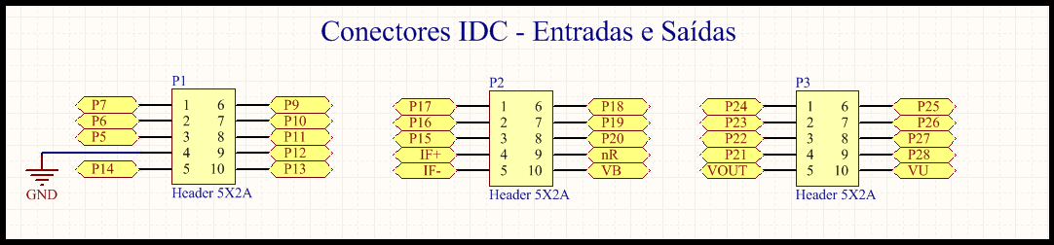

**4.2 Fig. 1: IDC I/O pinouts**

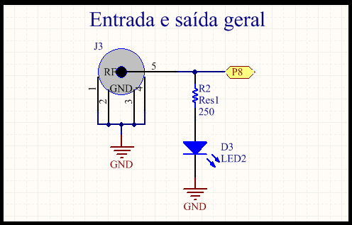

**4.2 Fig. 2: General Input/Output (SMA connector and red led)**

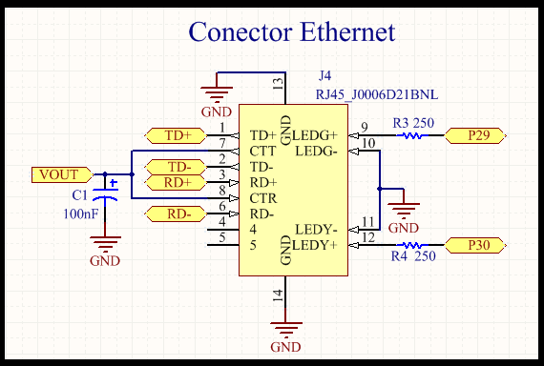

**4.2 Fig. 3: Ethernet Connector**

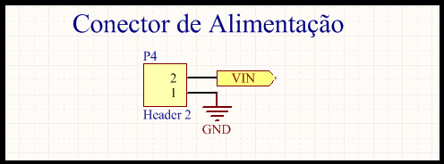

**4.2 Fig. 4: Power Supply Connector**

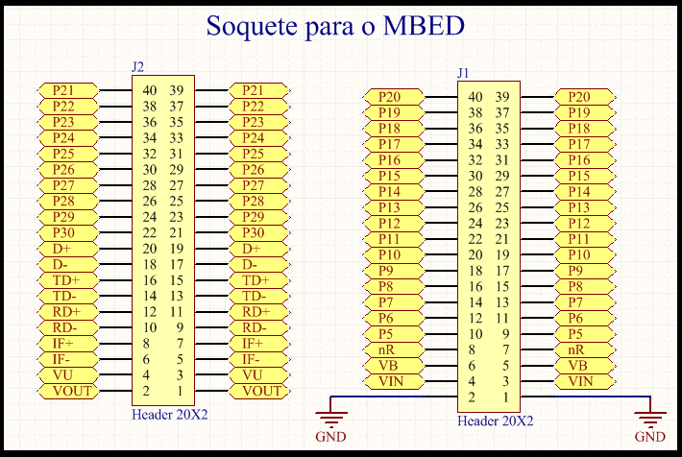

**4.2 Fig. 5: MBED Socket**

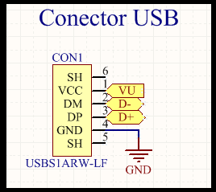

**4.2 Fig. 6: USB Connector**

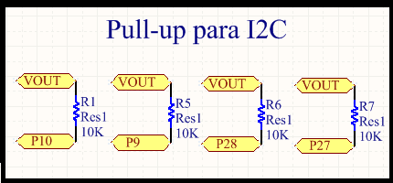

**4.2 Fig. 7: I2C Pull-up Resistors**

## 4.3. Layout

The following images describe the project’s schematic, its pins, connectors and peripherals.

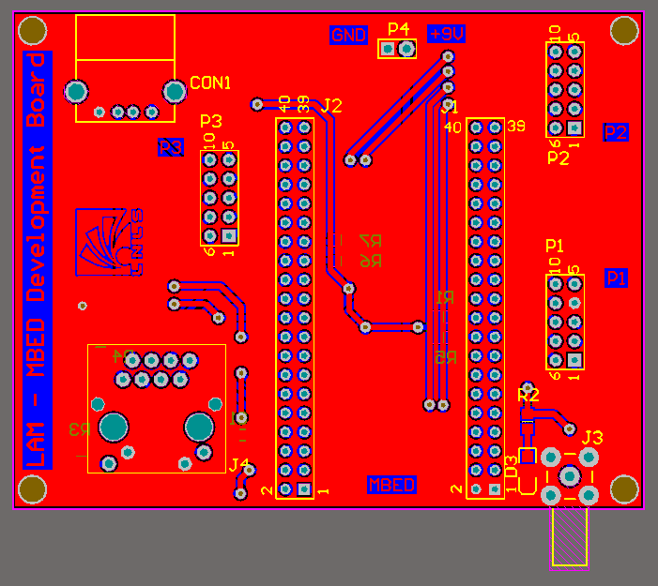

**4.3 Fig. 1: Top Layer**

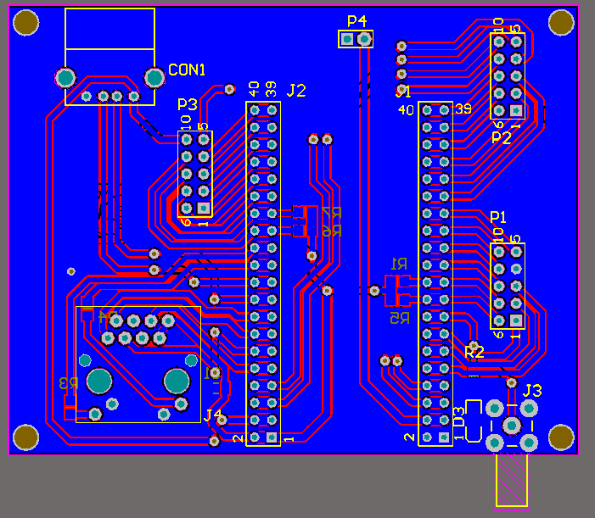

**4.3 Fig. 2: Bottom Layer**

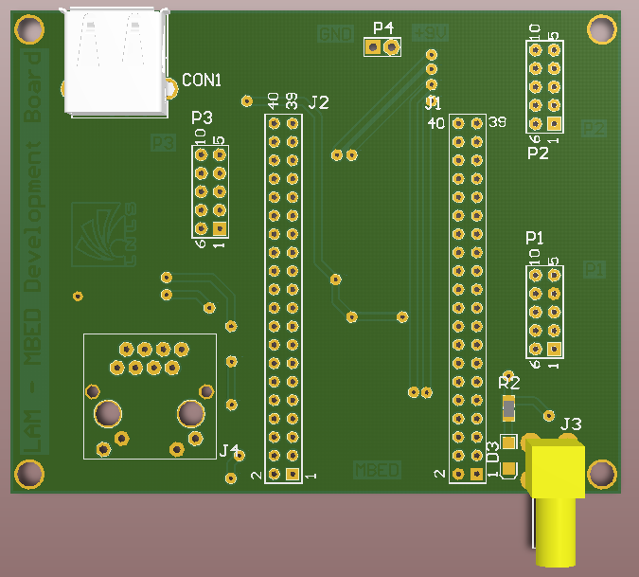

**4.3 Fig. 3: 3D Top View**

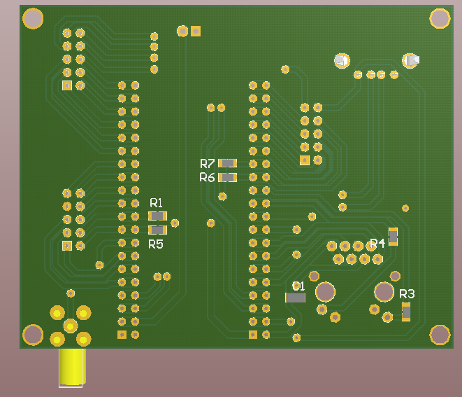

**4.3 Fig. 4: 3D Bottom View**

## 4.4. Pinout

|  |  |  |  |
| --- | --- | --- | --- |
| Connector/Physical Output | Pin (MBED) | Connector/Physical Output | Pin (MBED) |
| P1.1 | P7 | P3.1 | P24 |
| P1.2 | P6 | P3.2 | P23 |
| P1.3 | P5 | P3.3 | P22 |
| P1.4 | GND | P3.4 | P21 |
| P1.5 | P14 | P3.5 | VOUT |
| P1.6 | P9 | P3.6 | P25 |
| P1.7 | P10 | P3.7 | P26 |
| P1.8 | P11 | P3.8 | P27 |
| P1.9 | P12 | P3.9 | P28 |
| P1.10 | P13 | P3.10 | VU |
| P2.1 | P17 | Ethernet green led | P29 |
| P2.2 | P16 | Ethernet yellow led | P30 |
| P2.3 | P15 | Red led/SMA connector | P8 |
| P2.4 | IF+ | Ethernet data | TD+ |
| P2.5 | IF- | Ethernet data | TD- |
| P2.6 | P18 | Ethernet data | RD+ |
| P2.7 | P19 | Ethernet data | RD- |
| P2.8 | P20 | USB power supply | VU |
| P2.9 | nR (Low-level Reset pin) | USB data | D+ |
| P2.10 | VB (Real-time clock battery) | USB data | D- |

## 4.5. Board overview

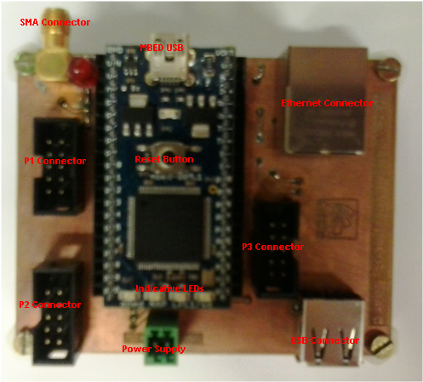

**4.5 Fig. 1: MBED Board Overview**