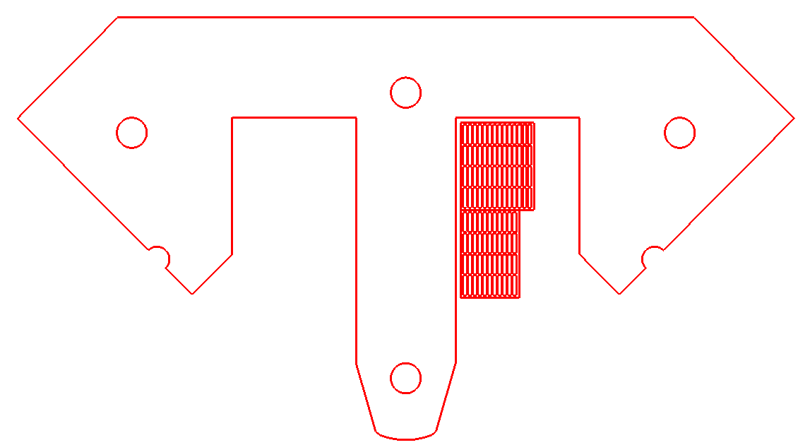

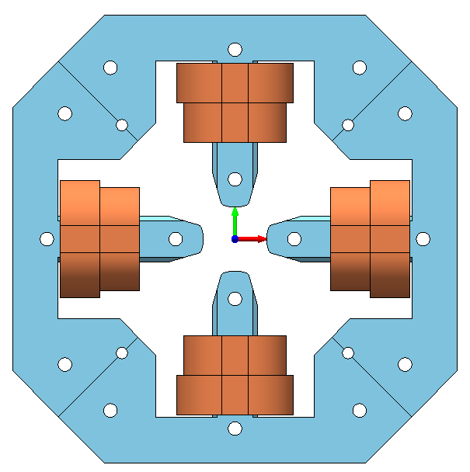

|  |  |  |  |  |  |  |  |  |
| --- | --- | --- | --- | --- | --- | --- | --- | --- |
| **Type** | **N** | **I [A]** | **E [J]** | **L [mH]** | **BI [T.m]** | **Kick(urad)** | **Resistência (Ω)**  **por Bobina** | **Resistência (Ω)**  **por Imã** |
| **QS** | 44 | 3 | 0.022909 | 5.090869 | 0.105714 |  | 0.03134 | 0.12536 |
| **CH** | 56 | 1 | 0.001922 | 3.843597 | -0.000310 | -31.026 | 0.04242 | 0.08485 |
| **CV** | 56 | 1 | 0.001922 | 3.843604 | 0.000310 | 31.026 | 0.04242 | 0.08485 |