1 Introduction 2
1.1 Purpose 2
1.2 Background 2
1.3 Definition 3
1.4 References 3
2 Overview of the Task 4
2.1 Objectives 4
2.2 User Characteristics 5
2.3 Assumptions and Constraints 6
3 Requirements Specification 6
3.1 Functional Specifications 6
3.2 Performance Specifications 9
3.3 Input/Output Requirements 10
3.4 Data Management Capability Requirements 10
3.5 Fault Handling Requirements 10
3.6 Other Specific Requirements 10
4 Operating Environment Specifications 11
4.1 Equipment 11
4.2 Supporting Software 11
4.3 Interfaces 12
4.4 Control 13

Eslay: Booking Travel Mobile App - Software Requirements Specification

1 Introduction

1.1 Purpose
This Software Requirements Specification (SRS) document provides a comprehensive architectural and operational blueprint for Eslay, the Booking Travel Mobile Application. Its primary purpose is to define the exact functional, non-functional, and environmental parameters required to engineer a cohesive platform. To ensure a highly focused and intuitive user experience, the application architecture is strictly partitioned into four primary modules: a Main Booking Dashboard, an Interactive Map, a Chronological Order Timeline, and a Personal Homepage. This document establishes the definitive baseline for the subsequent UI design and system implementation phases.

1.2 Background
Modern travelers often need to switch between multiple applications when planning a trip (e.g., finding inspiration, booking, map navigation). This project aims to develop an all-in-one, frontend-focused mobile app (integrated with BaaS/Mock data). Through a minimalist user interface, personalized recommendation feeds, flexible itinerary timelines, and an interactive map, the app aims to make trip planning simple, intuitive, and enjoyable.
A.App Name: Eslay(The name Eslay is an original brand word combined with Escape and Lay.It means escape from trivial daily life, wander toward the distance, and lay your heart in the journey.)
B.The project initiator and users: Travelling company and their users.
C.Developer: Zeqian Li, Zhongzheng Xie, Yunpeng Xu.
D.Ecological environment: Used in mobile environment.

1.3 Definition
Term/Acronym | Full Name (if applicable) | Definition
SRS | Software Requirements Specification | This document, providing a comprehensive definition of the software's requirements.
App | app | the frontend mobile application being developed in this project
MVP | Minimum Viable Product. | the simplest version of a product that delivers core value to users while allowing a team to validate assumptions and gather feedback for iterative improvement.
OTP | One-Time Password | used for SMS verification login
OAuth | Open Authorization protocol | used for Apple/Google social login
BaaS | Backend as a Service | e.g., Firebase, used to handle client-side authentication without a custom backend
POI | Point of Interest | attractions, restaurants, etc., marked as pins on the map

1.4 References
- iOS Human Interface Guidelines (Apple)
- Material Design Guidelines (Google)
- Google Maps / Mapbox SDK Official Documentation

2 Overview

2.1 Objectives
The core objective of this project is to solve specific user pain points in travel planning by delivering a high-performance, integrated frontend experience. The objectives are categorized as follows:
- Business & Product Goals:
  - One-Stop Planning: Eliminate the need for users to switch between map apps, note-taking apps, and recommendation platforms by integrating discovery, planning, and navigation into a single workflow.
  - Reduce Decision Fatigue: Utilize an algorithm-based "preference card" system to filter massive information and deliver personalized content tailored to the user's tastes.
  - Improve Planning Efficiency: Enable users to create a complete daily itinerary in under 15 minutes through an intuitive, drag-and-drop timeline interface.
- Technical & Quality Goals:
  - Extreme UI Responsiveness: Ensure zero lag (targeting 60 FPS) when loading high-resolution travel images and rendering complex map layers.
  - Architectural Scalability: Maintain a highly modular frontend architecture to allow easy integration with a proprietary backend recommendation engine in the future.
  - High-Reliability Local Sync: Ensure user itinerary data is perfectly preserved in local storage even if the app is closed or crashes.
- User Experience (UX) Goals:
  - Emotional Design: Use immersive imagery and fluid transitions to inspire the user's desire to travel.
  - Accessibility: Adhere to OS interaction guidelines, ensuring ease of one-handed operation and intuitive navigation.

2.2 User Characteristics
We segment our target audience into three typical "Personas" to guide the frontend interaction design:
- The Meticulous Planner:
  - Profile: 25-45 years old, planning family vacations or in-depth tours. Values certainty, transit times, and geographical sequences.
  - Focus: Heavily relies on Itinerary Creation (F3) drag-and-drop features and Interactive Map (F4) route drawing.
- The Social/Visual Explorer:
  - Profile: 18-25 years old (Gen Z), heavy social media users seeking "Instagrammable" locations. Dislikes text-heavy content.
  - Focus: Engages deeply with Discovery & Recommendations (F2) masonry layouts and high-quality image cards.
- The Minimalist Traveler:
  - Profile: Business or solo travelers looking for impromptu trips. Efficiency and speed are paramount.
  - Focus: Relies on One-click Login (F1) and system-generated Static Recommendations based on minimal input.

2.3 Assumptions and Constraints
- Technical Assumptions:
  - API Stability: Assumes third-party map providers (Google Maps/Mapbox) maintain stable services and compatible SDKs.
  - Hardware: Assumes target devices possess hardware graphics acceleration for smooth map and image rendering.
  - GPS: Assumes a positioning accuracy within a ±10-meter radius outdoors.
- Business Assumptions:
  - User Engagement: Assumes users are willing to spend ~30 seconds selecting preferences during onboarding for better recommendations.
  - Image Sourcing: Assumes landscape images are properly licensed or sourced from royalty-free APIs like Unsplash.
- Development Constraints:
  - Pure Frontend: All complex logic (e.g., sorting and filtering) must be computed client-side due to the absence of a custom backend.
  - Storage Limits: Local persistent storage (AsyncStorage/SharedPreferences) is limited (approx. 6-10MB), restricting the app to text-based JSON itineraries rather than full offline map tiles.
  - Network Costs: High-definition image loading requires strict thumbnail and caching strategies to minimize user data consumption.
- Compliance & Security Constraints:
  - Privacy: Must comply with regional data protection laws (e.g., GDPR) regarding geolocation data.
  - Auth Security: OAuth logic must follow standard authorization code flows; hardcoding API keys is strictly prohibited.

3 Requirements Specification

3.1 Functional Specifications
a. Qualitative description
As the core interface for the intelligent travel application, this system is responsible for handling the complete user journey from initial authentication and preference elicitation to dynamic destination discovery, itinerary management, and geographical route visualization. It must provide a highly responsive, multimedia-rich user interface while ensuring precise state management across complex interactions (such as drag-and-drop scheduling and dynamic recommendation weight adjustments). The core logic lies in processing user inputs, managing local and remote data states, and rendering interactive contextual maps.
b. IPO Form
Functional Module | Input | Process | Output
F1: Onboarding & Authentication | - Mobile number  - OTP code  - OAuth tokens (Apple/Google)  - Visual preference selections | 1. Initiate 60-second OTP countdown and auto-verify upon 6th digit entry.  2. Validate OAuth tokens to establish a secure local session.  3. Verify at least three preference tags are selected and apply visual highlight states.  4. Persist selected tags to the local ProfileStore. | - Established user session  - Initialized recommendation profile
F2: Discovery & Recommendations | - ProfileStore preference tags  - Local DestinationMockDB records  - User interaction events (Save, Click-through) | 1. Filter and sort DestinationMockDB utilizing tags from ProfileStore.  2. Render prioritized destination cards within a Masonry Grid and Horizontal Carousels.  3. Capture "Save" and "Click-through" events during the active session.  4. Dynamically recalculate recommendation weights (e.g., increasing specific tag weights upon multiple saves). | - Dynamically sorted Multimedia Content Feed  - Updated session recommendation weights
F3: Itinerary Creation & Management | - Trip metadata (Title, dates, cover image)  - User drag-and-drop gestures on timeline nodes | 1. Initialize trip state and allocate vertical scroll sections based on the specified date range.  2. Detect long-press events on itinerary nodes to trigger "Rearrange Mode" with haptic feedback.  3. Track drag coordinates and render visual lift effects.  4. Automatically recalculate the daily sequence and update local state upon node drop. | - Structured Vertical Timeline Interface  - Updated itinerary sequence state
F4: Interactive Map | - Active itinerary sequence data  - User tap events on map markers | 1. Parse active itinerary to generate coordinates for custom sequential markers (1, 2, 3...).  2. Calculate chronological paths between nodes to draw connecting Polylines.  3. Compute estimated travel distances and times for route overlays.  4. Retrieve location metadata (address, hours) upon pin tap to trigger the contextual Bottom Sheet. | - Rendered interactive map with sequential pins and polylines  - ETA label overlays  - Contextual Bottom Sheets with location details
c. System capacity requirements
Terminal support: The system shall be designed as a native or cross-platform mobile application, ensuring fluid rendering of multimedia grids, timeline interactions, and map integrations.
Performance & Rendering: The application must handle high-resolution image caching efficiently without memory leaks. The interactive map (F4) and drag-and-drop components (F3) must maintain a stable render rate to ensure smooth, responsive interactions.
Data Concurrency: The system must accurately synchronize dynamic interaction tracking (F2) and local state updates (F3) in real-time, supporting seamless transitions between the timeline view and the map visualization without data desynchronization.
d. UML use case diagram

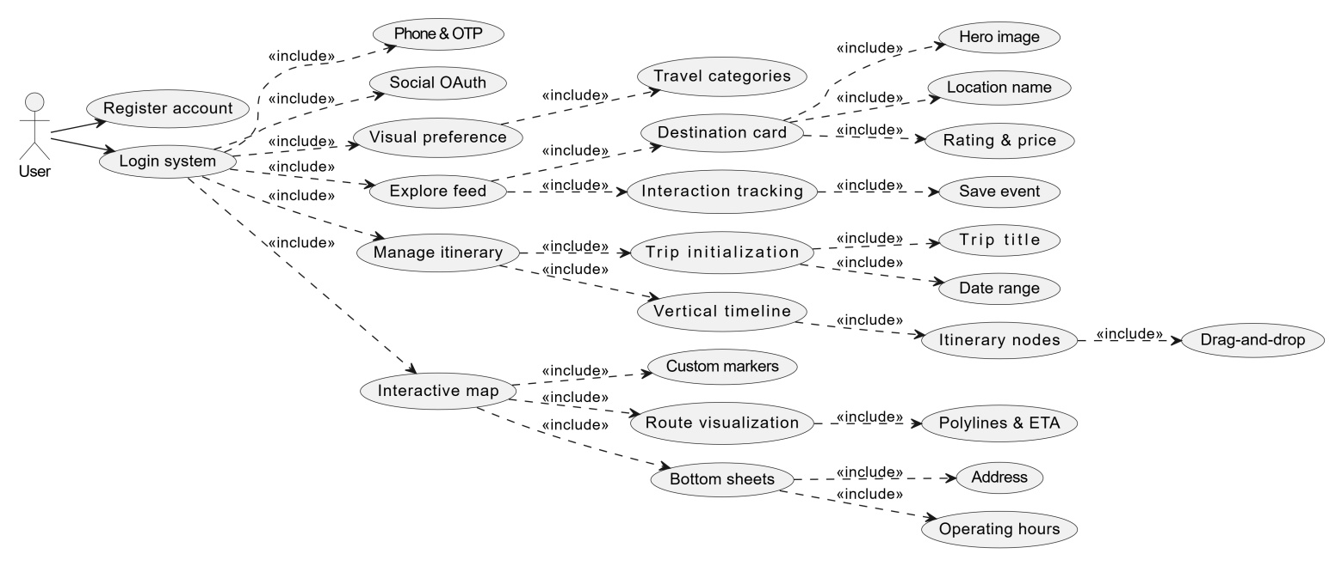

3.2 Performance Specifications
- Rendering Performance: The application must maintain a steady 60 FPS (Frames Per Second) during list scrolling and map manipulations.
- Image Optimization:
  - Implement Progressive Loading (blur-up effect) to improve perceived speed.
  - Aggregate image caching to ensure that previously viewed destinations load instantly (under 200ms) during the same session.
- Memory Management: The app should not exceed 300MB of RAM usage during active map interaction on mid-range devices.

3.3 Input/Output Requirements
- Input: Multi-touch gestures (pinch-to-zoom, two-finger rotate), biometric input (FaceID/Fingerprint for quick login), and voice-to-text for search bars.
- Output: Tactical Haptic Feedback for successful drags and deletions, push notifications for itinerary reminders, and high-fidelity UI animations.

3.4 Data Management Capability Requirements
- JSON Schema Integrity: All itinerary data must follow a standardized JSON structure to ensure compatibility between the Timeline view and the Map view.
- Local Persistence: Data must be auto-saved every time a change is made to the itinerary (Debounced Save) to prevent data loss.

3.5 Fault Handling Requirements
- Network Resiliency: In the event of a lost connection, the app shall switch to Read-Only Offline Mode, displaying a "Cached Data" badge.
- Graceful Degradation: If the Map SDK fails to load, the app shall provide a "List View" fallback for the itinerary without crashing.
- Input Validation: The system shall intercept and block invalid date ranges (e.g., end date before start date) with a non-intrusive Toast message.

3.6 Other Specific Requirements
- Localization Support: The frontend architecture must support i18n (Internationalization) for future expansion into multiple languages.
- Dark Mode Support: The UI shall automatically toggle between Light and Dark themes based on system settings, with specific emphasis on high-contrast map styles for night use.

4 Operating Environment Specifications

4.1 Equipment
The application requires specific hardware capabilities to ensure smooth map rendering and fluid UI animations without frame drops.
- Target Devices:
  - iOS: iPhone 8 and newer models (requires Apple A11 Bionic chip or better).
  - Android: Devices with ARM64 architecture, equivalent to Snapdragon 660 or higher performance tiers.
- Sensors & Hardware:
  - GPS Module: Required for real-time location tracking and accurate route distance calculations.
  - Haptic Engine: Requires a linear motor or vibration module to trigger physical feedback during drag-and-drop actions in the itinerary module.
- Display Constraints:
  - Minimum Resolution: 320x568 pixels (e.g., iPhone SE 1st Generation).
  - Safe Area Insets: The UI must dynamically adapt to system-defined safe areas, ensuring compatibility with notches, hole-punch displays, and dynamic islands.

4.2 Supporting Software
- Client Operating Systems:
  - iOS: Version 14.0 and above.
  - Android: Version 8.0 (API Level 26) and above.
- Frontend Frameworks:
  - React Native: Version 0.72+ (utilizing the New Architecture/Fabric for better UI thread performance).
  - OR Flutter: Version 3.10+ (utilizing the Impeller rendering engine for jank-free 60fps map overlays).

4.3 Interfaces
- Interface with Booking Travel Mobile App

As a frontend-centric application relying on BaaS, strict interface definitions for third-party SDKs are mandatory.
- BaaS & Authentication Interfaces:
  - Integration with Firebase Authentication SDK via RESTful APIs or native RPC channels for secure token exchange, SMS OTP handling, and session persistence.
- Mapping & Location APIs:
  - Integration with Google Maps SDK (for iOS/Android) or Mapbox Maps SDK v10+.
  - The client must dynamically switch between development and production API keys based on the current build environment.
- Native Bridge Interfaces:
  - Access to system-level APIs for Local Storage (e.g., UserDefaults on iOS, SharedPreferences on Android) for caching the JSON itinerary schemas.
  - Access to OS-level Biometric APIs (FaceID/TouchID) to support rapid, secure re-authentication.
- UML Component diagram
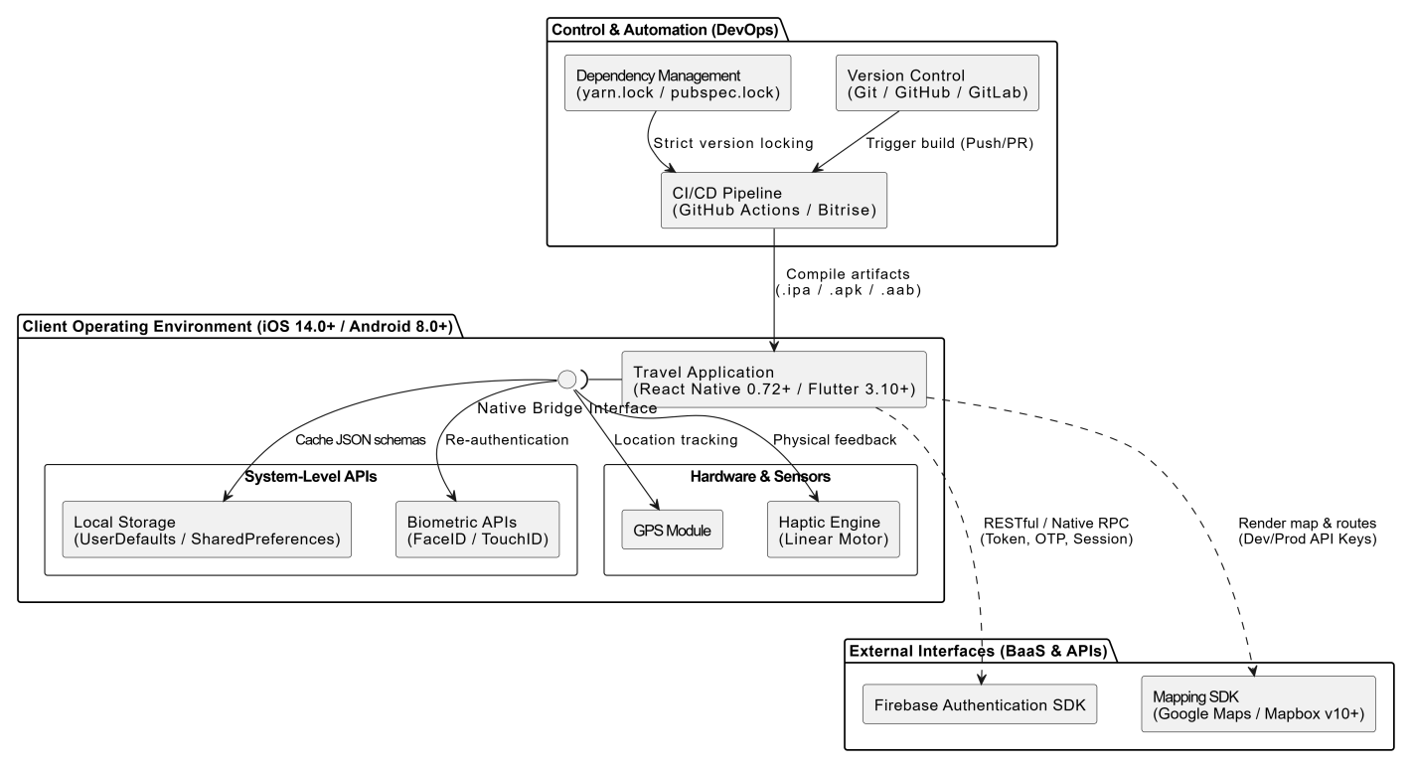

4.4 Control
- Version Control:
  - Source code managed via Git (hosted on GitHub or GitLab).
  - Adherence to GitFlow or GitHub Flow branching strategies. The `main` branch must be protected by mandatory Code Review (Pull Request) policies.
- CI/CD Automation:
  - Pipelines configured via GitHub Actions or Bitrise.
  - Automated triggers upon every push to run code linting (ESLint/Dart Lint), unit tests, and compile `.ipa` (iOS) and `.apk/.aab` (Android) builds.
- Dependency Management:
  - Strict version locking is required to prevent build failures from unexpected minor version updates of third-party libraries.
  - Must commit and maintain lockfiles: yarn.lock (for React Native) or pubspec.lock (for Flutter).
